Light – Reflection And Refraction

in-text-1

Q1 Define the principal focus of a concave mirror.

Answer. The principal focus of a concave mirror is a point on its principal axis to which all the light rays which are parallel and close to the axis, converge after reflection from the concave mirror.

Q2 The radius of curvature of a spherical mirror is 20 cm. What is its focal length? Answer. Focal length = 2 x Radius of curvature = 2 x 20 cm = 10 cm

Q3 Name a mirror that can give an erect and enlarged image of an object.
Answer. Concave mirror.

Q4 Why do we prefer a convex mirror as a rear-view mirror in vehicles?

Answer.
We prefer a convex mirror as a rear-view mirror in vehicles because of two reasons -1. A convex mirror always produces an erect image of the objects. 2 The image formed in a convex mirror is highly diminished or much smaller than the object, due to which a convex mirror gives a wide field of view of the traffic behind. A convex mirror enables the driver to view such larger area of the traffic behind him.

in-text-2

Q1 Find the focal length of a convex mirror whose radius of curvature is 32 cm.Answer:

Answer:
Radius of curvature, R = 32 cm
Radius of curvature = 2 × Focal length (f)
R = 2f
f = R/2 = 32/2 = 16cm

Hence, the focal length of the given convex mirror is 16 cm.

Q2 A concave mirror produces three times magnified (enlarged) real image of an object placed at 10 cm in front of it. Where is the image located?

Answer:
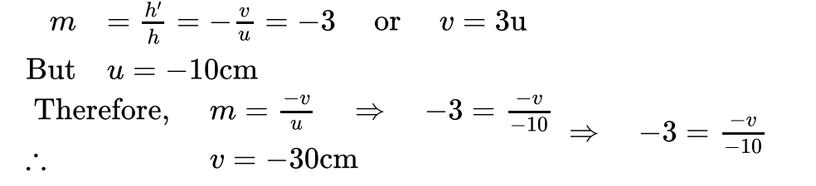
in-text-3

Q1 A ray of light travelling in air enters obliquely into water. Does the light ray bend towards the normal or away from the normal? Why?

Answer.
The light-ray bends towards the normal because the ray of light goes from a rarer medium to a denser medium.

Q2 Light enters from air to glass having refractive index 1.50. What is the speed of light in the glass?

Answer:
The speed of light in vacuum is 3 × 108 m s–1.
Refractive index of a medium n{subscript}m is given by,
n{subscript}m = Speed Of light in vacuum/ Speed of Light in the medium = c/v Speed of light in vacuum, c = 3 × 10^8 m s−1
Refractive index of glass, n{subscript}g = 1.50
Speed of light in the glass, v = Speed of light in Vacuum/Refractive index of glass v = c/ n{subscript}g
= 3 x 10^8/1.50 = 2 x 10^8 ms^-1

Thus, speed of light in the glass = 2 x 10^8 ms^-1

Q3 Find out, from Table 10.3, the medium having highest optical density. Also find the medium with lowest optical density.

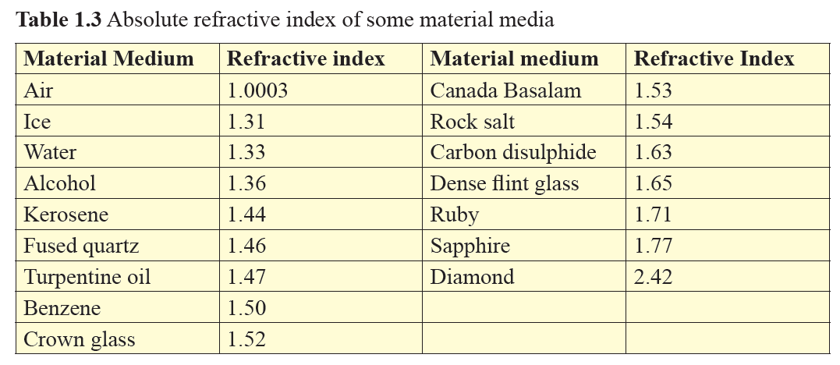

Answer.
From table 10.3, diamond has highest refractive index (- 2.42), so it has highest optical density. Air has lowest refractive index 1.0003), so it has lowest optical density.

Q4 You are given kerosene, turpentine and water. In which of these does the light travel fastest? Use the information given in Table 10.3.



Answer.
For kerosene, n = 144 For turpentine, n 1.47 For water, n - 1.33 Because water has the lowest refractive index, therefore light travels fastest in this optically rarer medium than kerosene and turpentine oil.

Q5 The refractive index of diamond is 2.42. What is the meaning of this statement?

Answer.
By saying that the refractive index of diamond is 2.42, we mean that the speed of light in diamond is lower by a factor of 2.42 relative to that in vacuum.

in-text-4

Q1 Define 1 dioptre of power of a lens.
Answer. One dioptre is the power of a lens whose focal length is 1 metre.
Q2. A convex lens forms a real and inverted image of a needle at a distance of 50 cm from it. Where is the needle placed in front of the convex lens if the image is equal to the size of the object? Also, find the power of the lens.

Answer.
When an object is placed at the centre of curvature, 2F{subscript}1, of a convex lens, its image is formed at the centre of curvature, 2F{subscript}2, on the other side of the lens. The image formed is inverted and of the same size as the object.
It is given that the image of the needle is formed at a distance of 50 cm from the convex lens. Hence, the needle is placed in front of the lens at a distance of
50 cm.
Object distance, u = −50 cm Image distance, v = 50 cm Focal length = f
According to the lens formula,

Hence, the power of the given lens is +4 D.

Q3 Find the power of a concave lens of focal length 2 m.

Answer.

Focal length of concave lens, f = 2 m

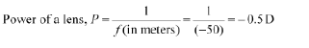

Here, negative sign arises due to the divergent nature of concave lens.
Hence, the power of the given concave lens is −0.5 D.
Exercise

Q1 Which one of the following materials cannot be used to make a lens? (a) Water (b) Glass (c) Plastic.
- Water
- Glass
- Plastic
- Clay

Answer.
(d) Clay

Q2 The image formed by a concave mirror is observed to be virtual, erect and larger than the object. Where should be the position of the object?
(a) Between the principal focus and the centre of curvature
(b) At the centre of curvature
(c) Beyond the centre of curvature
(d) Between the pole of the mirror and its principal focus.

Answer.
(d) Between the pole of the mirror and its principal focus.
Q3 Where should an object be placed in front of a convex lens to get a real image of the size of the object?
(a) At the principal focus of the lens
(b) At twice the focal length
(c) At infinity
(d) Between the optical centre of the lens and its principal focus.

Answer.
(b) At twice the focal length.
Q4 A spherical mirror and a thin spherical lens have each a focal length of –15 cm. The mirror and the lens are likely to be
(a) both concave.
(b) both convex.
(c) the mirror is concave and the lens is convex.
(d) the mirror is convex, but the lens is concave.

Answer. (a) Both concave

Q5 No matter how far you stand from a mirror, your image appears erect. The mirror is likely to be.
(a) only plane.
(b) only concave.
(c) only convex.
(d) either plane or convex.

Answer (d) Either plane or convex.

Q6 Which of the following lenses would you prefer to use while reading small letters found in a dictionary?
- A convex lens of focal length 50 cm.
- A concave lens of focal length 50 cm.
- A convex lens of focal length 5 cm.
- A concave lens of focal length 5 cm.

Answer. (c) A convex lens of focal length 5 cm.
Q7 We wish to obtain an erect image of an object, using a concave mirror of focal length 15 cm. What should be the range of distance of the object from the mirror? What is the nature of the image? Is the image larger or smaller than the object? Draw a ray diagram to show the image formation in this case.

Answer.
A concave mirror gives an erect image when the object is placed between the focus F and the pole P of the concave mirror, i.e., between 0 and 1 5 cm from the mirror. The image thus formed will be virtual, erect and larger than the object. A'

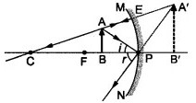

Q8 Name the type of mirror used in the following situations.
(a) Headlights of a car.
(b) Side/rear-view mirror of a vehicle.
(c) Solar furnace. Support your answer with reason.

Answer.
(a) Concave mirrors are used as reflectors in headlights of cars. When a bulb is located at the focus of the concave mirror, the light rays after reflection from the mirror travel over a large distance as a parallel beam of high intensity.
- A convex mirror is used as a side/rear-view mirror of a vehicle because A convex mirror always forms an erect, virtual and diminished image of an object placed anywhere in front it. A convex mirror has a wider field of view than a plane mirror of the same size.
- Large concave mirrors are used to concentrate sunlight to produce heat in solar furnaces.

Q9 One-half of a convex lens is covered with a black paper. Will this lens produce a complete image of the object? Verify your answer experimentally. Explain your observations.

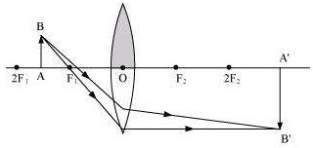
Answer. A convex lens forms complete image of an object, even if its one half is covered with black paper. It can be explained by considering following two cases. Case I When the upper half of the lens is covered In this case, a ray of light coming from the object will be refracted by the lower half of the lens. These rays meet at the other side of the lens to form the image of the given object, as shown in the following figure.

Case II: When the lower half of the lens Is covered In this case, a ray of light coming from the

object is refracted by the upper half of the lens. These rays meet at the other side of the lens to form the image of the given object, as shown in the given figure.

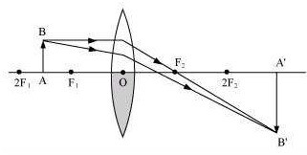

Q10 An object 5 cm in length is held 25 cm away from a converging lens of focal length 10 cm. Draw the ray diagram and find the position, size and the nature of the image formed.

Answer.

Object distance, u = −25 cm Object height, ho = 5 cm Focal length, f = +10 cm According to the lens formula:
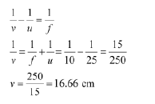

The positive value of v shows that the image is formed at the other side of the lens. Magnification m = -Image distance/Object Distance = -v/u = -16.66/25 = -0.66

The negative sign shows that the image is real and formed behind the lens. Magnification m = Image Height/Object Height = H1/H0 = H1/5
H1 = m x H0 = -0.66 x 5 = -3.3 cm

The negative value of image height indicates that the image formed is inverted. The position, size, and nature of image are shown in the following ray diagram.

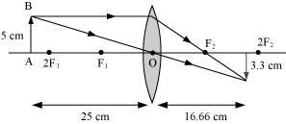

Q11 A concave lens of focal length 15 cm forms an image 10 cm from the lens. How far is the object placed from the lens? Draw the ray diagram.

Answer.

Focal length of concave lens (OF{subscript}1), f = −15 cm Image distance, v = −10 cm
According to the lens formula
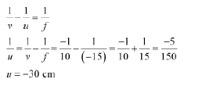

The negative value of u indicates that the object is placed 30 cm in front of the lens. This is shown in the following ray diagram.
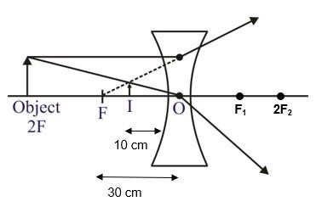

Q12 An object is placed at a distance of 10 cm from a convex mirror of focal length 15 cm. Find the position and nature of the image.

Answer.

Focal length of convex mirror, f = +15 cm Object distance, u = −10 cm
According to the mirror formula,
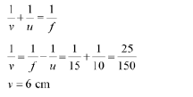

The positive value of v indicates that the image is formed behind the mirror.


The image is located at a distance 6 cm from the mirror on the other side of the mirror.
The positive and value less than 1 of magnification indicates that the image formed is virtual, erect and diminished

Q13 The magnification produced by a plane mirror is +1. What does this mean?

Answer.
Magnification produced by a mirror is given by the relation
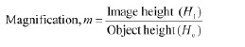

The magnification produced by a plane mirror is +1. It shows that the image formed by the plane mirror is of the same size as that of the object. The positive sign shows that the image formed is virtual and erect.

Q14 An object 5.0 cm in length is placed at a distance of 20 cm in front of a convex mirror of radius of curvature 30 cm. Find the position of the image, its nature and size.

Answer.

Object distance, u = −20 cm Object height, h = 5 cm
Radius of curvature, R = 30 cm Radius of curvature = 2 × Focal length R = 2f
f = 15 cm
According to the mirror formula,
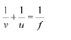

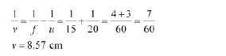

The positive value of v indicates that the image is formed behind the mirror.

The positive value of image height indicates that the image formed is erect. Therefore, the image formed is virtual, erect, and smaller in size.

Q15 An object of size 7.0 cm is placed at 27 cm in front of a concave mirror of focal length 18 cm. At what distance from the mirror should a screen be placed, so that a sharp focussed image can be obtained? Find the size and the nature of the image.

Answer.
Object distance, u = −27 cm
Object height, h = 7 cm
Focal length, f = −18 cm
According to the mirror formula:

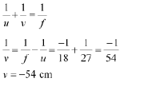

The screen should be placed at a distance of 54 cm in front of the given mirror.



The negative value of magnification indicates that the image formed is real.

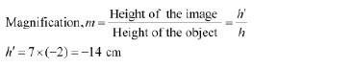

The negative value of image height indicates that the image formed is inverted.

Q16 Find the focal length of a lens of power – 2.0 D. What type of lens is this?

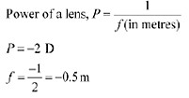

A concave lens has a negative focal length. Hence, it is a concave lens.

Q17 A doctor has prescribed a corrective lens of power +1.5 D. Find the focal length of the lens. Is the prescribed lens diverging or converging?

Answer
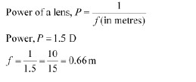

A convex lens has a positive focal length. Hence, it is a convex lens or a converging lens.

