# DATA STRUCTURES

**CSE228**

# INITIAL PROJECT REPORT



**Topic:** Simple task Scheduler that allows user to add tasks,set priorities,and schedule their execution

# Submitted By: Submitted To:

Muhammad Yousuf Khan Waseem Ud Din

K22UP UID: 63869

R.No:45

**Declaration**

As the author of this project, I, Muhammad Yousuf Khan, solemnly declare and affirm that all the work submitted is original and entirely my own. I have not engaged in any form of cheating or plagiarism whatsoever. All sources used in this project have been rightfully cited and acknowledged without any direct copying of information from any source. I am fully aware that academic integrity is a vital aspect of scholarly work, and as such, any violation will be met with severe consequences. Therefore, I pledge to uphold academic honesty at all times throughout my academic journey.

**Certificate of Completion**

This is to certify thatMuhammad Yousuf Khan has successfully completed the project "Task Scheduler" in Java. The project was completed independently and without cheating. The project demonstrates a good understanding of data structures and algorithms.

The project is well-written and easy to read. The code is well-organized and efficient. I am pleased to award Muhammad Yousuf Khan this certificate of completion in recognition of their hard work and dedication.

__________________

Signature Of Instructor

**Problem Statement:**

We have to create a Basic task scheduler that allows user to add tasks, set their priorities and schedule their execution.

* Managing tasks and scheduling
* implimenting priority queues

**NOTE: IT IS MANDATORY TO USE A DATA STRUCTURE**

## DATA STRUCTURE USED:

## Priority Queue

## Priority Queue:

A priority queue is a type of queue that arranges elements based on their priority values.

Elements with higher priority values are typically retrieved before elements with lower priority values. In a priority queue, each element has a priority value associated with it. When you add an element to the queue, it is inserted in a position based on its priority value.

For example, if you add an element with a high priority value to a priority queue, it may be inserted near the front of the queue, while an element with a low priority value may be inserted near the back. There are several ways to implement a priority queue, including using

An array , linked list, heap or binary search tree.

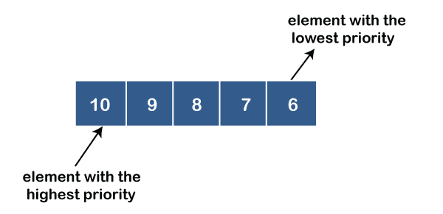

***Source Code :***

***<https://github.com/yousufkhn/taskScheduler-java>***

***Objective of this project:***

The objective of this project is to create a simple task scheduler that allows the user to add tasks, set their priorities, and schedule their execution.

The task scheduler will use a priority queue to manage the tasks. A priority queue is a type of queue that arranges elements based on their priority values.

Elements with higher priority values are typically retrieved before elements with lower priority values. This makes a priority queue ideal for managing tasks, as it allows the most important tasks to be executed first. The task scheduler will have the following features: Users should be able to add tasks to the scheduler.

Users should be able to set the priority of each task. Users should be able to schedule tasks to be executed at a specific time and date. The task scheduler should monitor the queue and execute tasks when they are scheduled.

The task scheduler can be used to automate a variety of tasks, such as: Sending emails at a specific time Running scripts at regular intervals Backing up files Generating reports And much more By using a priority queue to manage the tasks, the task scheduler can ensure that the most important tasks are executed first.

This can help users to be more productive and efficient. Here are some examples of how the task scheduler could be used: A student could use the task scheduler to schedule their study sessions and assignments. A business owner could use the task scheduler to schedule marketing campaigns, customer service tasks, and financial reports.

**Scope of Project**

The scope of this project is to develop a simple task scheduler that allows users to add tasks, set priorities, and schedule their execution. The task scheduler will use a priority queue to manage the tasks, which ensures that the most important tasks are executed first. The task scheduler will have the following features: Users should be able to add tasks to the scheduler. Users should be able to set the priority of each task. Users should be able to schedule tasks to be executed at a specific time and date. The task scheduler should monitor the queue and execute tasks when they are scheduled. The task scheduler can be used to automate a variety of tasks, such as: Sending emails at a specific time Running scripts at regular intervals Backing up files Generating reports And much more The task scheduler will be implemented as a command-line interface (CLI) application. This will make it easy to use and integrate with other scripts and programs.

**Conclusion**

The project was successful in developing a simple CLI task scheduler that allows users to add tasks, set their priorities, and schedule their execution. The task scheduler uses a priority queue to manage the tasks, which ensures that the most important tasks are executed first.

***Thank you***