**HTML**

HTML = Hyper Text Markup Language

What is the work of HTML in browser?

Where we write HTML for executing in browser?

**Notepad, Nodepad++, visual studio code, Atom, Sublime, etc**

What is Developer Tool?

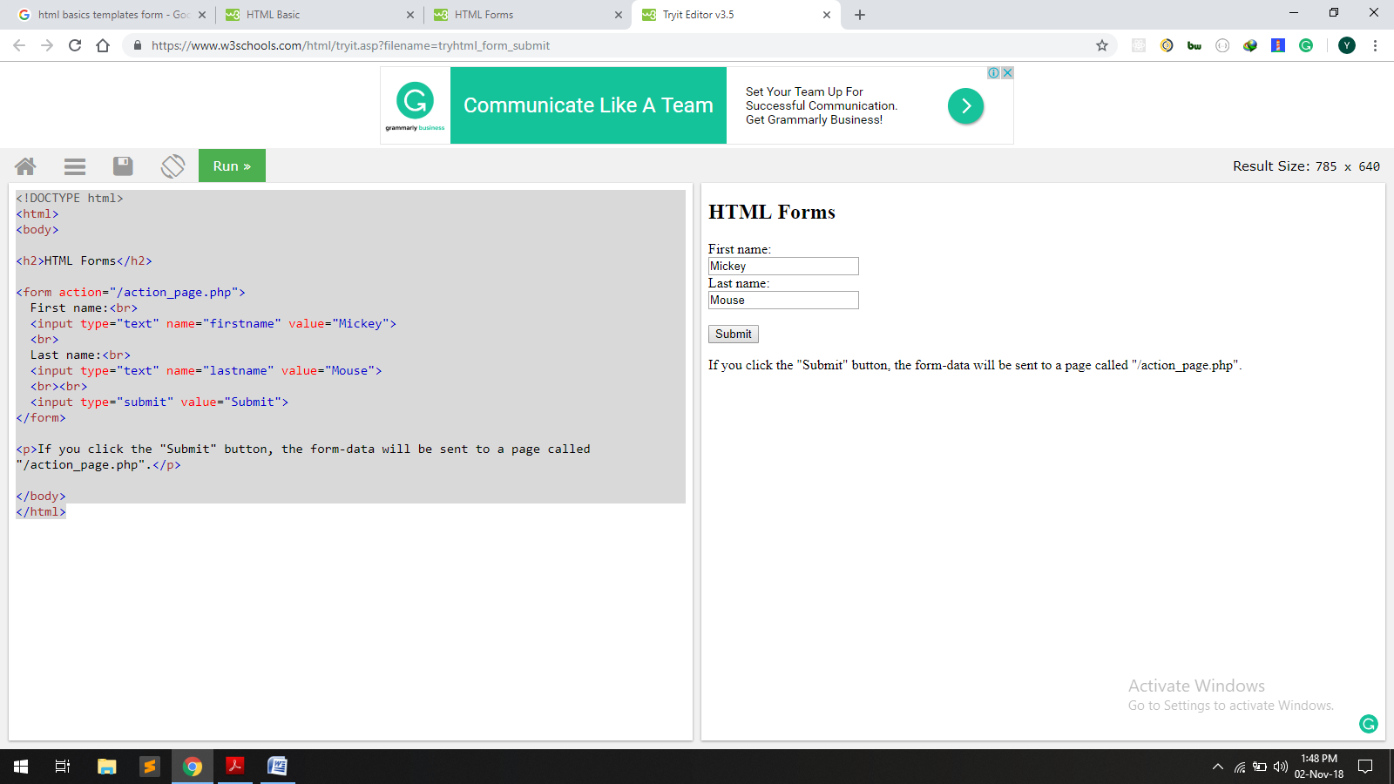

How we can save HTML file?

# This is the main heading

This is the normal text

## This is the second level heading

This is the normal text

### This is the third level heading

This is the normal text