ENERGIZE

Youth Energy Commission, IIT Kharagpur

February 2014

Note: The name of the newsletter is still being discussed. I encourage all members to come up with something good and post it on the page. All of us can select the best option. I have posted this message on the facebook page and I am hoping for some good suggestions from everyone!

Cover story: We plan to write a cover story about the Triangle of Academicians – Government – Industry with some illustrations and past achievements due to the completion of this triangle.

Cover story continued.

An article about technical terms that are used in the energy sector and unknown to the masses(like per capita consumption, measurement of power, working of electrical household meters etc)

An article about an energy start up like (O Energy, , etc). Every month we will write an article about a start up and try to contact people working or people who are associated with the startup. (May not be possible all the time, but we can try our best)

An article about renewable sources of energy. We will select any one resource every issue and give a comprehensive study about the merits and the demerits(if any) of the system and how feasible it is and at what level.

Optionally, we may write something about activities inside the campus related to energy. Recent guest lectures, workshops, achievements by KGPians in the energy sector etc.

Article about new research and achievements in the field of renewable sources and optimization and increase of efficiency of renewable sources for daily household and industrial use.

An article about examples of usage of non-renewable sources efficiently and in a useful manner.

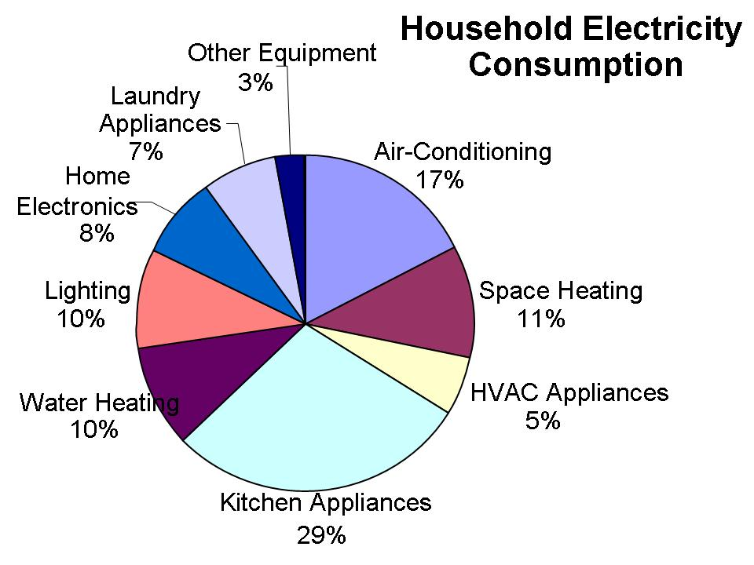

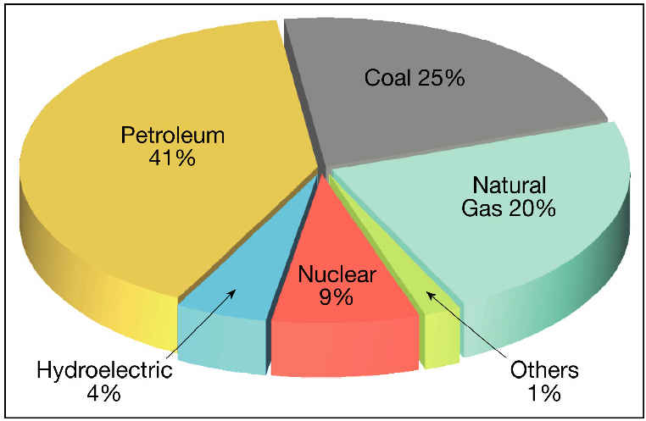

We will add some more graphs and illustrations that will force the reader to think about the usage of energy and will probably create an awareness in him/her about the efficient use of energy. We may try to conduct a survey about the use of energy inside the campus or talk with related people inside the campus. We can think about this once we are two-three issues into the newsletter.