# Meeting Analysis

### Speaker Analysis

Spoke the most: SPEAKER_02 (690.91 seconds)

Spoke the least: SPEAKER_04 (24.57 seconds)

Average speaking time: 297.07 seconds

### Common Triagrams

1st common trigram:('ready', 'ready', 'ready'), (Count:50 )

2nd common trigram:('like', 'feel', 'little'), (Count:18 )

### Sentiment Analysis

Positivity Score: 0.270

Neutrality Score: 0.518

Negativity Score:0.213

### Word Frequency

Total Word Count: 1980

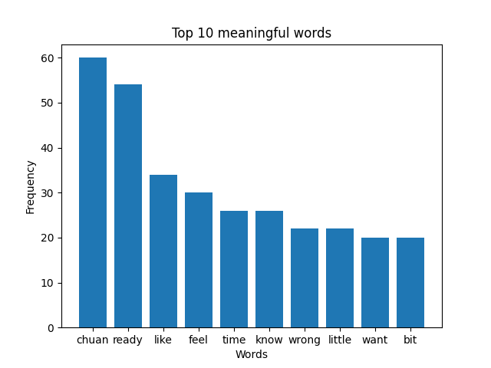

### Word Cloud

