# Medication Administration Form

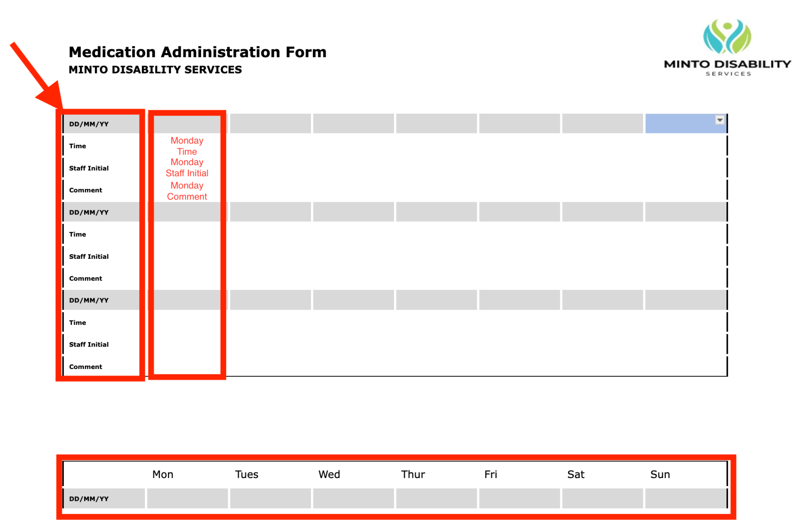

Notice the days of the week running horizontal to and the other information running vertically. Your response should correlate horizontally to the day of reference and vertically for the information you are providing. Only enter information horizontally and not diagonally across the other days.