**Minto Disability Services - Onboarding Guide**

**Getting Started with ShiftCare**

Welcome to Minto Disability Services! This guide will walk you through using the ShiftCare app, which is an integral part of managing your shifts, timesheets, and client interactions

**Setting Up Your Account**

● **Email Invitation**: Look for an invitation in your email to join ShiftCare. Follow the instructions to set up your account.

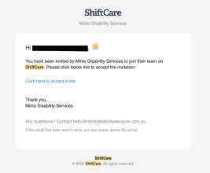

**Download the App:** A follow-up email will guide you to download the ShiftCare app from the Apple Store or Google Play.

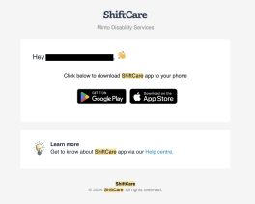

**Accessing Your Roster**

After setting up your account, you’ll use the ShiftCare app to access your roster. Here’s how to get started:

**My Schedule**

● **First View**: Upon opening the app, you'll see 'My Schedule' with a weekly calendar showing your assigned shifts.

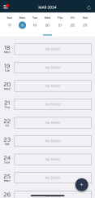

● **Viewing the Full Calendar**: Drag the bottom of the calendar to expand and view the full calendar. Navigate to different dates as needed.

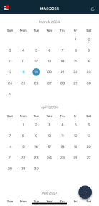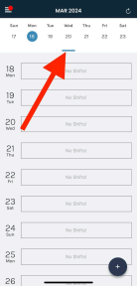

● **Assigned Shifts**: Your assigned shifts will automatically populate in the calendar. 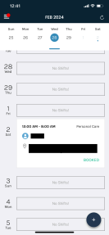

**During Your Shift**

Interacting with the app before and during your shift is crucial for accurate timesheet recording. **Clocking In and Out**

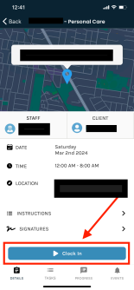

● **Timing**: You must clock in 5 minutes before and clock out immediately after your shift. ● **Double Shift**: When doing a double shift, you must clock in and clock out of the first shift before the second shift starts, then you must clock in and out of the second shift individually for both shifts to count.

● **Window for Clocking In**: You can clock in up to three hours before the scheduled shift starts and anytime during the shift, as long as it hasn't ended.

● **Window for Clocking Out**: After your shift ends, you have a 6-hour window to clock out, provided you clocked in successfully.

**Taking Breaks**

● **Mandatory Break**: Each shift has a mandatory 30-minute break assigned to them. The default timesheet reflects a 7.5-hour workday.

● **Opting Out**: If you have opted out of the break, your shift is logged as an 8-hour workday. ● **Progress Note**: Add a progress note during your shift indicating the time you took your break.

**Leaving Notes**

● **Finding the Option**: At the bottom of the shift detail, you’ll see tabs for details, tasks, progress, and events.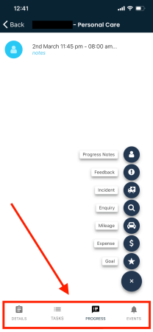

● **Adding a Note**: Select 'Progress' and then tap the plus icon to access options for documenting

shift events.

**Types of Notes**

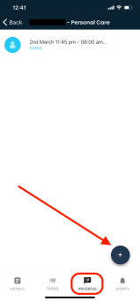

● **Progress Notes**: Leave multiple notes during the shift to document ongoing progress or important details.

● **Feedback**: Provide suggestions on what could be improved for client care. ● **Incident**: Report any incidents that occur during your shift.

● **Enquiry**: Note any questions or clarifications you had during your shift. ● **Mileage**: Enter the distance you drove during the shift. This will be reimbursed and included in your payslip.

● **Expenses**: Log any personal funds spent on the client for reimbursement.

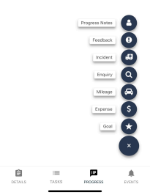

Please ensure that all notes and entries are made in the correct timesheet and using the appropriate options provided within the ShiftCare app.

For further assistance or questions, don't hesitate to contact hello@mintodisabilityservices.com.au. We are committed to helping you succeed and providing the best care to our clients. Welcome to the team!

**Need Help?**

If you encounter any issues or have questions, please reach out to hello@mintodisabilityservices.com.au for assistance. Our goal is to make your transition to ShiftCare as smooth as possible.