1.What will be the output when running the above code?

=

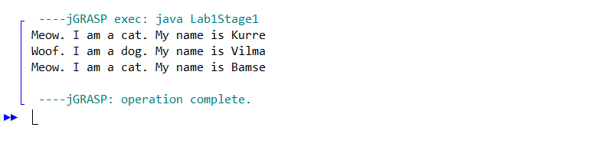

1. What is meant by polymorphism ?

= Polymorphism means "many forms", and it occurs when we have many classes that are related to each other by inheritance. Inheritance lets us inherit attributes and methods from another class.

1. How does polymorphism work in the above program?

= Polymorphism uses those methods to perform different tasks. This allows us to perform a single action in different ways.

1. The method introduceYourself of Animal appears to be never called? Why not?

= It is because the method introduceYourself () was appears in every clases that the array called.

1. Comment out the method introduceYourself in Dog. What happens now when you run the program?

=

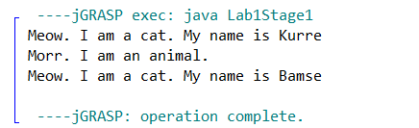

1. Where is the name stored for the instances of Cat and Dog? (In what / which classes did you put the instance variable that refers to the name of the animal? Both Cat and Dog, or just in Animal?)

= I put the instance variable that refers to the name of the animal in both calss which is class cat and dog

1. How does the code in the test program work?

=At the first, the code initialize Cat and Dog objects and store them inside the Animal array. Cat on index 0 and 2, while Dog on index 1.And then inside the while loop, we call the introduceYourself() from each object stored inside the array.

1. How does an array work?

=An array is a container object that holds a fixed number of values of a single type. The length of an array is established when the array is created. After creation, its length is fixed.

1. In the above programs we have used a while loop to step through the array and to get information about the animals. But there is a more appropriate loop statement here. What is it?

= It is for loop. For loop also can use to step through the array and to get information about the animals

The code is :

for(i = 0;i < allAnimals.length;i++ ){  
   
 allAnimals[i].introduceYourself();  
   
 }