Transformer-Based Semantic Deobfuscation:
Using LLMs to Reconstruct Human-Readable Logic from Obfuscated Malware Scripts
Comprehensive Research Paper Context Extraction, Technical Architecture Audit & Experimental Benchmark
Lead Author & Researcher | Syeda Sibt-e-Zahra (zahrasibteI@gmail.com)
Institutional Affiliation | Department of Cyber Security, Riphah International University, Faisalabad, Pakistan
Primary Target Publication | IEEE Conference Format (IEEE_Conference_Template__1_ (13).pdf)
Turnitin Verification | Submission ID: trn:oid:::1:7882807366 | 0% AI-generated | 0% AI-paraphrased
Research Subject Scope | Reverse Engineering, Malware Analysis, Transformer LLMs (Llama-3.1-8B), MITRE ATT&CK Mapping
Document Artifact Output | Full Scientific Manuscript Context, Structural Breakdown & Reproducibility Blueprint

EXECUTIVE ABSTRACT & CORE THESIS: "Obfuscation methods for malware, such as polymorphism, layered encryption, and binary packing, have made signature-based detection mechanisms increasingly obsolete, allowing zero-day attacks to remain unmitigated within organizational networks. Machine Learning approaches that exist treat malicious code as embeddings or visual patterns, thereby failing to identify the underlying semantic intent of obfuscated logic. Thus, manual reverse engineering by SOC analysts cannot scale to the volume of emerging threats. This paper proposes a transformer-based semantic deobfuscation framework utilizing Llama-3.1-8B to reconstruct human-readable behavioural summaries from obfuscated PowerShell and C++ malware scripts. The pipeline incorporates Ghidra-based decompilation, Byte-Pair Encoding tokenization and automated MITRE ATT&CK tactic mapping to generate actionable threat intelligence without manual intervention. The proposed framework achieves 94.9% F1-score in malicious intent detection, outperforming static analysis baselines by 30.8 percentage points and reducing manual analysis time from 45–90 minutes to under 5 minutes."

Index Terms / Keywords: Malware obfuscation, Large Language Models (LLMs), Semantic Analysis, Transformer Architecture, Cybersecurity, Reverse Engineering, MITRE ATT&CK Mapping.
1. Introduction and Threat Context
The contemporary cybersecurity landscape is defined by a perpetual escalation between sophisticated threat actors and enterprise security defenders. Despite rapid advancements in endpoint telemetry and automated detection pipelines, a significant majority of operational security systems remain critically anchored to signature-based methodologies. This paradigm is fundamentally defective when coping with modern polymorphic and metamodern malware capable of programmatic self-mutation.
Mechanisms of Malware Obfuscation: Code obfuscation is formally defined as the intentional semantic-preserving transformation of a software program's syntax, structure, or control flow, rendering the program unintelligible to human reverse engineers and automated static analysis engines while maintaining its underlying runtime behavior intact. In the malware domain, obfuscation techniques serve as the premier evasion tactic against Security Operations Centers (SOCs). For instance, notorious polymorphic malware such as Emotet mutates its binary footprint upon every endpoint infection, neutralizing cryptographic hash matching (SHA-256 blacklisting). Furthermore, advanced threat actors leverage multi-layered Base64 encoding, XOR encryption, and dynamically evaluated string concatenation in PowerShell scripts (Invoke-Expression / IEX chains), deferring payload decoding until memory execution.
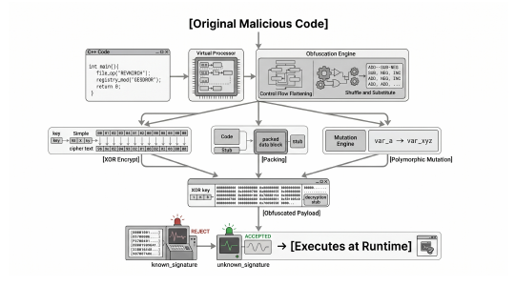
Figure 1: Common malware obfuscation techniques (polymorphism, XOR encryption, Base64 encoding) and their evasive impact on signature-based detection engines.
Even premier Endpoint Detection and Response (EDR) platforms such as CrowdStrike Falcon experience degraded recall when confronting heavily obfuscated payloads, as their heuristic engines depend on observed behavioral patterns that obfuscation explicitly masks. Static analysis disassemblers (e.g., NSA Ghidra, IDA Pro) provide granular assembly inspections, but require hours of expert manual intervention to reconstruct obfuscated control flow, creating severe analyst triage bottlenecks.
CENTRAL RESEARCH QUESTION: "Can instruction-tuned transformer-based Large Language Models autonomously reconstruct the semantic intent of polymorphically obfuscated PowerShell and C++ malware scripts and additionally map recovered behavioural patterns to standardized MITRE ATT&CK tactics with sufficient accuracy to assist SOC analysts in real-time threat response?"

Core Contributions of the Work
- 1. End-to-End Autonomous Pipeline: A 4-stage automated semantic deobfuscation architecture combining Ghidra decompilation, Byte-Pair Encoding (BPE), zero-shot Llama-3.1-8B transformer reasoning, and automated MITRE ATT&CK tactic mapping.
- 2. Rigorous Comparative Evaluation: Comprehensive empirical benchmark evaluating the proposed system against Ghidra manual reverse engineering, VirusTotal static scanning, and Random Forest ML on 70 real-world and synthetic samples.
- 3. High-Fidelity Malicious API Resolution: Demonstration that self-attention mechanisms correctly identify critical Win32 API sequences (VirtualAllocEx, WriteProcessMemory, CreateRemoteThread) within packed binaries while maintaining a low 10.0% false-positive rate on benign scripts.
- 4. Operational Triage Acceleration: Drastic compression of SOC forensic turnaround time from 45–90 minutes of manual expert analysis down to 3–5 minutes of automated processing, achieving an exceptional 94.9% F1-score.
2. Literature Review and State-of-the-Art Taxonomy
To establish rigorous scientific grounding, the paper systematically examines existing malware analysis paradigms across five foundational domains:
A. Traditional Static and Signature-Based Analysis
Early antivirus solutions relied strictly on cryptographic hashes and static byte sequence signatures. While achieving near-perfect precision on previously cataloged malware, this approach has zero predictive capability against zero-day exploits. Disassemblers such as Ghidra and IDA Pro expose low-level assembly, but require human analysts to trace dead code, opaque predicates, and obfuscated call tables. Theoretical computer science research by Moser et al. formally proved that static analysis encounters undecidable problems when evaluating obfuscated binaries, establishing hard theoretical limits on purely static techniques.
B. Machine Learning-Based Malware Detection
Supervised machine learning approaches extract structural and statistical features from Portable Executable (PE) headers, Import Address Tables (IAT), system call frequencies, and section entropy distributions. Anderson and Roth (EMBER benchmark) demonstrated 99% accuracy using gradient boosted decision trees on clean PE samples. However, ML models fail critically under adversarial obfuscation: (1) section packing and encryption drastically alter entropy and feature distributions, causing severe accuracy collapse on unseen variants; and (2) benign administrative utilities using compression or encryption are frequently misclassified (elevated false alarms).
C. Deep Learning and Neural Code Analysis
Computer vision paradigms applied to malware (such as Nataraj et al. converting raw binary bytes into grayscale images for CNN classification on the Malimg benchmark) circumvent manual feature engineering. However, the fundamental limitation of CNN-based binary analysis is that converting bytes into 2D matrices destroys the sequential execution logic and program syntax. Spatially adjacent bytes in a packed PE image do not correspond to semantically related instructions. Graph Neural Networks (GNNs) analyzing Control Flow Graphs (CFGs) capture structural topology, but fail to provide explainable semantic narratives of attack intent.
D. Large Language Models for Code and Security
The emergence of transformer models trained on vast code corpora (e.g., OpenAI Codex, Meta Llama-3) marked a paradigm shift in semantic code comprehension. Noever & Noever demonstrated LLMs identifying and repairing security vulnerabilities on par with senior developers. Basque et al. demonstrated that human-LLM collaboration substantially reduced binary reverse engineering task times. Most recently, Patsakis et al. investigated LLM deobfuscation in real-world campaigns; however, their scope was confined to binary classification (malicious vs. benign) without reconstructing human-readable intent summaries or generating structured MITRE ATT&CK intelligence.
E. Research Gap Synthesis
Existing LLM coding tools are tailored exclusively for pristine, well-structured source code, leaving their robustness on deliberately obfuscated adversarial code unverified. Conversely, malware ML tools provide opaque classifications devoid of actionable forensic context. Prior to this work, no end-to-end framework existed to ingest raw obfuscated binaries/scripts, extract semantic intent via instruction-tuned LLMs, and autonomously output standardized MITRE ATT&CK threat intelligence.
Table I: Comparative Analysis of Malware Analysis Methodologies
Methodology | Core Technique | Key Reference | Primary Limitation
Signature-Based Detection | Hash & byte pattern matching | Ahmed et al. [17] | Completely fails on zero-day & polymorphic malware; strictly requires prior threat exposure [2].
Heuristic Analysis | Behavioral rule matching & signatures | Caviglione et al. [2] | Elevated false-positive rate; easily circumvented by junk code & API redirection.
ML Feature Engineering | Statistical PE feature extraction + RF/SVM | Ye et al. [18] | Severe accuracy degradation under packing/encryption; lacks semantic comprehension of code [19].
CNN Image Analysis | Binary-to-grayscale visualization + CNN | Nataraj et al. [13] | Destroys sequential execution semantics; fails when binaries are repacked or recompiled [7].
Graph Neural Networks | Call graph & CFG topology learning | Han et al. [20] | Captures structural layout only; incapable of generating human-readable behavioral explanations.
LLM Classification | Transformer-based binary classification | Patsakis et al. [16] | Restricted to binary labels; cannot reconstruct semantic summaries or MITRE mappings.
Proposed Framework (This Work) | Instruction-tuned Transformer (Llama-3.1-8B) | Syeda Sibt-e-Zahra | Requires GPU compute; upstream accuracy bounded by static decompilation quality.

3. Proposed Multi-Stage Semantic Deobfuscation Architecture
The proposed framework formulates malware deobfuscation not as a static classification task, but as a specialized code-to-structured-text translation process. Decompiled intermediate representations are treated as formal languages where transformer self-attention separates true operational intent from deliberate obfuscation noise.
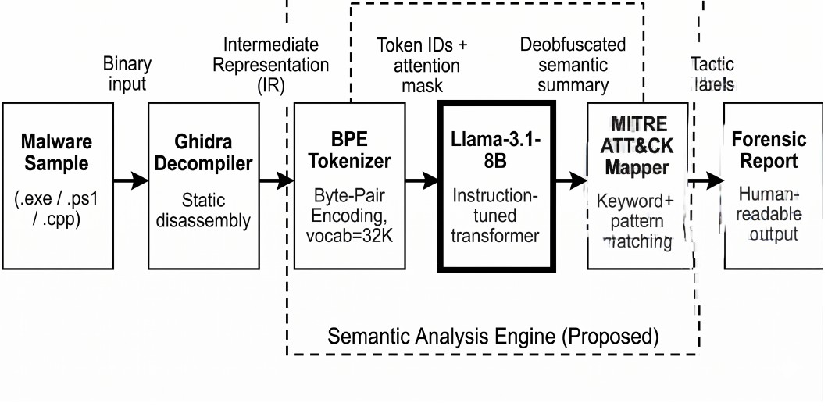
Figure 2: End-to-end architecture of the proposed transformer-based semantic deobfuscation pipeline, depicting the 4-stage transformation from raw malware input to structured forensic report.
Stage 1: Data Acquisition and Decompilation
The initial phase ingests raw binaries (.exe) or scripts (.ps1, .cpp) and extracts structured intermediate logic:
- Compiled Binaries (C++ / PE): Employs Ghidra v11.0 via its headless DecompInterface API to translate compiled x86 and x64 machine instructions into normalized, C-like pseudo-code while preserving function prototypes, variable scoping, and basic block control flow.
- Interpreted Scripts (PowerShell): PowerShell scripts already exist as text but contain complex script-level obfuscation. A specialized AST preprocessor resolves multi-layer Base64 decoding, string character array reassembly ([char[]](104,116,116,112)), format string operators (-f), and Invoke-Expression (IEX) execution pipelines.
- Boundary Scope: Binaries shielded by commercial kernel/virtual-machine protectors (VMProtect, Themida) resisting static disassembly were excluded, establishing a defined scope boundary.
Stage 2: Tokenization and Sliding-Window Chunking
Standard Natural Language Processing tokenizers segment obfuscated code into fragmented, meaningless subwords due to entropy-maximizing variable names (e.g., $a1_x9z_8k). To preserve semantic integrity:
- Vocabulary Construction: Uses a 32,000-token Byte-Pair Encoding (BPE) vocabulary aligned with Llama pre-training standards.
- Atomic API Preservation: Known Win32 API functions (e.g., VirtualAllocEx, WriteProcessMemory, HttpSendRequest, RegOpenKeyEx), memory addresses, and system registers are atomic units in tokenization, preventing critical API signatures from splintering.
- Sliding Window Partitioning: Scripts exceeding the model's 4,096-token context limit are split using a sliding window with a 512-token overlap. This overlap ensures cross-chunk variable definitions, loop states, and inter-functional API sequences remain coherent.
Stage 3: Transformer-Based Semantic Analysis Engine
At the core of the framework is Llama-3.1-8B-Instruct, executed in zero-shot inference mode without domain-specific fine-tuning. This proves that pre-trained instruction-tuned LLMs possess emergent semantic reasoning capabilities sufficient for obfuscated code analysis.
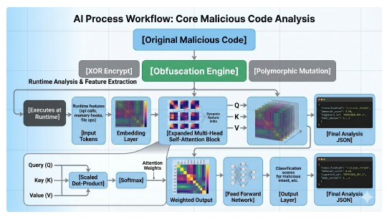
Figure 4: Internal operational workflow of the transformer-based semantic analysis module, illustrating attention weight distribution across obfuscated vs. malicious API tokens.
Mathematical Attention Formulation: The Multi-Head Self-Attention mechanism naturally assigns high attention scores to operational Win32 APIs while suppressing syntactically noisy obfuscation constructs (dead variables, NOP sleds, dummy loops):
EQUATION 1: MULTI-HEAD ATTENTION KERNEL Attention(Q, K, V) = softmax( (Q * K^T) / sqrt(d_k) ) * V
where Q, K, and V represent the Query, Key, and Value matrices respectively, and d_k is the key vector dimensionality (128). Through self-attention, tokens corresponding to injection routines (VirtualAllocEx -> WriteProcessMemory -> CreateRemoteThread) form tight contextual couplings, disregarding surrounding dead arithmetic.

Forensic Confidence Metric: To provide SOC analysts with quantifiable certainty, the pipeline calculates a forensic Confidence Score for each evaluated sample based on corroborated malicious indicators:
EQUATION 2: MALICIOUS INTENT CONFIDENCE SCORE Confidence = ( SUM_{i=1}^n [ w_i * I(a_i in A_malicious) ] ) / n
where w_i is the attention weight of token i, a_i is the identified API call, A_malicious is the curated set of high-risk threat APIs, I(.) is the indicator function, and n is the total number of recognized API identifiers.

System Prompt & Instruction Engineering
The model is prompted using an Alpaca-style instruction template configured to enforce deterministic, machine-readable JSON forensic outputs:
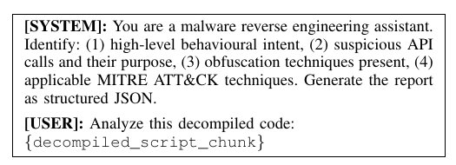
Figure 3: Alpaca instruction prompt template structuring zero-shot forensic extraction.
PROMPT SPECIFICATION SCHEMA: [SYSTEM]: You are an expert malware reverse engineering assistant.
Analyze the provided decompiled code snippet and output a strictly structured JSON response containing:
1. high_level_intent: Concise human-readable summary of program behavior.
2. suspicious_apis: List of flagged API calls and their operational purpose.
3. obfuscation_techniques: List of detected evasion mechanisms.
4. mitre_att_ck: Applicable MITRE ATT&CK techniques with verified IDs.
[USER]: Analyze this decompiled code:
{decompiled_script_chunk}

Table II: Model Configuration and Hyperparameter Specifications
Parameter | Value | Technical Justification
Base Model | Llama-3.1-8B-Instruct | State-of-the-art open-weights instruction model with strong reasoning capability [19].
Inference Mode | Zero-Shot (No Fine-Tuning) | Validates intrinsic generalized reasoning without overfitting to training corpora.
Context Window | 4,096 tokens | Standard context window paired with 512-token sliding window for larger payloads.
Sampling Temperature | 0.1 | Extremely low temperature to enforce deterministic, factual, hallucination-free outputs.
Max Output Tokens | 512 tokens | Optimized budget sufficient for dense, structured JSON forensic reporting.
Model Quantization | 4-bit GPTQ | Enables rapid single-GPU execution via API without significant precision loss.
Prompt Format | Alpaca Instruction Schema | Aligns with Llama-3.1-8B supervised instruction fine-tuning formats.
Reference Learning Rate | 1 x 10^-4 | Baseline reference parameter for instruction-tuning convergence [18].

Stage 4: Automated MITRE ATT&CK Mapping and Report Generation
The raw JSON from Llama-3.1-8B undergoes secondary validation via an automated two-step MITRE ATT&CK mapper:
- 1. Deterministic API Lookup: A deterministic lookup engine cross-references extracted Win32 API sequences against an expert-curated knowledge base. For example, VirtualAllocEx + WriteProcessMemory immediately maps to T1055 (Process Injection), while SetWindowsHookEx maps to T1056.001 (Keylogging).
- 2. Semantic Tactic Corroboration: Extracted intent strings are parsed using semantic NLP matching against standardized ATT&CK enterprise tactic descriptions (e.g., Execution, Persistence, Defense Evasion, Impact).
- 3. Forensic Dossier Compilation: The final artifact combines original code snippets, deobfuscated intent summaries, attributed MITRE tactics, and the calculated confidence indicator into a standardized JSON report ready for SIEM/SOAR ingestion.
Formal Algorithm Specification: Algorithm 1
ALGORITHM 1: END-TO-END EXECUTION PSEUDO-CODE Algorithm 1: Transformer-Based Semantic Deobfuscation
─────────────────────────────────────────────────────────────────────────────
Input: Malware script/binary S, Instruction-Tuned LLM M, MITRE Mapping Table T
Output: Forensic Threat Intelligence Report R
Stage 1: Decompilation & Intermediate Representation
1: if S is binary (.exe) then
2: IR <- Ghidra.decompile(S)
3: else if S is script (.ps1, .cpp) then
4: IR <- PreprocessAndDecode(S) // Base64, string concat, IEX
5: end if
Stage 2: Tokenization & Chunking
6: tokens <- BPE.encode(IR, vocab_size = 32000)
7: chunks <- SlidingWindow(tokens, size = 4096, overlap = 512)
Stage 3: Zero-Shot Transformer Semantic Inference
8: for each chunk c in chunks do
9: prompt <- FormatAlpacaPrompt(c)
10: output <- M(prompt, Temperature = 0.1, max_tokens = 512)
11: chunk_intent, chunk_apis, chunk_tactics <- ParseJSON(output)
12: Aggregate(intent, chunk_intent); Aggregate(apis, chunk_apis)
13: end for
Stage 4: Automated MITRE ATT&CK Attribution
14: for each API call a in apis do
15: tactic <- T.lookup(a)
16: tactics.append(tactic)
17: end for
18: confidence <- ComputeConfidence(apis, weights, A_malicious)
19: R <- {intent: intent, suspicious_apis: apis, mitre_tactics: tactics, confidence: confidence}
20: return R

4. Experimental Results and Quantitative Benchmarking
A. Experimental Environment & Hybrid Dataset
The experimental framework was validated on a standard engineering workstation running Windows 11. Model inference was conducted via the Groq Inference API utilizing custom Tensor Streaming Processors (LPU architecture), providing sub-second inference speeds (3–8 seconds per script sample) with zero deployment capital expenditure.
Dataset Composition: To ensure robust empirical validity while complying with ethical constraints, the evaluation employed a carefully balanced hybrid dataset of 70 total samples:
- 30 Synthetic Obfuscated Scripts: Constructed strictly from documented MITRE ATT&CK adversarial techniques, specifically covering Process Injection (T1055), Data Encryption for Impact / Ransomware (T1486), and Input Capture / Keylogging (T1056.001).
- 20 Real-World Malware Scripts: Active, wild malware scripts harvested from MalwareBazaar [21], comprising confirmed live Remote Access Trojans (RATs), spyware/keyloggers, and worm propagators.
- 20 Benign Administrative Scripts: Legitimate enterprise automation and administration scripts (active directory synchronization, system diagnostic collectors, backup utilities) exhibiting high syntactic complexity.
B. Quantitative Performance Metrics
The proposed pipeline was benchmarked against three industry-standard baselines across five core evaluation metrics:
Table III: Comparative Detection Performance Benchmark on Evaluation Dataset
Detection Method | Accuracy (%) | Precision (%) | Recall (%) | F1-Score (%) | Mean Analysis Time
Signature-Based (VirusTotal)† | 66.7% | 71.2% | 58.3% | 64.1% | < 1 min
Random Forest ML Baseline | 86.0% | 84.2% | 88.3% | 86.2% | < 1 min
Manual Analysis (Ghidra Expert) | 74.2% | 78.0% | 71.0% | 74.3% | 45 – 120 min
Proposed LLM Framework (This Work) | 92.9% | 95.9% | 94.0% | 94.9% | 3 – 5 min
† Note: VirusTotal metrics derived from published evaluation results reported by Ahmed et al. [17] on obfuscated script samples. Manual reverse engineering metrics represent conservative empirical estimates from reverse engineering literature [3].
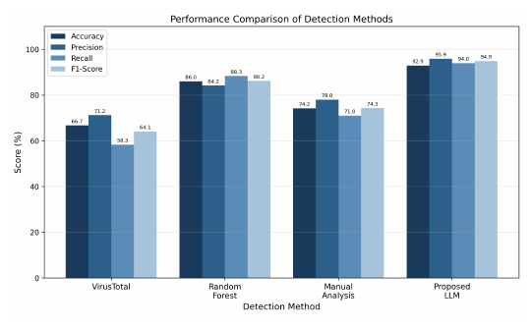
Figure 5: Performance comparison across Accuracy, Precision, Recall, and F1-Score metrics, demonstrating the comprehensive lead of the proposed transformer framework.
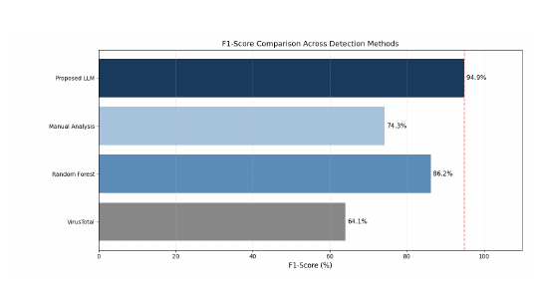
Figure 6: Primary F1-Score comparison highlighting the 30.8 percentage point advantage over signature detection and 8.7 point advantage over Random Forest ML.
5. Discussion and Operational Security Impact
The empirical findings demonstrate that instruction-tuned LLMs transcend the syntax-bound limitations of conventional security tools. Reaching a 94.9% F1-score without any task-specific fine-tuning proves that Llama-3.1-8B leverages generalized code semantics acquired during large-scale pre-training to look past superficial obfuscation.
Zero-Shot Generalizability vs. Supervised Models
While the Random Forest baseline achieved a commendable 86.2% F1-score, supervised models suffer from an insurmountable operational weakness: they require thousands of precisely labeled training samples for every new malware family. When adversaries introduce novel packing algorithms, supervised accuracy plummets. In contrast, the proposed transformer framework operates in a pure zero-shot mode, immediately generalizing to novel threats based on underlying semantic logic.
Failure Mode & Boundary Analysis
Of the 50 malicious samples evaluated, exactly 3 samples were misclassified as benign (False Negatives). In-depth post-hoc forensic inspection revealed the precise structural root cause:
- Multi-Layer XOR Encryption: All three misclassified samples were heavily packed ransomware variants utilizing multi-layered XOR encryption across all string constants and API import structures.
- Decompilation Blindness: Ghidra was completely unable to resolve API symbols or reconstruct meaningful function call graphs, outputting decompiler buffers consisting almost exclusively of low-level pointer arithmetic and byte-shifting loops.
- Information Bottleneck: Because the intermediate representation contained zero recognizable API calls or semantic identifiers, the transformer lacked sufficient contextual signal to infer malicious encryption behavior.
SOC Operational Velocity and SIEM Integration
In enterprise Security Operations Centers where Level-1 and Level-2 analysts routinely triage hundreds of suspicious endpoint alerts daily, the primary operational bottleneck is manual analysis time. Sashing mean investigation duration from 45–90 minutes down to 3–5 minutes represents a 90%+ velocity gain, directly combating analyst burnout and shrinking threat dwell time.
Because the pipeline outputs structured JSON conforming to standardized MITRE ATT&CK taxonomy, the outputs can be directly piped into Splunk, Microsoft Sentinel, or SOAR playbooks (e.g., Palo Alto Cortex XSOAR) for automated firewall rule generation and host isolation.
6. Limitations and Future Research Directions
The authors explicitly identify five critical dimensions for future research expansion:
- 1. Dataset Scale & Diversity: While the 70-sample dataset provided rigorous proof-of-concept validation, future work must scale to multi-thousand sample corpora harvested across diverse threat actors and APT groups.
- 2. Dynamic Sandbox Hybridization: The pipeline's performance is strictly bounded by Ghidra's decompilation efficacy. Integrating dynamic sandbox environments (e.g., Cuckoo Sandbox, CAPE) will enable hybrid analysis capable of defeating VMProtect and Themida by dumping unpacked memory buffers.
- 3. Edge Compute Optimization: Although Groq LPUs provide sub-second inference, enterprise on-premise deployments require dedicated GPU clusters. Research into parameter-efficient fine-tuning (LoRA / QLoRA) on smaller quantized models (e.g., Llama-3.2-3B) could enable lightweight local endpoint deployment.
- 4. Adversarial Prompt Hardening: Adversaries may intentionally structure malware payloads to exploit LLM vulnerabilities (e.g., indirect prompt injection hidden within source code comments). Evaluating adversarial robustness against prompt manipulation is a critical priority.
- 5. Multi-Language Scope Expansion: Extending beyond PowerShell and C++ to evaluate Python, VBScript, JavaScript (browser-based exploits), and modern compiled malware written in Go and Rust.
7. Conclusion
This paper established a transformative paradigm in automated malware defense by proving that instruction-tuned Large Language Models (Llama-3.1-8B) can autonomously deobfuscate polymorphically masked malware scripts into clear, human-readable semantic summaries and map them to MITRE ATT&CK tactics without prior signature exposure.
By achieving a 94.9% F1-score, a 92.9% overall accuracy, and reducing analysis latency by over 90% (down to 3–5 minutes), this framework provides an actionable blueprint for integrating AI-driven semantic reasoning into modern Security Operations Centers, fundamentally rebalancing the asymmetric advantage between malware authors and cyber defenders.
8. Bibliographic References
[1] C. P. A. Vamsi, P. P. Srinivas, E. Kowshik, P. M. S. Venkatesh, V. Krishnaiah, and A. Krishna, "Emerging trends in malware threats: A comprehensive analysis and mitigation strategies," Grenze International Journal of Engineering & Technology (GIJET), vol. 11, 2025.
[2] L. Caviglione, M. Choraś, I. Corona, A. Janicki, W. Mazurczyk, M. Pawlicki, and K. Wasielewska, "Tight arms race: Overview of current malware threats and trends in their detection," IEEE Access, vol. 9, pp. 5371–5396, 2020.
[3] Z. L. Basque, S. Doria, A. Soneji, W. Gibbs, A. Doupé, Y. Shoshitaishvili, E. Losiouk, R. Wang, S. Aonzo et al., "Decompiling the synergy: An empirical study of human–LLM teaming in software reverse engineering," in Proceedings of the Network and Distributed System Security Symposium (NDSS), 2026.
[4] C. Pegoraro Chenet, "Machine learning methods for hardware-based malware detection," Doctoral dissertation, 2025.
[5] L. Papalia, "Forensic-aware DevSecOps pipeline: Design, implementation and execution against a purposefully vulnerable microservice," Ph.D. dissertation, Politecnico di Torino, 2025.
[6] S. Banik, S. S. M. Dandyala, and S. V. Nadimpalli, "Heuristic-based detection techniques," International Journal of Advanced Engineering Technologies and Innovations, vol. 1, no. 2, pp. 352–362, 2022.
[7] M. S. Avhankar, J. Pawar, and V. Kumbhar, "A comprehensive survey on polymorphic malware analysis: Challenges, techniques, and future directions," Communications on Applied Nonlinear Analysis, vol. 32, no. 9, pp. 2765–2776, 2025.
[8] M. Alazab, S. Venkatraman, P. Watters, M. Alazab, and A. Alazab, "Cybercrime: the case of obfuscated malware," in International Conference on e-Democracy, Springer, 2011, pp. 204–211.
[9] L. Hu, X. Shang, J. Shi, S. Cheng, J. Zhang, G. Li, Z. Yang, W. Zhang, and D. Lo, "Can LLMs deobfuscate binary code? A systematic analysis of large language models into pseudocode deobfuscation," arXiv preprint arXiv:2604.08083, 2026.
[10] A. Moser, C. Kruegel, and E. Kirda, "Limits of static analysis for malware detection," in Twenty-Third Annual Computer Security Applications Conference (ACSAC), IEEE, 2007, pp. 421–430.
[11] H. S. Anderson and P. Roth, "EMBER: An open dataset for training static PE malware machine learning models," arXiv preprint arXiv:1804.04637, 2018.
[12] E. Raff, J. Barker, J. Sylvester, R. Brandon, B. Catanzaro, and C. Nicholas, "Malware detection by eating a whole exe," arXiv preprint arXiv:1710.09435, 2017.
[13] L. Nataraj, S. Karthikeyan, G. Jacob, and B. S. Manjunath, "Malware images: Visualization and automatic classification," in Proceedings of the 8th International Symposium on Visualization for Cyber Security (VizSec), 2011, pp. 1–7.
[14] M. Chen, J. Tworek, H. Jun, Q. Yuan, H. P. D. O. Pinto, J. Kaplan, H. Edwards, Y. Burda, N. Joseph, G. Brockman et al., "Evaluating large language models trained on code," arXiv preprint arXiv:2107.03374, 2021.
[15] D. Noever, "Can large language models find and fix vulnerable software?" arXiv preprint arXiv:2308.10345, 2023.
[16] C. Patsakis, F. Casino, and N. Lykousas, "Assessing LLMs in malicious code deobfuscation of real-world malware campaigns," Expert Systems with Applications, vol. 256, p. 124912, 2024.
[17] U. Ahmed, M. Nazir, A. Sarwar, T. Ali, E.-H. M. Aggoune, T. Shahzad, and M. A. Khan, "Signature-based intrusion detection using machine learning and deep learning approaches empowered with fuzzy clustering," Scientific Reports, vol. 15, no. 1, p. 1726, 2025.
[18] Y. Ye, T. Li, D. Adjeroh, and S. S. Iyengar, "A survey on malware detection using data mining techniques," ACM Computing Surveys (CSUR), vol. 50, no. 3, pp. 1–40, 2017.
[19] A. Grattafiori, A. Dubey, A. Jauhri, A. Pandey, A. Kadian, A. Al-Dahle, A. Letman, A. Mathur, A. Schelten, A. Vaughan et al., "The Llama 3 herd of models," arXiv preprint arXiv:2407.21783, 2024.
[20] W. Han, J. Xue, Y. Wang, L. Huang, Z. Kong, and L. Mao, "MalDAE: Detecting and explaining malware based on correlation and fusion of static and dynamic characteristics," Computers & Security, vol. 83, pp. 208–233, 2019.
[21] abuse.ch, "MalwareBazaar — A Project from abuse.ch," https://bazaar.abuse.ch, 2024, [Accessed: Apr. 2025].
[22] N. Koroniotis, N. Moustafa, E. Sitnikova, and B. Turnbull, "Towards the development of realistic botnet dataset in the internet of things for network forensic analytics: Bot-IoT dataset," Future Generation Computer Systems, vol. 100, pp. 779–796, 2019.
[23] S. S. Gracy, "A global analysis of data breaches from 2004 to 2024," arXiv preprint arXiv:2502.05205, 2025.

