Welcome!

This is the Electrical Sub team Training. Firstly, we discuss the requirements and suggestions, we require everyone to bring your own device/Chromebook, we also require students to join GitHub and join the GitHub organization. We recommend students bring their own tools such as a precision screwdriver set and a multimeter should cover everything from basic repairs and learning to use these devices.

On Day 1 we will discuss the ins and outs of the robot. The Electrical Sub team in FRC is the cauldron between the Mechanical moving parts of CAD and the witchcraft that is programming. We will be talking about the serial busses used in the robot and basic Electrical knowledge needed to do basic repairs on daily items. On Day 2 we will discuss wiring the robot and prototyping (for people who want to do more)

**Everything we discuss is available online + more on:[1]**

[team-1280.github.io/electrical book/](https://team-1280.github.io/electrical-book/)

This meeting will conclude all items regarding the FRC Robots and basic Prototyping. But first,

# What is Electricity?

Electricity is a form of magic only welded by skilled wizards and witches who have the desire to create complex systems that make no sense at all; these wizards and witches are called Electrical Engineers, Material Scientists, technicians, Electronics Engineers. Basic knowledge of DC current is necessary for all Electrical Engineers and mediocre FRC enjoyers need. Most circuits (like FRC) use DC (Direct Current) which has a Positive and Negative charge, you may commonly see these in toys, cars, and computers, as they provide portability and are much safter to work around with.

Like magic there are constraints, or laws. The laws in electricity help us manipulate the outcome of what we are looking for. There are many laws out there such as:

* Kirchhoff’s Circuit Laws,
* Power Law
* Moore’s Law
* Gauss’s Law
* Ampere’s Law
* Ohm’s Law
* Coulomb’s Law
* Electromagnetic induction
* Faraday’s Law

Many of these wizards are famous for their own breakthroughs, but we will be primarily talking about Ohm’s Law.

## Current, Voltage and resistance.

When electricity flows through a wire, “charges” can be imagined moving in the wire like water in a pipe.[2] Though electricity flows at the speed of light unlike water.

### Current

**Current** is the measure of how many “charges” of electricity is passing the wire per second. Current is measured in **Amperes or Amps**, which essentially measure the volume of water flowing through the pipe per second. Any **power supply** (or **battery**) has a + and – terminal and if you’d imagine the **amps** as the amount of + power flowing through a circuit to the – terminal. [3]

### Voltage

**Voltage** is the “Potential Difference” between two points, voltage is the driving force of current. Voltage is measured in **Volts or V. When** taking a multimeter to it, the number represents the volts. Bringing back the pipe metaphor, voltage is the Pascal of water or pressure in which the water is traveling. Each terminal on a **power supply** (or **battery**) has a negative and positive terminal, in which the power source is rated to a certain voltage. Most low power electronics such as a Bluetooth speaker, flashlight, (some) laptops use a 3.5**v** battery or rated to be 3.5 pascals of water force.[4]

### Resistance

**Resistance** is the limiter of **current**. Resistance as the name suggests, resists the current. Tired of the pipe metaphor? Imagine the resistance like a traffic jam or a construction site, limiting the thousands of cars passing by that highway (wire) to only two lanes. Resistances are measured in **Ohms** or **Ω.** Taking the multimeter to a resistor (a component) you can see the number of **Ohms** displayed when in contact with both ends of the resistor**.** Resistance is helpful to shield circuits from raw power as it may end to long term damage to the components, for example, you should never connect a LED diode to a 9**v** battery without a resistor as it is too much **current** for the LED’s thin wire to take.

Alternately you can refer to this highly sophisticated diagram for help. 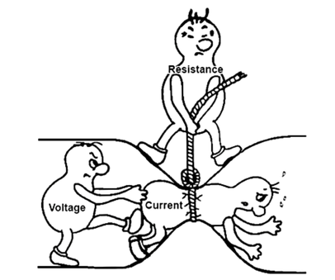

## Ohm’s Law

Is the belief that Electric current though a conductor between two points is directionally proportional. We can find the outcome of a circuit in terms of power when knowing this law.

V=I∗R I=R/V​ R=V/I

### Static Discharge

Although a myth, when handling devices skilled wizards believe that grounding themselves touching the – terminal on a battery or anything similar. We also request all students be careful while working around these devices as they all have 12 volts moving at 30 amps which is enough mana to zap you to death.

### Analog, Digital, and PWM.

#### Analog –

Analog Input is a way in which we might be able to receive a signal in which there are small incremental changes in the voltages and can be easily identified and translated by microcontroller. Analog is useful in precise applications.

#### Digital –

Opposite of analog in which a High or Low signal typically 1.5**V** usually allowing you read it as HIGH or LOW, or 1 or 0 on a binary scale. Usually, can be used for most applications with PWM.

#### PWM –

Or Pulse Width Modulation, using the digital 1s and 0s. PWM technique basically manipulates the 1s and 0s from the input and translates it to a sine wave which can help you. PWM manipulates digital signals to make it analog.

## Multimeter

We will have a fleet of tools that will help us diagnose issues in the electrical parts of the robot. But you only need to know how to use one if you’re an avid FRC enjoyer. Introducing the multimeter. Multimeter, as the name suggests, has multiple ways to measure electronics. To measure dc current, you will need to look at the symbols. There is one for DC voltage which is **V⎓** and AC voltage is measured in **V~.** There should be an opinion and **Ω** which is for measuring resistance in Ohms. And there is another one for measuring amps via the same **A⎓.**

# FRC Devices

In FRC, there are many ways for movement and sensing. We have serial buses which could help us connect from the main control board to the peripheral devices.

## RoboRio and Export Code

Our main control board is the **RoboRio** which is a cortex A9 CPU running a Linux backend. We will be demonstrating how to export code and help with control and export the code in class. Check for your connection with the robot, you would need to open the laptop and press the windows key and enter “FRC Driver station” and open “Visual Studio Code”. When in Visual Studio Code press “ctrl + shift + p” and type in “robot code” and the first one should trigger a shell opening and Gradle would do its thing and compile the code to binary for the RoboRio then you should be able to enable it via the Drive station.

## Wiring the robot

We will discuss in depth of wiring the robot in the following articles but in this section, you basically know how the robot is wired and controlled. In the following diagram there 3 – 4 serial busses which are present, we have the CAN bus, PWM, DIO (Digital Input Output). Exploring this diagram, you can make use context clues to understand how the robot is wired up.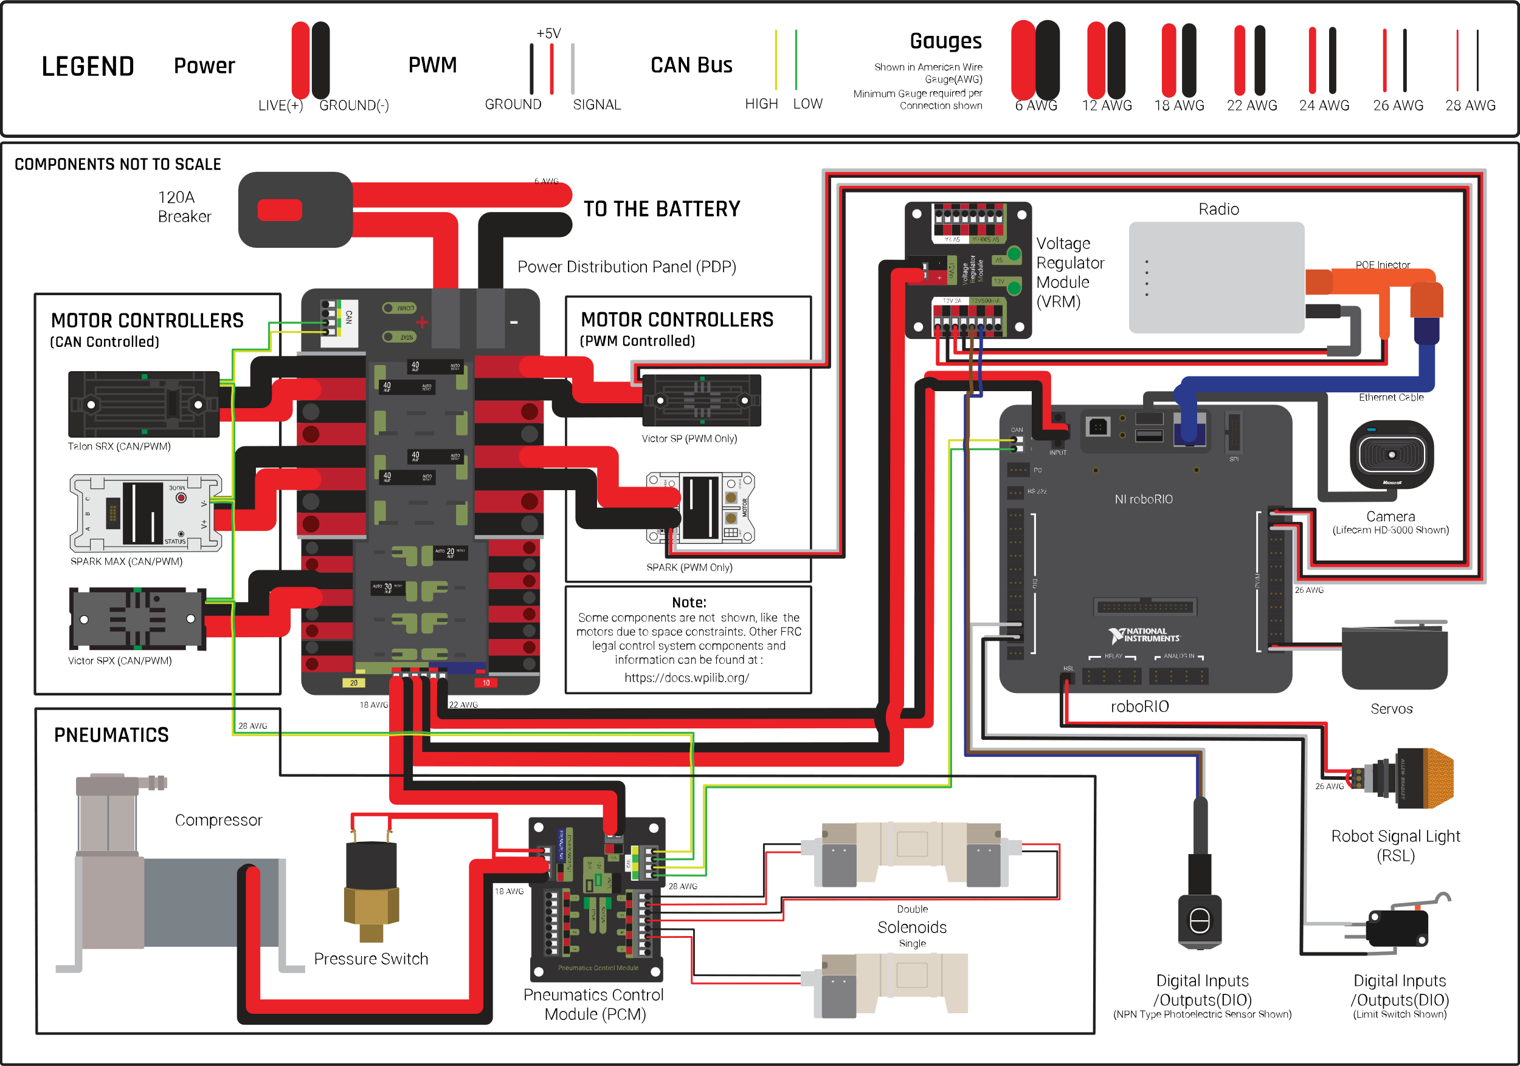

## Radio/WLAN

Instead of tethering the robot to the computer. We use a radio, the radio in FRC, is basically a WLAN[5] which is available for each device to connect. The WLAN network uses a Router to transmit the signals, and since the FRC robot is a device that is mobile and carry, routers could not be powered via AC power, so robots use a technique called POE (Power over Ethernet). Ethernet is a connection to the robot via LAN[6].

## Serial Buses

A serial bus is a hardware interface where there is a master device controls and communicates with a slave device.[7] Serial buses are used daily for prototyping and for most applications busses are easy ways to program.

The main control board, which is called a **RoboRio,** features many buses that are industrial standards such as, CAN Bus, I^2C Bus, SPI Bus, RS-232. These seral buses all have their own advantages and disadvantages. For simplicity our robot uses 3 buses, MXP (myRIO expansion port), CAN (controlled Area Network), and PWM (Pulse width modulation).

#### CAN Bus

Controlled Area Network or the CAN Bus is a serial bus in which there is a set “ID” for the slave device and the master device sends the signal down one power line. The CAN bus can be daisy chained on multiple devices. The CAN bus starts with a chain identifying the CAN device in which we can set. Then, the master asks the slave to receive 0-8 bytes of data. Then the CAN signal ends in 01 sequence. CAN Busses also need a terminating resistor preferably 120 ohms but we can use 100 ohms. 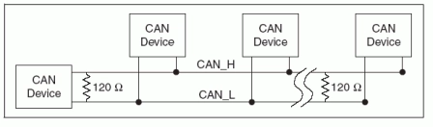

In this photo the device to the very left is the transmitter, ignoring the first resistor you can see the CAN device on the very right is cut off the main CAN line, hence it’s terminated via a resistor.

We usually use CAN Bus for FRC Devices but there are alternate buses also give flexibility for the robot in input and output.

#### MXP (myRIO expansion port)

Like all prototyping boards, Robo Rio offers an expansion port in which we could interface with components on an Arduino scale, it’s a 2x17 pin port in which you may find the pinout online when googling the number. Basically, this port we use to control our Gyroscope and knowing our kinematics a direction. There are not many devices used for the MXP but it will depend.

#### PWM

Pulse width Modulation or PWM is an electrical signal coming in and out of a single wire. PWM is a connector, or an electrical connection where the pulse of the HIGH and LOW will determine the information transmitted within the computer. PWM signals in FRC can be used as shown above for servos, motor controllers.

# Prototyping/Projects

Assuming you are not a mediocre FRC enjoyer, and you join the team because you want to collaborate and build your projects and prototypes, Team 1280’s EECS Department offers all hands and information on building your own projects. The last few articles provide information on starting your own projects. Remember the possibilities are limitless. Remember that any prototypes are encouraged and might be incorporated in our robot.

**Extensive information and references are all available online on the website**

[team-1280.github.io/electrical-book/docs/sac/](https://team-1280.github.io/electrical-book/docs/sbc/)

## Microcontrollers

Microcontrollers are a huge part of prototyping and engineering, since the possibilities are limitless. Microcontrollers such as Arduinos, ESPs, STMs; are boards which can be programmed with anyone with 0 knowledge of code as projects and information are all available online. Everyone can learn and use these boards without knowledge. You would usually use a solderless breadboard for testing and prototyping when you are looking to simplifying your circuits.

## SBCs

Single board computers such as the Raspberry Pis, Latte Pandas, and NUCs are single board computers. These single board computers are usually low powered and used to prototype computers for your own or incorporating the GPIO pins included the computer.

## Soldering

Soldering is a skill in which requires a lot of finesse. Each wizard waves their wands that could heat up to 900C to these little tin/lead wires that melt easily for people to make permanent changes to their circuits, we will go over this we have extra time in class but is what everyone uses to make computers, laptops, phones, any device you can think of.

## Oscilloscope

Oscilloscope is a tool which measures voltage overtime. Unlike multimeters these devices are expensive and requires skills. Oscilloscope is a device that could help you diagnose and understand the voltage changes on the device. For example, we could stick the oscilloscope to the CAN bus and we can read the differences in the voltages whenever something is being sent.

1. Contents in this website are still being revised.
2. Get used to the pipe metaphor electrical engineers love it.
3. Ermm actually🤓☝️, current flows form the – terminal due to electrons moving more towards the + terminal (no one cares)
4. There is a voltage difference is a thing in batteries, for example an 18650 is rated to be a 3.7**v** battery but when you take a multimeter to it (when it’s fully charged) the multimeter will read 4.1**v** which is misleading.
5. WLAN – Wireless LAN, or in North America, WIFI
6. Whenever the WLAN is out, LAN is an alternative choice but can be used to export and test robot code fast
7. The master-slave name has been deprecated because it’s not “politically correct” many use a principal-agent or primary-secondary relations to describe serial buses.