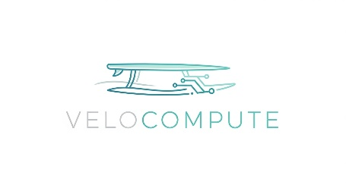

Information Security Management System Scope

  - Classification: Internal
This document may only be shared internally without prior confirmation from the owner.

Purpose of Document
This document defines the boundaries and applicability of VeloCompute’s Information Security Management System (ISMS).
The purpose of this scope is to ensure that all interested parties—including our US and EU e-commerce clients—have a clear understanding of the assets we protect. Furthermore, we highlight the process of Information Security of multiple departments that handle Personally Identifiable Information (PII).

Introduction
VeloCompute is a pioneer technology company, legally based on El Salvador. Formed by 25 employees, working 100% remotely.
The organization business model is based on proprietary machine learning algorithms, working to enable their flagship service: VeloAnalytics SaaS Platform. This tool analyses consumer behavior and optimize inventory forecasting for retail enterprises.
The company manages large datasets of Personally Identifiable Information (PII), such as purchase histories and contact details. The company’s success relies entirely on the integrity of its predictive models and the confidentiality of the data that’s managed.

Scope Statement
The Scope of the information Security Management System (ISMS) at VeloCompute includes the processes, systems, communications channels, employees and departments that are involved in maintaining the VeloAnalytics SaaS Platform, as well as managing Personally Identifiable Information (PII).
Organizational Units: The ISMS covers all departments of the company: Engineering, Data Science, Sales and Operations and HR Departments.
Logical and Technological Units: The ISMS encompasses the AWS Production Environment, version control systems (Github) and Google Workspace.
Remote Units: All remote company-used endpoints used my employees to manage the VeloAnalytics SaaS Platform and process involved with PII.

Purpose of the ISMS
At VeloCompute, our ISMS is specifically designed to protect our core information assets—primarily our proprietary predictive algorithms and client PII—by ensuring their confidentiality, integrity, and availability. This system is the cornerstone of our strategy to maintain the trust of our international e-commerce partners and safeguard the intellectual property that drives our market value.

Context of the Organisation

Internal and External Issues
External Issues
- Aligning GDPR (EU) and CCPA (US) requirements. (Legal Regulations)
- Ransomware and unauthorized access to AWS S3/RDS. (Cloud Threats)
Internal Issues
- Managing 25 devices across El Salvador without a physical office (Remote Culture)
- Preventing the leak of proprietary AI models (Intellectual Property)
Stake Holders Requirements
- Clients: Expect ISO 27001 certification and proof of data encryption.
- Regulators: Demand GDPR/Salvadoran Law compliance and breach notification.
- Employees: Expect their payroll and personal data (DUI) to be handled securely.
Technical Scope Details
Asset Type | Specifics | Location/Owner
Cloud Services | AWS | AWS Virginia/CTO
Software | Github Enterprise, Google Workspace | Cloud/DevOps
Hardware | 25 Managed Laptops | Distributed (SV)

