**Stat 133 Final review**

**15 pts : Part I, general R commands**

***# Create sequence***

y<-seq(2,200,by=2)

# with y[i]=T if x[i] is divisible by 10, otherwise F

y <- ifelse(x%%10==0, T, F) ###ifelse(test, yes, no)

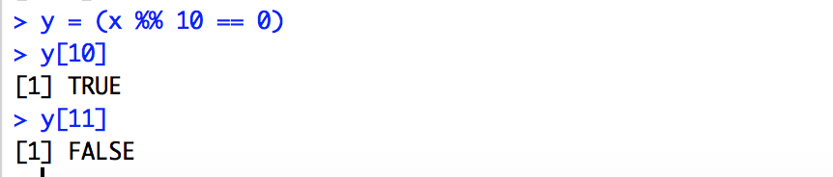

# Standard normal with increasing order

z <- sort(rnorm(100), decreasing=FALSE)

***# Create data frame***

recipe= data.frame (amount=1:3,

unit=c("cup", "cups", "oz"),

ingredient = c("flour", "salt", "sugar"))

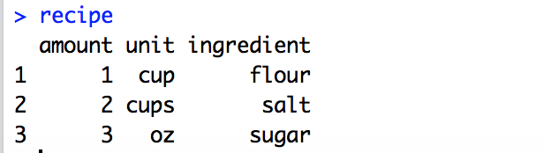

***# Create vector***

vec <- c(1, "abc", “TRUE”)

vec[1] ## Select elements from a vector

***# Create character vector/use of paste***

tests <- paste("test", 1:200, sep='')

tests.all <- paste(tests, collapse=" ")

even <- paste("even", seq(from=2, by=2, length=1000), sep='')

***# Create a list***

l <- list(1,2,3)

names(l) <- c("a","b","c")

# select from a list

l[[1]] #####list当中第一列数

l[["a"]] ####OR l$a

l <- list(); for(i in 1:12) l[[i]] <- rpois(n=100, lambda=5)

OR

l = list()

for(i in 1:12){

l[[i]] = rpois(100, lambda=5)}

***# Create matrix***

b <- matrix(c(seq(10, 120, by=10)), nrow=3, ncol=4, byrow=T)

> t(B) # transpose of B

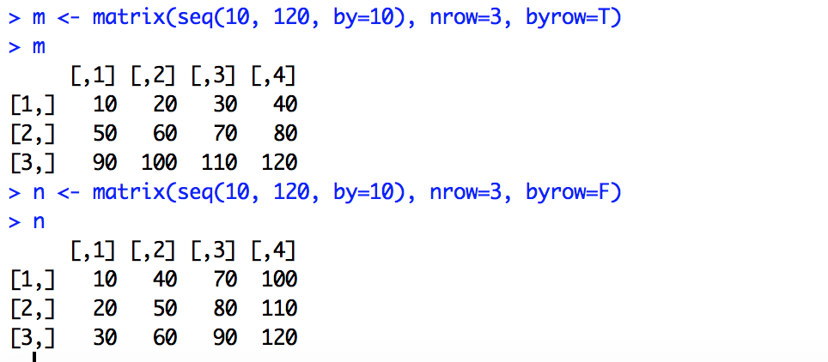

***# Create table***

athTab <- table(athletes$Sex, athletes$Sport)

t <- table(infants$ed[ infants$married=="Married" & infants$parity==1]) ##midterm2

***# Data frame manipulation***

# add a column “bmi” to the data frame

family2 <- data.frame(family, bmi)

# how many rows in the data frame

n.wr <- nrow(wr1500m)

# find row names of a data frame

model <- row.names(mtcars)

# Change NA data

wr1500m$month[is.na(wr1500m$month)] <- 6

***# Subset data***

* mtcars$disp ####OR mtcars[ ,"disp"] ####OR mtcars[ ,3] ##return第几列
* family.men<-subset(family, gender=="m") OR family.men <- family[family$gender=="m", ]
* family.30y68i<-subset(family, age>"30" & height<"68")
* housing.less3.berkeley <- housing[(housing$br < 3) & (housing$city=="Berkeley"), c("city", "br", "date")]
* wr1500m$month[is.na(wr1500m$month)] <- 6

# double brackets used to select elements in a list

* rainfall.subset <- rain[[1]][yr.2000]

# find specific value in the data frame

* wr.name <- wr1500m[which.min(wr1500m$times), 4] #[, 4] select the 4th column; [, ] select all data in that row
* length(athletes$Name[which(athletes$Sex == "F")])

# Create [f3] a subset of family of people whose name starts with T

* f3 <- family[ substr(family$name, 1, 1)=="T" , ] ##从第一个到第一个

# Select certain values of a column in a data

* mw <- mean(infants$bwt[infants$gestation>=259])

# Select top 5 data in a data frame

* top5 <- as.character(SO2012Ctry$Country[order( SO2012Ctry$Total, decreasing = TRUE)[1:5]])

# Select a row with minimum or maximum value

* f4 <- family[family$age == min(family$age),]

# Select 1st column of the datas

* data[,1]

# Remove 1st column

* mtcars[mtcars$gear==4, -1] # return everything where gear=4, but remove 1st column

# Remove rows from data set

* mtcars[-c(2, 4, 6), ]

# Remove certain data from the data frame using subset.

* mtcars2<-subset(mtcars, gear!=4)

***# Use of %in% and %%***

# %in% whether an element of ….

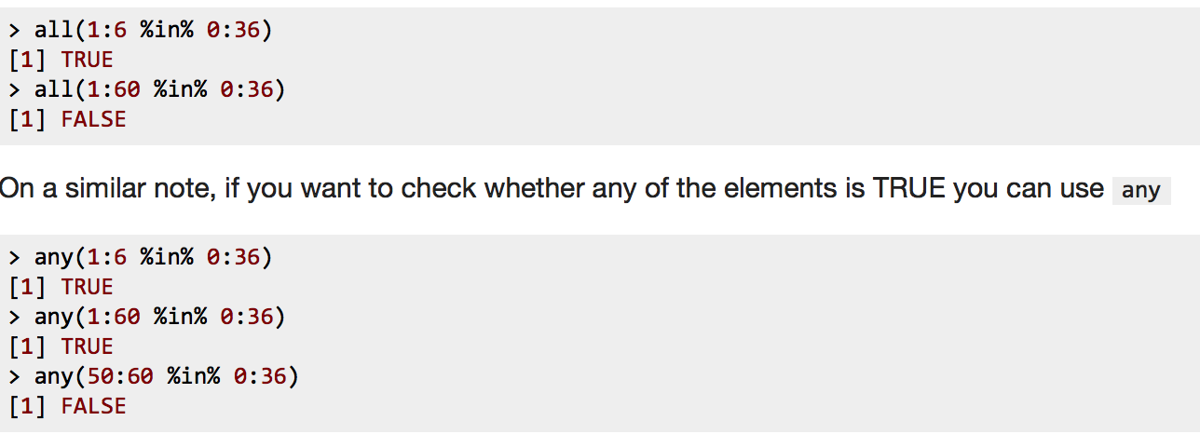

# %% whether 被某数整除



**20 pts : Part II, plotting**

***# Make box plot***

boxplot(iris$Sepal.Length ~ iris$Species) # Make a box plot of Sepal Length by Species, midterm2

***# Make bar plot***

* athTab <- table(athletes$Sex, athletes$Sport)
* barplot(athTab[, orderSport], beside = TRUE, las=3, cex.names = 0.8, main="London 2012 Male vs. Female athlets" ) ##hw2

***# Scatter plot with color***

# Make a scatterplot of petal width (y-axis) versus petal length (x-axis); plot(y~x)

plot(iris$Petal.Length, iris$Petal.Width, main=”graph”, xlab="Petal Length", ylab="Petal Width", col=as.numeric(iris$Species))

# Use “*” as the plotting symbol

plot(infants$gestation, infants$bwt, pch='*')

# Make a scatterplot of ( sepal length / petal length) (y-axis) as a function of index (order, x-axis); Color the plotting symbol by Species (any 3 colors)

ratio <- iris$Sepal.Length / iris$Petal.Length

plot(ratio ~ seq(1, length(iris$Sepal.Length)),

xlab = "Index", ylab = "Ratio of Sepal to Petal length", col = iris$Species)

***# Step plot***

plot(wr1500m$new_year, wr1500m$times, type="s")

***# Connect two points (2000,5) and (2014, 6)***

lines (x=c(2000, 2014), y= c(5, 6))

***# Add text on the plot***

text(x=3, y=3, “China”, cex=1 ,col="blue") ##x&y indicate the coordinate position of the text

text(x=mds[,1], y=mds[,2], labels=as.character(unique(speechesDF$Pres)), col = cols[presParty[rownames(presDist)]]) #hw7

***# Make histogram and density curve***

hist(infants$age, prob=T, xlab="Mother's age")

# Add density plot to the historgram

lines(density(infants$age, na.rm=T), col="blue")

***# Use of liner model***

### use the lm function to fit a line of a quadratic

### e.g. y ~ x or y ~ x + I(x^2)

fitModel = function(x, y, degree = 1){

if(degree == 1){

coeff = coef(lm(y ~ x))

}

if(degree == 2){

coeff = coef(lm(y ~ x + I(x^2)))

}

return(coeff)

}

**15 pts : Part III, apply statements (also know how to use by and replicate)**

***# The use of ‘by’***

# Create a variable [max.petal.width] _a numeric vector of length 3 that has the maximum petal length for each iris species.

max.petal.width <- as.vector(by(iris$Petal.Width, iris$Species, max)) ???? ##找每个species中width最大的 by(data, list of factors each length nrow(data),function )

***# Use of sample and replicate***

# k个骰子扔B次，求每次骰子的和

dice_sum <- function(k=2, B=100){

replicate(B, sum(sample(1:6, size=k, replace=T)) )

} ## replicate: apply a function multiple times

replicate (10, sample(c(1:6), 1)) 重复这个process 10次

replicate (sample(c(1:6), 10)) 复制这个结果 10次

# different from rep.

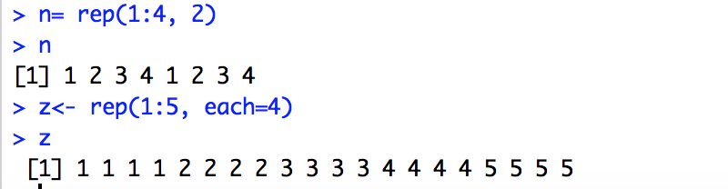

***# sapply***

# Create [first.cache], a vector where each entry is the _first_ element of the corresponding vector in the list Cache500

first.cache <- sapply(Cache500, "[", 1) ###OR

first.cache <- sapply(Cache500, function(x) x[1])

# a vector of length 5 with the number of measurements at each station in the year 1989 (use [day])

n1989.rain <- sapply(day, function(x) sum(floor(x)==1989)) ##floor(x) 舍去法 OR

n1989.rain <- sapply(day, function(x) sum(x >= 1989 & x<1990))

***# sapply with function***

# Create [mean.long.cache], a vector where mean.long.cache[i] is the mean of Cache500[[i]] IF it has 50 or more entries. NA IF Cache500[[i]] has less than 50 entries.

* mean.long.cache <- sapply(Cache500, function(x){ if(length(x)>=50) return(mean(x)) else return(NA)}) ##OR
* mean.long.cache <- sapply(Cache500, function(x) if(length(x) >= 50) mean(x) else NA)
* words <- sapply(speechWords, function(x) length(unlist(x)))

***# tapply:***

We want to break it up into groups; Within each group, we want to apply a function；分别找几个sub group的mean, sd etc.

# tapply(Summary Variable(最后要return的数据), Group Variable(不同的group), Function)

genBootY = function(x, y, rep = TRUE){

result = tapply(y, x, function(y) sample(y,size = 10, replace = T))

result = unlist(result)

return(result)

}

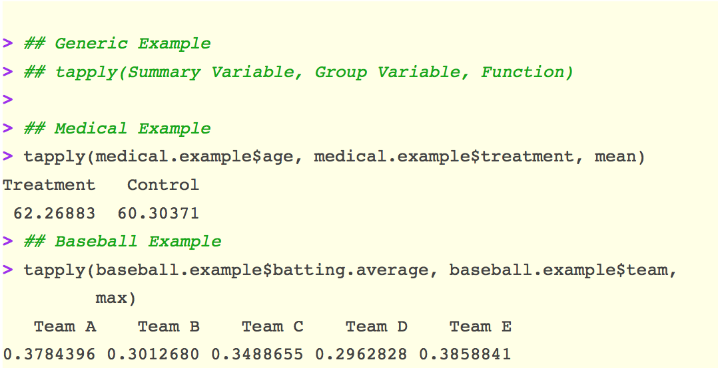

***# lapply:***

# Create [l], a list with 12 elements, each a vector of length 100. Each vector of length 100 of Poisson (hint:rpois) random variables with mean 5

l <- lapply(1:12, function(x) rpois(100, 5))

lapply(food, “[”, 1) #1st element of each vector in the list

**15 pts : Part IV, functions**

***# Remove columns/rows of a matrix***

m <- matrix(c(1, 5, 3, 8, 2, 5, 7, 9), ncol=4, byrow=T)

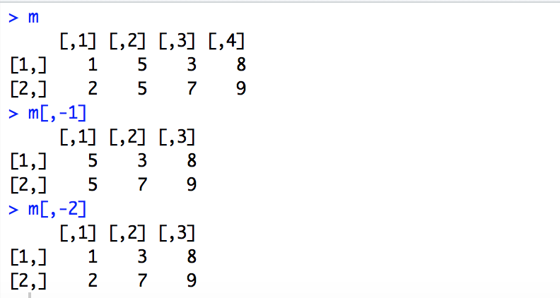

firstColToNames <- function(m){

if(length(dim(m))!=2) print("m is not a matrix or dataframe")

else{

names <- as.character(m[,1])

m <- m[, -1]

rownames(m) <- names

return(m)

}

}

# a function to convert temperature.

TempConv <- function(t, scale){

if(scale=="F") return((t - 32) * 5/9)

else if(scale=="C") return(t * 9/5 + 32)

}

# a function to convert cup to gram, oz to ml; hw4

recipeConversion <- function(recipe){

if (!all(colnames(recipe)==c("amount", "unit", "ingredient")))

stop("Error unexpected column names")

recipe$unit=as.character(recipe$unit)

for (i in 1:nrow(recipe))

if(recipe$unit[i] == "cup" | recipe$unit[i] == "cups") {

recipe$unit[i] = "ml"

recipe$amount[i]= 5*round(236.5*recipe$amount[i]/5)

}

else if (recipe$unit[i]=="oz"){

recipe$amount[i]=5*round(28.3*recipe$amount[i]/5)

}

recipe.metric = recipe

return(recipe.metric)

}

# Bootstrap example; hw4

bootstrapVarEst <- function(x, B){

bootstrap.mean=c()

for(i in 1:B){

new.sample = sample(x, length(x), replace=T)

bootstrap.mean[i]= mean(new.sample)

}

boot.sigma2.est = var(bootstrap.mean)

return(boot.sigma2.est)

}

# Sample without one value; hw4

jackknifeVarEst <- function(x){

jack.mean=c()

for(i in 1:length(x)){

new_sample = sample(x[-i], length(x)-1, replace=T)

jack.mean[i]= mean(new_sample)

}

jack.sigma2.est = var(jack.mean)

return(jack.sigma2.est)

}

# While loop; hw5

bml.sim <- function(r, c, p){

m = bml.init (r,c,p)

count=0

while(count < 5000) {

if (bml.step(m)[[2]] == TRUE) {

m=bml.step(m)[[1]]

count=count+1

}else{

return(count)

}

}

return(count)

}

# Create an empty matrix first; hw6

sim.doctors <- function(initial.doctors, n.doctors, n.days, p){

m = matrix(0, nrow=n.doctors, ncol=n.days)

for (k in 1:n.days){

n= sample (1:n.doctors, 2, replace = F)

if ( !(m[n[1],k]== m[n[2],k])){

x=n[m[n, k]==0]

m[x, k:n.days] = sample (c(1,0),1,prob=c(p, 1-p))

}

}

return(m)

}

# Create a power matrix; <k> : an integer

* powers <- function(x, k){

x.powers <- sapply (1:k, function(a) {x^a})

colnames(x.powers) <- colnames(x.powers, do.NULL = FALSE, prefix = "x^")

return(x.powers)

}

**15 pts : Part V, simulations**

***# Use of sample and replicate***

# k个骰子扔B次，求每次骰子的和

dice_sum <- function(k=2, B=100){

replicate(B, sum(sample(1:6, size=k, replace=T)) )

} ## replicate: apply a function multiple times

# Create [w], a random permutation of the numeric values of a deck of cards

w <- sample(rep(seq(1, 13), each = 4), 52, replace = F)

# Sampling the data other than i

* new_sample = sample(x[-i], length(x)-1, replace=T)

# Bootstrap

n <- 100

boot_mean <- rep(0,100)

for (i in 1:n){

dat <- sample(x=iris$Sepal.Length, size=nrow(iris), replace=T)

boot_mean[i] <- mean(dat)

}

var(boot_mean)

* bootstrapVarEst <- function(x, B){

bootstrap.mean=c()

for(i in 1:B){ new.sample = sample(x, length(x), replace=T)

bootstrap.mean[i]= mean(new.sample)}

boot.sigma2.est = var(bootstrap.mean)

return(boot.sigma2.est)

}

**20 pts : Part VI, string manipulation and regular expressions**

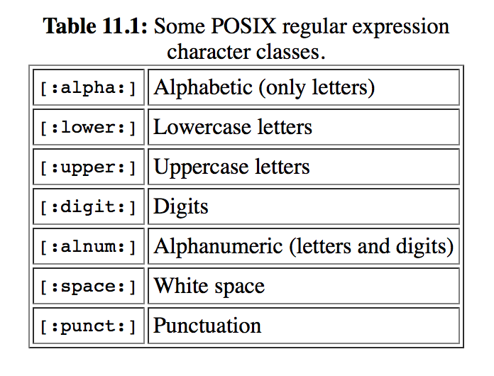

***# Meta characters:***

"[[:lower:]]at" means: any lowercase letter in any language, followed by the letter *`a'*, followed by the letter *`t'*. Eg. [[:lower:]]at  The cat sat on the mat .

"[a-z]at" means: any (English) lowercase letter, followed by the letter *`a'*, followed by the letter *`t'*.

^ means: the beginning of the string;

* ^[Tt]he  The cat sat on the mat. vs. [Tt]he  The cat sat on the mat.
* text2 <- grep("^d.+", phrases) ##a vector [text2] that lists the elements in phrases that START with the letter "d"

"[^c]at"  The cat sat on the mat . [^c]at means: any letter *except* *`c'*, followed by the letter *`a'*, followed by the letter *`t'*.

$ The dollar character matches the end of a piece of text. the letter *`a'*, followed by the letter *`t'*, followed by any character, *at the end of the text*.

at.$  The cat sat on the mat.

text1 <- grep("d.$", phrases) ## phrases that 2nd last letter is “d”, midterm4

\\< at the beginning of the phrase

\\> at the end of every single phrase;

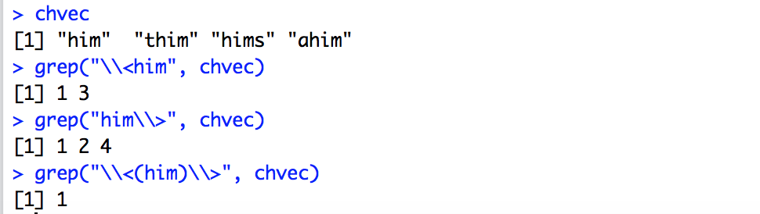

\\: 不运行

Eg: chvec=c('star', 'st*r', '***'); a= grep("\\*", chvec)

*.* The full stop character matches any single character ".at"  The cat sat on the mat .

at.  The cat sat on the mat.

at[.]  The cat sat on the mat.

[] Within square brackets, most metacharacters revert to their literal meaning. For example, [.] means a literal full stop.

"at[.]" means: the letter *`a'*, followed by the letter *`t'*, followed by a full stop.

"at[.]"  The cat sat on the mat.

at[.]?  The cat sat on the mat. *optionally* followed by a full stop.

|：或者； cat|sat  The cat sat on the mat.

cats = c("diplocat", "Hi cat", "mat", "at", "t!", "ct")

grep("\\<(cat|at|t)\\>", cats)

## [1] 2 4 5

+ means that the subpattern can occur one or more times

grep(“c.+t”, test)

[a-z]+ The cat sat on the mat .

grep("I{2,}", movies) 出现I两次以上的位置

grep(".+((at){2,}.+)", temp) #something in front of and after a match to any multiple of "at", _two or more times_ (atat" or "atatat" etc.)

"(.at )+" ##one or more repetitions of: any letter at all, followed by the letter `a', followed by the letter `t', followed by a space.

* means that the subpattern can occur zero or more times

***# Use of strsplit (create a list)***

strsplit(example, "") ##split string by character

strsplit(example, " ") ##split string by word

# Select the 3rd element from left in the splitted string; 在split的string 中截取第三个. hw7 (split string by space)

* speechYr <- as.numeric(sapply(strsplit(tempDates, " "), "[[", 3))
* words = unlist(strsplit(sen, "[[:space:]]+|[[:punct:]]+"))
* strsplit(".a.b.c","\\.") ##表示不运行

[[1]]

[1] "" "a" "b" "c"

* strsplit("11/03/2013","/")

[[1]]

[1] "11" "03" "2013"

***# Remove certain lines of text***

randj <- randj[-(1:65)]

***# Use of grep/gsub***

# “cat” change to “cot”

gsub("(.)at", "\\1ot", text)

"The cot sot on the mot." ### \1 refers to the first subpattern (reading from the left), \2 refers to the second subpattern, and so on.

>x<-c("abc","bcd","cde","def")

>grep("bc",x)

[1] 1 2

>grep("bc",x,value=TRUE)

[1] "abc" "bcd"

>x[grep("bc",x)]

[1] "abc" "bcd"

***# Use of gregexpr/reexpr***

regexpr("\\(.*\\)", movies[1]) ####找一个string中的第几个

The gregexpr() does the same thing as regexpr("D", x), except that its returned object is a list rather than a vector.

> x <- c("ABCDE", "CDEFG", "FGHIJ")

> regexpr("D", x)

[1] 4 2 -1

attr(,"match.length")

[1] 1 1 -1

***# Use of substr***

# Write a vector of the same length with only the first [k] characters from the original vector

abbreviate <- function(vector, k){return(substr(vector, start=1, stop=k))}

# Create [f3] a subset of family of people whose name starts with T

* f3 <- family[substr(family$name, 1, 1)=="T" , ] ##从第一个到第一个

# Find the most common letter in a string; midterm3; chvec=c('s', 'st*r', '***')

mostCommonLetter <- function(chvec){

new.chvec = tolower(chvec)

new.chvec = gsub("'", "", new.chvec)

new.chvec = gsub("[[:digit:]]+", "", new.chvec)

new.chvec = gsub("[[:punct:]]+", "", new.chvec)

new.chvec = gsub("/", "", new.chvec)

x = strsplit(new.chvec, "")

tab = table(unlist(x))

lettermax = max(tab)

letter = names(tab)[tab==max(tab)]

return(letter)

}

***hw1: sequence/ data frame***

***hw2: plot/symbol/barplot***

***hw3: ggplot/apply***

***hw4: fxn & bootstrap (recipe)***

***hw5: bml function***

***hw6: fxn / traffic simulation***

***hw7: text analysis***

***hw8: genboot &simulation***

***# Linear model: hw8***

mod <- lm(mpg~., data=mtcars)

mod$fitted

mod$coef

mod$residuals