Documentation

Introduction
A severe weather can ruin your plans for tomorrow, with Weather System(WS) you will know how to prepare you.

Description
Weather System(WS) is an application that can predict you the weather for tomorrow. Today, users have a lot of choices: Storm Radar, AccuWeather, Waay Weather, Weather Now, etc.
These applications are simple but offer a lot of functionalities. We think it's a good way to get familiar with the Spring Boot.

User
As a user I should have option to see the weather for tomorrow by providing the zip code of the city
Acceptance criteria
The weather information should be visible including the minimum temperature, the maximum temperature, the sun rise, the sun set, the description and the coolest temperature for tomorrow.

Benefit
Benefit of the Weather System:
A user can predict the weather in one click.

How to use Weather System(WS)
url for accessing the application on the client side
The input for the zip code
View the weather according to the zip code

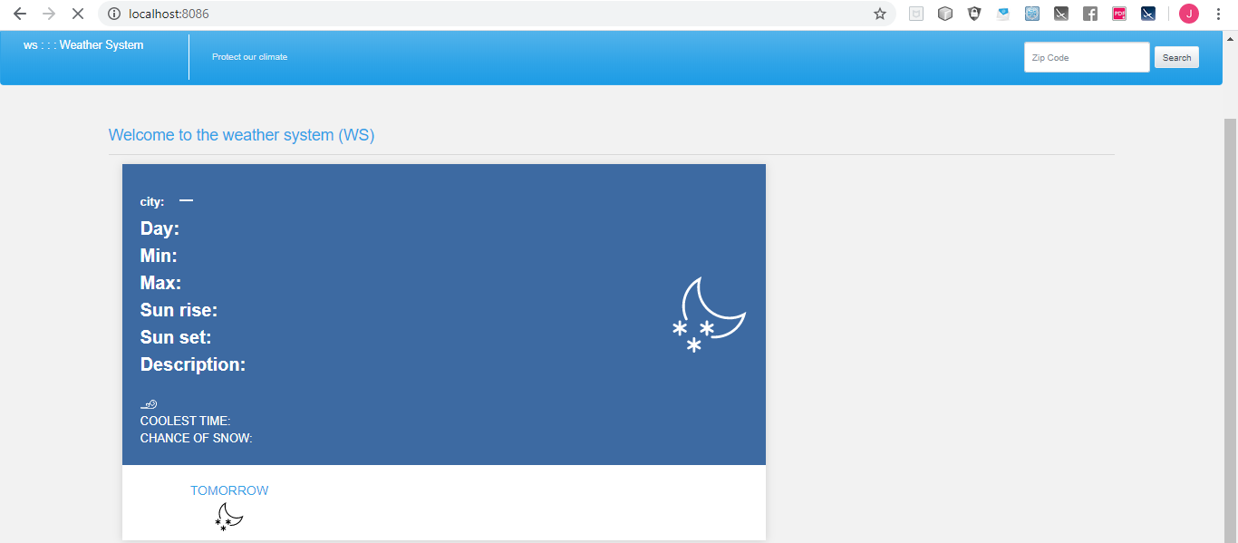

Example:
For viewing the weather of FairField(IOWA)
- Mention the url of the application : http://localhost:8086
- Mention the zip code of the city : ex. : 52557
- Then click on search in order to view the weather for tomorrow.
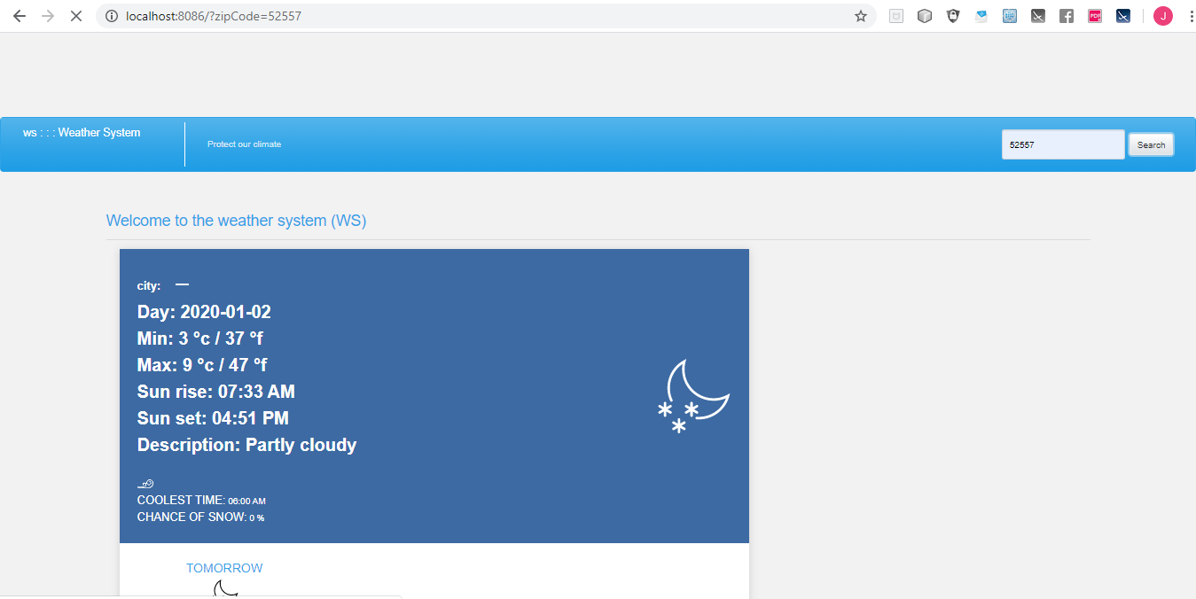

Swagger: Documentation API
- Mention this url (http://localhost:8081/swagger-ui.html)
- Click on Expand operations
- In the parameter zip code please insert the value of the zip code
- Click on try it out.
- The system prints the details

Curl
curl -X GET --header 'Accept: application/json' 'http://localhost:8081/weatherTomorrow/52557'

Request URL
http://localhost:8081/weatherTomorrow/52557

Request Headers
{
"Accept": "application/json"
}

Response Body
{
"date": "2020-01-02",
"maxtempC": 9,
"maxtempF": 47,
"mintempC": 3,
"mintempF": 37,
"avgtempC": 5,
"avgtempF": 41,
"totalSnow_cm": 0,
"sunHour": 5.2,
"uvIndex": 1,
"astronomy": {
"sunrise": "07:33 AM",
"sunset": "04:51 PM",
"moonrise": "12:02 PM",
"moonset": "No moonset",
"moon_phase": "First Quarter",
"moon_illumination": "44"
},
"hourly": {
"time": "06:00 AM",
"tempC": 3,
"tempF": 37,
"chanceofsnow": 0,
"weatherDesc": {
"value": "Partly cloudy"
}
}
}

Response Code
201

Response Headers
{
"content-type": "application/json",
"date": "Wed, 01 Jan 2020 07:50:44 GMT",
"transfer-encoding": "chunked",
"vary": "Origin, Access-Control-Request-Method, Access-Control-Request-Headers"
}

