**15组ABC已经 更换为 25个逻辑链** **3**

**fuels-pollution-diseases-health** **3**

**climate change-diseases-health** **4**

**empathy -communication-relationship** **6**

**-belonging/cohesive society** **6**

Have the chance to communicate with people from different cultural/economic/ professional backgrounds 6

**relationship-belonging** **7**

**spend time with people-relationship-belonging** **11**

**high-tech-save time-efficient** **12**

**broader views-creative-efficient** **13**

every culture has stereotypical views and shortcomings 13

The learning ability of adults tends to vary significantly, 15

**tourism/consumerism-demand-economy** **16**

**新:education-jobs-money-happy** **17**

**新:moral value-copying misbehaviour -crimes-stable society** **18**

**crime report-insecure/panic-efficient** **19**

**新题目_who affect behaviour** **20**

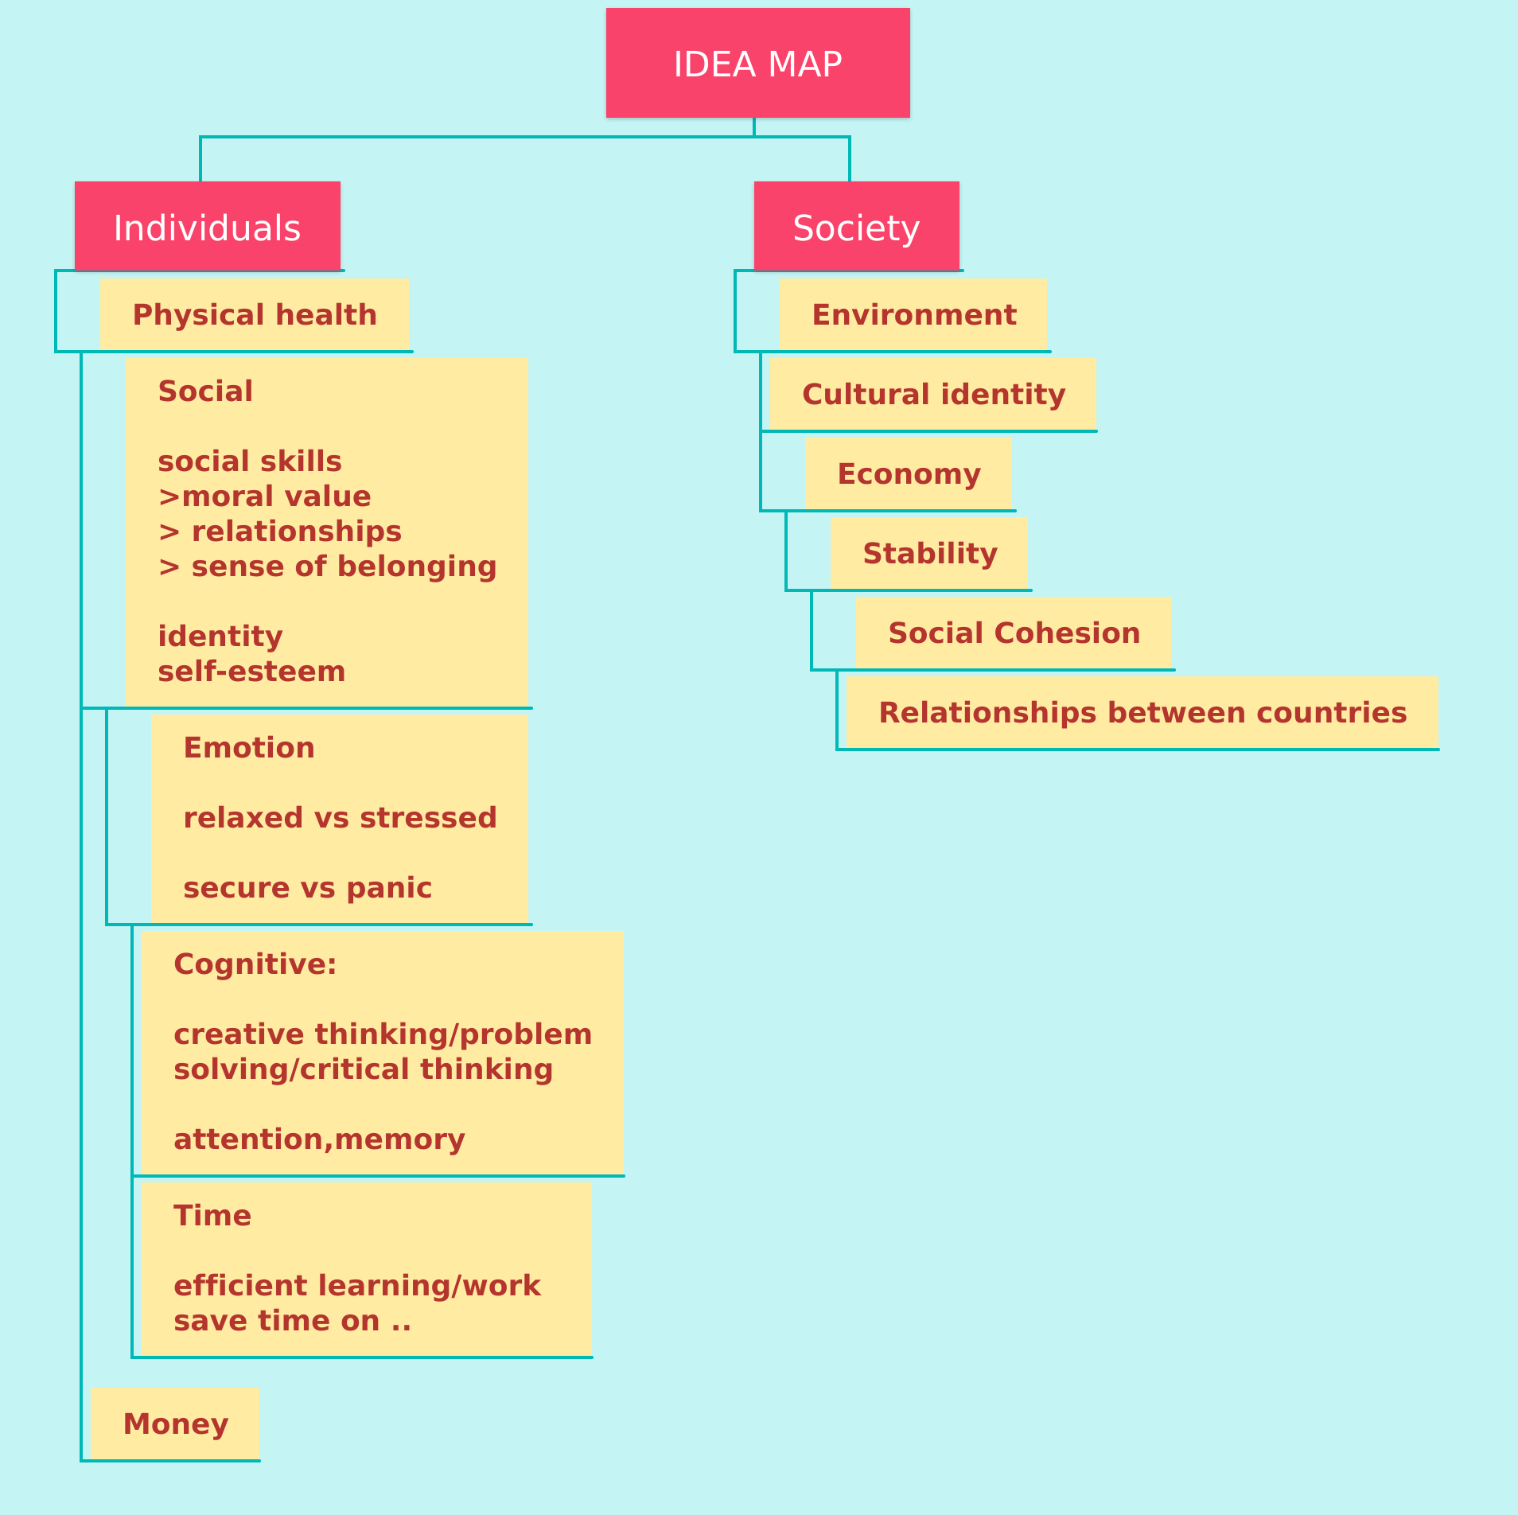

# 15组ABC已经 更换为 25个逻辑链

<https://www.youtube.com/watch?v=y5LqSSHn3l8>

收看视频,阅读视频下面的comments

每1条评论,我都会回复的哈

2020年5月以前的comments,你看不到我的回复,因为5月更换了Youtube 频道,都丢了 😢

论坛讨论: <https://kissielts.com/forum>

7天免费课,具体讲解,如何视频 逻辑链

注册链接: <https://kissielts.academy/7ak>

# fuels-pollution-diseases-health

vehicles emit significant amount of pollutants to the air

increase the risk of several **diseases**

endanger one’s health

# 

# climate change-diseases-health

The demand for goods has increased the need to produce them

result(s) in more air pollutant emissions, changes in land use and deforestation, which are the main factors contributing to climate change

Climate change / global warming can cause extreme weather,

which can increase our risks of several infectious diseases like malaria,

thus endangering human health.

**activities-diseases-health**

diseases

vision disorder

obesity

# 

# empathy -communication-relationship

# -belonging/cohesive society

## Have the chance to communicate with people from **different cultural/economic/ professional backgrounds**

**(raise one’s awareness of cultural diversity)**

**(raise cultural awareness)**

enhance one’s ability to stand in the shoes of others, which is an important social skill

This empathy helps people get along with others, especially those from different backgrounds

contribute to stronger bonds and a sense of connection with other people

lead(s) to a more cohesive society

**face-to-face-communication-**

# relationship-belonging

If we are equipped with excellent social skills

we can communicate and interact with each other effectively, both verbally and non-verbally, through gestures, body language and personal appearance.

For example , .. we are able to put ourselves in the shoes of others **…+ empathy ..**

-

When using modern/ online communication, it is harder to read emotional cues , body language and facial expressions,

but it has been proven that the majority of communication is non-verbal.

So, if we always use mobile phones/ computers to communicate with each others ,

misunderstandings and conflicts may occur frequently, especially when we need to explain very complex things

We might have to spend time clarifying when confusions arise, which is very time-consuming

-

If we usually use online communication to connect with each other

we may find it difficult to converse effectively in daily life: some may feel afraid of being rejected by another person or worry about how their appearance would be judged

misunderstandings and conflicts may occur frequently ..

**history-feel related-belonging**

studying the history of our own country

deepen our understanding about the thoughts and behaviour of past generations

inspire us to relate our current life to the past

enhance our sense of belonging to the nation and strengthen our cultural identity

Furthermore,

we would feel proud of our culture,

thus becoming concerned about others and the environment

-

Many people from developing countries feel that foreign culture is better than their local culture

If they are exposed to foreign culture,

they follow it blindly and ignore their own traditions

,which undermines their own cultural identity

# spend time with people-relationship-belonging

If we do not spend a great deal of time

communicating with our family,

it may result in a lack of intimacy and connection

misunderstandings can occur .

impair our sense of belonging to our family group, which may lead to loneliness

# high-tech-save time-efficient

Educational programs on TV can explain very boring information through the medium of intriguing / interesting videos

help children understand some complex/difficult concepts more quickly than by reading books

(附加)so that children feel engaged in the learning process.

e.g. mobile

Using mobile phones to communicate with each other is less time consuming than face-to-face communication because we do not need to travel to a physical location to meet each other

# broader views-creative-efficient

## every culture has stereotypical views and shortcomings

If students were to only study local history,

it would restrict their point of view and potential to succeed

By contrast,

if they are exposed to world history,

they could learn new ways to approach tasks and this would encourage them to think outside the box

cultivate creative thinking

When they are faced with a problem,

they will consider it from different angles

resulting in efficient problem solving skills

which can be used in various areas of life:

studying, working or dealing with practical problems such as fixing a car

**self-paced learning-efficient**

## The learning ability of adults tends to vary significantly,

（ Everyone’s learning ability is different ）

so studying by themselves and at their own pace can help cater for these differences,

thus allowing slow learners to have sufficient time to comprehend knowledge whereas

fast learners can accelerate their learning.

(fast learners can make progress quickly)

# tourism/consumerism-demand-economy

**economic growth**

an increase **in the amount of** goods and services produced per head of the population over a period of time.

E.g. 旅游业的发展

An increase in the demand for related services and products such as accommodation, transport and tickets for tourist attractions

Furthermore, there would be more and better employment opportunities

so that more people can find lucrative jobs and therefore earn a higher income,

motivating them to purchase more goods and services

Both （以上的2个方便） factors would contribute to economic growth.

# 新:education-jobs-money-happy

## 

If people are equipped with competitive knowledge and skills,

it would be easy for them to find decent jobs and receive a high income,

thus contributing to a good quality of life

---------------

If there are more well-educated people,

it would increase the size and quality of the labour force / they could produce more products and services for society

improve national productivity and the economy

-

# 新:moral value-copying misbehaviour -crimes-stable society

## 

School education teaches students what behaviours are morally right and acceptable

prevent students from being misled by negative influences / criminal elements presentin society

help with reducing crime and increase social stability

# crime report-insecure/panic-efficient

If the news is to inform/notify the public that there are a significiant number of crimes or accidents happening every day in society,

people would also worry about becoming victims of crimes or accidents and so they may feel insecure or anxious

distract them from focusing/concentrating on more meaningful activities

# 新题目_who affect behaviour

## 

they may share some commonalities with students

（For example, bla bla bla .. ）

students will feel that they can stand in their shoes more effectively,

thus providing them sensible suggestions.

Make them more willing to follow their advice

**e.g. criminals**

some reformed criminals committed crimes when they were the same age that the school children are.

The difficulties that reformed criminals encountered in life which triggered them to commit crimes may also be the difficulties these students are currently facing.

**e.g. friends**

They possess similar traits and characteristics like creativity, or being driven.

Most of them also face with the same difficulties:

the pressure of getting into a decent university or finding a promising job

and confusion about their passions or

their identity.