ASSUREX CLAIM ENGINE
Multimodal Consumer Electronics Warranty Adjudication Platform
Technical and Academic Project Documentation
System release | 2026.1
Backend | Python, FastAPI, SQLAlchemy 2.0
Machine learning | Random Forest and MobileNetV2
Document status | Submission-ready consolidated report
Prepared from | Supplied project documentation artifacts
Prepared for direct university / project submission

Document Basis and Verification Status
This consolidated report was prepared from the supplied project artifacts: README.md, PROJECTREPORT.md, TECHNICALBLOGPOST.md, datadictionary.md, AIUSAGE.md, DEMOVIDEO_SCRIPT.md and requirements.txt. The Python source files, frontend files, model files and test files were not supplied for this preparation; therefore, implementation claims are reproduced as documented rather than independently verified by code execution. Where the source artifacts disagree, the disagreement is retained in Section 19 rather than silently resolved.
Formatting conventions. Headings use Word heading styles for navigation and table-of-contents generation. Tables have repeated header rows, captions, consistent cell padding and alternating shading. Mermaid source diagrams have been rendered as numbered figures. Code excerpts use a monospaced shaded style. Page numbers are live Word fields and may be refreshed in Word with Update Field / F9.

Table of Contents
Document Basis and Verification Status 2
Table of Contents 3
1. Introduction 6
1.1 Purpose 6
1.2 Problem Statement 6
1.3 Objectives 6
1.4 Scope 7
2. System Overview and Features 7
2.1 Feature Summary 7
2.2 Adjudication Outcomes 8
3. Technology Stack 8
3.1 Contents of `requirements.txt` 9
4. System Architecture 9
4.1 Architecture Diagram 9
4.2 Tier Responsibilities 10
4.3 Repository Structure 10
4.4 Module Descriptions 11
5. User Roles and Use Cases 12
5.1 Roles 12
5.2 Use Case Diagram 13
5.3 Use Case Descriptions 13
6. Authentication and Authorization 14
6.1 Mechanism 14
6.2 User Authentication Flow 15
6.3 Access Matrix 15
7. Functional Modules 16
7.1 Product and Warranty Registration 16
7.2 Claim Submission Wizard 16
7.3 Receipt OCR (`receipt_ocr.py`) 16
7.4 Duplicate Evidence Detection 16
7.5 Tabular Machine Learning 16
7.6 Claim Summary Card and Visual Classification 17
7.7 Deterministic Rule Engine 17
7.8 Decision Engine 18
7.9 Reviewer Workflow 20
7.10 Administrator Dashboard 21
7.11 PDF Certificate and CSV Export 21
7.12 Batch Evaluation 21
8. Database Design 21
8.1 ER Diagram 21
8.2 Table Reference 22
8.3 Claim Status Lifecycle 26
9. API Documentation 26
9.1 General Information 26
9.2 Router Modules 27
9.3 Routes Explicitly Named in the Documents 27
9.4 Claim Submission Sequence 28
10. Data Flow Diagrams 28
10.1 DFD Level 0 (Context Diagram) 28
10.2 DFD Level 1 29
11. System Flowcharts and Workflows 30
11.1 System Flowchart 30
11.2 Overall System Workflow 32
12. Machine Learning Components and Evaluation 32
12.1 Dataset 32
12.2 Tabular Model Training 33
12.3 Tabular Model Results (225 held-out test records) 33
12.4 Full Pipeline Results (36 unseen test claims) 34
13. User Interface 34
14. Installation and Setup 35
14.1 Prerequisites 35
14.2 Steps 35
14.3 Demo Accounts (from README) 36
15. Testing 36
15.1 Automated Test Suites (`tests/`) 36
15.2 Other Verification Scripts 37
15.3 Commands 37
15.4 Demonstration Fixtures (`sample_claims/`) 37
15.5 Reported Results 38
16. Security Considerations 38
16.1 Implemented Controls (as documented) 38
16.2 Regulatory Checks 38
16.3 Recommendations (analysis, not documented as implemented) 38
17. Limitations 39
18. Future Enhancements 39
19. Documentation Consistency Notes 40
20. Conclusion 41
21. Appendix 41
A. Glossary 41
B. Dataset Feature Reference (26 columns) 42
C. Source Documents 42

Note: Update the table of contents in Microsoft Word after opening the document so page references reflect the final pagination.

1. Introduction

1.1 Purpose
AssureX is a web-based platform that automates the adjudication (accept, reject or escalate decision) of consumer electronics warranty claims. A customer registers a product, files a claim with supporting documents, and the system evaluates the claim using four cooperating components:
- a tabular Random Forest classifier operating on features engineered from the claim data,
- a visual classifier (Google Teachable Machine, MobileNetV2) that inspects a standardized Claim Summary Card image rendered for the claim,
- a deterministic warranty rule engine that enforces 12 policy rules, including Pakistani regulatory checks (PTA DIRBS for handsets and NTN/STRN tax numbers on invoices), and
- a decision engine that arbitrates between the above and produces a final decision with a written explanation.
Claims that are clean are decided automatically. Claims that are ambiguous, contradictory or where the two models disagree are routed to a human reviewer.

1.2 Problem Statement
The project documents identify five problems in manual warranty processing:
Table 1. # / Problem / Description
# | Problem | Description
1 | Turnaround delay | Manual inspection of invoices, warranty cards and serial numbers is slow.
2 | Fraud | Altered receipts, swapped serial tags, and claims on units with excluded damage.
3 | Regulatory exposure | PTA DIRBS compliance for handsets and FBR NTN/STRN tax validation in the Pakistani market.
4 | Inconsistent decisions | Different handlers reach different outcomes on similar claims.
5 | Evidence in isolation | Tools examine either forms or documents, not the tabular data, images, OCR output and rules together.

1.3 Objectives
The project report states these measurable objectives:
Table 2. Objective / Target
Objective | Target
Automate routine, clean claims | at least 70% without human review
Agreement between tabular and visual models on unseen data | at least 80%
Adjudication accuracy on balanced benchmark data | at least 90%
Policy enforcement | never auto-approve expired, excluded-damage or non-compliant claims
Processing latency | under 500 ms per claim for ML, rules and arbitration
Auditability | log all submissions, state changes, reviewer actions and predictions

1.4 Scope
In scope
- Customer self-registration, product registration and automatic warranty creation.
- Four-step claim submission wizard with document upload.
- Receipt OCR (EasyOCR with regex parsing).
- Duplicate-evidence detection via SHA-256 hashes.
- Tabular classification, visual classification, rule evaluation and arbitration.
- Reviewer queue with approve, reject and override actions.
- Administrator dashboard with metrics, Chart.js charts, search/filter and CSV export.
- PDF claim certificates (ReportLab).
- Five product categories: Smartphone, Laptop, Washing Machine, Smart TV, Audio / Soundbar.
Out of scope (per the project report)
- Robotic disassembly of appliances.
- Payment gateway integration for repair fees.
- Live integration with PTA DIRBS carrier APIs (compliance is simulated through deterministic rules).

2. System Overview and Features

2.1 Feature Summary
Table 3. # / Feature / Summary
# | Feature | Summary | Primary role(s)
1 | Authentication and role switching | Login by username or email; navigation adapts to role | All
2 | Product and warranty registration | Creates a Product and a 12-month Warranty record | Customer
3 | Claim submission wizard | Product, fault details, evidence upload, review and submit, with live OCR | Customer
4 | Claim tracking | Status badge, timeline, warranty coverage card, evidence gallery with SHA-256 checksums | Customer, Reviewer
5 | Reviewer queue | Manual-review claims, consensus matrix, decision explanation, approve/reject/override | Claim Reviewer
6 | Admin analytics | Total claims, decision distribution, model agreement rate, average confidence, Chart.js charts | Administrator
7 | Search and filtering | Filter by status, category and keyword | Administrator
8 | PDF claim certificate | Downloadable adjudication report generated with ReportLab | Customer, Reviewer, Administrator
9 | CSV export | Filtered claims export with predictions, confidences, rule results and reviewer notes | Administrator
10 | Batch unseen-claims evaluation | Script that runs test claims through the full pipeline and writes CSV and Markdown reports | Developer / evaluator
11 | Audit trail | Events written to the audit_logs table | Administrator

2.2 Adjudication Outcomes
The pipeline produces one of three final decisions, which are then reflected in the claim status.
Table 4. Final decision / Meaning
Final decision | Meaning
Likely Valid | Models agree with adequate confidence and all rules pass. Claim is auto-approved.
Likely Invalid | Models agree on rejection, or a hard rule fails. Claim is auto-rejected.
Manual Review Required | Disagreement, low confidence, weak consistency or a rule that needs human judgement.

3. Technology Stack
Table 5. Layer / Technology / Purpose
Layer | Technology | Purpose
Language | Python 3.10 to 3.14 | Backend, ML, scripts
Web framework | FastAPI, Starlette, Uvicorn | REST API, static file serving, ASGI server
Validation | Pydantic v2 | Request and response schemas
ORM and database | SQLAlchemy 2.0; SQLite by default, PostgreSQL-compatible | Persistence
Authentication | JWT (HS256), salted bcrypt, OAuth2 password-bearer flow | Sessions and password storage
Tabular ML | scikit-learn (Random Forest), pandas, numpy, joblib | Claim classification
Vision ML | Google Teachable Machine export (Keras MobileNetV2, keras_model.h5), TensorFlow | Claim Summary Card classification
OCR | EasyOCR with regular expressions | Receipt field extraction
Imaging | Pillow | Claim Summary Card rendering
Reporting | ReportLab | PDF certificates
Frontend | HTML5, CSS3, vanilla JavaScript (ES6+), Chart.js | Single-page application and charts
Testing | pytest | Automated tests

3.1 Contents of `requirements.txt`
Table 6. Package / Minimum version / Group
Package | Minimum version | Group
fastapi | 0.115.0 | Web framework
uvicorn | 0.30.0 | Server
starlette | 0.38.0 | Web framework
sqlalchemy | 2.0.0 | Database
pydantic | 2.8.0 | Data modeling
pyjwt | 2.9.0 | JWT handling
python-multipart | 0.0.9 | Form and file uploads
email-validator | 2.0.0 | Email validation
httpx | 0.27.0 | HTTP client (also used by FastAPI's test client)
reportlab | 4.2.0 | PDF generation
pillow | 10.0.0 | Image handling
pandas | 2.0.0 | Data processing
numpy | 1.24.0 | Numerical computing
scikit-learn | 1.3.0 | Machine learning
joblib | 1.3.0 | Model serialization
python-dateutil | 2.8.0 | Date handling

Note. The documents also reference bcrypt, TensorFlow, EasyOCR and pytest, which do not appear in this requirements.txt. See Section 19 and Section 14.

4. System Architecture

4.1 Architecture Diagram
AssureX uses a layered design. The project documents describe five tiers.
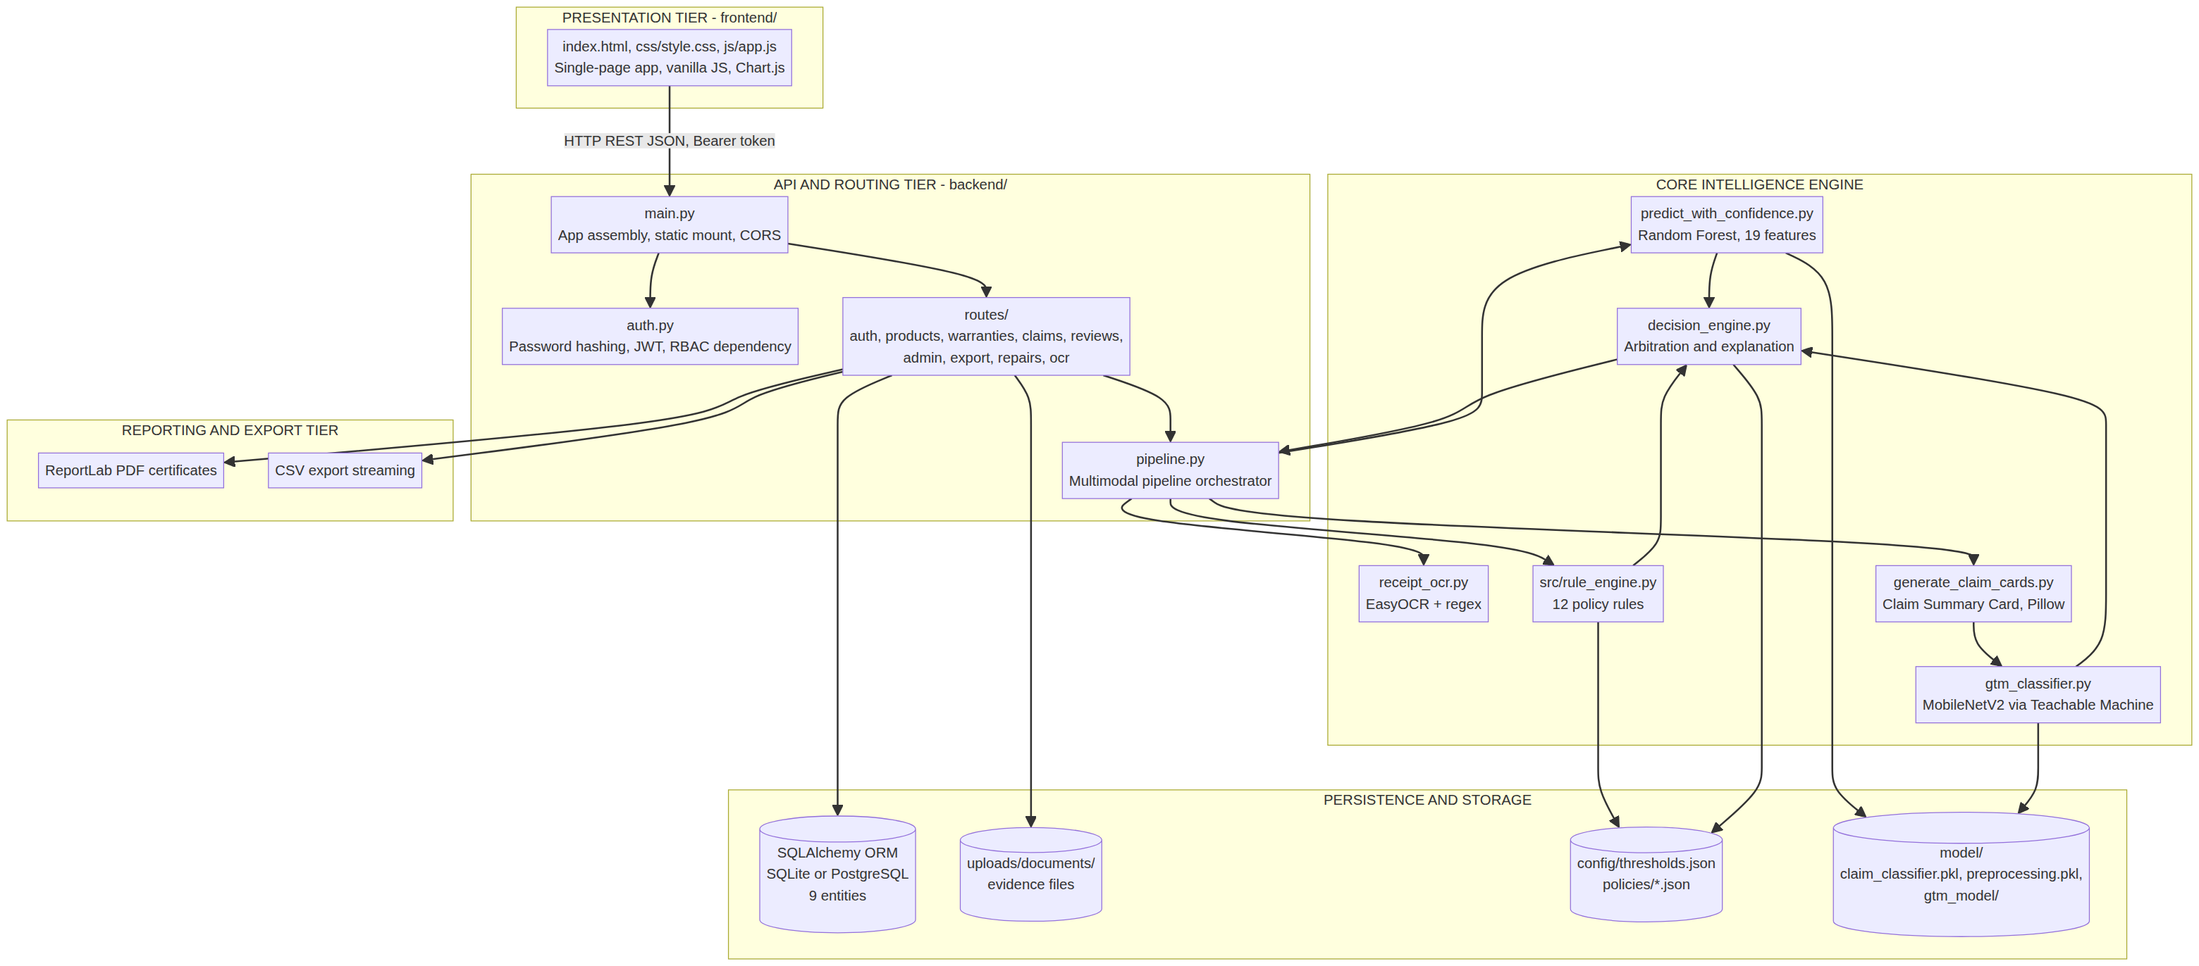
Figure 1. 4.1 Architecture Diagram

4.2 Tier Responsibilities
Table 7. Tier / Responsibility
Tier | Responsibility
Presentation | Browser SPA: login, registration, claim wizard, tracker, reviewer queue, admin dashboard. Calls the API with JSON and a Bearer token.
API and routing | FastAPI routers validate input with Pydantic, enforce authentication and role checks, and delegate to the pipeline.
Core intelligence | OCR, two ML models, rule engine and decision engine.
Persistence and storage | Relational database, uploaded files (with SHA-256 hashes), model artifacts, JSON configuration.
Reporting and export | PDF certificates and CSV streaming.

4.3 Repository Structure
As documented in the README (with two additions noted in the last column):
AssureX/
├── backend/ FastAPI application core
│ ├── main.py App assembly, static mounting, CORS
│ ├── config.py Database path, JWT secret, storage config
│ ├── database.py SQLAlchemy engine and session factory
│ ├── models.py 9 relational entities
│ ├── auth.py Password hashing, JWT, RBAC
│ ├── pipeline.py Multimodal pipeline orchestrator
│ └── routes/ auth, products, warranties, claims,
│ reviews, admin, export
│ (repairs, ocr also referenced in AI_USAGE.md)
├── frontend/
│ ├── index.html SPA markup
│ ├── css/style.css Styling and responsive layout
│ └── js/app.js Client logic, API calls, Chart.js
├── model/
│ ├── claim_classifier.pkl Random Forest
│ ├── preprocessing.pkl StandardScaler, encoders, feature schema
│ └── gtm_model/ keras_model.h5, labels.txt
├── policies/ smartphone_policy.json, laptop_policy.json,
│ washing_machine_policy.json
├── config/thresholds.json Decision engine thresholds
├── dataset/ train.csv, val.csv, test.csv (1,500 records)
├── documentation/ PROJECT_REPORT.md, data_dictionary.md
├── sample_claims/ 11 demo fixtures
├── tests/ pytest suites
├── CREDENTIALS.md Evaluation accounts and scenario guide
├── requirements.txt
├── run_server.py Uvicorn launcher
├── seed_db.py Database seeding
├── gtm_classifier.py Visual classifier
├── predict_with_confidence.py Tabular inference
├── receipt_ocr.py EasyOCR parsing
├── decision_engine.py Arbitration engine
└── run_model_comparison_pipeline.py Batch evaluator
Other files named in the documents but not in the README tree: src/rule_engine.py, generate_claim_cards.py, generate_claims_dataset.py, run_feature_engineering.py, train_classifiers.py, test_login_end_to_end.py, verify_all_roles_rbac.py, and the reports/ output folder.

4.4 Module Descriptions
Table 8. Module / File(s) / Description
Module | File(s) | Description
Application core | backend/main.py, config.py, database.py | Assembles the FastAPI app, mounts the frontend, configures CORS, database engine and settings.
Domain models | backend/models.py | Nine SQLAlchemy entities.
Security | backend/auth.py | Password hashing, JWT creation and decoding, role-based dependency.
Pipeline orchestrator | backend/pipeline.py | Runs OCR, the two models, the rule engine and the decision engine for a submitted claim, then persists results.
Tabular ML | predict_with_confidence.py, train_classifiers.py | Loads the Random Forest and preprocessors and returns class probabilities.
Visual ML | gtm_classifier.py | Loads the Keras model, resizes the card to 224 by 224 RGB, normalizes to [-1, 1], returns 3-class confidences. Raises RuntimeError if TensorFlow or the model is missing.
Rule engine | src/rule_engine.py, policies/*.json | Evaluates 12 category-specific rules.
Decision engine | decision_engine.py, config/thresholds.json | Consistency classification and final arbitration with explanation payload.
OCR | receipt_ocr.py | Extracts date, invoice number, product, model, serial, retailer and amount with per-field confidence flags.
Seeding | seed_db.py | Creates tables, four demo users, products, warranties, repair histories and demo claims.
Batch evaluation | run_model_comparison_pipeline.py | Runs unseen test claims through the pipeline and writes comparison reports.

5. User Roles and Use Cases

5.1 Roles
The system defines four roles, stored in users.role.
Table 9. Role / Value / Documented capabilities
Role | Value | Documented capabilities
Customer | customer | Register products, file claims, upload evidence, use OCR, track claims, download PDF report
Service Center | service_center | Physical diagnostic intake, repair logging, serial audits
Claim Reviewer | claim_reviewer | View manual-review queue, inspect evidence, approve, reject or override, download PDF report
Administrator | admin | Dashboard and analytics, search/filter, CSV export, audit log inspection, override authority

The use case diagram in the project report additionally lets the Service Center register products, submit claims and upload evidence. The README describes the role more narrowly (intake, repair logging, serial audits). The diagram below follows the project report.

5.2 Use Case Diagram
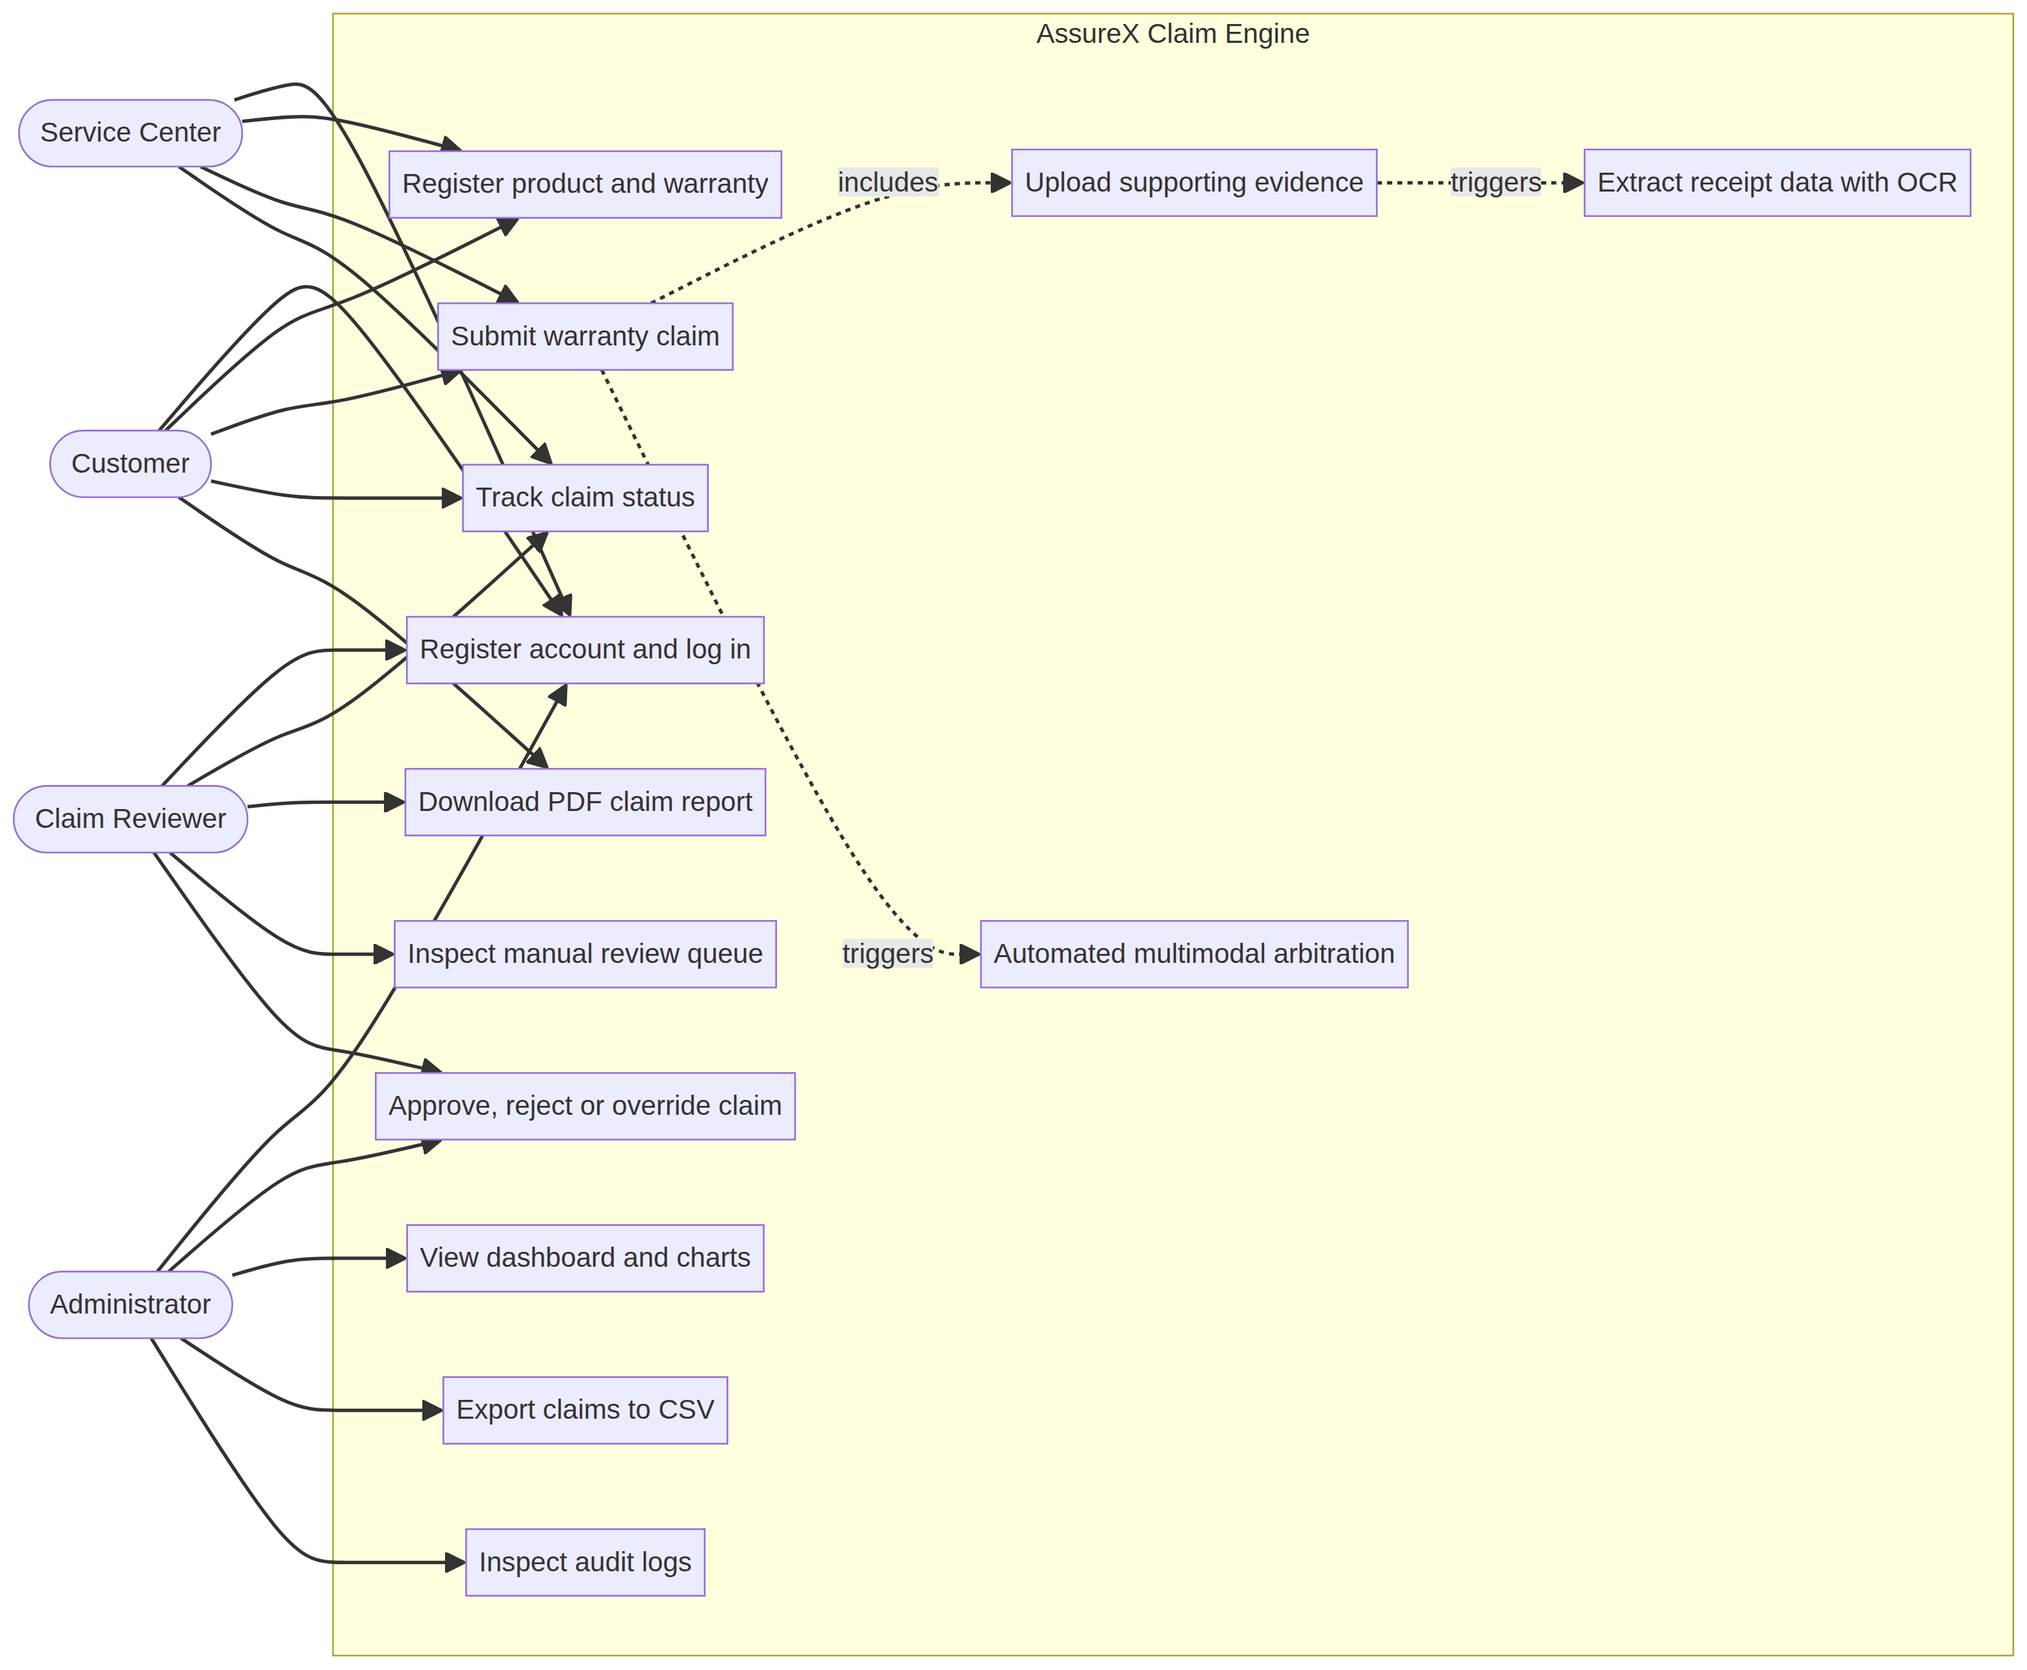
Figure 2. 5.2 Use Case Diagram

5.3 Use Case Descriptions
Table 10. Use case / Actor / Precondition
Use case | Actor | Precondition | Main flow | Result
Log in | Any user | Account exists | Enter username or email and password | JWT issued; UI adapts to role
Register product | Customer | Logged in | Fill category, name, brand, model, serial, price, date, retailer | Product created and 12-month Warranty generated
Submit claim | Customer | Registered product | Select product, enter fault details, upload evidence, verify OCR data, submit | Pipeline runs; claim ID assigned (for example CLM-2026-00014)
Track claim | Customer | Claim exists | Enter claim ID | Status, timeline, warranty card and evidence gallery
Review claim | Reviewer | Claim in Manual Review | Open claim, inspect matrix and explanation, choose action | Status updated; reviews and audit_logs rows written
View analytics | Administrator | Logged in | Open Admin Dashboard | KPIs and charts
Export CSV | Administrator | Logged in | Apply filters, click Export CSV | CSV download

6. Authentication and Authorization

6.1 Mechanism
Table 11. Aspect / Implementation (as documented)
Aspect | Implementation (as documented)
Login identifiers | Username or email, plus password
Password storage | Salted bcrypt hash in users.hashed_password
Session token | JWT signed with HMAC-SHA256 (HS256)
Token lifetime | 1440 minutes (24 hours), configurable via ACCESS_TOKEN_EXPIRE_MINUTES
Token transport | Authorization: Bearer <token> header
Clock tolerance | 60-second leeway when decoding, added after a clock-drift bug
Access control | FastAPI dependency (require_role in the report, require_roles in the blog post) checks the role claim
Failure responses | HTTP 401 for missing or invalid token, HTTP 403 for insufficient role
Bypass | None. The security audit removed all demo shortcuts and hardcoded tokens.

6.2 User Authentication Flow
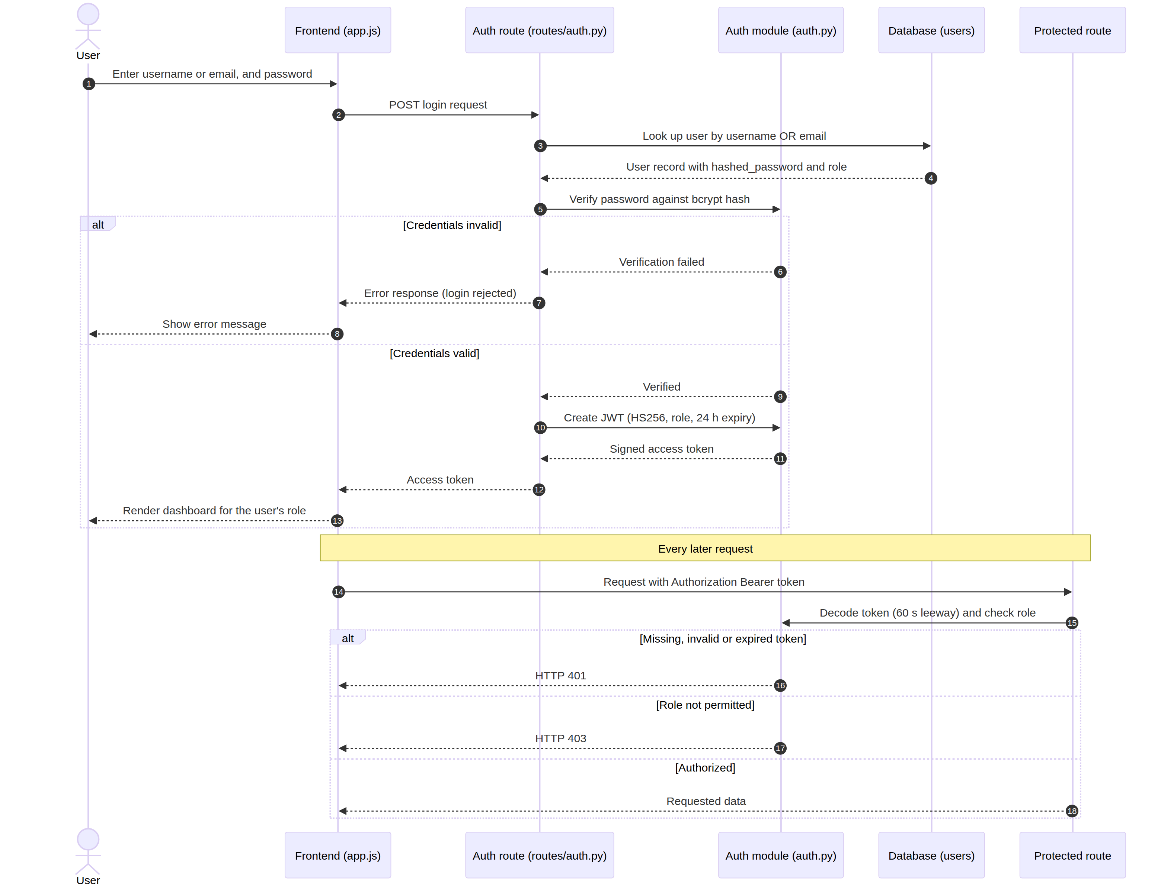
Figure 3. 6.2 User Authentication Flow

6.3 Access Matrix
Table 12. Capability / Customer / Service Center
Capability | Customer | Service Center | Claim Reviewer | Administrator
Register / log in | Yes | Yes | Yes | Yes
Register product | Yes | Yes | No | No
File claim, upload evidence | Yes | Yes | No | No
Track claim | Yes | Yes | Yes | Not stated
Log repairs, diagnostic intake | No | Yes | No | No
View manual review queue | No | No | Yes | Not stated
Approve / reject / override | No | No | Yes | Yes (per use case diagram)
Download PDF report | Yes | Not stated | Yes | Yes
Dashboard, filters, CSV export | No | No | No | Yes
Inspect audit logs | No | No | No | Yes

Cells marked "Not stated" are not specified in the supplied documents. Confirm against the route dependencies in backend/routes/*.py.

7. Functional Modules

7.1 Product and Warranty Registration
The customer enters category, product name, brand, model, chassis serial number or IMEI, purchase date, retailer and purchase price (PKR). On submission the backend creates the products record and automatically creates a one-to-one warranties record with a default duration of 12 months, start and expiry dates and status Active. Serial numbers are unique.

7.2 Claim Submission Wizard
Table 13. Step / Content
Step | Content
1 | Select one of the customer's registered products
2 | Fault occurrence date, damage category, fault description, prior repair status and replacement declaration
3 | Upload purchase receipt, dealer-stamped warranty card and serial barcode evidence; OCR runs on the receipt
4 | Review extracted fields and confidence flags, tick the declaration, submit for automated adjudication

7.3 Receipt OCR (`receipt_ocr.py`)
- Uses EasyOCR and regular expressions.
- Extracts purchase_date, invoice_number, product_name, model_number, serial_number, retailer and purchase_amount.
- Each field carries a confidence flag so low-confidence values are highlighted for user verification.
- Includes patterns for Pakistani 7-digit NTN and STRN numbers.
- Supports YYYY-MM-DD, DD/MM/YYYY and DD-Mon-YYYY date formats.
- Includes fallback heuristics for faded thermal receipts.

7.4 Duplicate Evidence Detection
Every uploaded file is hashed with SHA-256 at ingestion. If the hash matches a document already stored, the new documents row is flagged with is_duplicate = True and duplicate_of_document_id points to the original. Proof of purchase is then treated as invalid.

7.5 Tabular Machine Learning
Table 14. Item / Detail
Item | Detail
Algorithm | RandomForestClassifier
Input | 19 engineered features
Output | Probabilities for Valid Claim, Invalid Claim, Manual Review
Function | predict_with_confidence()
Artifacts | model/claim_classifier.pkl, model/preprocessing.pkl

Feature groups: temporal (days_since_purchase, days_until_warranty_expiry, days_to_report, warranty_lifespan_ratio), integrity (serial_match, all_docs_present, the four has flags, prior_replacement), categorical risk (damage_type_invalid_risk, damage_type_freq, retailer_freq, one-hot product_category) and repair history (prior_repair_count, unauthorized_repair_flag). Numeric features are scaled with a StandardScaler fitted on training data only.

7.6 Claim Summary Card and Visual Classification
Raw customer photographs are not classified directly. Instead the system renders a standardized 600 by 800 pixel Claim Summary Card (Pillow) containing a status banner colored by warranty state (green, amber, red), product identity, a coverage-consumption progress bar, a checklist of evidence items, the reported defect and a barcode. The card is resized to 224 by 224 RGB, normalized to [-1, 1] using x / 127.5 - 1 and classified by the MobileNetV2 model exported from Google Teachable Machine. If TensorFlow or the model files are unavailable the module raises a RuntimeError; it does not fabricate scores.

7.7 Deterministic Rule Engine
Rules are evaluated per product category using thresholds and terms from policies/*.json. New categories can be added by adding a policy file.
Table 15. # / Rule / Check
# | Rule | Check
1 | EXCLUDED_DAMAGE_CHECK | Liquid ingress (LDI/LCI), physical cracks, power surges, unauthorized firmware
2 | UNAUTHORIZED_REPAIR | Third-party servicing or broken tamper seals
3 | WARRANTY_ACTIVE | Fault date within coverage plus statutory grace period (typically 7 to 14 days)
4 | PROOF_OF_PURCHASE_PRESENT | Invoice present, dated, with valid NTN/STRN format
5 | SERIAL_NUMBER_MATCH | Chassis serial equals invoice serial; PTA DIRBS compliance for handsets
6 | MANDATORY_DOCUMENTS_COMPLETE | Receipt, warranty card and CNIC attachments
7 | FAULT_COVERED | Defect appears in the policy's covered faults
8 | REPORTING_PERIOD_VALID | Claim filed within the allowed window after the incident
9 | LEMON_LAW_CHECK | Three or more major repairs (documents cite a 180-day window)
10 | PRIOR_REPLACEMENT_CHECK | Unit not already replaced under an earlier total-loss claim
11 | DUPLICATE_CLAIM_CHECK | Duplicate evidence or repeated/open claims for the same serial
12 | CONTRADICTION_DETECTION | Chronological impossibilities such as fault before purchase

Rule results have three outcomes: PASS, FAIL and MANUAL_REVIEW. In the evaluation tables, examples include FAIL (WARRANTY_ACTIVE) and MANUAL_REVIEW (SERIAL).

7.8 Decision Engine
Confidence gap: the absolute difference between the top confidence of the tabular model and of the visual model.
Thresholds (config/thresholds.json):
{
"confidence_difference_thresholds": {
"strong_match_max_difference": 0.15,
"acceptable_match_max_difference": 0.30,
"weak_match_max_difference": 0.45
},
"min_confidence_for_automated_decision": 0.70
}
Model consistency status
Table 16. Status / Condition
Status | Condition
Strong Match | Both models agree on the class and the gap is at most 0.15
Acceptable Match | Agree, gap above 0.15 and at most 0.30
Weak Match | Agree, gap above 0.30 and at most 0.45
Model Disagreement | The models predict different canonical classes
Uncertain Result | Confidence too low (see Section 19 for the differing definitions)

Arbitration rules
Table 17. Consistency / Rule audit / Top confidence
Consistency | Rule audit | Top confidence | Final outcome
Strong or Acceptable | All rules pass | at least 0.70 | Model consensus (Likely Valid or Likely Invalid)
Strong or Acceptable | Any hard rule fails | Any | Veto: Likely Invalid or Manual Review Required
Strong or Acceptable | All rules pass | below 0.70 | Manual Review Required
Model Disagreement | Any | Any | Manual Review Required
Weak or Uncertain | Any | Any | Manual Review Required

A machine learning prediction can never override a hard contractual failure. Each decision includes an explanation payload with factors_supporting, factors_opposing, rules_passed, rules_failed and evidence still needed.
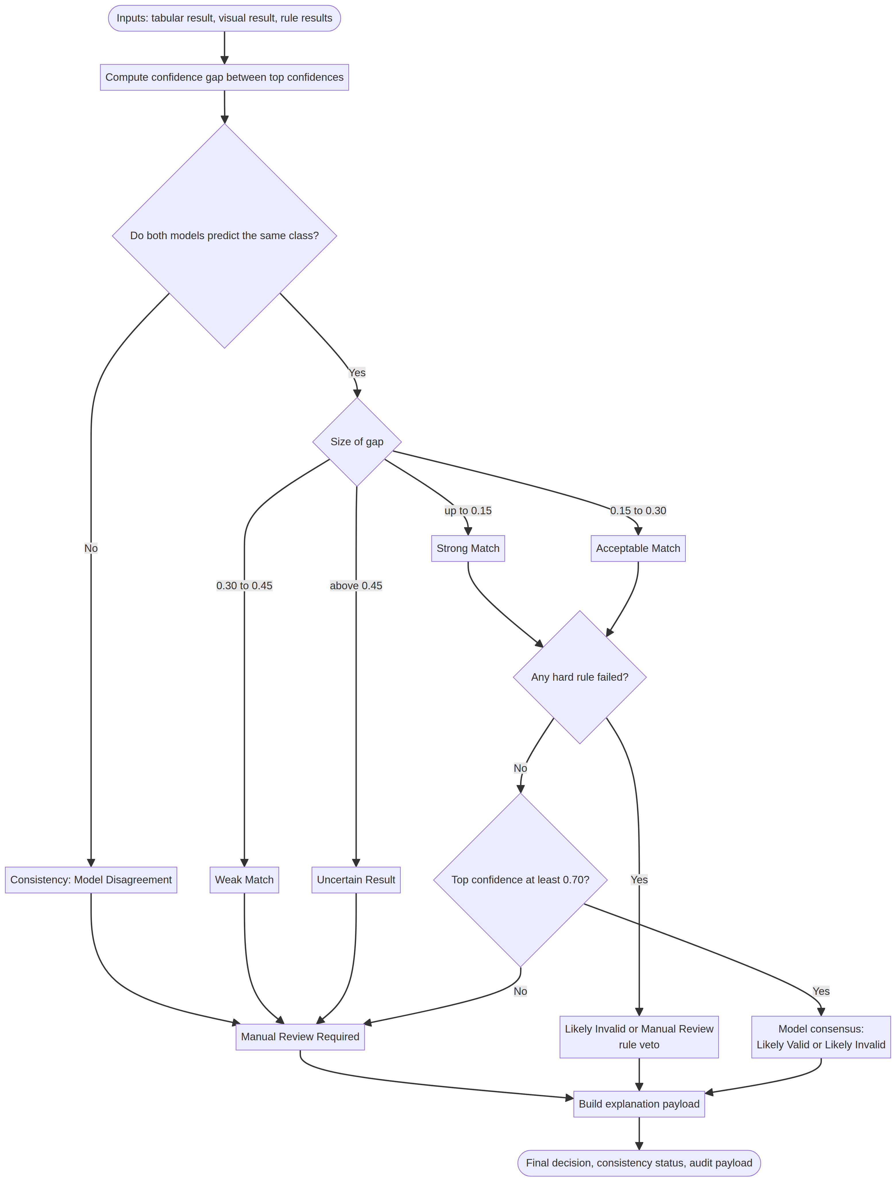
Figure 4. 7.8 Decision Engine

7.9 Reviewer Workflow
The queue lists claims with status Manual Review. For each claim the reviewer sees a consensus matrix (tabular confidence, visual confidence and rule results side by side), the written explanation, uploaded evidence and repair history. Available actions are Approve, Reject and Override (which requires justification notes). Each action creates a reviews row and an audit_logs entry and updates the claim status. The reviews.action column also lists request_evidence.

7.10 Administrator Dashboard
Shows total claims filed, adjudication distribution, multi-model agreement rate and average top confidence, with Chart.js charts for adjudication trends and category distribution. Claims can be filtered by status, category and keyword (claim ID, serial number, customer name or fault keywords) without page reloads. The project report additionally lists date-range filtering and confusion-matrix metrics.

7.11 PDF Certificate and CSV Export
- PDF: generated natively with ReportLab (available at /api/claims/{claim_id}/report). Contents: branded header with barcode, claimant, product and serial metadata, warranty timeline, the 12-rule audit checklist, and the multimodal decision breakdown with explanation.
- CSV: streams claim attributes, predictions, confidences, rule audit results and reviewer notes, honoring the active filters.

7.12 Batch Evaluation
run_model_comparison_pipeline.py runs unseen claims from dataset/test.csv through the full pipeline (default 36 claims; --all for all 225) and writes reports/unseen_test_claims_report.csv and .md.

8. Database Design

8.1 ER Diagram
The database has nine entities. Default engine is SQLite (database/assurex.db); PostgreSQL is stated to be compatible via DATABASE_URL.
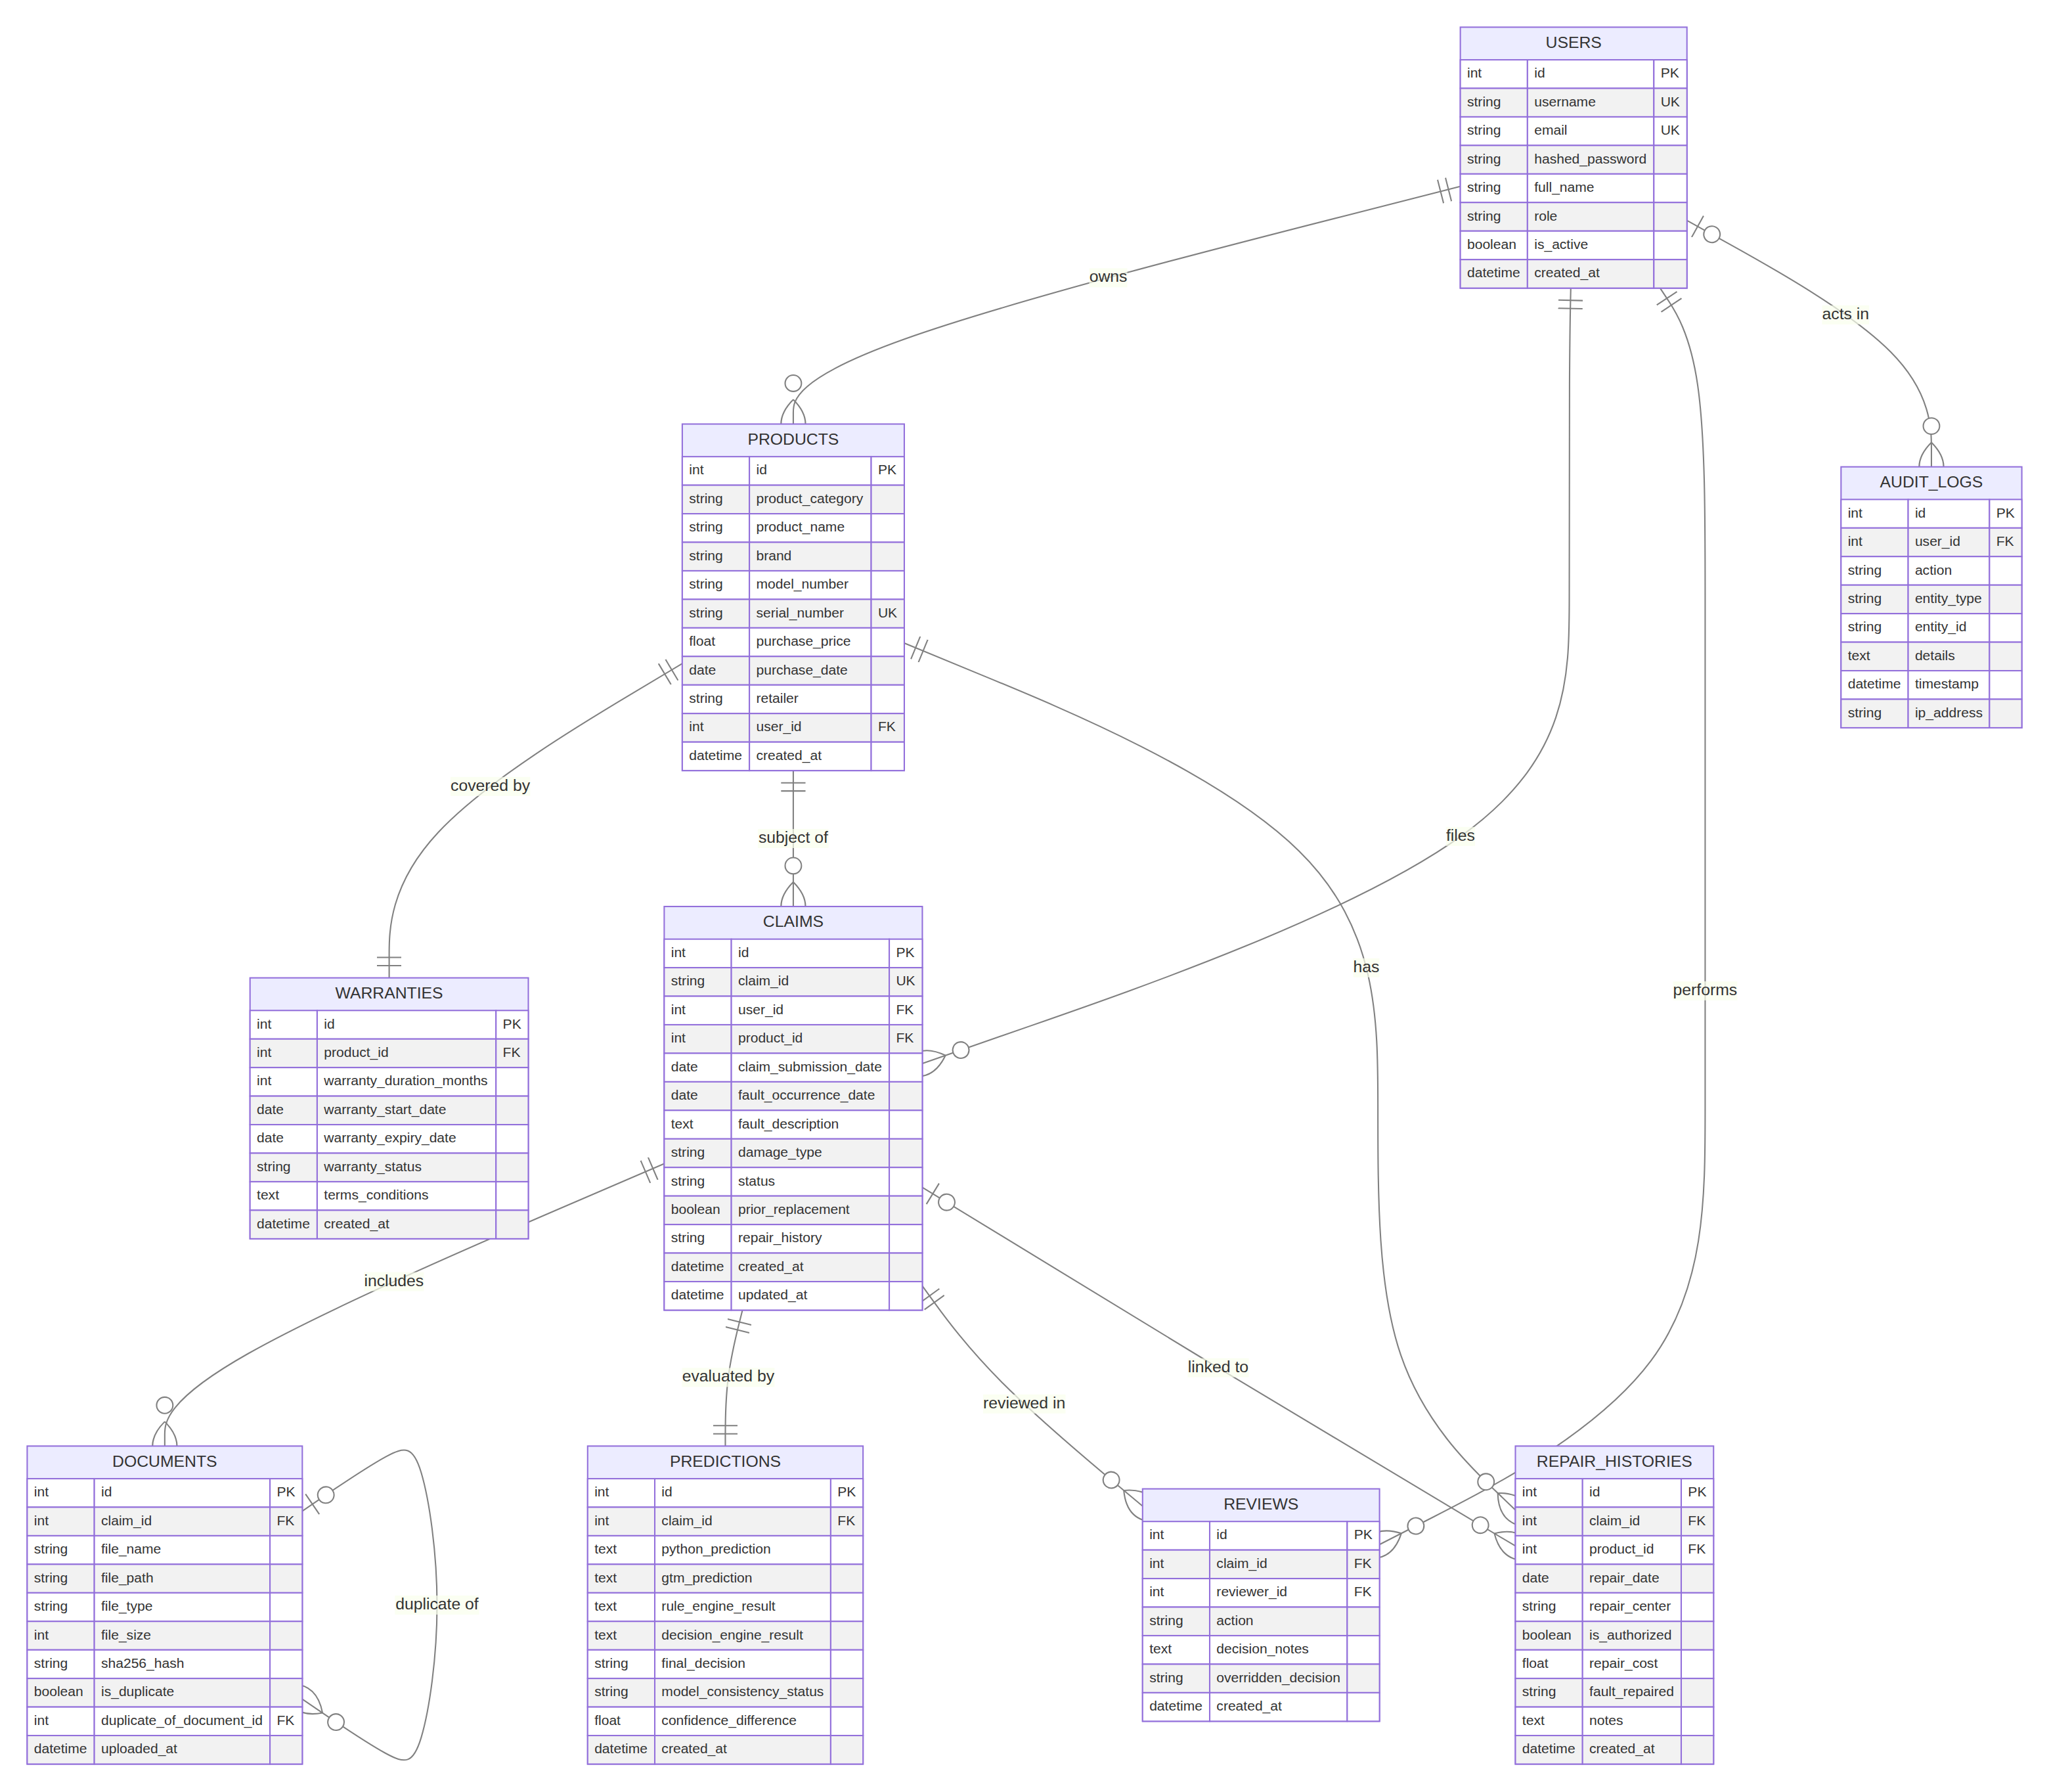
Figure 5. 8.1 ER Diagram

8.2 Table Reference
users
Table 18. Column / Type / Constraints
Column | Type | Constraints
id | INTEGER | PK, auto-increment
username | VARCHAR(64) | Unique, indexed
email | VARCHAR(120) | Unique, indexed
hashed_password | VARCHAR(256) | Bcrypt hash
full_name | VARCHAR(128) | Required
role | VARCHAR(32) | Default customer; one of customer, service_center, claim_reviewer, admin
is_active | BOOLEAN | Default true
created_at | DATETIME | Default UTC now

products
Table 19. Column / Type / Constraints
Column | Type | Constraints
id | INTEGER | PK
product_category | VARCHAR(64) | Required
product_name | VARCHAR(128) | Required
brand | VARCHAR(64) | Required
model_number | VARCHAR(64) | Required
serial_number | VARCHAR(64) | Unique, indexed
purchase_price | FLOAT | 0 or greater
purchase_date | DATE | Required
retailer | VARCHAR(128) | Required
user_id | INTEGER | FK to users.id
created_at | DATETIME | Default UTC now

warranties
Table 20. Column / Type / Constraints
Column | Type | Constraints
id | INTEGER | PK
product_id | INTEGER | Unique FK to products.id (one-to-one)
warranty_duration_months | INTEGER | Default 12
warranty_start_date | DATE | Required
warranty_expiry_date | DATE | Required
warranty_status | VARCHAR(32) | Default Active; Active, Expired or Void
terms_conditions | TEXT | Nullable
created_at | DATETIME | Default UTC now

claims
Table 21. Column / Type / Constraints
Column | Type | Constraints
id | INTEGER | PK
claim_id | VARCHAR(32) | Unique, indexed; format CLM-2026-NNNNN
user_id | INTEGER | FK to users.id
product_id | INTEGER | FK to products.id
claim_submission_date | DATE | Default today
fault_occurrence_date | DATE | Required
fault_description | TEXT | Required
damage_type | VARCHAR(64) | Required
status | VARCHAR(32) | Default Submitted; also Under Evaluation, Manual Review, Approved, Rejected, Overridden
prior_replacement | BOOLEAN | Default false
repair_history | VARCHAR(128) | Default 0 repairs
created_at, updated_at | DATETIME | Default UTC now

documents
Table 22. Column / Type / Constraints
Column | Type | Constraints
id | INTEGER | PK
claim_id | INTEGER | FK to claims.id
file_name | VARCHAR(256) | Original name
file_path | VARCHAR(512) | Storage path
file_type | VARCHAR(64) | receipt, warranty_card, product_image or serial_evidence
file_size | INTEGER | Bytes
sha256_hash | VARCHAR(64) | Indexed
is_duplicate | BOOLEAN | Default false
duplicate_of_document_id | INTEGER | Nullable self-referencing FK
uploaded_at | DATETIME | Default UTC now

repair_histories
Table 23. Column / Type / Constraints
Column | Type | Constraints
id | INTEGER | PK
claim_id | INTEGER | Nullable FK to claims.id
product_id | INTEGER | FK to products.id
repair_date | DATE | Required
repair_center | VARCHAR(128) | Required
is_authorized | BOOLEAN | Default true
repair_cost | FLOAT | Default 0.0
fault_repaired | VARCHAR(128) | Required
notes | TEXT | Nullable
created_at | DATETIME | Default UTC now

predictions
Table 24. Column / Type / Constraints
Column | Type | Constraints
id | INTEGER | PK
claim_id | INTEGER | Unique FK to claims.id (one-to-one)
python_prediction | TEXT | JSON: tabular output
gtm_prediction | TEXT | JSON: visual output
rule_engine_result | TEXT | JSON: rules passed and failed
decision_engine_result | TEXT | JSON: full explanation payload
final_decision | VARCHAR(64) | Likely Valid, Likely Invalid, Manual Review Required
model_consistency_status | VARCHAR(64) | Consistency tier
confidence_difference | FLOAT | 0 or greater
created_at | DATETIME | Default UTC now

reviews
Table 25. Column / Type / Constraints
Column | Type | Constraints
id | INTEGER | PK
claim_id | INTEGER | FK to claims.id
reviewer_id | INTEGER | FK to users.id
action | VARCHAR(32) | approve, reject, override, request_evidence
decision_notes | TEXT | Required
overridden_decision | VARCHAR(64) | Nullable; automated decision that was overridden
created_at | DATETIME | Default UTC now

audit_logs
Table 26. Column / Type / Constraints
Column | Type | Constraints
id | INTEGER | PK
user_id | INTEGER | Nullable FK to users.id (null for system events)
action | VARCHAR(64) | Indexed, for example CLAIM_SUBMISSION, PREDICTION_RUN, REVIEW_OVERRIDE
entity_type | VARCHAR(64) | Indexed
entity_id | VARCHAR(64) | Indexed
details | TEXT | JSON context
timestamp | DATETIME | Indexed, default UTC now
ip_address | VARCHAR(64) | Nullable

8.3 Claim Status Lifecycle
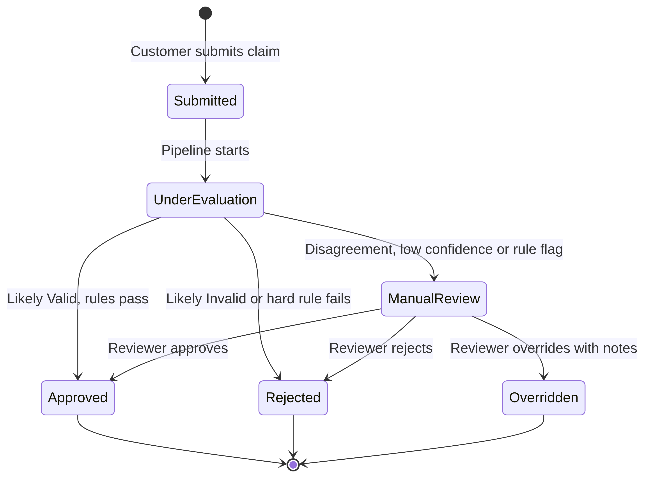
Figure 6. 8.3 Claim Status Lifecycle

9. API Documentation

9.1 General Information
Table 27. Item / Value
Item | Value
Base URL (local) | http://localhost:8000/
Interactive documentation | http://localhost:8000/docs (Swagger UI) and /redoc
Format | JSON over HTTP; multipart for file uploads
Authentication | Authorization: Bearer <JWT> on protected routes
Framework version tag | FastAPI application version 1.0.0 (README badge)

The supplied documents describe the API at router level and name only four exact routes. The table below therefore lists router modules and responsibilities, plus the routes that are explicitly named. Use Swagger UI at /docs for the authoritative list of paths, methods and schemas.

9.2 Router Modules
Table 28. Router file / Responsibility
Router file | Responsibility
routes/auth.py | Registration, login, current-user profile, profile update (name, password); the report also mentions token refresh
routes/products.py | Product registration, serial validation, per-user inventory
routes/warranties.py | Warranty status lookups and policy inquiries
routes/claims.py | Claim filing, evidence upload, OCR verification, pipeline execution, claim retrieval, PDF report
routes/reviews.py | Manual review queue, approve, reject, override
routes/admin.py | Dashboard statistics, model agreement metrics, confusion matrices, audit log inspection
routes/export.py | Filtered CSV export
routes/repairs.py | Repair logging (named in AI_USAGE.md)
routes/ocr.py | Receipt OCR extraction (named in AI_USAGE.md)

9.3 Routes Explicitly Named in the Documents
Table 29. Method / Path / Purpose
Method | Path | Purpose | Access
POST | /claims/ | Submit claim with payload and evidence files, triggers the pipeline | Authenticated (customer flow)
GET | /api/claims/{claim_id}/report | Download PDF claim certificate | Authenticated
GET | /reviews/queue/ | Retrieve claims awaiting manual review | Claim Reviewer
POST | /reviews/adjudicate | Submit approve, reject or override decision | Claim Reviewer

The path prefixes are inconsistent across documents (/claims/ in the report's sequence diagram, /api/claims/... in AI_USAGE.md). Verify against /docs.

9.4 Claim Submission Sequence
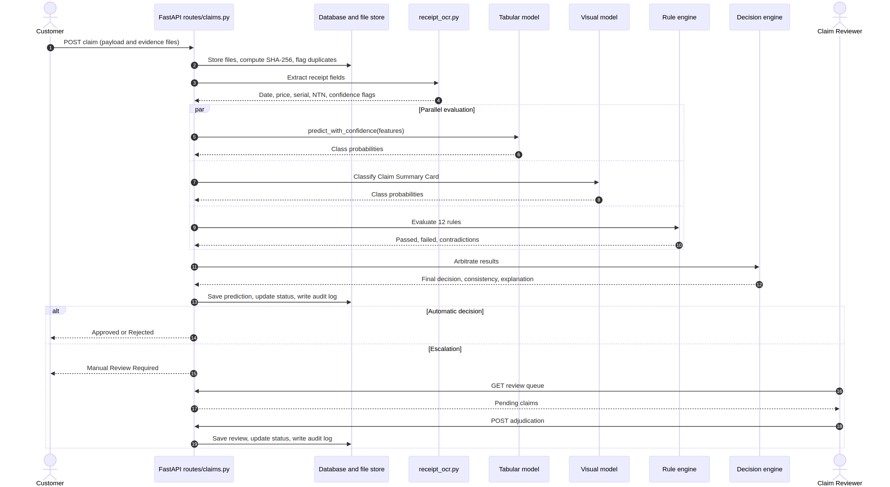
Figure 7. 9.4 Claim Submission Sequence

10. Data Flow Diagrams

10.1 DFD Level 0 (Context Diagram)
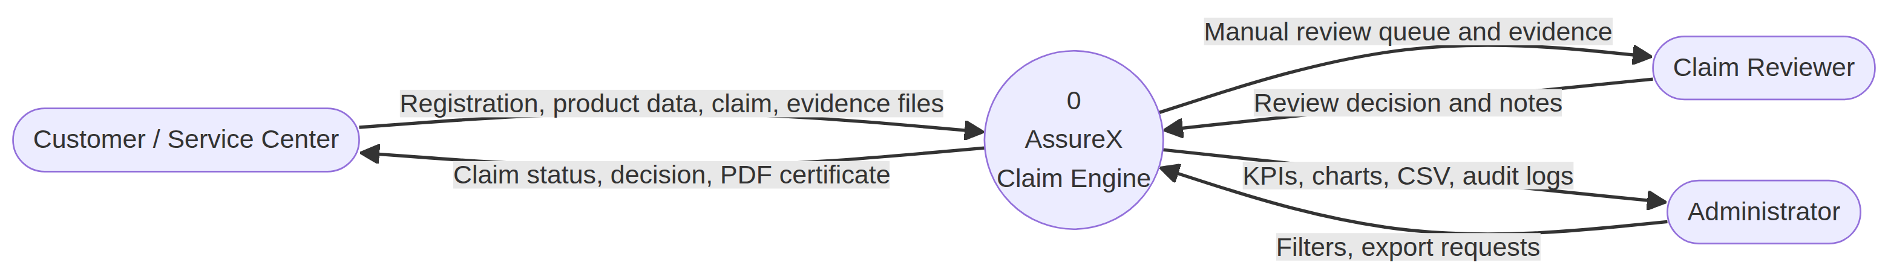
Figure 8. 10.1 DFD Level 0 (Context Diagram)

10.2 DFD Level 1
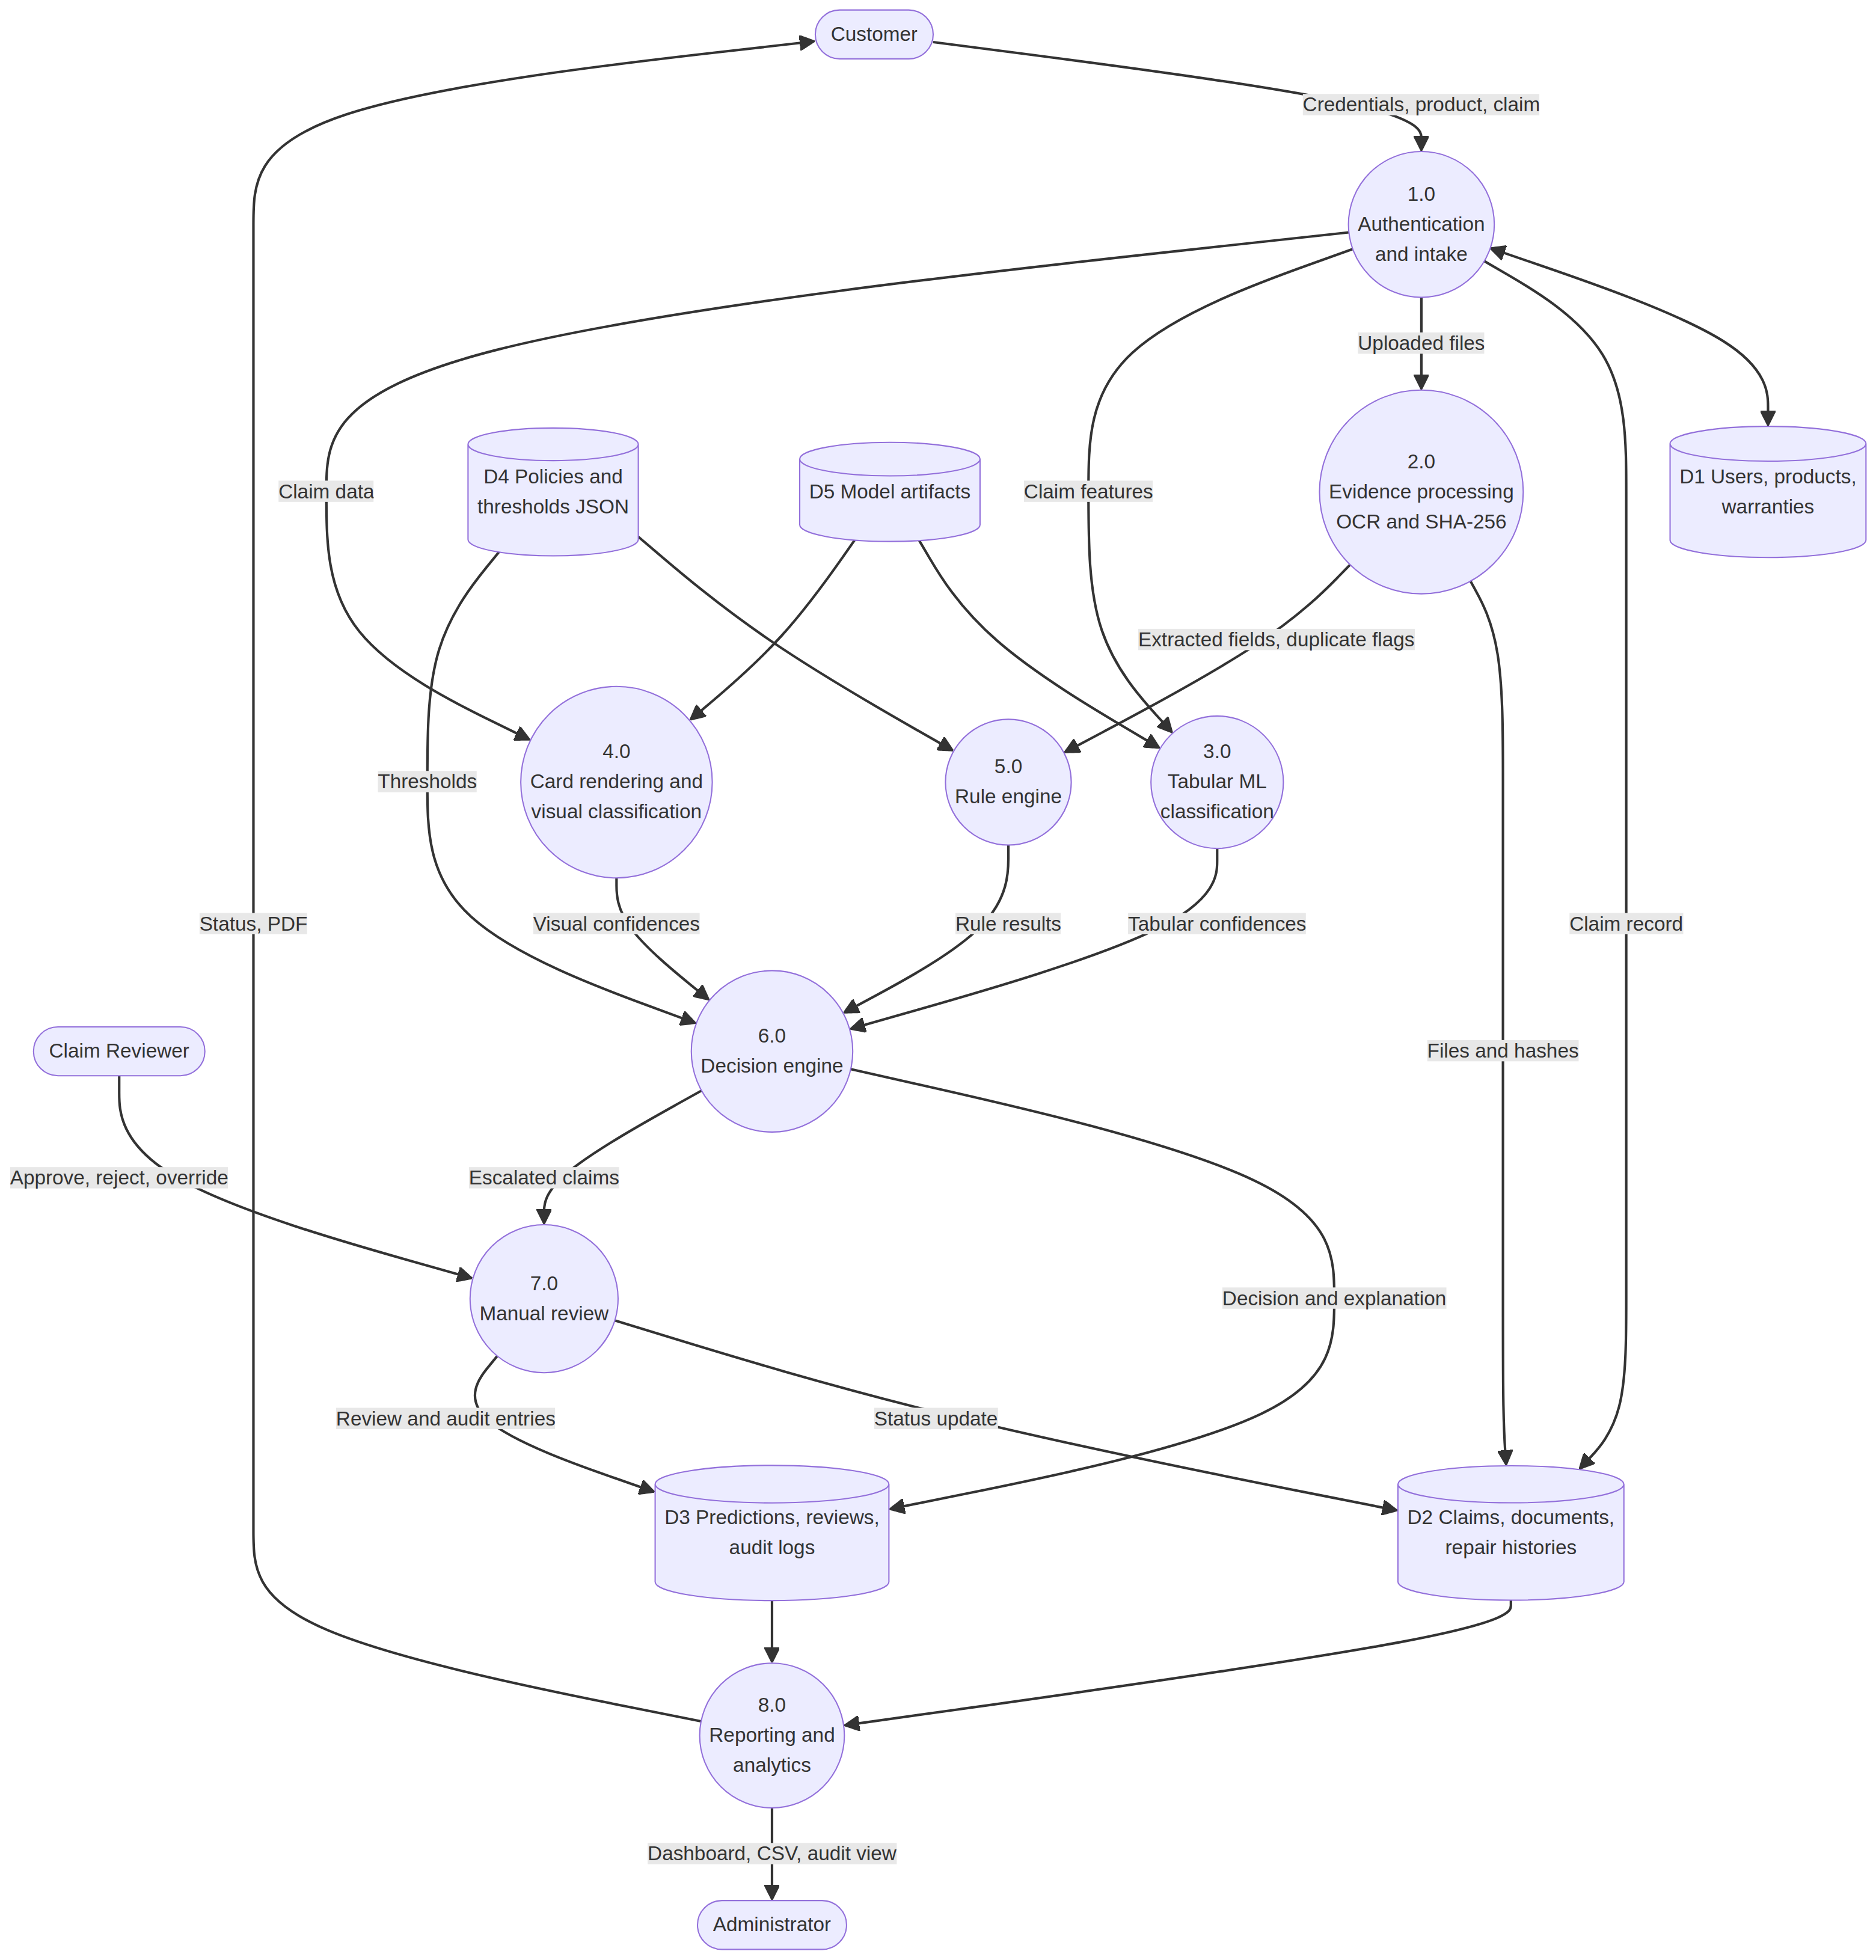
Figure 9. 10.2 DFD Level 1

11. System Flowcharts and Workflows

11.1 System Flowchart
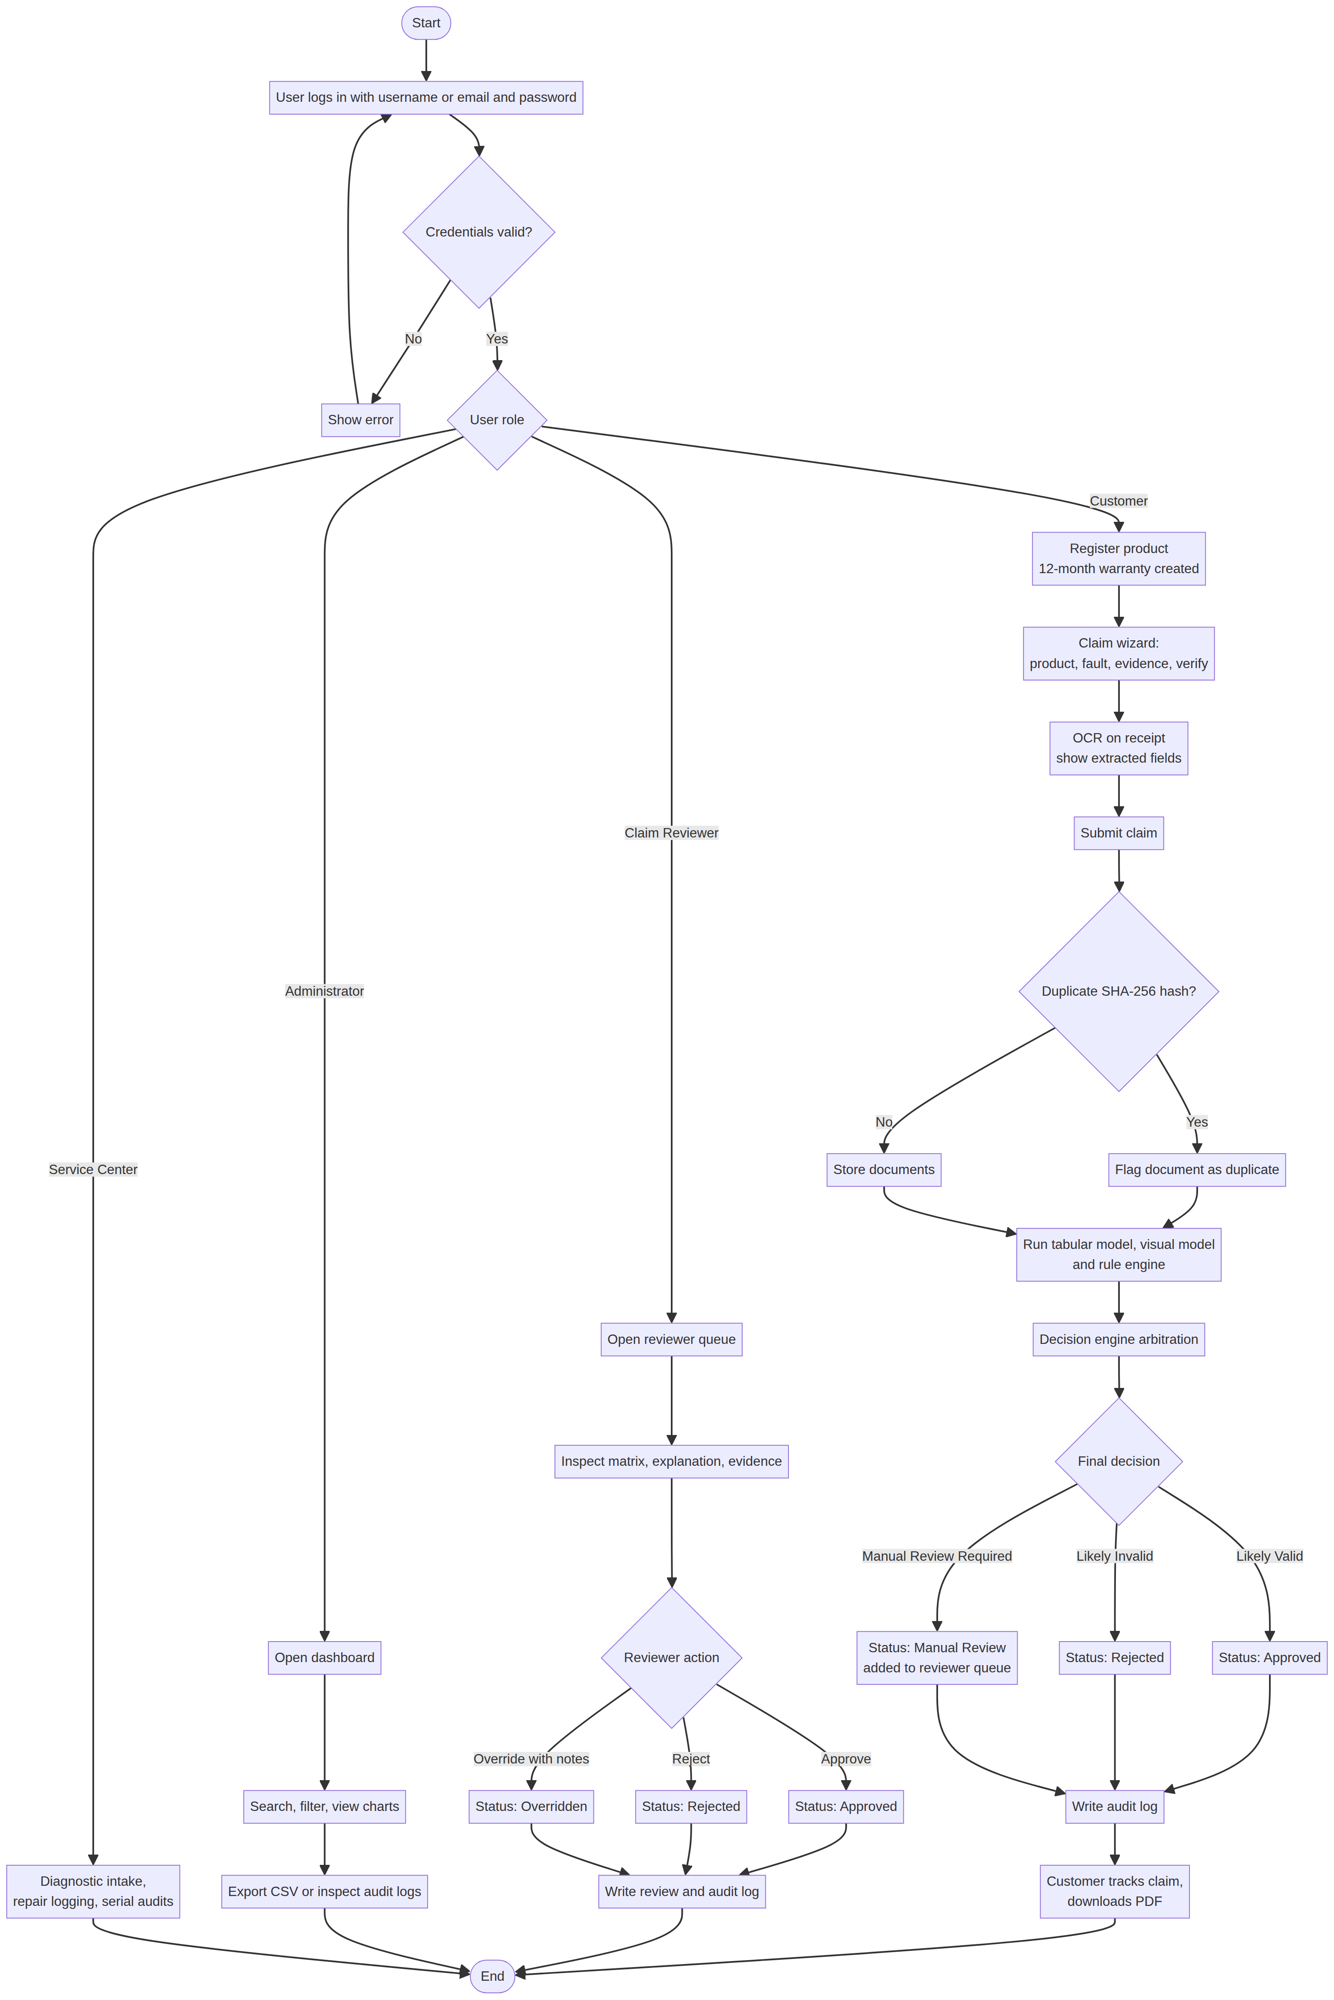
Figure 10. 11.1 System Flowchart

11.2 Overall System Workflow
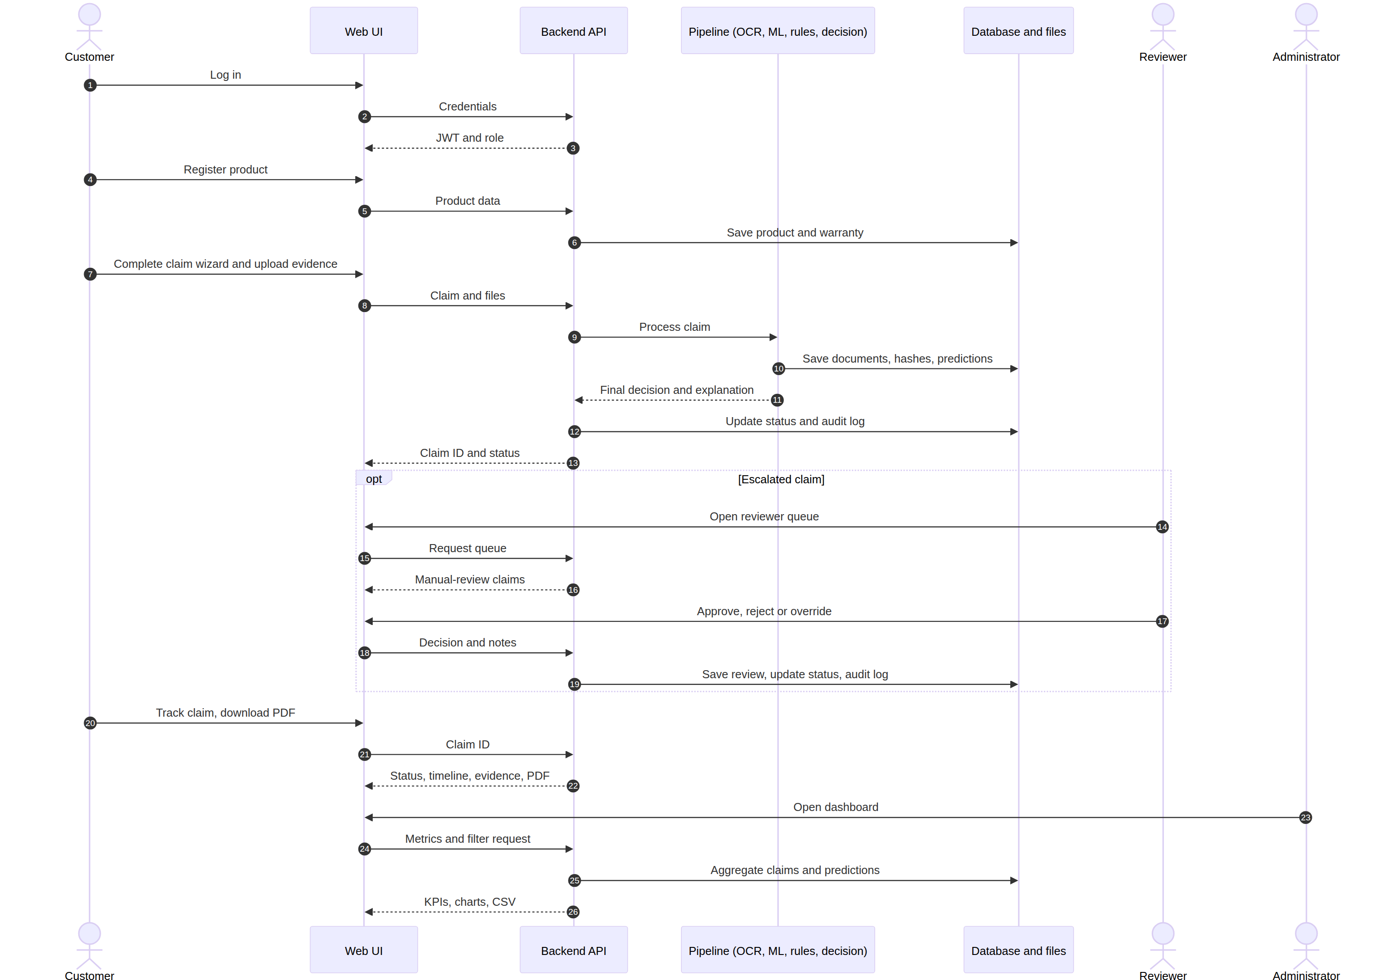
Figure 11. 11.2 Overall System Workflow

12. Machine Learning Components and Evaluation

12.1 Dataset
The project uses a synthetic dataset generated by generate_claims_dataset.py, because real customer claims were not used.
Table 30. Property / Value
Property | Value
Records | 1,500
Columns | 26 (25 attributes plus target class_label)
Classes | Valid Claim, Invalid Claim, Manual Review: 500 each
Split | Stratified 70/15/15: 1,050 train, 225 validation, 225 test
Categories | Laptop 313, Smartphone 307, Washing Machine 301, Audio / Soundbar 298, Smart TV 281
Noise | 139 records (9.27%) with controlled clerical or data-quality issues
Nullable columns | retailer (12 missing), serial_number_on_receipt (108 missing)
Distinct values | 11 brands, 10 retailers, 35 damage types, 6 repair-history categories
Currency | PKR

Class definitions (summary). Valid: active warranty, covered defect, all four documents present, matching serial, timely filing (1 to 5 days), clean service record. Invalid: expired warranty, excluded damage, no receipt, serial mismatch, prior replacement, or gross reporting delay (45 to 120 days). Manual Review: partial documents, boundary dates, plausible unauthorized or repeat repairs, or minor clerical discrepancies.

12.2 Tabular Model Training
Table 31. Setting / Value
Setting | Value
Algorithm | Random Forest
n_estimators | 200
max_depth | 12
min_samples_split | 4
min_samples_leaf | 2
max_features | sqrt
class_weight | balanced
random_state | 42
Tuning | 5-fold stratified cross-validation, macro-F1

12.3 Tabular Model Results (225 held-out test records)
Table 32. Class / Precision / Recall
Class | Precision | Recall | F1 | Support
Valid Claim | 0.88 | 0.97 | 0.92 | 75
Invalid Claim | 0.96 | 0.96 | 0.96 | 75
Manual Review | 0.93 | 0.83 | 0.87 | 75
Macro average | 0.92 | 0.92 | 0.92 | 225

Test accuracy is 92.0% (207 of 225).
Table 33. Actual \ Predicted / Valid / Invalid
Actual \ Predicted | Valid | Invalid | Manual Review
Valid Claim | 73 | 0 | 2
Invalid Claim | 0 | 72 | 3
Manual Review | 10 | 3 | 62

No Valid claim was predicted Invalid and no Invalid claim was predicted Valid. All Valid/Invalid confusion involved the Manual Review class.

12.4 Full Pipeline Results (36 unseen test claims)
The batch evaluator was run on 36 claims (12 per class) from dataset/test.csv.
Table 34. Metric / Result
Metric | Result
Model agreement (tabular vs visual) | 88.9% (32 of 36)
Decision adjudication accuracy | 100.0% (36 of 36, counting correct classification or safe escalation)
Strong Match | 21 (58.3%)
Acceptable Match | 9 (25.0%)
Weak Match | 2 (5.6%)
Model Disagreement | 4 (11.1%), all escalated to human review

The "100%" figure counts a claim as correct when it was classified correctly or safely escalated to manual review. It should not be read as 100% exact-class accuracy.

13. User Interface
The frontend is a single-page application (index.html, css/style.css, js/app.js). The supplied files contain no screenshots, so the views are described from the README and demo script.
Table 35. View / Role / Content
View | Role | Content
Login | All | Username or email and password; no shortcut buttons
Customer Dashboard | Customer | Active warranties, filed claims, links to Register Product and File Claim
Register Product | Customer | Category, name, brand, model, serial, date, retailer, price
Claim Wizard | Customer | Four steps with live OCR result and confidence indicators
Track Claim | Customer, Reviewer | Status badge, visual timeline (Submitted, Automated Multi-Model Evaluation, Decision), warranty coverage card, evidence gallery with SHA-256 checksums, PDF download
Reviewer Queue and Review page | Claim Reviewer | Manual-review list, consensus matrix, decision explanation, approve/reject/override
Admin Dashboard | Administrator | KPI cards, Chart.js charts, search and filter toolbar, Export CSV
Profile | All | View details, update name and password

Navigation items change with the user's role. The AI usage log states the layout was tested from 375 px mobile to 1440 px desktop widths in Chrome and Edge.

14. Installation and Setup

14.1 Prerequisites
Table 36. Requirement / Detail
Requirement | Detail
OS | Windows 10/11, macOS 13+, Ubuntu 20.04/22.04
Python | 3.10 to 3.14 (64-bit recommended)
pip | 22.0 or later
Disk | At least 2 GB free
Memory | 4 GB minimum, 8 GB recommended for local OCR

14.2 Steps
1. Open the project folder
cd AssureX
2. Create and activate a virtual environment
# Windows PowerShell
python -m venv venv
.\venv\Scripts\Activate.ps1
# Linux or macOS
python3 -m venv venv
source venv/bin/activate
3. Install dependencies
python -m pip install --upgrade pip
pip install -r requirements.txt
requirements.txt does not list TensorFlow, EasyOCR, bcrypt or pytest, all of which the documents say the project uses. If the visual model, OCR, password hashing or tests fail with import errors, install the missing packages (for example pip install tensorflow easyocr bcrypt pytest) and consider adding them to requirements.txt. Confirm the exact packages against the imports in the source.
4. Confirm model artifacts are present (the README says they are bundled):
model/claim_classifier.pkl
model/preprocessing.pkl
model/gtm_model/keras_model.h5
model/gtm_model/labels.txt
5. (Optional) Create a `.env` file
DATABASE_URL=sqlite:///database/assurex.db
JWT_SECRET_KEY=<use-a-long-random-secret>
JWT_ALGORITHM=HS256
ACCESS_TOKEN_EXPIRE_MINUTES=1440
ENVIRONMENT=production
LOG_LEVEL=INFO
Defaults are used if no .env exists, and the SQLite database is created automatically at database/assurex.db.
6. Seed the database
python seed_db.py
This creates the tables, four demo users, registered products, warranties, repair histories and demo claims with documents and predictions.
7. Run the application
python run_server.py
# or
python -m uvicorn backend.main:app --host 0.0.0.0 --port 8000 --reload
Table 37. Resource / URL
Resource | URL
Web application | http://localhost:8000/
Swagger UI | http://localhost:8000/docs
ReDoc | http://localhost:8000/redoc

Use python run_server.py --port 8080 if port 8000 is busy. To reset the data, delete database/assurex.db and run python seed_db.py again.

14.3 Demo Accounts (from README)
Table 38. Role / Username / Email
Role | Username | Email | Password
Administrator | admin | admin@assurex.com | Admin@12345
Claim Reviewer | reviewer | reviewer@assurex.com | Reviewer@12345
Service Center | service_center | service@assurex.com | Service@12345
Customer | customer | customer@assurex.com | Customer@12345

These are seeded evaluation credentials. Change or remove them for any real deployment.

15. Testing

15.1 Automated Test Suites (`tests/`)
Table 39. File / Covers
File | Covers
conftest.py | Fixtures: test client, in-memory SQLite database, seeded entities
test_auth.py | Authentication, password hashing, token validation
test_claims.py | Claim submission, status transitions, PDF export
test_decision_engine.py | Arbitration, consistency tiers, explanations, rule overrides
test_rule_engine.py | The 12 rules, PTA/NTN checks, lemon law
test_security_rbac.py | Role enforcement, SQL injection, XSS, bypass attempts
test_ocr_and_duplicates.py | OCR parsing (with mock output), SHA-256 duplicate detection
test_model_inference.py | Tabular and visual model inference guarantees

15.2 Other Verification Scripts
Table 40. Script / Purpose
Script | Purpose
test_login_end_to_end.py | Login and profile retrieval for all four roles
verify_all_roles_rbac.py | Confirms unauthenticated and cross-role requests return 401 or 403
run_model_comparison_pipeline.py | Batch evaluation of unseen claims

15.3 Commands
python -m pytest
python -m pytest -v
python -m pytest tests/test_rule_engine.py tests/test_decision_engine.py
python test_login_end_to_end.py
python verify_all_roles_rbac.py
python run_model_comparison_pipeline.py # 36 claims
python run_model_comparison_pipeline.py --all # all 225 test claims

15.4 Demonstration Fixtures (`sample_claims/`)
Table 41. # / Scenario / Expected outcome
# | Scenario | Expected outcome
1 | Valid smartphone claim | Likely Valid (auto-approved)
2 | Invalid laptop with liquid damage | Likely Invalid (auto-rejected)
3 | Washing machine, missing dealer stamp | Manual Review Required
4 | Expired warranty (42 days past) | WARRANTY_ACTIVE fails, rejected
5 | Missing receipt | PROOF_OF_PURCHASE_PRESENT fails, Manual Review
6 | Duplicate document hash | Flagged as duplicate
7 | Fault date before purchase date | CONTRADICTION_DETECTION, Manual Review
8 | Serial mismatch | SERIAL_NUMBER_MATCH fails
9 | Unauthorized repair | Policy violation
10 | Fault on last day of warranty | Active under grace period
11 | Model disagreement | Escalated to Manual Review

15.5 Reported Results
The AI usage log states that all pytest suites passed, and the report records the metrics in Section 12. Test counts and coverage figures are not given in the supplied files, and no tests were executed while preparing this document.

16. Security Considerations

16.1 Implemented Controls (as documented)
Table 42. Control / Description
Control | Description
Password hashing | Salted bcrypt; plaintext never stored
Token-based sessions | JWT (HS256), 24-hour expiry, 60-second decode leeway
Role-based access | Dependency-injected role checks; 401 for unauthenticated, 403 for unauthorized
No authentication bypass | Demo shortcuts and hardcoded tokens removed after audit
Parameterized queries | SQLAlchemy ORM used for database access
Duplicate-evidence detection | SHA-256 hash of every uploaded file
Audit logging | Submissions, predictions, status changes and reviews logged with user, timestamp, IP and JSON details
Configuration outside code | Secrets and thresholds in .env and JSON files
Fail-safe ML behavior | Visual model raises an error rather than returning fabricated scores; rules can veto ML output; disagreement escalates to a human
Security tests | test_security_rbac.py covers privilege escalation, SQL injection, XSS and bypass attempts

16.2 Regulatory Checks
- PTA DIRBS: handset IMEIs validated for compliance (simulated by deterministic rules, not a live API).
- FBR NTN/STRN: invoices checked for valid tax-number formats.

16.3 Recommendations (analysis, not documented as implemented)
Table 43. Area / Recommendation
Area | Recommendation
Secrets | The README's sample JWT_SECRET_KEY is a readable placeholder string; use a long random secret in every deployment and never commit .env.
Demo credentials | Passwords are listed in plain text in documents. Remove or rotate them outside evaluation.
Transport | Serve behind HTTPS in production; the report refers to HTTPS but the launcher runs plain HTTP.
Login abuse | No rate limiting or lockout is described; consider adding it.
File uploads | Validate file type, size and content on upload, and store files outside the web root.
Audit log integrity | The log is called immutable, but no database-level enforcement is described. Consider restricting update and delete permissions on audit_logs.
Duplicate detection | SHA-256 detects only byte-identical files; a re-saved or cropped receipt gets a different hash.
CORS | Restrict allowed origins in production.

17. Limitations
- Synthetic data. All models were trained and evaluated on generated data, so reported accuracy may not carry over to real claims.
- Correlated evidence (analysis). The Claim Summary Card is rendered from the claim's own data, so the visual model does not see independent physical evidence. Agreement between the two models is therefore weaker evidence than agreement between independent sources.
- Vision scope. The visual model classifies rendered cards, not photographs of hardware damage such as micro-cracks or solder faults.
- OCR quality. Faded thermal receipts and low-resolution photos reduce extraction accuracy and need manual verification.
- Simulated compliance. PTA DIRBS is checked by rules, not by querying live regulator services.
- Duplicate detection scope. Limited to documents already in the current deployment's database, and to identical file content.
- Platform dependency. TensorFlow native libraries can fail to initialize on Windows with Python 3.14; the README describes an automatic fallback inspector, which conflicts with the "no synthetic fallback" statement elsewhere (see Section 19).
- Scale. SQLite is the default database, suitable for evaluation rather than heavy concurrent use.
- Evaluation size. The multimodal pipeline result comes from 36 claims, a small sample.

18. Future Enhancements
The following are the roadmap items stated in the project documents.
Table 44. # / Enhancement / Description
# | Enhancement | Description
1 | Deep visual defect segmentation | YOLOv10 or Mask R-CNN trained on hardware imagery to detect burn marks, capacitor damage and liquid residue
2 | Direct PTA DIRBS integration | Real-time IMEI status verification through regulator or carrier services
3 | Mobile applications | iOS and Android apps with camera guidance for barcode and receipt capture
4 | LLM policy synthesizer | Retrieval-augmented generation (Gemini) to convert warranty contract PDFs into rule-engine JSON
5 | Digital warranty tokens | Blockchain-backed warranty credentials issued at point of sale

Additional suggestions from this analysis: add the missing packages to requirements.txt, publish an explicit endpoint table generated from the OpenAPI schema, evaluate on real anonymized claims, and add perceptual hashing for near-duplicate receipts.

19. Documentation Consistency Notes
These are points where the supplied files contradict each other or the implementation could not be confirmed. They should be resolved before final submission.
Table 45. # / Topic / Observation
# | Topic | Observation
1 | Dependencies | requirements.txt includes pyjwt but not bcrypt or passlib, TensorFlow, EasyOCR or pytest. The report names python-jose and passlib[bcrypt]. The README calls the file "pinned", but versions use >=.
2 | Bootstrap | The report and AI log mention Bootstrap 5.3; the README describes custom CSS only.
3 | Seeded claims | README text says 11 demo scenarios but its sample output says 12 claims; the report lists 11 fixtures; the demo script presents 5 "mandatory" cases.
4 | Uncertain Result | The decision flow diagram treats a gap above 0.45 as Uncertain; the blog defines Uncertain as both top confidences below 0.40.
5 | Duplicate rule | DUPLICATE_CLAIM_CHECK is described as open or rapid refilings in the report and as SHA-256 document duplication in the blog.
6 | Hashing | The report and blog say "perceptual and binary" hashing; only SHA-256 (binary) is described in detail.
7 | Entry point and paths | Report cites backend/app.py; README and AI log use backend/main.py. src/rule_engine.py is missing from the README tree. API prefixes differ (/claims/ vs /api/claims/).
8 | Role dependency name | require_role() in the report, require_roles in the blog.
9 | Visual model fallback | The report says there is no synthetic fallback; the README and report also mention a "visual telemetry fallback" on Windows with Python 3.14.
10 | Noise rate | Documents cite both a 10% target and an actual 9.27% (139 of 1,500).
11 | Service Center | README limits it to intake, repair logging and serial audits; the report's use case diagram also lets it register products and file claims.
12 | Report numbering | The report's table of contents ends at Section 20, but a Section 21 (Conclusion) follows.
13 | Unverified claims | The 500 ms latency, bcrypt cost factor 12 and frontend XSS sanitization appear as requirements; the files give no measurement or implementation detail.

20. Conclusion
AssureX combines a Random Forest classifier, a MobileNetV2 visual classifier, a 12-rule deterministic policy engine and a configurable arbitration engine into a warranty adjudication platform that explains its decisions and defers to a human whenever the evidence is ambiguous or the models disagree. Around this core sit a role-based FastAPI backend with JWT authentication, a nine-table relational schema with audit logging, SHA-256 duplicate detection, EasyOCR receipt parsing, PDF and CSV reporting, and a single-page frontend with reviewer and administrator tools.
On the documented benchmark, the tabular model reached 92.0% accuracy on 225 held-out synthetic claims, the two models agreed on 88.9% of a 36-claim unseen sample, and every disagreement was escalated to human review. The main caveats are that the data is synthetic, the visual model sees a rendering of the same claim data, and several details in the project files should be reconciled (Section 19). Within those limits, the design demonstrates a sound pattern for high-stakes automation: statistical models propose, deterministic rules constrain, and humans decide the uncertain cases.

21. Appendix

A. Glossary
Table 46. Term / Meaning
Term | Meaning
Adjudication | Deciding whether a warranty claim is accepted, rejected or escalated
GTM | Google Teachable Machine
PTA DIRBS | Pakistan Telecommunication Authority's Device Identification, Registration and Blocking System
NTN / STRN | National Tax Number / Sales Tax Registration Number (FBR, Pakistan)
LDI / LCI | Liquid Damage Indicator / Liquid Contact Indicator
CNIC | Computerized National Identity Card
RBAC | Role-based access control
JWT | JSON Web Token
Lemon law check | Flag for repeated major repairs, prompting replacement review
Macro-F1 | Average of per-class F1 scores, weighting classes equally

B. Dataset Feature Reference (26 columns)
Table 47. Group / Columns
Group | Columns
Identifiers | claim_id, user_id, product_id, serial_number
Product | product_category, product_name, brand, model_number
Purchase | purchase_date, purchase_price, retailer, serial_number_on_receipt
Warranty | warranty_duration_months, warranty_start_date, warranty_expiry_date
Fault | fault_occurrence_date, fault_description, damage_type, claim_submission_date
History and flags | repair_history, prior_replacement
Evidence flags | has_receipt, has_warranty_card, has_product_image, has_serial_evidence
Target | class_label

C. Source Documents
README.md, PROJECT_REPORT.md, TECHNICAL_BLOG_POST.md, data_dictionary.md, AI_USAGE.md, DEMO_VIDEO_SCRIPT.md, requirements.txt.
End of document.

