Project Address: https://github.com/kalyan02/NanoCMS

After downloading, the following files are available:
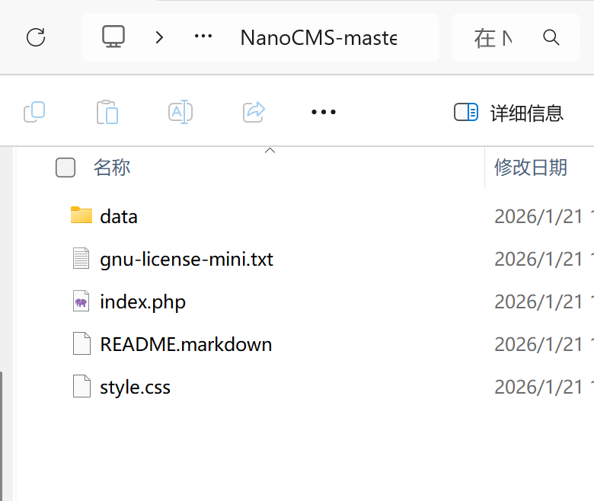
Deploy according to README.markdown
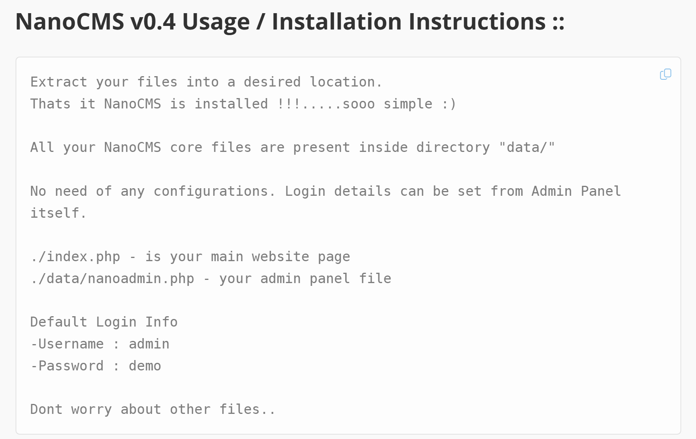
Open the website
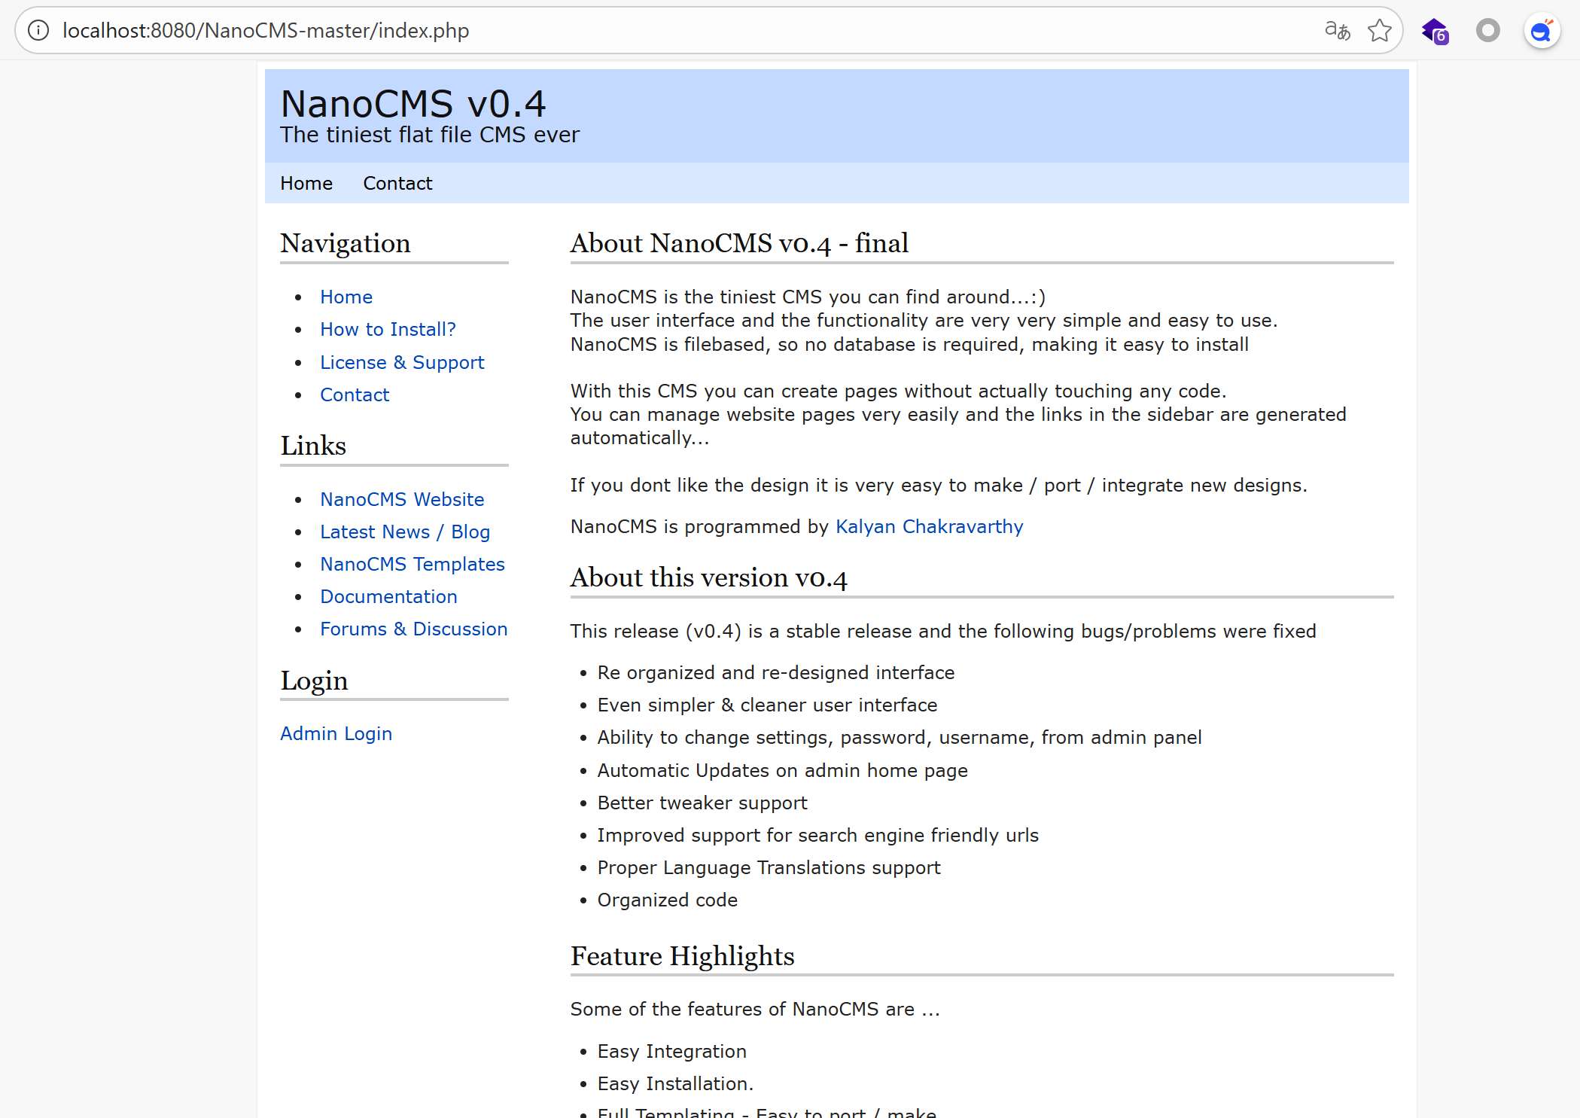
Log in according to README.markdown
-Username : admin
-Password : demo
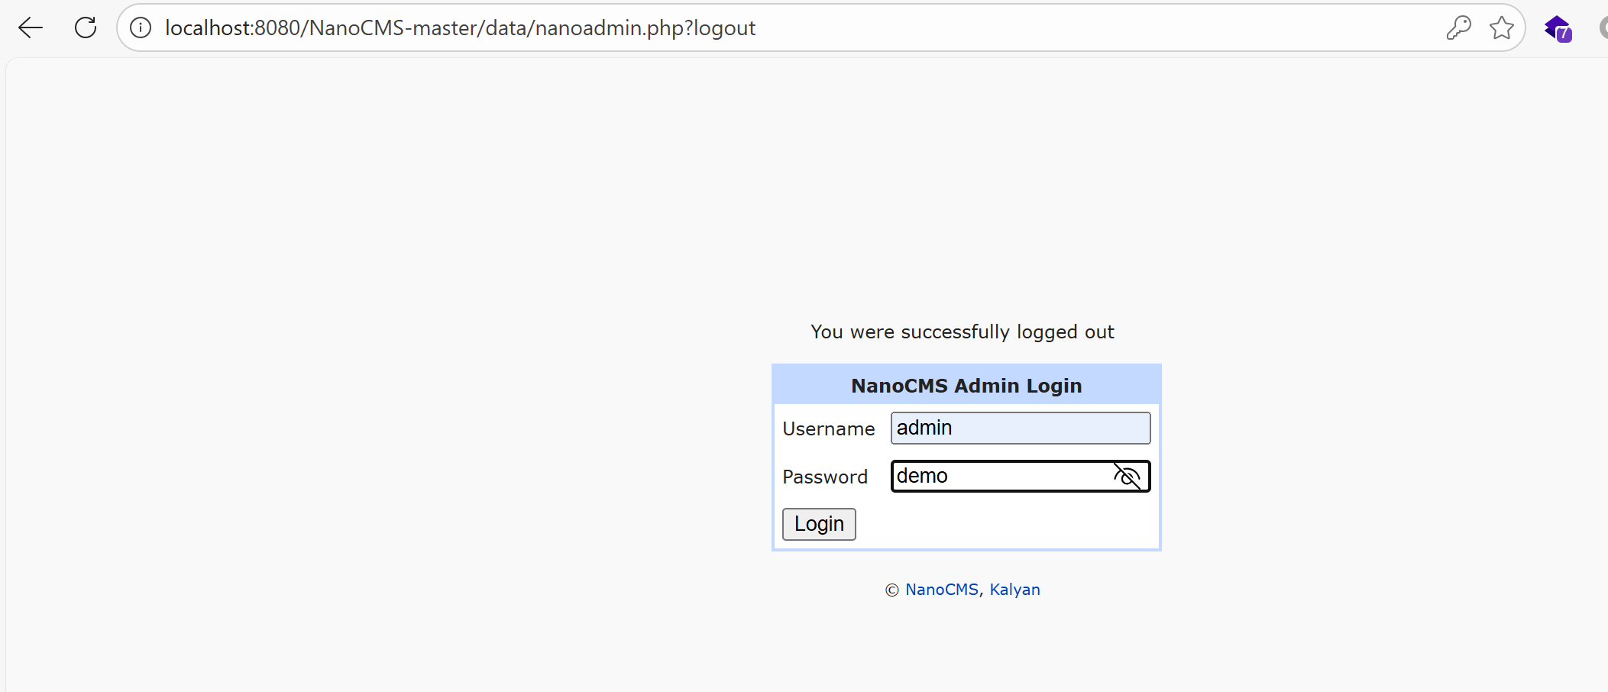
Login successful
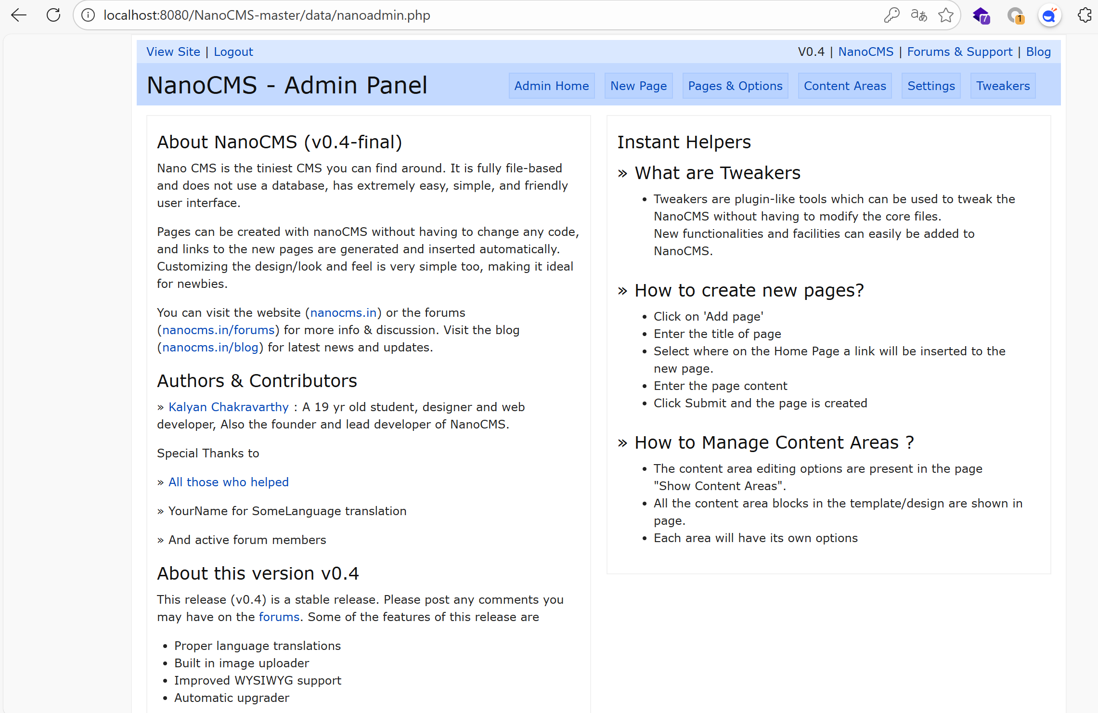
In the New page module
Payload：<script>alert(123)</script>
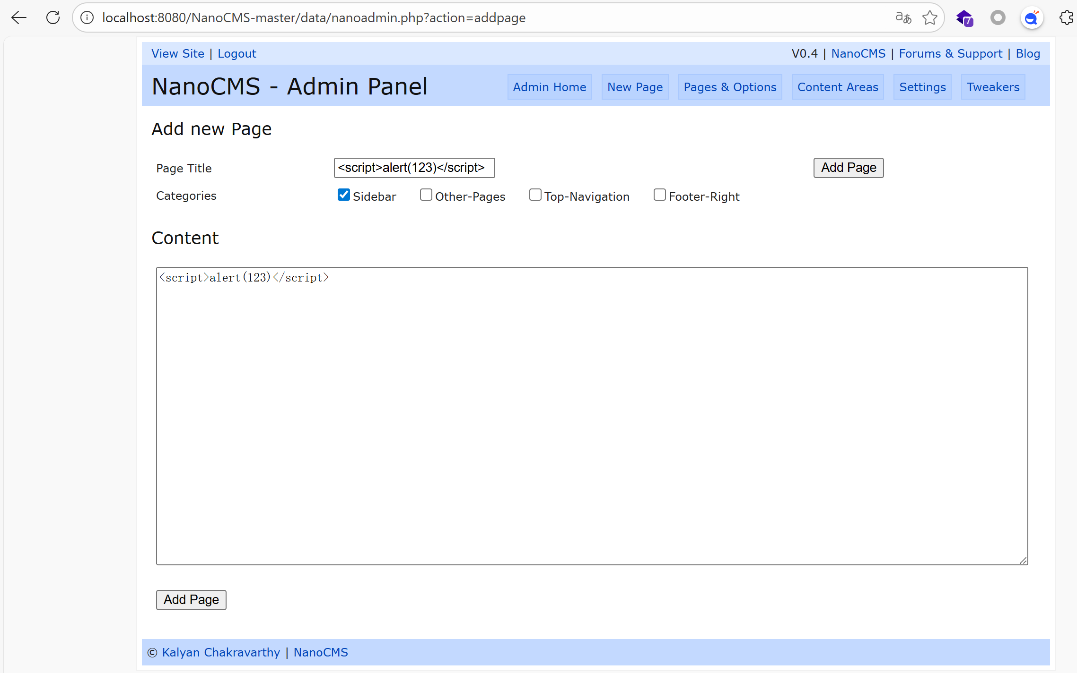
After Add, the path pages/scriptalert123script.php is echoed.
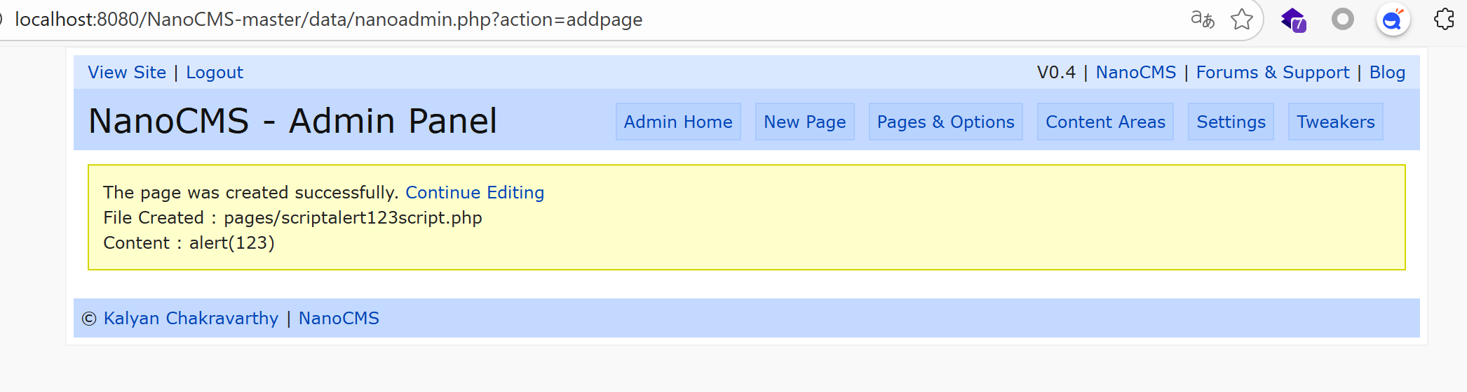
There is a pop-up window after access.
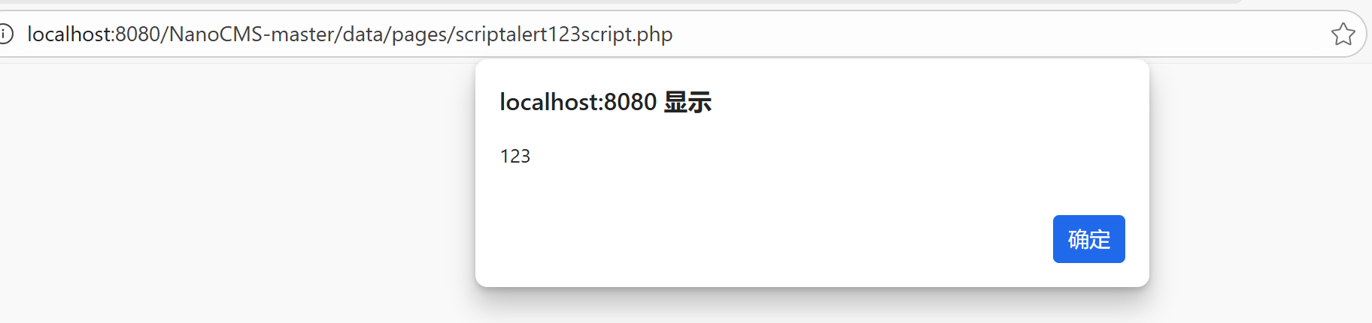
This website has an XSS vulnerability

