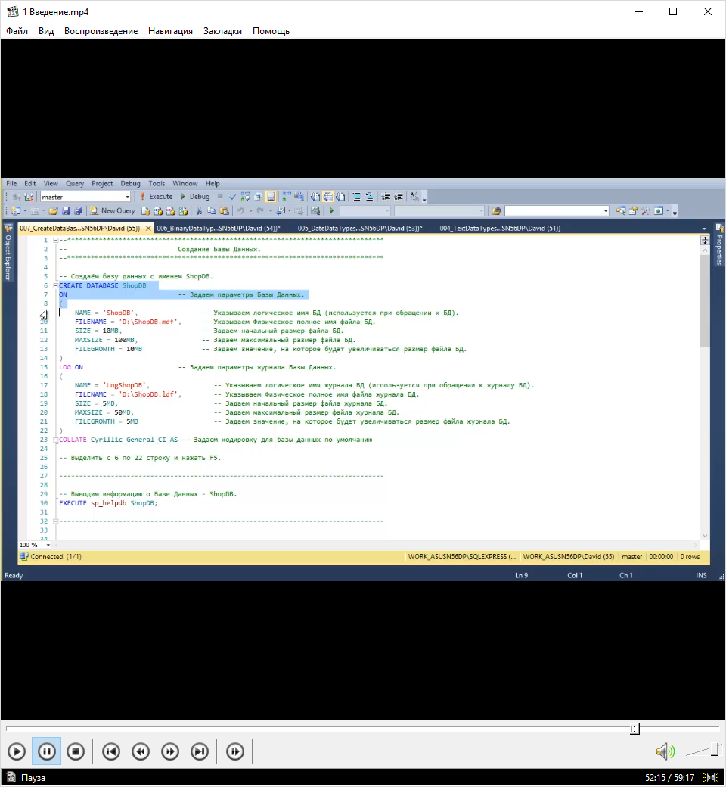

create database YDB

on

(

name = 'YDB',

filename = 'D:\Microsoft SQL Server\MSSQL13.MSSQL\MSSQL\DATA\YDB.mdf',

size = 10MB,

maxsize = 100MB,

filegrowth = 10MB

)

log on (

name = 'logYDB',

filename = 'D:\Microsoft SQL Server\MSSQL13.MSSQL\MSSQL\DATA\YDB.ldf',

size = 5MB,

maxsize = 50MB,

filegrowth = 5MB

)

collate Cyrillic_General_CI_AS

use YDB

create table Rab

(

id int not null identity,

nam varchar(20)not null,

fam varchar(20)not null,

otc varchar(20) null,

phone varchar(20)not null,

)

create table Dol

(

id int not null identity,

rabid int not null,

dolhnos varchar(20)not null,

oplat money not null,

)

create table Dat

(

id int not null identity,

rabid int not null,

wife varchar(20) null,

children int null,

daterad date not null,

city varchar(20)not null,

street varchar(20)not null,

house varchar(5)not null,

apartment int null,

)

insert into Rab

values

('yyyyy','xxxxxxx','trdedtg','775-58-85211')

\

create database YHomeWork

on

(

name = 'YHomeWork',

filename = 'D:\Microsoft SQL Server\MSSQL13.MSSQL\MSSQL\DATA\YHomeWork.mdf',

size = 10MB,

maxsize = 100MB,

filegrowth = 10MB

)

log on (

name = 'logYHomeWork',

filename = 'D:\Microsoft SQL Server\MSSQL13.MSSQL\MSSQL\DATA\YHomeWork.ldf',

size = 5MB,

maxsize = 50MB,

filegrowth = 5MB

)

collate Cyrillic_General_CI_AS

use YHomeWork

create table Dat

(

id int not null identity,

namep varchar(20)not null,

nump varchar(20)not null,

cost money not null,

countp int not null,

startdate date not null,

)

insert into Dat

values

('Корона','AK-53818',5,50,'2011-08-15'),

('Милка','AM-51122',6.1,50,'2011-07-15'),

('Аленка','AA-52211',2.5,20,'2011-06-15'),

('Snickers','BS-32118',2.8,50,'2011-08-15'),

('Snickers','BSL-3818',5,100,'2011-08-20'),

('Bounty','BB-38218',3,100,'2011-08-01'),

('Nuts','BN-37818',3,100,'2011-08-21'),

('Mars','BM-3618',2.5,50,'2011-08-24'),

('Свиточ','AS-54181',5,100,'2011-08-12'),

('Свиточ','AS-54182',5,100,'2011-08-1');

SELECT * FROM Product

where countp >59;

SELECT * FROM Product

where cost >3 and

sellstartdate like ('2011-08-2_')

;

update Dat

set Cost = 6.2

where namep = 'Свиточ'

SELECT * FROM Dat ;

select * from Production.Product

where StandardCost>100

select * from Production.Product

where Name like ('ML%') and

productNumber like ('RM%');

create database Yshop

on

(

name = 'Yshop',

filename = 'D:\Microsoft SQL Server\MSSQL13.MSSQL\MSSQL\DATA\Yshop.mdf',

size = 10MB,

maxsize = 100MB,

filegrowth = 10MB

)

log on (

name = 'logYshop',

filename = 'D:\Microsoft SQL Server\MSSQL13.MSSQL\MSSQL\DATA\Yshop.ldf',

size = 5MB,

maxsize = 50MB,

filegrowth = 5MB

)

collate Cyrillic_General_CI_AS

create table customers

(

id_customer int not null identity primary key,

customer_name varchar(50)not null,

customer_adress varchar(40)not null,

sity varchar(20) null,

customer_contact varchar(30)not null,

phone varchar(20)not null,

)

create table orders

(

id_order int not null identity primary key,

id_customer int not null

foreign key references customers(id_customer),

orderdate date not null,

goods varchar(30)not null,

)

insert into customers

(

customer_name,

customer_adress,

sity,

customer_contact,

phone

)

values

('Петренко петр Петрович','Луганская 25','Конотоп','PetrPetrenko@mail.ru','(093)123122'),

('Иваненко Иван Иванович','Девскариска 5','Чернигов','IvanenkoIvan@gmail.com','(095)231244');

insert into orders

(

id_customer,

orderdate,

goods

)

values

(1,GETDATE(),'Клавиатура'),

(2,GETDATE(),'Мыш'),

(2,GETDATE(),'ВКамера'),

(1,GETDATE(),'Мыш');

alter table orders

add constraint fk_key

foreign key (customers)_ references customers(id_custtomer)

on delete set null

create table customers

(

id_customer int not null identity ,

customer_name varchar(50)not null,

customer_adress varchar(40)not null,

sity varchar(20) null,

customer_contact varchar(30)not null,

phone varchar(20) unique check (phone like '([0-9][0-9][0-9])[0-9][0-9][0-9][0-9][0-9][0-9][0-9]'),

)

Задание 3.3

create database Yshop

on

(

name = 'Yshop',

filename = 'D:\Microsoft SQL Server\MSSQL13.MSSQL\MSSQL\DATA\Yshop.mdf',

size = 10MB,

maxsize = 100MB,

filegrowth = 10MB

)

log on (

name = 'logYshop',

filename = 'D:\Microsoft SQL Server\MSSQL13.MSSQL\MSSQL\DATA\Yshop.ldf',

size = 5MB,

maxsize = 50MB,

filegrowth = 5MB

)

collate Cyrillic_General_CI_AS

create table proizvoditel

(

id_proizvoditel int not null identity primary key,

name_proizvoditel varchar(30)not null,

)

create table tovar

(

id_tovar int not null identity primary key,

articel varchar(12)not null,

id_proizvoditel int not null

foreign key references proizvoditel (id_proizvoditel ),

tovar_name varchar(20)not null,

opisanie varchar(400)not null,

)

create table cost_pos

(

id_cost_pos int not null identity primary key,

id_tovar int not null

foreign key references tovar (id_tovar ),

cost money not null,

datestart date not null default getdate ,

dateend date null,

)

create table cost_pro

(

id_cost_pro int not null identity primary key,

id_tovar int not null

foreign key references tovar (id_tovar ),

cost money not null,

datestart date not null default getdate ,

dateend date null,

)

create table dolgnos

(

id_dolgnos int not null identity primary key,

dolgnos varchar(22)not null,

)

create table personal

(

id_menper int not null identity primary key,

pername varchar(42)not null,

perfam varchar(42)not null,

pernotc varchar(42)not null,

id_dolgnos int not null

foreign key references dolgnos(id_dolgnos),

oclad money not null,

)

create table customers

(

id_customer int not null identity primary key ,

customer_name varchar(50)not null,

customer_adress varchar(40)not null,

sity varchar(20) null,

customer_contact varchar(30)not null,

phone varchar(20) unique check (phone like '([0-9][0-9][0-9])[0-9][0-9][0-9][0-9][0-9][0-9][0-9]'),

)

create table postavhuc

(

id_postavhuc int not null identity primary key ,

postavhuc_name varchar(50)not null,

postavhuc_adress varchar(40)not null,

sity varchar(20) null,

postavhuc_contact varchar(30)not null,

phone varchar(20) unique check (phone like '([0-9][0-9][0-9])[0-9][0-9][0-9][0-9][0-9][0-9][0-9]'),

)

create table postavka

(

id_postavka int not null identity primary key,

id_postavhuc int not null

foreign key references postavhuc (id_postavhuc ),

id_menper int not null

foreign key references personal (id_menper ),

datepos date not null,

)

create table proda

(

id_proda int not null identity primary key,

id_customer int not null

foreign key references customers (id_customer ),

id_menper int not null

foreign key references personal (id_menper ),

datepro date not null,

)

create table proda_nap

(

id_proda_nap int not null identity primary key,

id_proda int not null

foreign key references proda(id_proda ),

id_cost_pro int not null

foreign key references cost_pro (id_cost_pro ),

countt int not null ,

)

create table postavka_nap

(

id_postavka_nap int not null identity primary key,

id_postavka int not null

foreign key references postavka (id_postavka ),

id_cost_pos int not null

foreign key references cost_pos (id_cost_pos ),

countt int not null ,

)

Задание 5.2

create database YJoinsDB

on

(

name = 'YJoinsDB',

filename = 'D:\Microsoft SQL Server\MSSQL13.MSSQL\MSSQL\DATA\YJoinsDB.mdf',

size = 10MB,

maxsize = 100MB,

filegrowth = 10MB

)

log on (

name = 'logYJoinsDB',

filename = 'D:\Microsoft SQL Server\MSSQL13.MSSQL\MSSQL\DATA\YJoinsDB.ldf',

size = 5MB,

maxsize = 50MB,

filegrowth = 5MB

)

collate Cyrillic_General_CI_AS

use YJoinsDB

create table sotr

(

id_sotr int not null primary key ,

pername varchar(42)not null,

perfam varchar(42)not null,

pernotc varchar(42)not null,

phone varchar(20) unique check (phone like '([0-9][0-9][0-9])[0-9][0-9][0-9][0-9][0-9][0-9][0-9]'),

)

create table dol

(

id_dol int not null primary key,

zarplata money not null,

dolgon varchar(42)not null,

)

create table daro

(

id_daro int not null primary key,

sema varchar(20)not null,

datera date not null,

city varchar(20)not null,

stret varchar(20)not null,

dom varchar(8)not null,

)

select id_sotr, pername, perfam,pernotc ,phone,city,stret,dom from sotr

join

dol

on id_sotr = id_dol

join

daro

on id_daro = id_dol;

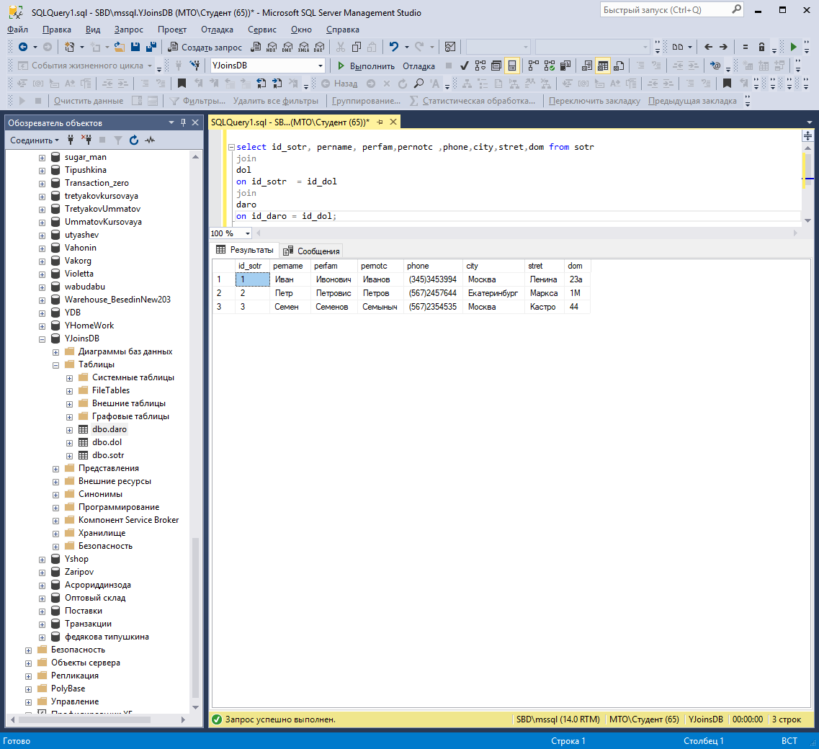

select id_sotr, pername, perfam,pernotc ,phone,datera from sotr

join

dol

on id_sotr = id_dol

join

daro

on id_daro = id_dol

where sema='Холост'

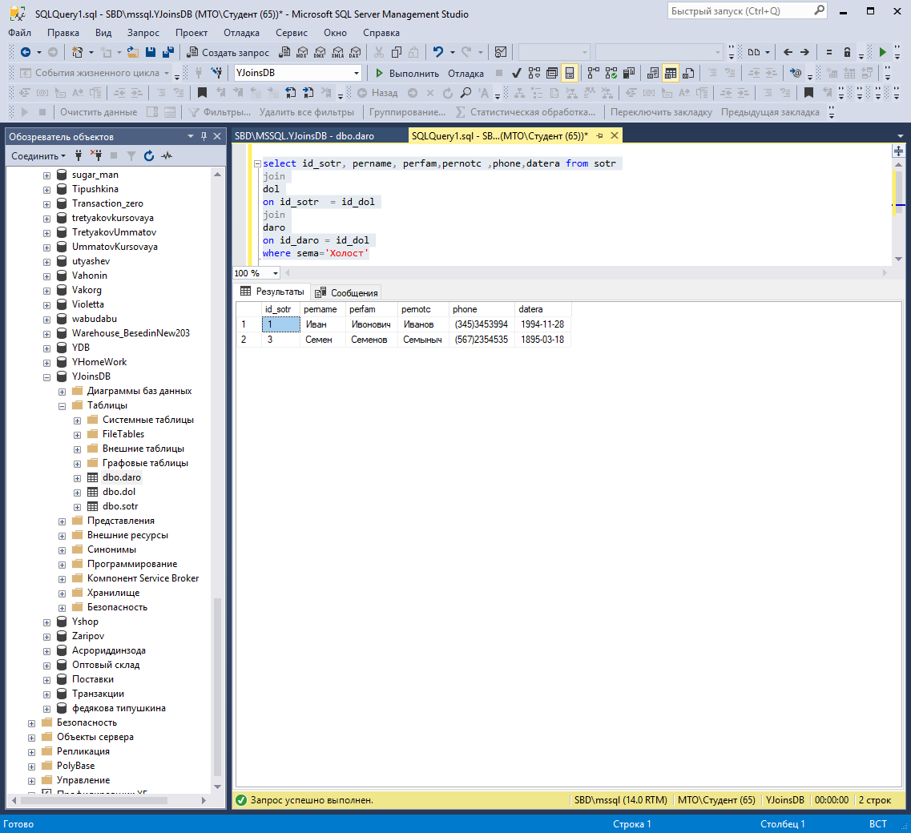

select id_sotr, pername, perfam,pernotc ,phone,datera from sotr

join

dol

on id_sotr = id_dol

join

daro

on id_daro = id_dol

where dolgon='Менеджер'

