**NerveNet-SDN Basic Function Confirmation**

Hito Ito, Nassua Solutions Co., Ltd.

* This material is a reference material for 2021/08/13 submitted to NICT.

The contents are excerpted and edited from the basic function confirmation test defined in 2021/2.

Base station machines 2

LAN Port and L2 Bridge Port Connection to PC 4

【Step 1】 4

【Step 2】 4

【Step 3】 4

【Step 4】 4

【Step 5】 4

【Step 6】 4

【Step1】 5

【Step2】 6

【Step3】 7

【Step4】 8

Other test examples 9

Example 1 9

Example 2 10

Example 3 11

# Summary

With the release of Nervenet -SDN, the tests that are always run as part of the comprehensive test are defined as "basic function confirmations".

The purpose of the test is as follows:

* Confirm that a link between NerveNet base stations is established
* Verify that the path tree generation and switching of links between base stations works
* Make sure that the terminals (PCs) can be accommodated in the base stations, and that they can communicate with each other across links and base stations.
* Verify that neveNet base station configuration changes can be performed using Configurator

# Test Procedure Steps

|  |  |
| --- | --- |
| **Representations in steps** | **Description** |
| BS | Short for BaseStation(s) |
| Route Tree Distribution Bureau | In addition to the three types of containers installed in the installation procedure of The Nervenet-SDN-Configurator (Configurator 2 types + base stations), the machine on which the ptmgr (**path tree generation**) container is running. |
| Link down | Unplug the LAN cable used to establish a link between the two base stations.  It is arbitrary which of the cables to pull out. |
| LINK(n) | (n) refers to the number surrounded by a blue square in the figure.  The procedure "LINK(1)" refers to unplugging the LAN cable used for the BS1 – BS2 link in the image below. |
| PING confirmation | The confirmation procedure is the basis for basic function confirmation.  After constructing The NerveNet, the LINK is taken down, one by one while PING test is done from the terminal attached to the PC, and finally it is made into a straight link before returning to its original state.  For details, see "Test procedure (PING confirmation)"below. |

# Environment Setup

Base station machines: Up to 5 units are required for the test environment:

* Base Station Machine: Particle i7
* OS: Debian 10 (with GUI)
* Turn off the operation-free automatic suspend
* Set up below and restart

vi /etc/NetworkManager/conf.d/10-unmanaged.conf

[keyfile]

unmanaged-devices=*,except:type:wwan,except:type:gsm

Install the following with installer (version as of 2021/02)

|  |  |
| --- | --- |
| **Container name** | **version** |
| nervenet-configurator-daemon | 1.0.0 |
| nervenet-configurator-httpd | 1.0.0 |
| nervenet-tsg-sqlite | 1.4.10 |

* The Routing Tree Distribution Bureau will operate an additional **nervenet-ptmgr:1.1.1 container**.

## LAN Port and L2 Bridge Port Connection to PC

Windows, Debian, Ubuntu, Raspberry Pi OS, etc., there is no OS or machine specification given. When Pinging, the test basically uses OS standard pings, but for Windows, EzPing is useful.

# Test procedure (PING Confirmation)

In the basic function confirmation, we mainly test the PING described below. The difference between each test scenario is the number of units used and the different Port settings that the base station provides.

1. Create a network with two to five base station machines (Partaker i7) defined in the test scenario
2. LAN Port for each base station machine, PCs more terminal-housed in L2 Bridge Port, with no IPV4 addresses assigned from base stations
3. Start Pinging (no automatic stop) between all PCs over LAN and L2 Bridge Port of each base station machine. If there is a WAN Port in the environment, PING to any (pingable) server over the Internet from all PCs connected to LAN Port

Note: PING does not need to be performed from both sides of the PCs. There is no problem implementing it from both sides. It is easier to see the test results later if you use tools such as EzPing in your work environment, especially if you run them on both PCs.

1. Take down one link at a time, and eventually create a network state where "all base stations are linked in only one path"

**Note:** When taking down links, please pay attention to the state of the PING. The PING becomes unresponsive with link down (depending on the status of the route), but in a few seconds the route switches and PING responds again.

1. Restore the downed links one at a time in reverse order
2. The HW operation is completed when the cable connection state is the same as at the start of the test.
3. Stop PING the terminal storage PC, collect and save the PING results.

# Specific Test Scenarios

Make a minimum mesh configuration with four base stations and confirm that you can migrate from

**Link Type"None" → LinkType"ERBUDP"**

### Step 1: BS settings in Configurator

* Link Port is three for 4 base stations, and Link Type is all "None"
* Base Station ID and System Name of each base station are optional (so as not to be covered)
* Operate ptmgr containers at one base station (Route Tree Distribution Bureau)
* See table and figure below for the number of LAN Ports, etc.
* Set "Default Gateway" to WAN Port
* No other settings need to be changed from default

|  |  |  |  |  |
| --- | --- | --- | --- | --- |
|  | **LAN Port** | **L2 Bridge Port** | **WAN Port** | **ptmgr container** |
| **BS1** | 1 | 1 | 1（Default Gateway = Yes） | TRUE |
| **BS2** | 1 | 1 | 0 | FALSE |
| **BS3** | 1 | 1 | 0 | FALSE |
| **BS4** | 1 | 1 | 0 | FALSE |

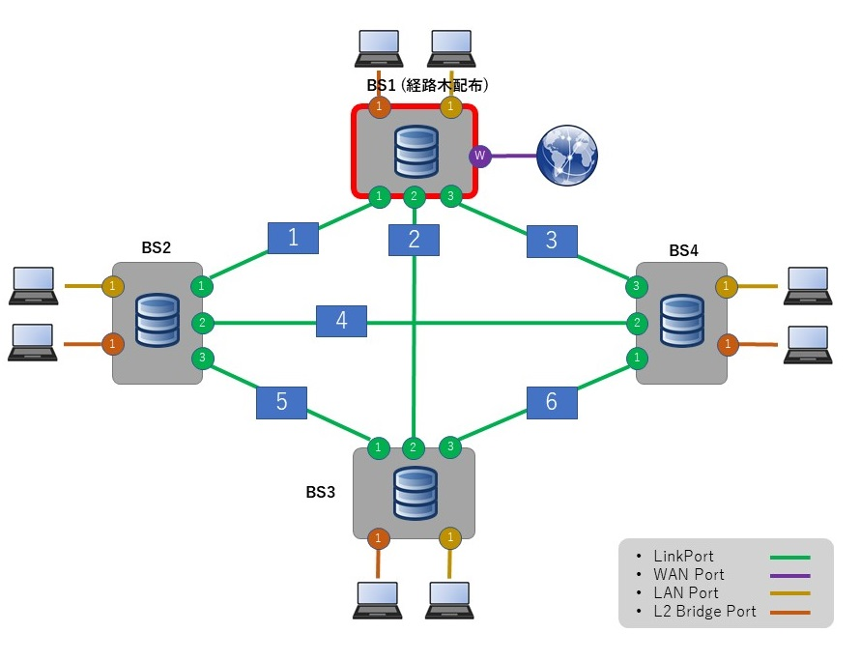

1. Step 2

PING confirmation. Make sure route trees and terminal housing are working in Link Type None

|  |  |
| --- | --- |
| **Link Type** | All "None" |
| **Link Down order** | (2) → (3) → (4) |

|  |  |  |
| --- | --- | --- |
| **S N** | **Procedure** | **Output** |
| 1 | Check the IPV4 address of the PC connected to LAN port and L2 Bridge Port of each base station machine | The IPV4 address is waved, and the IP address distributed by LAN Port to the PC in particular is not contrary to the "assigned IP" in the Configurator |
| 2 | Start PINGing from a PC connected to LAN Port and L2 Bridge Port of each base station machine to the IPV4 address examined at No. 1  BS1_LAN →　BS2_LAN  BS1_LAN →　BS3_LAN  BS1_LAN →　BS4_LAN  BS1_LAN → IP address on the Internet  BS2_LAN →　BS3_LAN  BS2_LAN →　BS4_LAN  BS2_LAN → IP address on the Internet  BS3_LAN →　BS4_LAN  BS3_LAN → IP address on the Internet  BS4_LAN → IP address on the Internet  BS1_L2 →　BS2_L2  BS1_L2 →　BS3_L2  BS1_L2 →　BS4_L2  BS2_L2 →　BS3_L2  BS2_L2 →　BS4_L2  BS3_L2 →　BS4_L2 |  |
| 3 | Take down LINK (2) | If the PING becomes unresponsive, return after a few seconds. |
| 4 | Take down LINK (3 ) | If the PING becomes unresponsive, return after a few seconds. |
| 5 | Take down LINK (4 ) | If the PING becomes unresponsive, return after a few seconds. |
| 6 | Restore LINK (4) |  |
| 7 | Restore LINK (3) |  |
| 8 | Restore LINK (2) | What PING continues to pass |

1. **Step 3**

Change link type one by one at each of the 4 base stations to ensure that the setting changes are reflected in the operation

|  |  |  |
| --- | --- | --- |
| **S N** | **Procedure** | **Output** |
| 1 | Start PINGing from a PC connected to LAN Port and L2 Bridge Port of each base station machine |  |
| 2 | Change all Link Types in Link Port 1-3 in BS2 to ERB-UDP | Link down does not occur and PING continues to arrive |
| 3 | Restart the base station container in BS2  (run with the Restart button in Configurator) | BS1,BS3, BS4 to BS 2 link down PING from BS1, BS3,BS4 terminal housing PCs will not reach Slave1's accommodating PCs |
| 4 | Change all Link Types in Link Port 1-3 in BS3 to ERB-UDP | No change in link state or PING |
| 5 | Restart the base station container in BS3  (run with the Restart button in Configurator) | BS1, BS4 to BS3 link down  BS1andBS4 terminal-housed PCs do not receive PING from BS2 and BS3 terminal-housed PCs  BS2-BS3 should be linked up  Pinging arrives from BS2 terminal-housed PCs to BS3 terminal-housed PCs |
| 6 | Change all Link Types in Link Port 1-3 in BS4 to ERB-UDP | No change in link state or PING |
| 7 | Restart the base station container on BS4  (run with the Restart button in Configurator) | BS1 to BS4 link down  BS1 terminal housing PCs do not reach BS2to4 terminal-housed PCs  BS2-4 should be linked up  Pings will be delivered between BS2 to 4 terminal-housed PCs |
| 8 | Change all Link Types in Link Port 1-3 in BS1 to ERB-UDP | No change in link state or PING |
| 9 | Restart the base station container on BS1  (run with the Restart button in Configurator) | All links should be linked up  Pings will arrive between all terminal-housed PCs |

### PING confirmation

Make sure route trees and terminal housing are functioning with Link Type ERB-UDP

|  |  |
| --- | --- |
| **Link Type** | All "ERB-UDP" |
| **Link Down order** | (4) → (2) → (1) |

|  |  |  |
| --- | --- | --- |
| **No.** | **procedure** | **confirmation** |
| 1 | Check the IPV4 address of the PC connected to lan port and L2 Bridge Port of each base station machine | The IPV4 address is waved, and the IP address distributed by LAN Port to the PC in particular is not contrary to the "assigned IP" in the Configurator |
| 2 | Start PINGing from a PC connected to LAN Port and L2 Bridge Port of each base station machine to the IPV4 address examined at No. 1  BS1_LAN →　BS2_LAN  BS1_LAN →　BS3_LAN  BS1_LAN →　BS4_LAN  B S1_LAN → IP address on the Internet  BS2_LAN →　BS3_LAN  BS2_LAN →　BS4_LAN  BS2_LAN → IP address on the Internet  BS3_LAN →　BS4_LAN  BS3_LAN → IP address on the Internet  BS4_LAN → IP address on the Internet  BS1_L2 →　BS2_L2  BS1_L2 →　BS3_L2  BS1_L2 →　BS4_L2  BS2_L2 →　BS3_L2  BS2_L2 →　BS4_L2  BS3_L2 →　BS4_L2 |  |
| 3 | TakeDOWN LINK (4 ) | If the PING becomes unresponsive, return after a few seconds. |
| 4 | TakeDOWN LINK (2 ) | If the PING becomes unresponsive, return after a few seconds. |
| 5 | TakeDOWN LINK (1 ) | If the PING becomes unresponsive, return after a few seconds. |
| 6 | RestoreLINK (1) |  |
| 7 | RestoreLINK (2) |  |
| 8 | RestoreLINK (4) | What PING continues to pass |

## Other test examples

### Example 1

1. Create an environment with four-unit and minimal mesh configurations. Each base station is equipped with a LAN and L2 Bridge Port. (See figure)
2. Set Link Port1 to ERB-TCP (Server) in BS1
3. Set Link Port1-3 to Link Type "None" on BS2-4 and go down
4. Change BS2's Link Port to one ERB-TCP (Client) and link to BS1
5. Perform ping confirmation. Down&UP is performed by LINK(5)only
6. Change the Link Type of the port on ERB-TCP (Client) in BS2 to Non e and let it down
7. In BS3, set ERB-TCP (Client) as well as BS2. However, link name is set to a different value than when it was performed in BS2.
8. Perform ping confirmation. Down&UP is performed by LINK(4)only
9. Change the Link Type of ERB-TCP (Client) in BS3 to ERB-UDP and take it down
10. In BS4, set ERB-TCP (Client) as well as BS2 and 3. However, link name is set to a different value from when it was performed in BS2.3 at this time.
11. Perform ping confirmation. Down&UP is performed by LINK(6)only

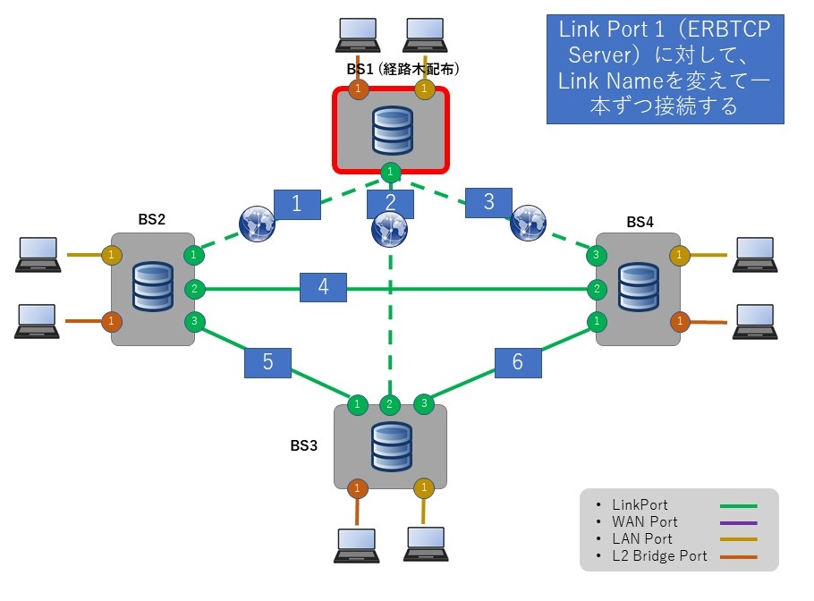

### Example 2

1. Prepare a maximum number of Link Ports (4, mix None and ERBUDP) and 5 LAN Port 1 base stations to check the PING. (See figure)
2. Change the LAN Ports at each base station one by one to the L2 Bridge Port, and verify that the configuration changes due to container restarts
3. Check the pc's assigned IP again and perform the PING check. Lan Port→ verify that changes to the L2 Bridge Port do not affect link operation.

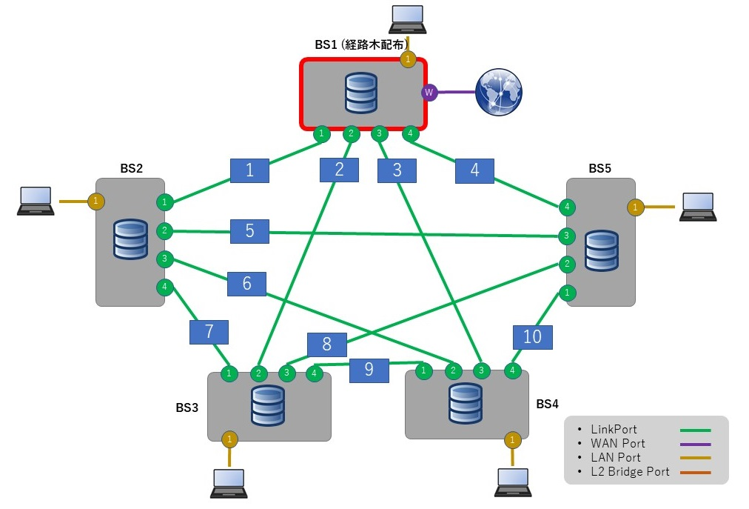

### Example 3

1. Three **BS** with **0** LAN Port, **4** **L2** Bridge Ports, and **2** LINK Ports (see figure) for PING checking. Link down is LINK(1)
2. Allocate four L2 Bridge Ports to the LAN Port. In other words: One L2 Bridge Port at each BS
3. **With one LAN Port and three L2 Bridge Ports at each base** station, check the IP assigned to PC and perform a PING check. Link down is LINK(2)
4. Change L2 Bridge Ports to LAN Port at only 1 BS
5. **With two LAN Ports and two L2 Bridge Ports at each base** station, check the IP assigned to the PC and perform a PING check. Link down is LINK(3)
6. Change L2 Bridge Ports to LAN Port at 2 BS
7. **With three LAN Ports and one L2 Bridge Port at each base station, check the** IP assigned to the PC and perform ping confirmation. Link down is LINK(1)
8. Change L2 Bridge Ports to LAN Port at 3 BS
9. **With four LAN Ports and 0 L2 Bridge Port at each** base station, check the IP assigned to the PC and perform a PING check. Link down is LINK(1)

