**Issue1:**

**Title: [Warranty Web][Minor]No feedback on invalid serial number input**

**1. Detail Test Steps:**

Step1. Open browser and navigate to: https://www.barco.com/eu-en/support/clickshare-extended-warranty/warranty---------OK

Step2. Locate serial number input filed and input invalid serial number such as:1234----OK

Step3. Click get info and there should be feedback indicating serial number is invalid-----no feedback

**2. Expected Result:**

Step3. There should be feedback when input invalid serial numbers

**3. Actual Result**

Step3. No feedback provided after input invalid serial number.

**4. Analysis**

Upon submitting an invalid serial number, the h5 element responsible for displaying results has the d-none class applied, causing it to be hidden. This class is also applied if a valid serial number is first entered and then replaced with an invalid one. **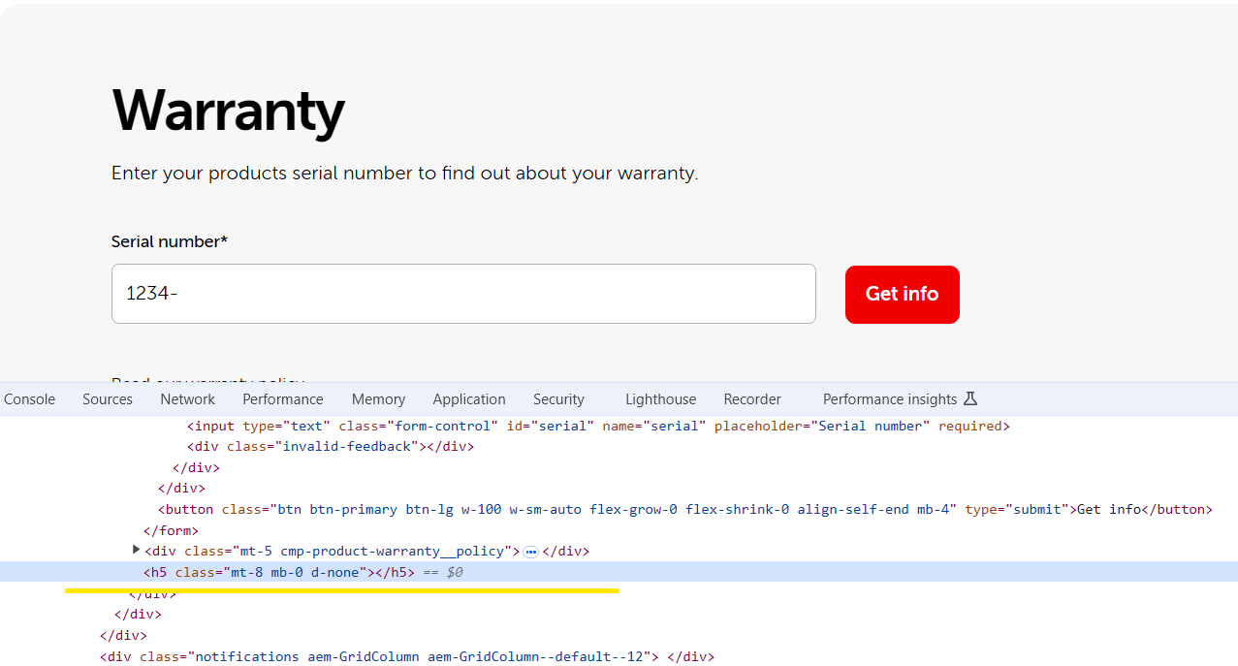  
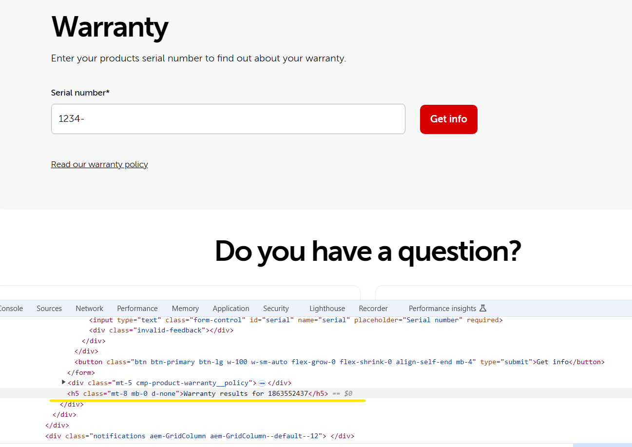**

**5. Test Environment**

First tested: Chrome: 127.0.6533.120 (Official Build) (64-bit); System: Win10

**6. Test Occurrence:** Permanent

**7. Priority:** Minor

**8. Influence:**

User Experience, user couldn’t get error feedback caused duplicate invalid data input

**9. Found in:** Functional test

**10. Recovery Action:** Not Exists

**11. Suggested Fix:**

Implement proper error handling that triggers a clear and visible feedback when an invalid serial number is entered.