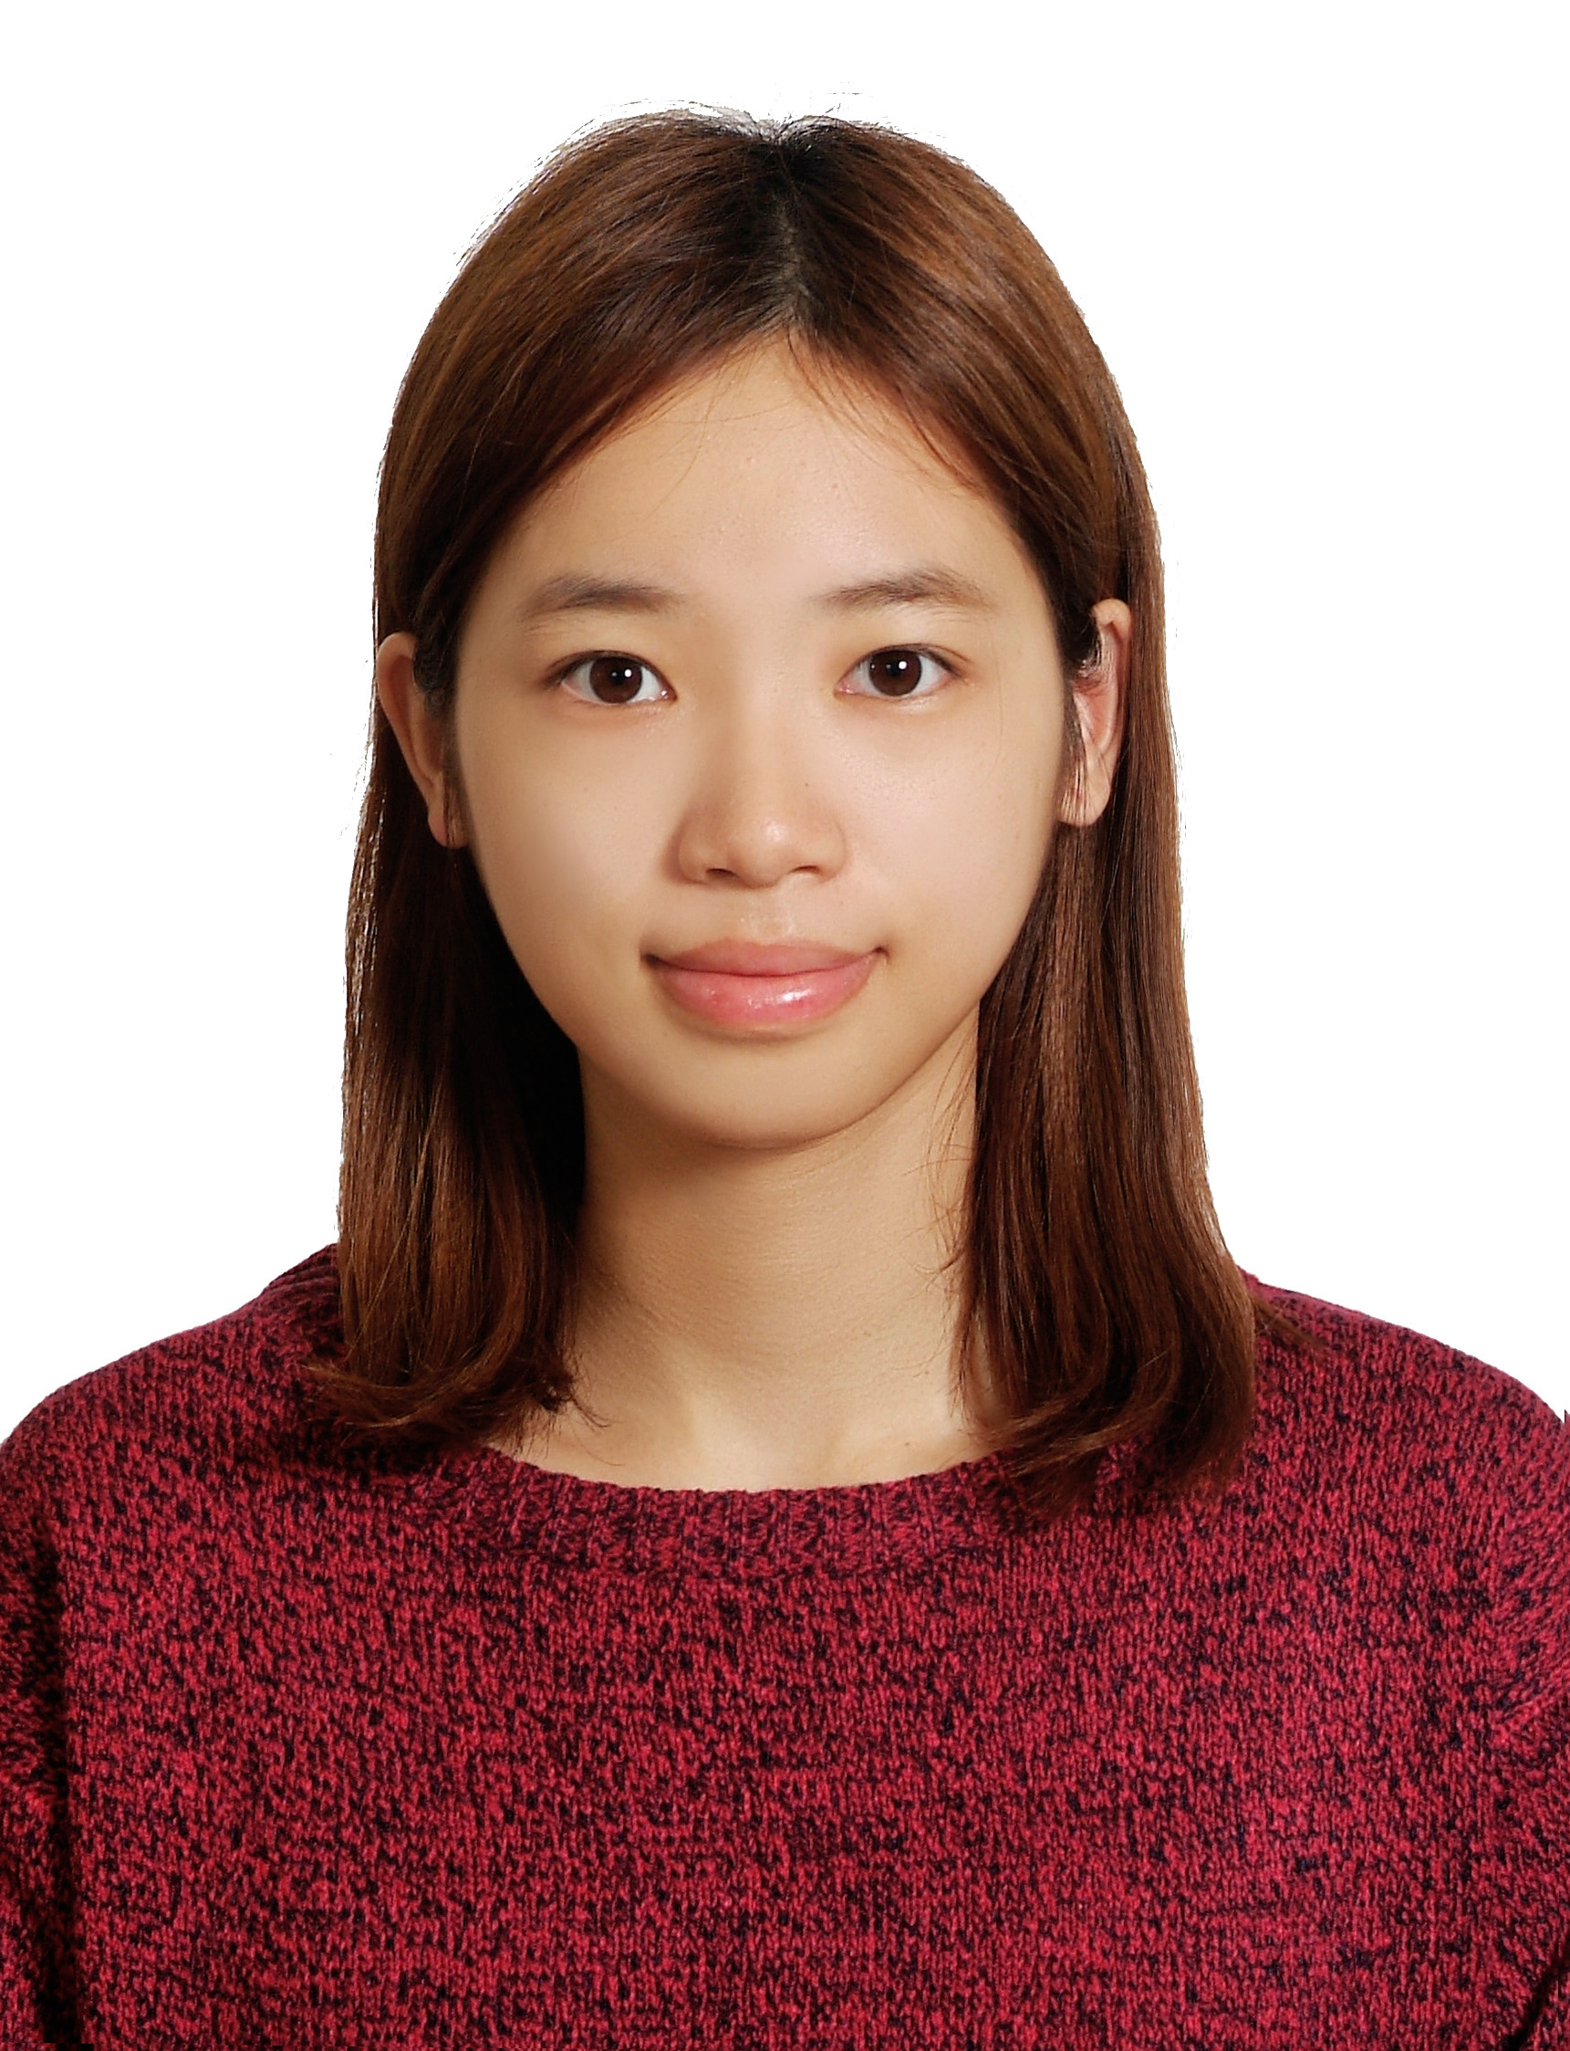**張悠然 Daisy Yu-Jan Chang**

＋886-952351-939 / [ooorangee76@gmail.com](mailto:ooorangee76@gmail.com)

**EDUCATION**

**National Taiwan University Taipei, Taiwan**

*Bachelor of Science, major in Bio-industry communication and development*  Expected Jane, 2014

* **Cumulative GPA:** 3.83
* **Relevant Coursework:** Marketing/Economics/Sociology /Research Methods for Social Sciences/Creative thinking /Service design
* **Communication program:** Communication studies/Advertisement/ Integrated Marketing Communication

**WORK EXPERIENCE**

**GIGABYTE ——Product Specialist 2014.10 － 2015.03**

* In charge of gaming laptop program executing、cost control、product kick off meeting to EOL issues
* Managed Product forecast tracking and fulfillment plan
* Coordinated with Marketing team to fine tune Marketing materials

**NTU Career Center ——art designer / Campaign Executive (Part-time) 2013.02－2014.06**

* Poster design for Career Center speeches, NTU vision2014 Job exposition visual design
* Assisted in excel/word files for NTU Etiquette Class and speeches

**McCann World Group ——Summer program intern 2013.07－2013.09**

* Participated in creative conferences to discuss advertising strategies of new products (FMCG field)
* Maintained daily records and compiled new CFs in Rainmaker XKM
* Participated in CF shooting and product sound recording (FMCG field)

**EXTRA CURRICULUM EXPERIENCE**

**6th Veterinarian Festival opening ceremony**

**Opening video producing project Executive (with other 3 members) 2013.10－2014.02**

* Interviewed with several veterinarians, Taipei zoo keeper, NTU professors to talk about Vet field issues
* Compiled and edited opening ceremony video by Adobe Premiere

**NTU international service learning program ——Activities planner 2012.09－2013.02**

* Hosted Future Career Camp which is about medical, business, service industry for local students
* Held Scientific Education Camp in Chung Hsing junior high school in Chiang Rai
* Cleaned garbage with Mae Fah Luang university (Thai) students at aboriginal village and promoted Recycling knowledge to the local

**18th NTU Art Fest —— Friday night parties planner**   **2011.09 － 2012.06**

•Prepared Art Fest opening ceremony, which attracted more than 500 audiences to participate in

•Served as a receptionist to contact with opening ceremony bands and singers

•Arranged Fashion show model training and fashion show party activities

**SKILLS, OTHER EXPERIENCES**

**Special activities:**

Working holiday in Okayama, Japan 2014.02

Outsider factory in Taipei—art intern 2013.04－2013.06

UC Berkeley summer session class 2012.07－2012.08

**Languages:**

Native speaker of Chinese/Fluent in English (TOEIC 840)/Basic in Japanese (JLPT N2)

**Computer Skills:** Microsoft Office, Adobe Illustrator, Photoshop, Google AdWords certification