DDRMO Event Personnel Assignment and Management System

A Capstone Project
Presented to
the Faculty of the Master in Information Technology College of Computing Studies Western Mindanao State University

In Partial Fulfillment of the Course Requirements in MIT 202, 203, and 204

By:
John Fredrick N. Lim
Hans Reynold B. Macrohon

Chapter 1
Introduction

State universities and colleges (SUCs) are complex public places where large academic, athletic, and cultural gatherings constitute significant crowd safety and management challenges. Pursuant to Republic Act No. 10121 (the Philippine Disaster Risk Reduction and Management Act of 2010) and Commission on Higher Education (CHED) Memorandum Order No. 09, Series of 2013, higher education institutions must institutionalize disaster risk mitigation mechanisms and sustain operational preparedness for human-induced and natural hazards.
At Zamboanga Peninsula Polytechnic State University (ZPPSU) located at R.T. Lim Boulevard, the Disaster Risk Reduction and Management Office (DRRMO) manage event deployments through paper rosters, verbal instructions, and decentralized messaging. This manual workflow creates operational bottlenecks, resulting in scheduling conflicts, unverified attendance at posts, and delayed situational updates. The absence of individual traceability in physical records prevents administrators from verifying duty compliance or maintaining permanent duty records. Additionally, mandatory two-hour site reports are often delayed or lost, and dispatchers lack reliable documentation of volunteer readiness. These vulnerabilities are further exacerbated by the transmission of personnel details and location data via commercial chat applications, which constitutes a violation of Republic Act No. 10173 (Data Privacy Act of 2012).
Hence, the DRRMO Event Personnel Assignment and Monitoring System has been proposed. This integrated web application intends to lessen operational risks by standardizing duty assignments through automated scheduling conflict and headcount validation, reducing unverified attendance via periodic browser-based GPS telemetry, digitizing two-hour scheduled site reports through designated reporters, and managing volunteer availability. The system incorporates strict role-based access control, comprehensive audit logging, and automated data retention policies to provide a secure, compliant, and auditable operational system for university event monitoring.

1.2 Project Context
The Disaster Risk Reduction and Management Office (DRRMO) of ZPPSU, located at R.T. Lim Blvd. in Zamboanga City, Philippines, is responsible for public safety, disaster preparedness, and crowd control during institutional gatherings. Major campus events, such as annual convocations, intramural athletics, multi-sectoral assemblies, and academic congresses, attract large crowds, particularly in the gymnasium, open grandstands, and main ingress and egress points. The DRRMO manages these events by deploying approximately 30 to 60 personnel, including administrative officers, departmental coordinators, field marshals, and auxiliary student volunteers. These personnel are organized into three teams: Security/Crowd Control, Emergency Response Team (ERT), and Fire Suppression.
The current operational relies on paper-based processes, including duty rosters, verbal instruction and commercial messaging applications. The current operational relies on paper-based processes, including duty rosters, verbal instruction and commercial messaging applications. Preliminary interviews with DDRMO personnel indicate that this analog workflow produces substantial administrative friction during university events. Scheduling conflicts and accidental double bookings frequently occur across multi-day deployments. Administrative staff lack an objective method to verify whether marshals are stationed at designated perimeter points. Mandatory site condition reports, required every two hours to maintain situational awareness, are consistently delayed. Emergency callouts are hindered by the absence of a centralized record of volunteer operational availability. Furthermore, the distribution of personnel rosters and unvetted location data through consumer chat platforms carries a significant risk to the University's compliance with Republic Act No. 10173 (the Data Privacy Act of 2012).
These operational deficiencies stem from the absence of an integrated, auditable information architecture that supports DRRMO’s specific coordination workflows, particularly the linkage between administrative event scheduling and field presence monitoring. Without a unified digital platform that incorporates periodic GPS presence verification, scheduled two-hour digital site reporting, automated assignment validation, and privacy-compliant data management, the university remains vulnerable to unmonitored crowd surges, delayed incident responses, and inadequate audit trails required for institutional accountability. To deal with these operational limitations and compliance risks, this study will design, develop, and empirically evaluate the DRRMO Event Personnel Assignment and Monitoring System, specifically designed for the institutional context of ZPPSU.

1.3 Purpose and Description
The main objective of this study is to design, develop, and evaluate a web-based DRRMO Event Personnel Assignment and Monitoring System for Zamboanga Peninsula Polytechnic State University (ZPPSU). This system seeks to address operational and compliance challenges related to manual, paper-based rosters and decentralized messaging during campus events. The platform establishes a centralized and auditable operational system for approximately 30 to 60 registered personnel, organized into four user tiers: Administrators, Coordinators (who oversee event scheduling without field duty assignments), Field Marshals, and auxiliary Student Volunteers. These users are further distributed across three operational teams: Security/Crowd Control, Emergency Response Team (ERT), and Fire Suppression.
The platform architecture supports a user workflow that begins with role-based authentication, followed by administrative assignment of personnel to event posts and shifts. Once assignments are made, automated validation checks are performed to detect scheduling conflicts and to confirm that the required headcount for each post is met. Administrators, coordinators, field marshals, and student volunteers receive automated email notifications regarding their assignments and upcoming reporting intervals. During events, active personnel verify their presence through browser-based GPS telemetry, which is periodically captured, and their locations are displayed on administrative monitoring map that refreshes every 30 to 60 seconds. Administrators manage the active or inactive status of the student volunteers, and every status change is kept in status history. A designated site reporter is tasked with submitting digital condition reports every two hours, giving administrator periodic situational awareness of each event site. Official safety guidelines and directives are accessible to all users through a centralized policy repository.

To comply with Republic Act No. 10173 (the Data Privacy Act of 2012), the platform integrates comprehensive privacy and governance controls. These measures include digital consent capture during initial authentication, collection of location data only active duty periods, location visibility restricted to administrator, audit logging of assignment, status changes and every administrative view of location data, and automated purging of GPS coordinate records after 10 working days. System development adheres to the Rapid Application Development (RAD) model. Through structured stages of requirements planning, iterative user design workshops, rapid construction, and final cutover, the development process allows continuous prototyping and validation with ZPPSU DDRMO personnel, so that each functional component can be checked against the operational requirements of the office.

1.4 Objectives of the Study
1.4.1 General Objective
This study aims to design, develop, and evaluate the DRRMO Event Personnel Assignment and Monitoring System for Zamboanga Peninsula Polytechnic State University (ZPPSU). This system intends to replace manual paper rosters and decentralized messaging with an auditable web platform that validates duty assignments, verifies post presence using periodic GPS telemetry, digitizes two-hour scheduled site reports, and enforces personnel data protection in compliance with Republic Act No. 10173.
1.4.2 Specific Objectives
Specifically, this study has the following objectives:
- To determine the baseline performance of the current manual process of the ZPPSU DRRMO over events in terms of the time needed to staff an event, the percentage of the site reports submitted on time, and the number of double bookings, using office records and interviews with DRRMO personnel.
- To design the system architecture, database schema, role-based access model and audit trail for administrators, coordinators, field marshals and student volunteers, so that every assignment and sensitive action can be traced to an individual user.
- To develop the web-based platform using the rapid application development (RAD) model (Requirements Planning, User Design prototyping and Construction), with the following features; administrator duty assignment with automated conflict and headcount validation, automated email notifications, administrator-managed volunteer active or inactive status, periodic browser-based GPS duty presence checks (30-seconds client pings and 30-60-second administrator map refreshes), schedule two-hour digital site reporting by a designated site reporter, and an institutional policy repository.
- To evaluate the software quality of the system based on ISO/IEC 25010:2023 in terms of functional suitability, interaction capability, performance efficiency, reliability and security, using a five-point likert-scale questionnaire answered by DRRMO personnel, student volunteers and IT experts, with a weighted mean of at least 3.50 as the acceptance level.

1.5 Scope and Limitation
This study covers the design, development, testing, and ISO/IEC 25010:2023 software quality evaluation of the web-based DRRMO Event Personnel Assignment and Monitoring System for ZPPSU. The platform manages 30 to 60 users distributed across four roles (Administrators, Coordinators, Field Marshals, and Student Volunteers) and three operational teams: Security/Crowd Control, Emergency Response Team (ERT), and Fire Suppression. Key features include event scheduling, administrative duty allocation with automated conflict and headcount validation, administrator-manage volunteer active or inactive status, automated email notifications, periodic browser-based GPS presence monitoring (30-second client pings and 30-to-60-second map refreshes), digital two-hour site reporting by a designated reporter, an institutional policy repository, and statutory data privacy controls in compliance with RA 10173, including automated telemetry purging after 10 working days.

The study does not include hardware-based biometric, RFID, or QR-code attendance logging, and instead relies on authenticated web-based duty check-in and check-out actions. It also excludes algorithmic auto-dispatch engines, quantitative employee performance appraisals, predictive analytics, native mobile applications (.apk/.ipa), and background offline data synchronization. External operational limitations comprise campus Wi-Fi or cellular network latency during high-density assemblies, consumer smartphone GPS positional drift, signal attenuation within multi-story concrete structures and covered gymnasiums, client battery depletion, and institutional event scheduling constraints.
1. 6 Significance of the Study
The implementation of the DRRMO Event Personnel Assignment and Monitoring System delivers considerable administrative and operational improvements by transitioning the ZPPSU Disaster Risk Reduction and Management Office (DRRMO) from paper-based procedures to a centralized, auditable web platform. For university administration and DRRMO leadership, the system addresses persistent management issues by automating assignment validation, preventing double-booking, and enforcing headcount thresholds for approximately 30 to 60 registered personnel. Additionally, the integration of periodic browser-based GPS telemetry and scheduled two-hour site reports from designated site reporters establishes verifiable field responsibility and periodic situational awareness during campus assemblies. The platform also supports institutional compliance with Republic Act No. 10173 (the Data Privacy Act of 2012) by incorporating digital consent methods, restricting location visibility to administrator during active duty shifts, maintaining audit records of administrative actions, and automatically purging telemetry data after 10 working days. These aspects collectively mitigate the legal and operational risks associated with informal consumer messaging applications.
Operationally, the system benefits event coordinators, field marshals, and auxiliary student volunteers by forming clear functional boundaries among the Security/Crowd Control, Emergency Response Team (ERT), and Fire Suppression units. Departmental coordinators are provided with dedicated management interfaces to oversee event logistics and monitor personnel allocations without being assigned field duties. Field marshals receive objective post-presence verification and automated email reminders, which protect personnel from unverified duty disputes and streamline site status submissions. Student volunteers are safeguarded from operational overreach through administrator-managed active and inactive status profiling, ensuring that emergency mobilizations are based on validated availability records rather than outdated contact lists. This approach directs auxiliary personnel specifically toward fire suppression and secondary ERT support.
For the broader ZPPSU academic community, the platform enhances campus safety governance by ensuring that critical ingress, egress, and high-density areas are staffed and periodically monitored during major assemblies. Rapid emergency responsiveness is maintained through validated team deployments and structured two-hour reporting cycles. Additionally, for information systems researchers and disaster risk reduction practitioners, this study offers an empirical reference model showing how state universities can implement structured personnel assignment, periodic GPS presence verification, and statutory data privacy controls using a responsive web application, without the financial and infrastructure burdens of dedicated hardware tracking units or native mobile applications.

1.7 Definition of Terms
- Audit Log – A chronological record of system activities showing who performed an action and when. In this study, the audit log records assignments, volunteer status changes, consent, and every administrative view of personnel location data, supporting accountability under Republic Act No. 10173.
- Coordinator – In this study, a departmental officer who oversees event scheduling and personnel allocations through the system but is not assigned field duties.
- Data Retention – The rule that defines how long personal data is kept before it is deleted. In this study, it refers to the automatic deletion of GPS ping records 10 working days after collection.
- DRRMO (Disaster Risk Reduction and Management Office) – An office that performs disaster prevention, mitigation, preparedness and response functions consistent with Republic Act No. 10121 (Republic of the Philippines, 2010). In this study, DRRMO refers to the ZPPSU office responsible for event safety, issuing clearance memoranda, deploying field marshals and student volunteers, and monitoring operations through the system.
- Field Marshal – An operational officer responsible for crowd control, safety monitoring and initial incident response during public assemblies. In this study, field marshals are ZPPSU personnel assigned to event posts, mainly for Security/Crowd Control and ERT duties, whose presence at their posts is checked through periodic GPS pings.
- GPS Ping – In this study, a single location record (latitude, longitude, accuracy and time) sent by the user’s browser approximately every 30 seconds while the duty page is open during an active-duty period.
- ISO/IEC 25010 – The international standard that defines a product quality model for software (ISO/IEC, 2023). In this study, it is the basis of the evaluation instrument used to assess functional suitability, interaction capability, performance efficiency, reliability and security.
- Periodic GPS Presence Check – The repeated capture of a device’s location at fixed intervals rather than continuously. In this study, it refers to the browser-based function that sends GPS pings during duty and displays them on an administrator map refreshed every 30 to 60 seconds, to verify that personnel are at their assigned posts.
- Rapid Application Development (RAD) – A software development model that emphasizes iterative prototyping and active user involvement. In this study, RAD is carried out through requirements planning, user design, construction and cutover with DRRMO personnel.
- Site Reporter – In this study, the one person designated for each event, who must also hold an assignment in that event, to submit the scheduled two-hour site report.
- Situation Report (Sitrep) – A structured operational update submitted at regular intervals to report site conditions. In this study, a Sitrep is the digital site report submitted every two hours by the designated site reporter, replacing paper logs and appearing on the administrator dashboard.
- Student Volunteer – An enrolled student who provides unpaid support during university safety and emergency preparedness activities. In this study, student volunteers are registered ZPPSU students whose active or inactive status is managed by administrators and who are assigned mainly to fire suppression and auxiliary ERT duties.
- Volunteer Status – In this study, the active or inactive standing of a student volunteer, changed only by administrators after the volunteer confirms participation or withdrawal. Each change is kept in a status history, and inactive volunteers cannot be assigned.

CHAPTER II
REVIEW OF RELATED LITERATURE/SYSTEM
The purpose of this chapter is to justify and support the significance of the proposed DDRMO Event Personnel Assignment and Management System by compiling data and information on related themes and articles from local and foreign published books and other sources.

2.1 Related Literature
2.1.1 A Review of Incident Prediction, Resource Allocation, and Dispatch Models for Emergency Management
Mukhopadhyay et al. (2022), in A Review of Incident Prediction, Resource Allocation, and Dispatch Models for Emergency Management, analyzed various approaches to emergency response management, focusing on incident prediction, detection, resource allocation, and computer-aided dispatch. The study highlights that emergency management requires decision-making under uncertainty, and existing models vary in their underlying assumptions and methodologies. A key limitation identified is that the effectiveness of these models is contingent upon the accuracy of their assumptions and the quality of available information. Uncertainty in personnel availability, travel time, and resource requirements complicates resource allocation. Consequently, assignment processes that overlook actual personnel availability and existing commitments may lead to inadequate staffing or conflicting assignments. The review offers a comprehensive overview of current approaches but does not evaluate a specific campus personnel management system.
The findings inform the design of the proposed DDRMO Event Personnel Assignment and Management System by underscoring the importance of a structured personnel assignment process and accurate information regarding available resources. Rather than relying on automated dispatch or optimization algorithms, the proposed system enables authorized administrators to assign personnel to events, incorporating system-based checks for assignment conflicts, required headcount, and inactive personnel. These features address practical resource allocation challenges while preserving the administrator's authority in assignment decisions.

2.1.2 Key Features in Designing an Integrated Recall System for Dispatch in Mass Casualty Incidents; a Systematic Review
Mazaheri et al. (2024), in Key Features in Designing an Integrated Recall System for Dispatch in Mass Casualty Incidents: A Systematic Review, examined existing systems for mobilizing professional and volunteer responders during mass casualty incidents. From 31 included studies, the review identified 22 dispatch systems and grouped their features into general characteristics, dispatcher functions, responder requirements, and other supporting features. The authors noted that some dispatch systems may not have been identified because they are unpublished or documented outside recognized scientific databases, recommending that future reviews include grey literature. This limitation is important, as exclusive reliance on published academic sources may omit operational systems and practices that could provide further insight into actual dispatch requirements. (Jensen & Thompson, 2015) The review further demonstrates that dispatch systems vary in notification procedures, responder selection, status management, and reporting capabilities.
These findings inform the design of the proposed system's personnel management and communication features. Specifically, the identified dispatcher and responder functions support administrator-managed personnel assignments, volunteer active or inactive status, and email notifications. The review also supports the implementation of clear role-based access and a defined process for communicating assignments to personnel. However, the proposed system is intended for scheduled university events rather than emergency medical dispatch. Consequently, its functions will be designed for the operational requirements of the ZPPSU DRRMO, rather than replicating the dispatch procedures of the systems reviewed by the authors.

2.1.3 Personnel Scheduling: A Literature Review
Van den Bergh et al. (2013), in Personnel Scheduling: A Literature Review, examined research on personnel staffing and scheduling problems. The authors classified the literature from several perspectives, including the problem setting and technical features such as solution methods, and identified trends and areas that require further research. The review shows that personnel scheduling is a mature field in operations research. As a literature review, however, it does not evaluate an implemented scheduling system, and its emphasis on mathematical models and solution methods offers limited guidance to small offices that assign personnel manually.
The review informs the proposed system by framing event duty assignment as a personnel scheduling problem with constraints on availability, shift coverage, and staffing levels. Rather than adopting an optimization algorithm, which this study excludes from its scope, the proposed system applies the same constraints as validation rules: each assignment made by an administrator is checked for overlapping shifts, the required headcount per post, and inactive volunteers before it is saved.
2.1.4 Social Norms and Risks at Mass Gatherings: A Systematic Review
Alhajri et al. (2023) systematically reviewed 183 articles covering more than 83 mass gatherings in 42 countries to identify the types of risks present at planned gatherings. They grouped planned mass gatherings into religious, sporting, music festival, and other cultural events, and classified the risks as health, behavioral, environmental, and other or mental health risks. The authors concluded that each gathering poses different risks depending on its nature, and that social norms, which only five of the reviewed articles considered, partly explain these differences. This limitation is significant because it shows that event safety planning cannot rely on a single generic template; each event requires its own risk assessment and staffing plan.
The findings support treating each ZPPSU event, whether a convocation, an intramural meet, or an academic congress, as a distinct deployment with its own posts, shifts, and headcount requirements. The proposed system therefore allows administrators to define posts and staffing levels for each event rather than reusing a fixed roster.

2.1.5 Preventive Measures and Crowd Management Strategies to Mitigate the Risk of Stampedes in Public Gatherings: A Systematic Review
Chowhan et al. (2026) reviewed 13 studies, selected from 833 records, on strategies for preventing stampedes at mass public gatherings. They found that proactive pre-event planning is essential, that trained marshals and attendants stationed at bottlenecks such as stairs and narrow passages were associated with fewer scuffles and panic incidents, and that clear communication, including SMS alerts, helped manage crowd movement. The authors concluded that no single intervention is sufficient and that strategies combining environmental design, operational controls, monitoring, and trained personnel are most effective. The review is limited by the absence of randomized trials, the small number of eligible studies, and heterogeneous outcome measures, and only three of the included studies were rated high quality.
The review supports the central premise of the proposed system: trained marshals must be present at their assigned posts, and event safety depends on planning before the event as well as monitoring during it. The proposed system supports pre-event planning through event and post scheduling, verifies post presence through periodic GPS checks, and supports communication through email notifications and two-hour site reports.

2.1.6 Smartphone GPS Accuracy Study in an Urban Environment
Merry and Bettinger (2019) measured the horizontal position accuracy of an iPhone 6 at surveyed points in an urban environment across two seasons, two times of day, and periods of high and low WiFi use. The average horizontal accuracy was approximately 7 to 13 meters, which is comparable to recreation-grade GPS receivers in environments with heavy multipath interference, and errors tended to be larger at points near buildings. The study is limited to a single, older phone model and to static positions, so its results may not reflect current Android devices or moving users.
These findings justify setting an outdoor GPS error target in meters rather than assuming exact positions, and they explain why the scope of the present study lists GPS drift and signal loss inside concrete buildings and covered gymnasiums as limitations. The proposed system stores the accuracy value reported by the device with each GPS ping so that administrators can judge whether a position is reliable.

2.1.7 Linking location privacy, digital sovereignty and location-based services: a meta review
Özdal Oktay et al. (2024), in Linking Location Privacy, Digital Sovereignty and Location-Based Services: A Meta Review, examined existing research on location privacy and the relationship between location-based services and users' control over their personal information. The review identified concerns related to the collection, processing, storage, and disclosure of location data. The authors highlighted limitations in current privacy protection approaches, such as the challenge of balancing location privacy with service quality and the practical difficulties of implementing some protection mechanisms. Additionally, they noted a lack of research on users' control and understanding of location information management. These limitations are significant because location data can reveal individuals' movements, routines, and other sensitive information. Systems that collect personnel location data without robust access restrictions and data management procedures may expose users to privacy risks.
The findings directly inform the design of the proposed system's GPS monitoring and privacy features. Because the system will collect personnel location information during assigned duties, it must establish explicit rules regarding consent, access, data retention, and accountability. These insights support implementing user consent at first login, restricting location access to authorized administrators, recording location-data access in an audit log, and deleting stored GPS pings after 10 working days. The system will further limit location monitoring to the duty period and employ periodic browser-based GPS updates instead of continuous real-time tracking. Collectively, these features ensure that personnel monitoring aligns with legitimate operational requirements and that location information is not collected or exposed unnecessarily.

2.2 Related System
2.2.1 Development of a Campus Disaster Risk Reduction Response System Using ADDIE Model
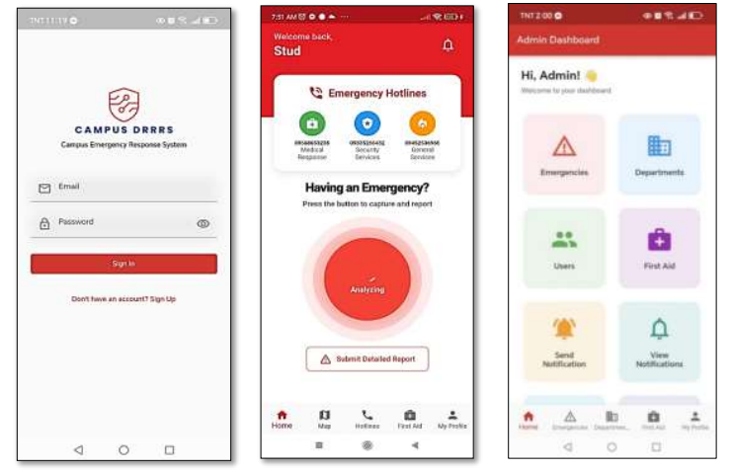
Basadre et al. (2025) developed a campus disaster risk reduction and response system utilizing the ADDIE Model, with an emphasis on establishing an information system to facilitate disaster management within a university context. The Basadre study addresses comprehensive campus-wide disaster response, which differs from the more targeted scope of the proposed system focused on event personnel assignment and monitoring. This distinction is important because campus disaster response systems and personnel management systems fulfill different operational requirements and serve different stakeholders. The Basadre research underscores the importance of considering institutional procedures and personnel needs, which the proposed system will incorporate for its specific objectives, including assigning DRRMO staff to events, verifying assignment conflicts, monitoring duty locations, and collecting site reports. System development must be aligned with the ZPPSU DRRMO’s workflow and operational requirements.

Figure 1 Development of a Campus Disaster Risk Reduction Response System Using ADDIE Model
2.2.2 Digitalized co-production of emergency response: ICT-enabled dispatch and coordination of volunteers at the emergency site
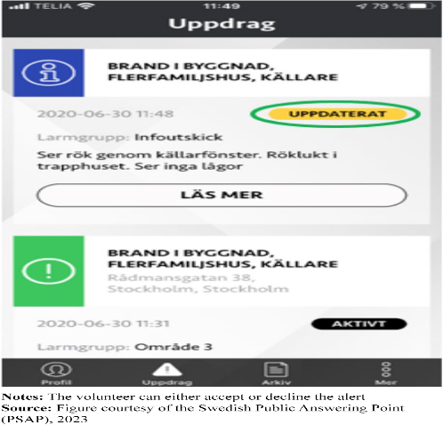
Pilemalm et al. (2025) a case study approach inspired by action research to examine the application of information and communication technology (ICT) to enhance the dispatch and coordination of volunteers collaborating with professional emergency response organizations. The study identified essential requirements for effective volunteer coordination, such as geofencing, location positioning, alert notifications, communication, and dynamic resource allocation. Additionally, it recommended selecting and assigning volunteers based on their competencies, training, capacity, and available equipment. The volunteer alerting application used in the Swedish initiative they studied (Figure 2) allows volunteers to accept or decline an alert. The authors noted that volunteers and rescue service representatives were interviewed separately and that human-computer interaction requirements were not addressed, which indicates that such designs still need user-centered evaluation with all stakeholder groups. These features illustrate the potential of digital systems to facilitate efficient deployment and monitoring of personnel during emergency operations. Nevertheless, the study primarily addresses volunteer dispatch for emergency incidents, rather than personnel assignments for scheduled disaster management events. Its principal contribution lies in the proposed integration of location-based coordination and competency-based volunteer allocation. The proposed DRRMO system extends these concepts by incorporating event scheduling, personnel assignment validation, duty monitoring, and scheduled reporting for assigned personnel.

Figure 2 Digitalized co-production of emergency response: ICT-enabled dispatch and coordination of volunteers at the emergency site
2.2.3 eDROMIS: Enhancing Disaster Response Through Monitoring and Information Management with GIS Integration
Gabi et al. (2024) introduced eDROMIS, a web-based Electronic Disaster Response Operations Monitoring Information System developed to organize and present post-disaster information. The system offers functionalities such as household management, evacuation center management, donation monitoring, geospatial visualization, and reporting dashboards. OpenStreetMap integration enables the display of evacuation centers and disaster-related information, supporting local authorities in monitoring affected communities and managing relief operations. The system was evaluated using ISO/IEC 25010 software quality characteristics. Nevertheless, eDROMIS primarily focuses on managing affected individuals and disaster relief information, lacking dedicated features for personnel assignment in scheduled public events. It does not provide functionalities for event-based duty scheduling, personnel conflict checking, or GPS-based monitoring of assigned marshals and volunteers. The proposed DRRMO system aims to address these gaps by incorporating event scheduling, personnel assignment, availability validation, GPS duty monitoring, and scheduled site situation reporting.
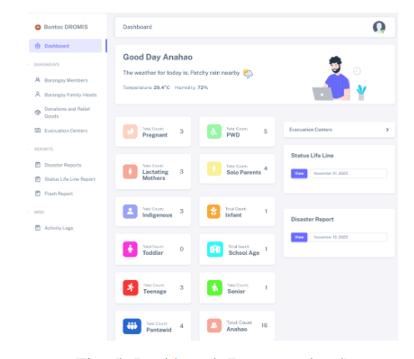

Figure 3 eDROMIS: Enhancing Disaster Response Through Monitoring and Information Management with GIS Integration

2.2.4 Mobile Application for Incident Reporting
Ignaco (2021) developed a Mobile Application for Incident Reporting to enhance the reporting and response to community incidents in the Philippines. This application enables users to report public disturbances, ordinance violations, and crime incidents by submitting detailed descriptions, photographs, and precise geographical locations. The system automatically retrieves the user's latitude and longitude via GPS or permits manual pinning of the incident location using Google Maps. Submitted reports are transmitted to the nearest barangay responder, who may request backup assistance from police officers, firefighters, or ambulance services as needed. Additionally, the system incorporates a web-based administrative platform for managing responder locations and generating statistical reports. Despite these features, the primary focus remains on incident reporting and emergency response, rather than on personnel assignment and management for scheduled public events. The proposed DRRMO system seeks to address this limitation by introducing event-based personnel assignments, availability management, assignment conflict checking, GPS-based duty monitoring, and scheduled site situation reports.
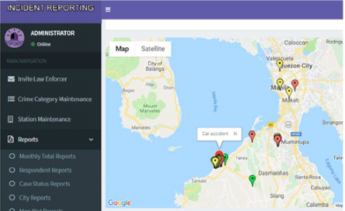

Figure 4 Mobile Application for Incident Reporting

2.2.5 Sagip Manileño: A mobile emergency response system with SMS-based offline alert capability
Camoral et al. (2026) developed Sagip Manileño, a mobile emergency response system for Manila that combines Android applications, a web-based Emergency Response Unit dashboard, a centralized database, GPS-based tracking, real-time notifications, and SMS transmission so that alerts can still be sent when internet connectivity is unavailable. The system was built using an Agile software development life cycle and was evaluated through functional testing and an ISO/IEC 25010 quality assessment by 20 respondents, obtaining an overall mean of 4.62, interpreted as Excellent. The study shows how GPS location and offline-capable alerts can be combined to improve coordination between citizens and responders in a Philippine urban setting.
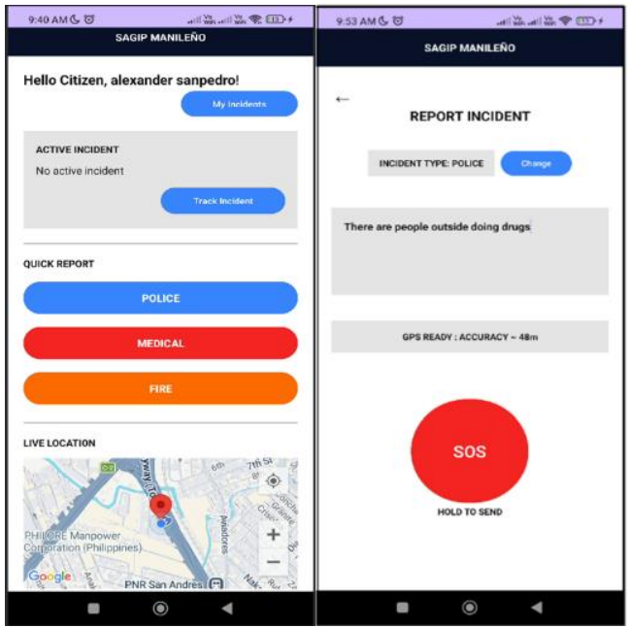
However, the Sagip Manileño architecture focuses primarily on reactive, incident-based emergency response, rather than on managing personnel for pre-scheduled institutional events. In contrast, the proposed DRRMO system addresses pre-event logistics by implementing automated checks for assignment conflicts and double-bookings, monitoring the availability of both active and inactive volunteers, and requiring a designated site reporter to submit two-hour site reports (Sitreps). While Sagip Manileño demonstrates the benefits of integrating geolocation into localized emergency dispatching, it underscores the distinct need for the proposed system’s capabilities in event scheduling, roster validation, and structured operational monitoring. In addition, its quality evaluation relied on the perceptions of 20 respondents, which limits how far the reported ratings can be generalized.

Figure 5 Sagip Manileño: A mobile emergency response system with SMS-based offline alert capability
2.1.6 SMART EMERGENCY RESPONSE SYSTEM USING GEO-LOCATION
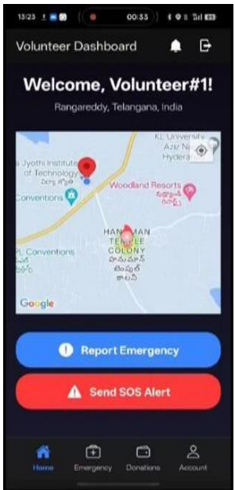
Panuganti and Divya (2026) developed the Smart Emergency Response System, a disaster-management platform for incident reporting, SOS alerts, location tracking, and coordination of volunteers and donations at Vidya Jyothi Institute of Technology. Built with the MERN stack, React Native, Google Maps, and Firebase, the system identifies incidents, processes alerts within seconds, and assigns nearby responders. However, the study provides little information about its development process or evaluation: it specifies no testing standards, sample size, quantitative ratings, or measured response times. It also contains inconsistencies about the technology used and includes unrelated image-captioning material. The system depends on network connectivity, while scalability and integration with government agencies remain unresolved. Although it combines geolocation and volunteer management, its focus is public SOS requests rather than scheduled safety staffing. The proposed DDRMO system extends this work through validated event assignments, two-hour site reports, privacy controls for personnel location, and evaluation against performance targets.

Figure 6 SMART EMERGENCY RESPONSE SYSTEM USING GEO-LOCATION
2.1.7 Facial and Geofencing-Based Attendance Tracking System for Deployed Personnel
Fernandez et al. (2025) developed an attendance tracking system for deployed officers of the Cagayan de Oro City Police Office (COCPO) to enhance patrol tracking accuracy and officer accountability. The system, implemented in Python, integrates facial recognition with GPS-based geofencing utilizing the Haversine formula. It permits officers to capture a real-time selfie only after confirming their presence within the designated patrol zone. Testing with COCPO officers demonstrated 99 percent facial recognition accuracy under optimal conditions, 92.18 percent geofencing accuracy in open areas, a decrease to 71.33 percent in urban environments, and a System Usability Scale score of 85.56.
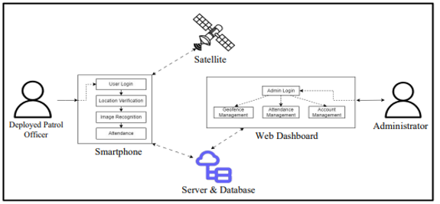
This study represents the most comparable Philippine example of verifying that deployed personnel are present at their assigned posts, which is the same challenge addressed by the proposed system for DRRMO marshals and volunteers. However, the referenced system relies on facial recognition, a biometric data type intentionally excluded from the present study, and is designed for daily police patrols rather than staffing for scheduled institutional events. The reduced geofencing accuracy in urban areas further corroborates the GPS limitations identified by Merry and Bettinger (2019). In contrast, the proposed system employs periodic browser-based GPS checks without biometrics, thereby minimizing the sensitivity of collected personal data while still providing verifiable evidence of post presence.

Figure 7 System Architecture of the Facial and Geofencing-Based Attendance Tracking System
2.3 Matrix of the Review Study
Table 2.1 Matrix of the Review Study
Author(year) | Focus | Method | Key Finding/ Feature | Limitation | Relevance to the Present Study
Mukhopadhyay et al. (2022) | Emergency incident prediction, resource allocation and dispatch | Literature review | Assignment is decision-making under uncertainty; models depend on accurate data on resource availability | Does not evaluate a specific personnel management system | Supports conflict, headcount and availability checks before assignment
Mazaheri et al. (2024) | Dispatch and recall systems for mass casualty incidents | Systematic review (PRISMA); 31 studies | 22 dispatch systems; features grouped into general, dispatcher, responder and other features | Unpublished and grey-literature systems may be missed | Supports admin-managed assignment, status management and notifications
Van den Bergh et al. (2013) | Personnel staffing and scheduling | Literature review | Classifies scheduling research by problem setting and technical features; identifies trends | Focus on optimization models; no implemented system evaluated | Frames assignment as scheduling with availability and coverage constraints
Alhajri et al. (2023) | Risks at planned mass gatherings | Systematic review; 183 articles | Four gathering types; health, behavioral, environmental and other risks; risks differ per event | Social norms rarely studied | Supports per-event posts and staffing levels

Table 2.1 Matrix of the Review Study (Continuation)
Chowhan et al. (2026) | Stampede prevention and crowd management | Systematic review; 13 studies | Pre-event planning, trained marshals at bottlenecks and communication; combined strategies work best | No randomized trials; small, heterogeneous evidence | Supports post presence checks, planning and site reports
Merry & Bettinger (2019) | Smartphone GPS accuracy | Field measurement; iPhone 6 at urban survey points | Average horizontal accuracy about 7–13 m; larger errors near buildings | One older device; static points only | Basis for the GPS error target and stated limitations
Özdal Oktay et al. (2024) | Location privacy and location-based services | Meta-review of survey papers | Location data enables sensitive inferences; users have limited control over it | Little research on users’ control of location information | Supports consent, admin-only access, audit log and 10-day retention

2.4 Synthesis in Matrix Form (Table of Comparison)
Table 2.2 Synthesis in Matrix Table
System Features | System Title
Event-based duty scheduling | System A | System A | System A | System A | System A | System A | System A | System A

CHAPTER III
TECHNICAL BACKGROUND

3.1 Technicality of the Project
The proponents obtained the requisite information on the current ZPPSU DRRMO deployment practices through interviews with the office staff and a review of the office records. They also looked at the various studies and systems to determine the technical specifications of the project. The system must be capable of assigning staff to campus events with the ability to detect any conflicting schedules. It must be able to email staff their duties, confirm the presence of staff at their posts during duty, collect site reports every two hours and ensure that all personal and location data is protected in accordance with R.A. 10173. It is a system for a very small group of users (approximately 30 to 60 users) with very limited resources and no dedicated technical staff.
After looking at the various options, the team have opted to go with a web app rather than a native mobile app or a solution that would require dedicated hardware (i.e. GPS trackers, RFID readers, biometric readers etc). DRRMO staff already have smartphones with built in GPS and the current web browsers are capable of getting the location of the device once the user has given permission. The web app would therefore require no additional hardware, no app store installation and just one code base which would run on both the desktop and the smartphone (and could be added to the home screen of the phone as a PWA). The team have also looked at the technical constraints of this approach. A web page can only read the device's location whilst the page is open and the screen is on. The project will therefore be doing periodic presence checks rather than continuous tracking, will keep the phone screen on during duty and will store the location readings on the phone when the signal is weak until they can be transmitted.
To keep it affordable for a state university office the whole shebang was built on open-source software and free service tiers where that was adequate. The app framework, the database, the UI libraries and the mapping library are all open source. The campus maps use free OpenStreetMap tiles. Email is sent via the free tier of a commercial email service which is more than adequate for the number of notices we expect to send. The security certificate is obtained free of charge from Let's Encrypt. It can be hosted on a free cloud virtual machine or on an existing university server. Text messaging was looked at but not adopted as there was no free and reliable SMS gateway available for the Philippines and the commercial ones all charge per message.
The advocates have also put in place a range of practices that will ensure the project is reliable and maintainable. The source code is version controlled; there are automated tests and code quality checks in place that run on every change and the project is developed in short iterations with each iteration culminating in a working version that is demonstrated on a real phone over a secure connection. Location data is obviously a sensitive piece of information and security has been a technical requirement from the outset: all communication is over HTTPS (which the browsers also require before they will release the device location) and passwords are stored only in hashed form.

3.2 Details of the Technologies to be used in Development of the Project
The tech that we're going to use in the development of the project has been selected on the basis of four criteria. It must be free or open source (so that it doesn't add any licensing cost to the office). It must be well documented and something that the proponents are familiar with (so that it can be maintained after the handover). It must be compatible with the hosting options we have available to us. It must have the security features that are required to be able to handle personal and location data.
Laravel 13 (on PHP 8.3) is the server-side framework of choice. Laravel was selected because PHP is so widely supported on Linux hosts and university servers, and the framework already has the validation, authorization, mail, job queue, and task scheduling features that we need, so there's a very small number of third-party packages to maintain. Laravel 13 requires PHP 8.3 or later. MySQL 8.4 is the database management system we will be using, as the records we have (people, events, assignments, site reports, etc.) are very relational and would benefit from foreign keys and transactions. The firebase/php-jwt library will be used to issue the JSON Web Tokens for user sign-in, and PHPMailer will be used to send email via SMTP.
React 19 with TypeScript will be used for the UI. React builds the UI out of reusable components, so the same components and data can be used to build both the desktop pages for the admin and the phone pages for the field staff. TypeScript will catch type errors before the code runs. React Router, TanStack Query, and Tailwind CSS 4 will be used for navigation, data fetching, and responsive styling, respectively, and Vite (on Node.js 22 LTS) will be the compiler. Leaflet 1.9 will be used to display the campus map. It was selected over the various commercial map services as it requires no paid API key when used with OpenStreetMap tiles (which can be used for light traffic as long as the appropriate attribution is provided) (OpenStreetMap Foundation, n.d.). The client side will be completed with three browser features: the Geolocation API (which will only give you the device's position on pages served over HTTPS) (MDN Web Docs, n.d.-a); the Screen Wake Lock API, which will keep the screen on during duty (MDN Web Docs, n.d.-b); and IndexedDB, which will store the location readings whilst the phone is offline.
VS Code will be the code editor. Local development will be via Laravel Sail (providing PHP 8.3, MySQL 8.4, and the Mailpit test mail server within Docker containers on Windows via WSL2) so that the local environment is as close as possible to the production server. XAMPP is out, as the current release still ships with PHP 8.2, which doesn't meet the Laravel 13 requirement; Laravel Herd could be used in lieu of Sail on machines that can't run Docker. Source control will be via Git on GitHub. Code quality will be maintained via Pest and Vitest for automated testing, Larastan for static analysis, Pint, ESLint, and Prettier for consistent code style, and GitHub Actions to run all of the above checks automatically on every change.

3.3 How the Project Works
The DDRMO Event Personnel Assignment and Management System coordinates campus-event staffing from account setup through post-event records. Administrators create accounts manually or by CSV import. Volunteers may request access and await approval. Users set passwords and accept a privacy notice.
For each event, administrators enter its location and schedule, define duty requirements and shifts, assign marshals and volunteers, and designate a site reporter. The system flags conflicts. Personnel receive assignment links by email, acknowledge duties on mobile devices, and receive reminders before shifts.
During shifts, personnel start and end duty through their assignment page. On first use, they consent to location collection and enable GPS. Phones send location updates every 30 seconds while the page is open; administrators monitor personnel on a map that refreshes every 30 to 60 seconds. Site reporters submit condition summaries every two hours, with optional photos. Late reports are marked overdue and trigger alerts. Duty ends manually or automatically after 30 minutes.
Users can search the memo and policy library and message the DRRMO office. Authorized users retain access to assignments, reports, notifications, and audit records after events. Administrators update volunteer status based on participation or withdrawal. GPS data is deleted after 10 working days.

Chapter IV
METHODOLOGY, RESULTS, AND DISCUSSION

4.1 Methodology

4.1.1 RAD Model


