Student Records API Presentation Cheat Sheet
MIT 202 Laboratory Activity No. 01
Use this sheet during the 5-minute presentation. It gives exact words to say, exact clicks to make, and exact text to paste. Keep the Supabase password hidden.

Five Minute Presentation
Time | Do | Say
0:00–0:45 | Show objective and diagram. | This project builds a Laravel Student Records REST API. It starts with local MySQL, then moves to Supabase PostgreSQL. The API code stays the same.
0:45–1:35 | Open routes, controller, model, and .env. | Routes expose GET and POST. The controller validates and creates records. Eloquent represents the students table. .env selects the database.
1:35–3:10 | Run Postman GET, then POST against Supabase. | GET returns HTTP 200. POST validates and creates a student, returning HTTP 201.
3:10–4:10 | Show MySQL and Supabase .env values. | Only database settings change. Routes, controller, model, URL, and request body stay the same.
4:10–5:00 | State takeaway and challenge. | The same API works with two databases. The main challenge was setting up the PostgreSQL connection. I now open the floor for questions.

Architecture Diagram
Point while speaking: Postman → routes → controller → model → .env → MySQL or Supabase.
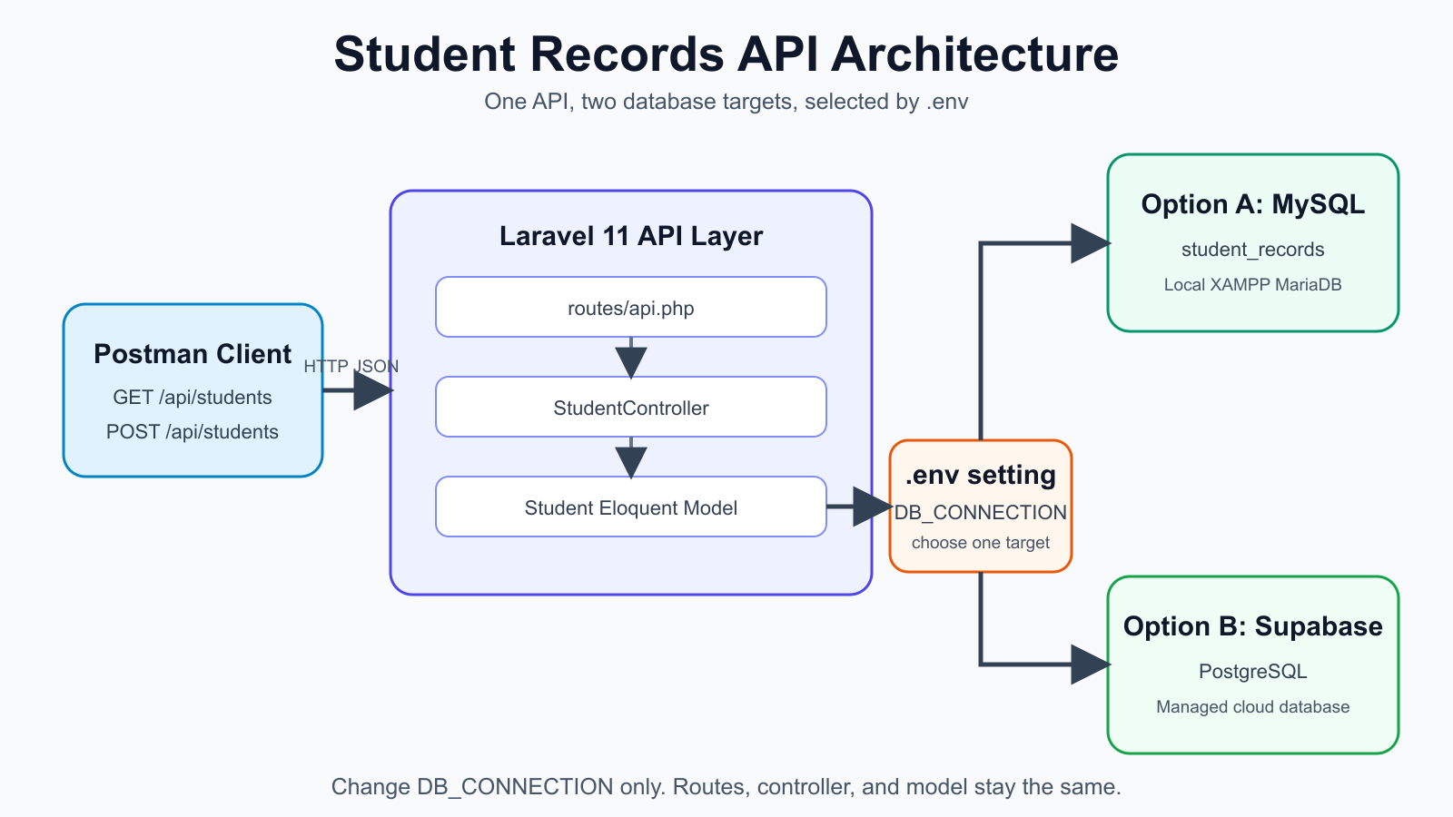
Figure 1. One Laravel API with two database targets.

Technical Steps One by One
Follow in order. Paste only the blocks shown. Replace placeholders in angle brackets. Never paste the real database password into slides or screenshots.

A Start the Laravel server
1. Open the project
Open this folder in VS Code:
C:\Users\PC\.codex\.chatgpt-projects\g-p-6aab8e17fed88191afa975fea2c352a1\student-records
2. Open the VS Code terminal
Click Terminal > New Terminal.
3. Start Laravel
Paste this command:
php artisan serve
Expected result: http://127.0.0.1:8000

B Postman GET demo
4. Choose GET
In Postman, choose GET.
5. Paste the URL
Paste this into the request URL:
http://127.0.0.1:8000/api/students
6. Click Send
Expected result: HTTP 200 and a JSON list of students.

C Postman POST demo
7. Choose POST
Choose POST and use the same URL:
http://127.0.0.1:8000/api/students
8. Choose the body type
Click Body > raw > JSON.
9. Paste the JSON body
Paste this block:
{
"student_number": "2026-9999",
"first_name": "Demo",
"last_name": "Student",
"email": "demo.student.9999@example.com",
"course": "BSIT"
}
10. Send the request
Click Send. Expected result: HTTP 201 and the new student record.
If Postman returns 422 because the number or email already exists, change both values, for example 2026-9998 and demo.student.9998@example.com.

D Confirm the Supabase row
11. Open Supabase
Open the Supabase project dashboard.
12. Open the table
Click Table Editor > public > students.
13. Point to the row
Show the new Demo Student row. Do not show the password.

E Show the required code changes
SECTION E IS CODE WORK. Do these steps in VS Code. Press Ctrl+A inside each file, paste the matching block, then press Ctrl+S. During the database migration, do not change routes or controller logic.
E1. Replace routes/api.php
Open routes/api.php. Press Ctrl+A. Paste the routes block below. Press Ctrl+S.
routes/api.php
use App\Http\Controllers\StudentController;
use Illuminate\Support\Facades\Route;
Route::apiResource('students', StudentController::class)
->only(['index', 'store']);
What this does: GET /api/students calls index(). POST /api/students calls store(). The route file tells Laravel which controller method handles each request.
E2. Replace app/Models/Student.php
Open app/Models/Student.php. Press Ctrl+A. Paste the model block below. Press Ctrl+S.
app/Models/Student.php
class Student extends Model
{
protected $fillable = [
'student_number', 'first_name', 'last_name',
'email', 'course',
];
}
What this does: $fillable allows Laravel to save these five fields when Student::create() runs. Without it, Laravel blocks mass assignment.
E3. Replace StudentController.php
Open app/Http/Controllers/StudentController.php. Press Ctrl+A. Paste the controller methods below inside the controller file. Press Ctrl+S.
StudentController methods
public function index(): JsonResponse
{
return response()->json(Student::all());
}
public function store(Request $request): JsonResponse
{
$student = Student::create($request->validate([
'student_number' => ['required', 'string', 'max:255', 'unique:students'],
'first_name' => ['required', 'string', 'max:255'],
'last_name' => ['required', 'string', 'max:255'],
'email' => ['required', 'email', 'max:255', 'unique:students'],
'course' => ['required', 'string', 'max:255'],
]));
return response()->json($student, 201);
}
What this does: index() reads every row and returns JSON. store() validates the POST body, creates one row, and returns HTTP 201. required means the field must exist. email checks email format. unique:students prevents duplicate student numbers and emails.
E4. Check the migration
Open the create_students_table migration. Confirm the table and fields match the block below. Press Ctrl+S only if you changed it.
database/migrations/..._create_students_table.php
Schema::create('students', function (Blueprint $table) {
$table->id();
$table->string('student_number')->unique();
$table->string('first_name');
$table->string('last_name');
$table->string('email')->unique();
$table->string('course');
$table->timestamps();
});
What this does: the migration creates the students table. The unique rules protect student_number and email. timestamps adds created_at and updated_at.

F Swap database backends
Change only the database values in student-records/.env. Do not change routes, controller, model, or Postman requests.
MySQL .env block
DB_CONNECTION=mysql
DB_HOST=127.0.0.1
DB_PORT=3306
DB_DATABASE=student_records
DB_USERNAME=root
DB_PASSWORD=
Supabase .env block
DB_CONNECTION=pgsql
DB_HOST=aws-0-ap-southeast-2.pooler.supabase.com
DB_PORT=5432
DB_DATABASE=postgres
DB_USERNAME=postgres.<PROJECT_REF>
DB_PASSWORD="<YOUR_SUPABASE_PASSWORD>"
14. Clear cached configuration
After saving .env, paste:
php artisan config:clear
15. Check migration state
Paste:
php artisan migrate:status
16. Run migrations only when the target database is empty
Paste:
php artisan migrate
Do not run migrate:fresh on the Supabase database. It can delete data.

G Final speaking lines
Key takeaway: The same Laravel API worked with MySQL and Supabase.
Only the .env database settings changed.
Main challenge: setting up the PostgreSQL driver and connection correctly.
That ends my demonstration. I now open the floor for questions.

