Decoupled API Architecture
MySQL to Supabase Migration
MIT 202 Advanced System Design and Implementation
Laboratory Activity No. 01

Name: [Student Name]
Section: [Section]
Date: September 17, 2026

Objectives
This laboratory built a Laravel REST API for student records, tested it against local MySQL, and migrated the database layer to Supabase PostgreSQL. The endpoint paths and controller logic remained unchanged during the migration.
- Create a relational students table with a Laravel migration.
- Expose Add and View operations through POST and GET endpoints.
- Test both operations in Postman with MySQL and Supabase.
- Demonstrate database decoupling by changing only environment configuration.
- Document the architecture, implementation, and results.

Tools Used
Tool | Version or use
PHP | 8.2.12
Laravel | 11.56.1
Composer | 2.10.3
Local database | MariaDB 10.4.32 through XAMPP
Cloud database | Supabase PostgreSQL 17.6.1
API testing | Postman 12.28.2
Editor and version control | Visual Studio Code and Git 2.47.0

Database Design
The students table stores a generated primary key, a unique student number, the student's name, a unique email address, a course, and Laravel timestamps.
Column | Type | Rule
id | big integer | Primary key
student_number | varchar(255) | Required and unique
first_name | varchar(255) | Required
last_name | varchar(255) | Required
email | varchar(255) | Required and unique
course | varchar(255) | Required
created_at and updated_at | timestamp | Laravel timestamps
Schema::create('students', function (Blueprint $table) {
$table->id();
$table->string('student_number')->unique();
$table->string('first_name');
$table->string('last_name');
$table->string('email')->unique();
$table->string('course');
$table->timestamps();
});
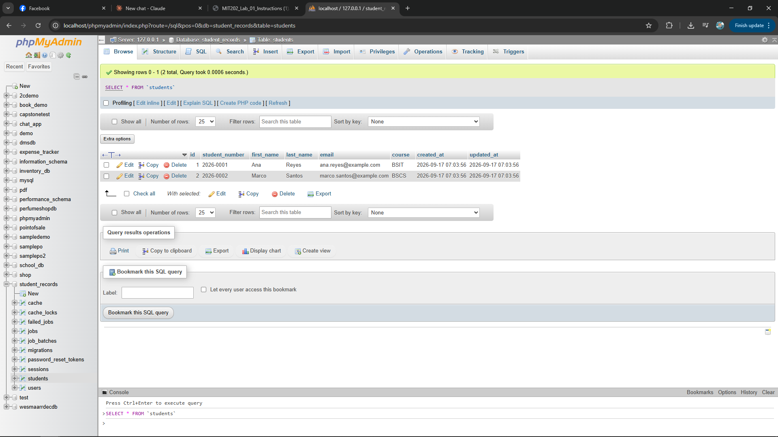
Screenshot Set 1. Local MySQL students table with two sample records

API Implementation
The API uses plural resource routes. GET returns all student records. POST validates client input, creates a Student model, and returns the new record with HTTP status 201.

Routes
Route::apiResource('students', StudentController::class)
->only(['index', 'store']);

Controller
public function index(): JsonResponse
{
return response()->json(Student::all());
}
public function store(Request $request): JsonResponse
{
$student = Student::create($request->validate([
'student_number' => ['required', 'string', 'max:255', 'unique:students'],
'first_name' => ['required', 'string', 'max:255'],
'last_name' => ['required', 'string', 'max:255'],
'email' => ['required', 'email', 'max:255', 'unique:students'],
'course' => ['required', 'string', 'max:255'],
]));
return response()->json($student, 201);
}

Testing Results Local MySQL
Postman confirmed that the API returned the two seeded records and accepted a new student without exposing database-specific logic in the endpoint contract.
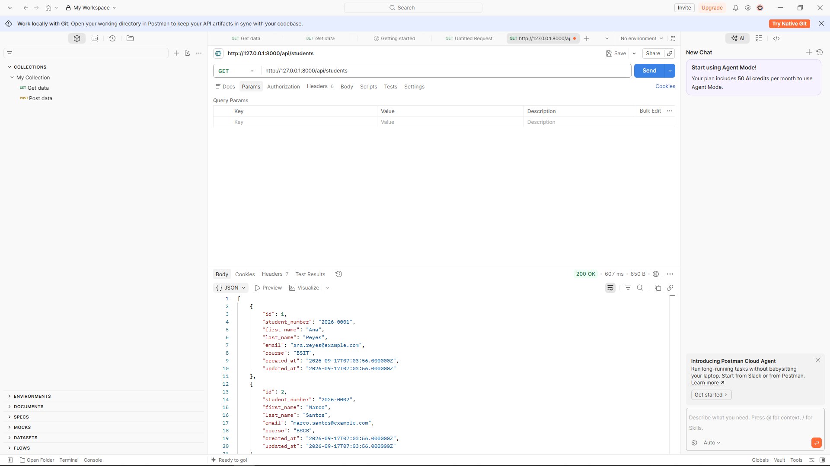
Screenshot Set 2. GET request against local MySQL returned HTTP 200
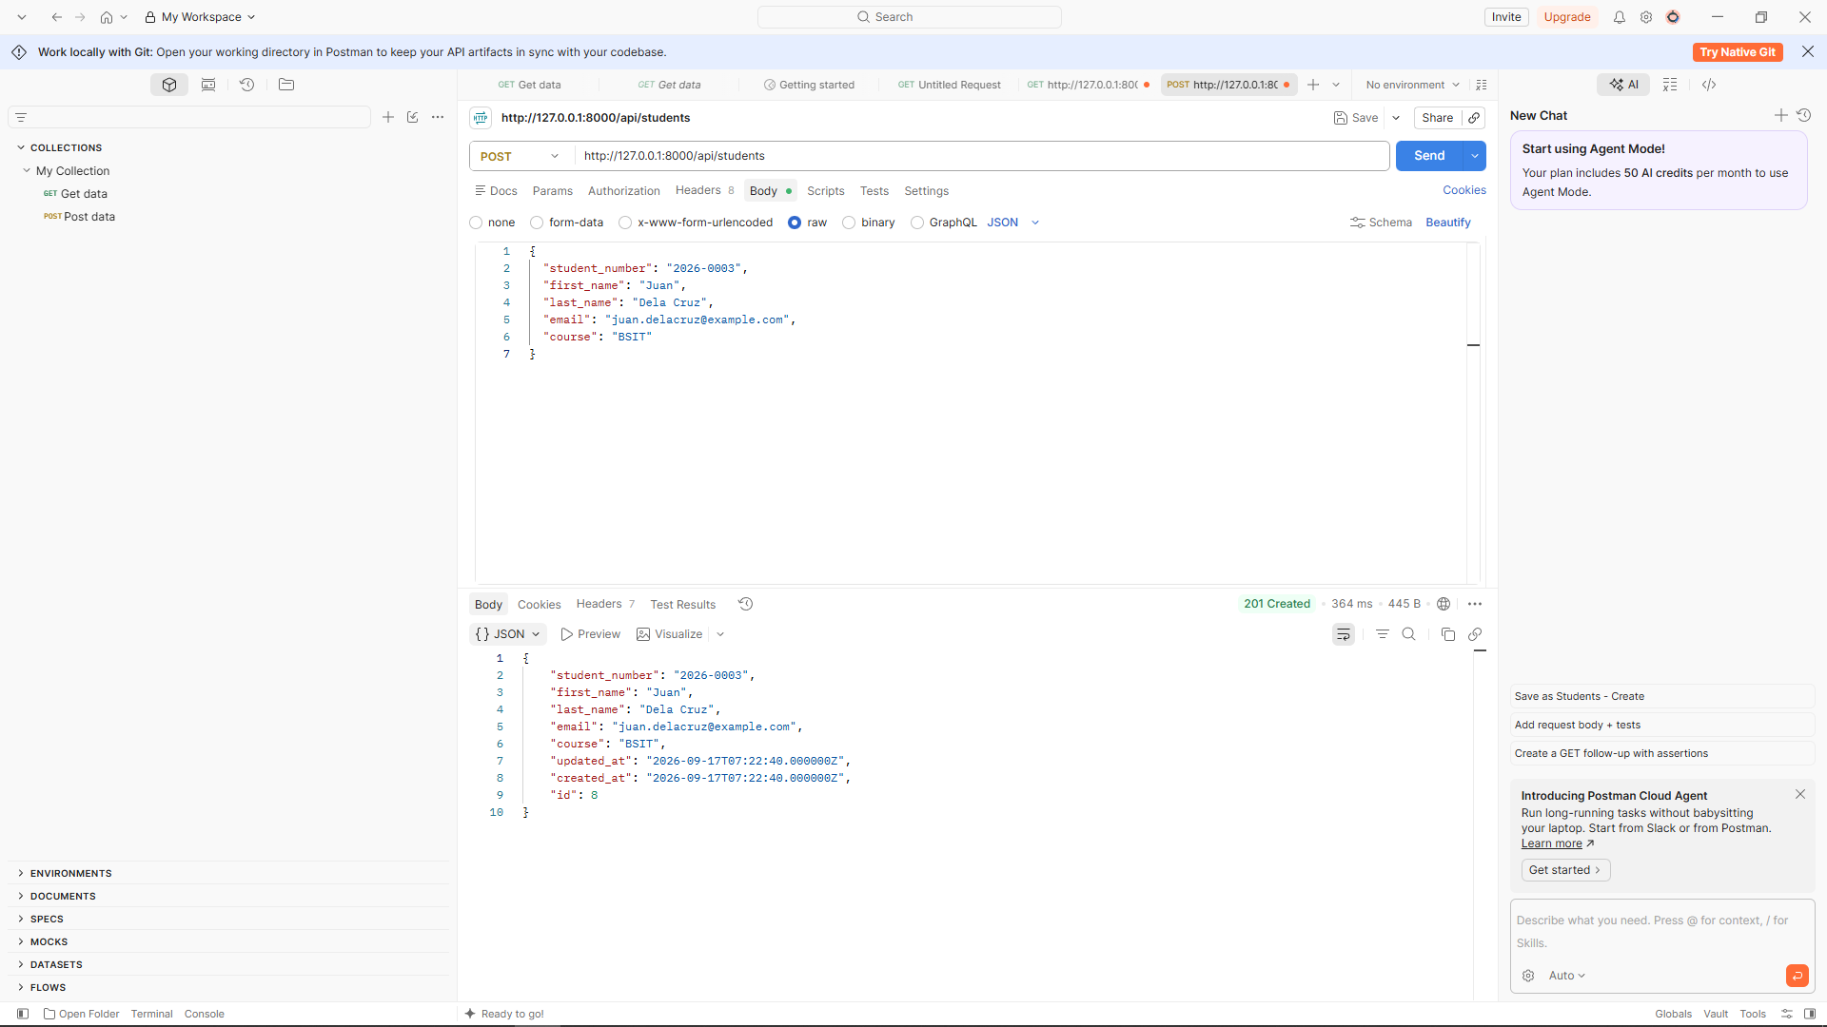
Screenshot Set 3. POST request against local MySQL returned HTTP 201

Supabase Migration
The Supabase project provided a managed PostgreSQL database. The Laravel PostgreSQL PDO extension was enabled, the existing migrations were executed, and the same seed data was inserted.
- Created the Supabase project and recorded its connection parameters.
- Enabled pdo_pgsql in the local PHP configuration.
- Changed only the database values in .env.
- Cleared Laravel's configuration cache and ran the existing migrations.
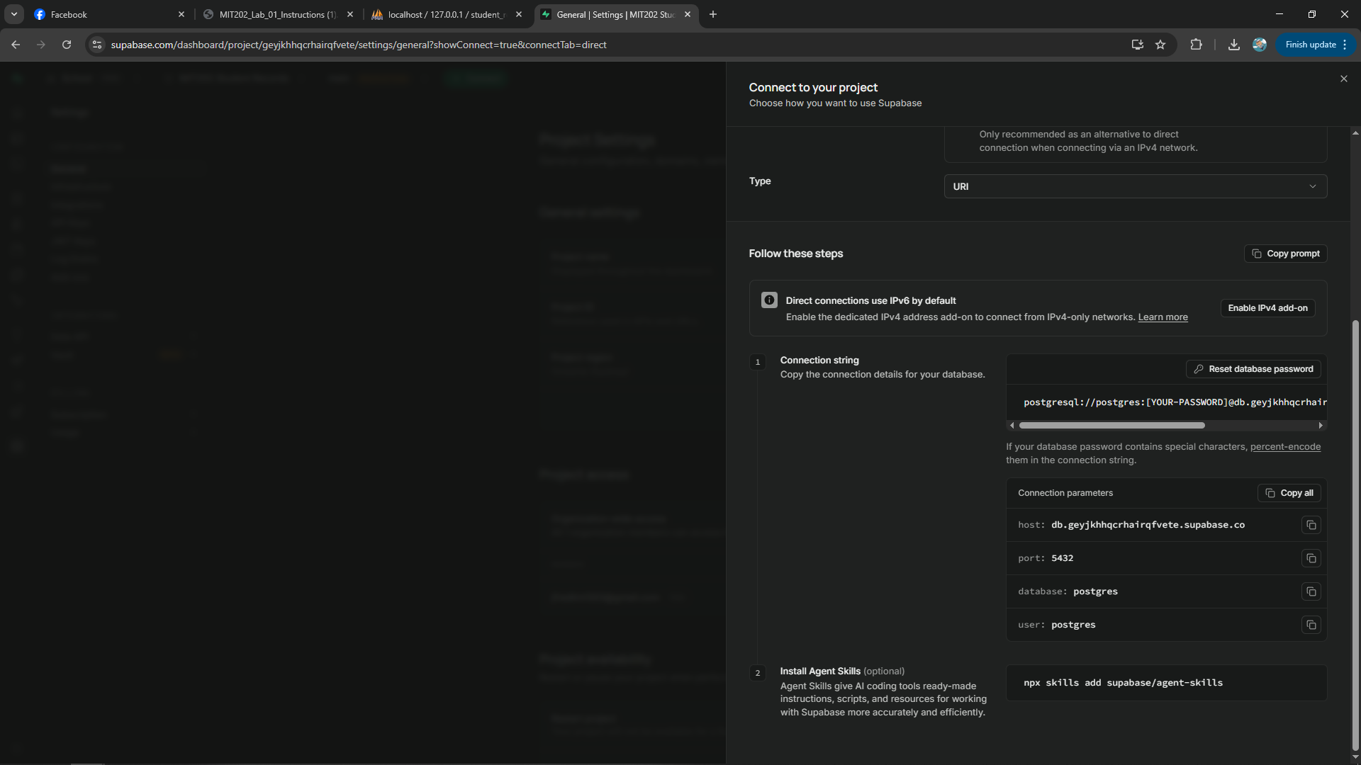
Screenshot Set 4. Supabase database connection parameters

Environment Configuration
DB_CONNECTION=pgsql
DB_HOST=aws-0-ap-southeast-2.pooler.supabase.com
DB_PORT=5432
DB_DATABASE=postgres
DB_USERNAME=postgres.[PROJECT_REFERENCE]
DB_PASSWORD=[REDACTED]

Testing Results Supabase
The API contract stayed the same after migration. The same URL, request body, and controller methods worked with PostgreSQL.
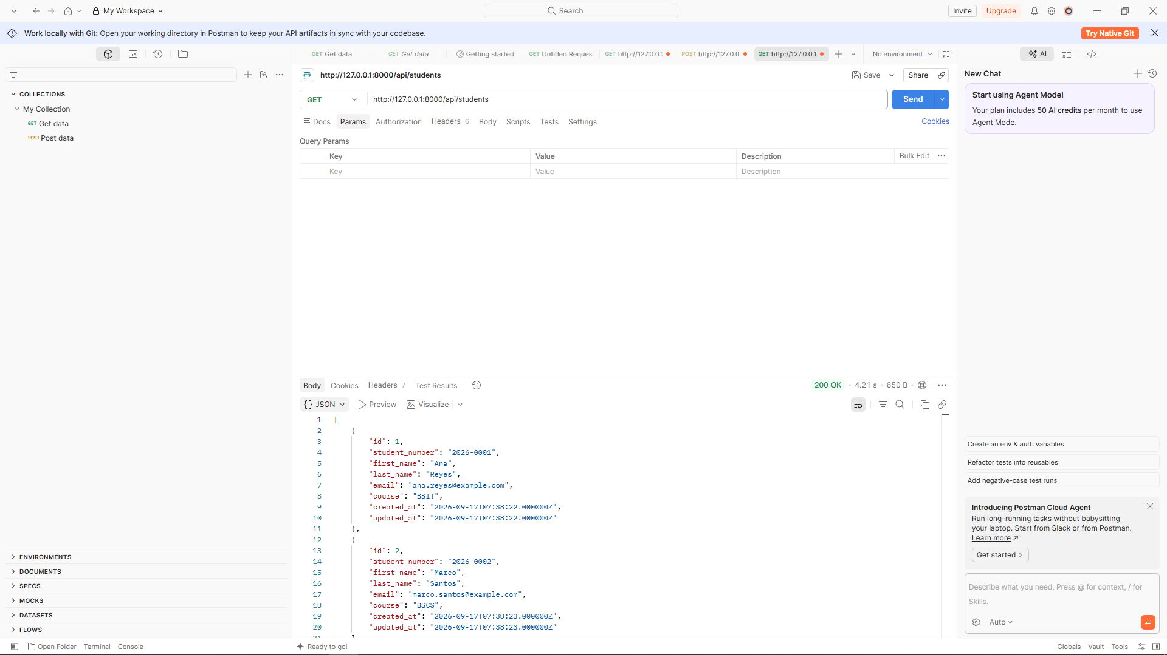
Screenshot Set 5. GET request after migration returned HTTP 200
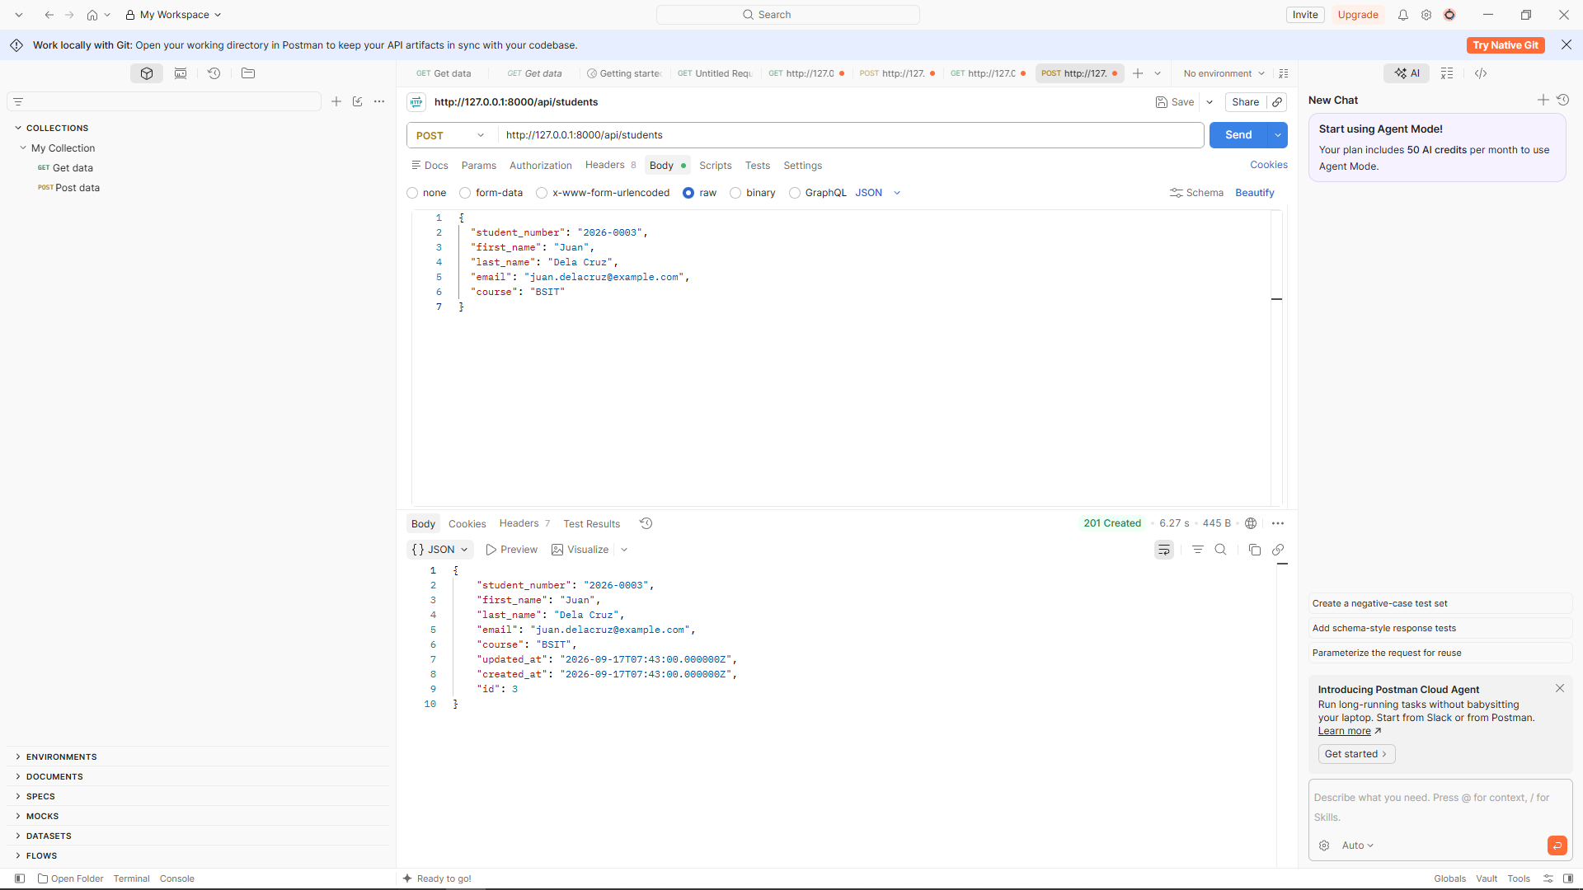
Screenshot Set 6. POST request after migration returned HTTP 201
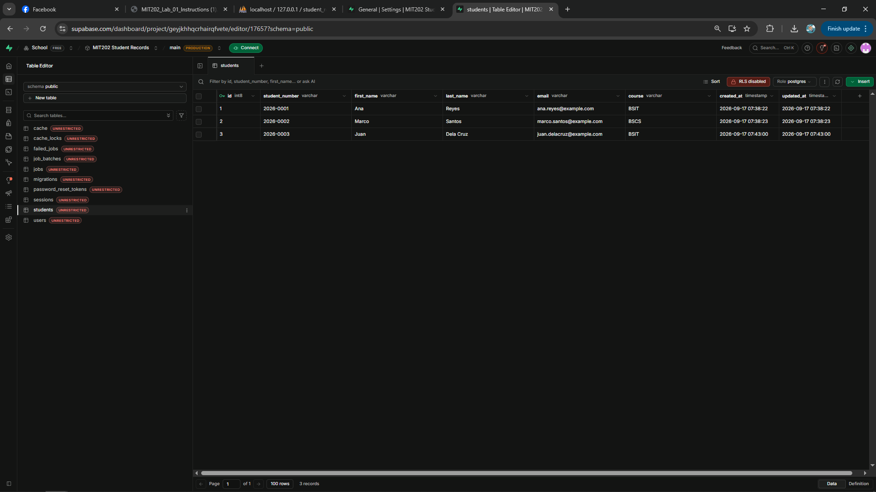
Screenshot Set 7. Supabase Table Editor showing the newly created Juan Dela Cruz row

System Architecture Diagram
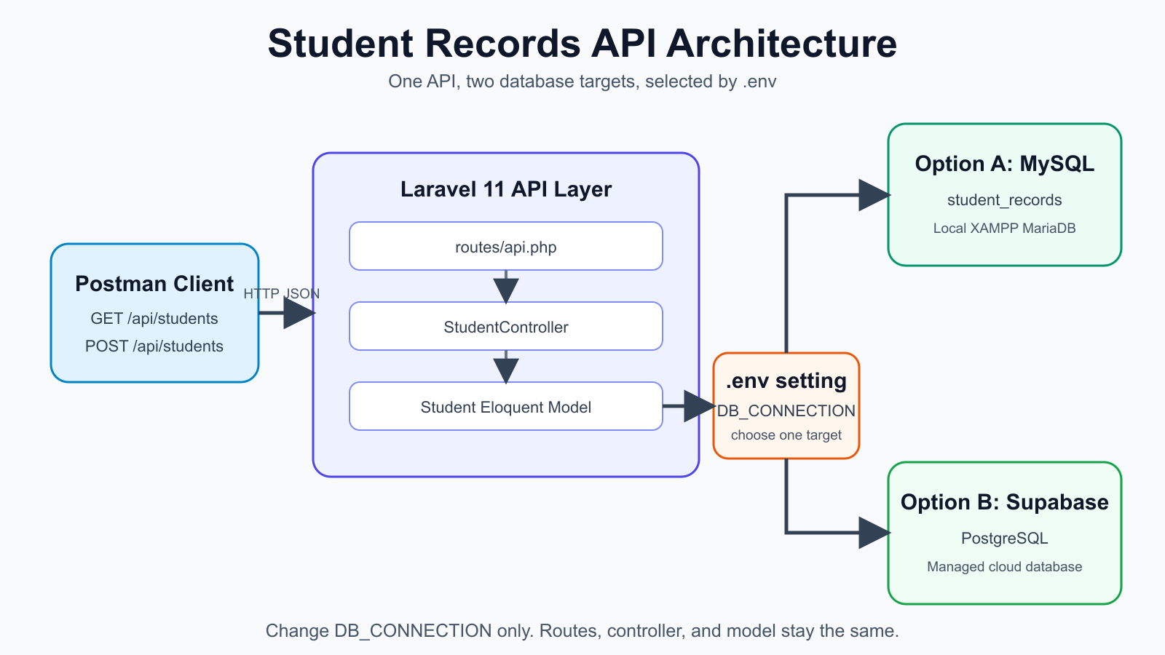
Postman communicates with a stable HTTP and JSON contract. Laravel routes requests to the controller, which uses the Student Eloquent model. Laravel reads the active database driver from .env, allowing MySQL and Supabase PostgreSQL to serve the same application code.

Conclusion and Reflection
The activity demonstrated that a database can change without rewriting the API contract. The GET and POST endpoints, validation rules, controller methods, routes, and Eloquent model worked with both database systems. The migration required only database configuration and the PostgreSQL driver, which confirms that the application logic was separated from storage details.
The main challenge was establishing a reliable PostgreSQL connection from a local IPv4 environment. The Supabase session pooler resolved the network limitation, while careful handling of the database password prevented configuration parsing errors. The result shows why environment-based configuration and an ORM reduce migration risk and keep client behavior consistent.

