## 专业英语

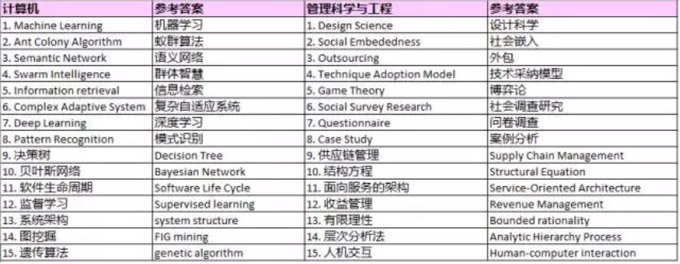

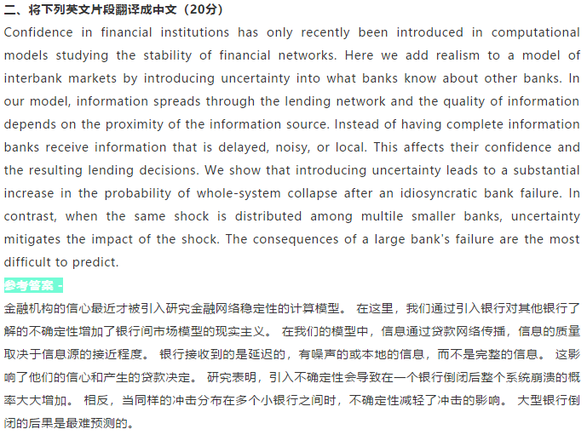

**三、选择一篇论文写中文的读书笔记（即阅读提纲）（25分）**

**选择文章：**

**MATRIX FACTORIZATION TECHNIQUES FOR RECOMMENDER SYSTEMS**

一些最成功的潜在因子模型的实现是基于矩阵分解的。

在其基本形式中，矩阵分解通过从项目评分模式推断的因素（factor）向量来表征项目和用户。

项目与用户因素之间的高度对应导致推荐。

近几年来，这些方法通过结合良好的可扩展性和预测准确性而变得流行起来。

另外，它们为建模各种现实生活情况提供了很大的灵活性。

**推荐系统依赖于不同类型的输入数据，这些输入数据通常放置在矩阵中，其中一维代表用户，而另一维代表感兴趣的项目。**

最方便的数据是高质量的显式反馈，其中包括用户对产品兴趣的明确输入。

我们将明确的用户反馈称为评分。

**通常，显式反馈包含一个稀疏矩阵，因为任何单个用户可能只有一小部分可能的项目。**

矩阵分解的一个优点是它允许并入额外的信息。

当显式反馈不可用时，推荐系统可以使用隐式反馈来推断用户偏好，其通过观察用户行为（包括购买历史，浏览历史，搜索模式甚至鼠标移动）来间接反映意见。

隐式反馈通常表示事件的存在或不存在，所以它通常由密集填充的矩阵表示。

使这些技术更加方便的是，模型可以自然地集成数据的许多关键方面，如多种形式的反馈、时间动态和置信水平

**四、结合所学专业，就自己感兴趣的问题，用英文写一个研究计划提纲（25分）**

**Research plan outline**

The Market Research Plan proposes a plan for conducting the study. It answers the following questions: What are the questions to be studied? How will this (or these) questions or research methods be

studied? It will be research when the research project is completed. What kind of results the client

provides and so on.

**1.Initial information of the research proposal Header page**

The title of the research topic, the client of the research, the executor of the research, the research time, etc. should all appear on the head page.

**2. Description letter**

This text message was written to the person in charge of the research client, stating the reason for

submitting the plan, the content of the plan and related matters.

**3. Summary**

The summary section provides a brief overview of the key elements of the research proposal, which allows the reader to quickly understand the basics of the proposal. The length of the summary is generally limited to 1-2 pages. Second, the text of the plan Background

**The background section** summarizes the environment, historical background, and background information

related to the topic in the company. 2, the definition of problems and opportunities

This section will define the marketing issues that led to the study or some of the opportunities that companies face. In many cases, figuring out the problem or the opportunity itself may be a topic. In

this section, it is often necessary to describe the collection of second-hand data, such as the source of second-hand information, literature review of existing data, etc., and a reference list is given

in the appendix of the plan.

**The purpose of the 3 topics**

This section sets out the purpose and research hypotheses of the research topic. Statements of research purposes and assumptions should be as clear as possible. Finally, list them one by one, and point

out which are the main purposes and which are the specific branch objectives or goals. Finally, it is also necessary to indicate what type of information will be collected to answer questions related to

each research goal and corresponding hypothesis. In some cases, examples of certain issues are also

given. The research objectives listed above must be linked to the subject matter of the study.

**4. Research methods**

Follow the outline below to give enough detail to the research method and give reasons for the chosen method:

(1) What type of research design is used: exploratory, descriptive, or causality research?

(2) What kind of second-hand information is used to help answer the research purpose or verify the

hypothetical question?

(3) What method is used to collect the original data?

————The definition of the target population

————Sample design method: Probability sampling or non-probability sampling:

————determination of sample composition;

————Data collection methods: qualitative research methods, survey methods (telephone

access/personal visit/mailing questionnaire access), observation methods, experimental methods

————Design of the questionnaire

--- Determination of data analysis methods, etc.

(4) What are the limitations of the subject?

**5. Organizational division of the research team**

Explain the organizational division of the research team and give a brief introduction to each member's knowledge background, experience and expertise.

**6. Project budget**

A detailed estimate of the cost and expense items for the entire project. The cost items include

travel expenses, data fees, consulting fees, computer use, printing, telephone, stamps, labor costs

and other parts.

**7. Research project of the subject**

This section presents a detailed research plan or schedule for the topic. This part of the content is usually the following outline of the research client's most concerned can be used as a reference for

the research project of the design topic.

The general process of the project is as follows: Phase I Feasibility Study Exploratory Study 1.

Definition of marketing problems 2. Research problem definition

3. The study plan and the completion of the plan

4. Study the client's decision to continue or discontinue the study The second stage of the questionnaire design

1 qualitative data requirements

2 quantitative data requirements

Phase III Sample Selection and Data Collection

1. Select the sample composition to identify potential investigations

2 The issuance and collection of the questionnaire, the implementation of the investigation

3, editing and finishing of materials

The fourth stage of data analysis and interpretation Analytical data

2. Explain the analyzed information and propose a plan or suggestion Phase V Preparation of the research report 1. Preparation of the report

2. Conduct written or oral reports

Phase VI Implementation and feedback

1. Help implement the plan based on the research results

2. Feedback, control, and modification of the implemented plan