In Class Practice Test - 1

Due Date: Week 6.

Purpose: The purpose of this practice test is to:
- Help you develop an interactive Android application using Kotlin, Jetpack Compose, Material Design 3, and MVVM architecture on Android 14.

References: Textbook, ppt slides. This material provides the necessary information that you need to complete the exercises.

Be sure to read the following general instructions carefully:
- This practice test must be completed individually by all the students.
- You will have to implement & demonstrate your solution in a scheduled lab session.

Exercise 1

In this exercise you will write a simple MyNotes app.
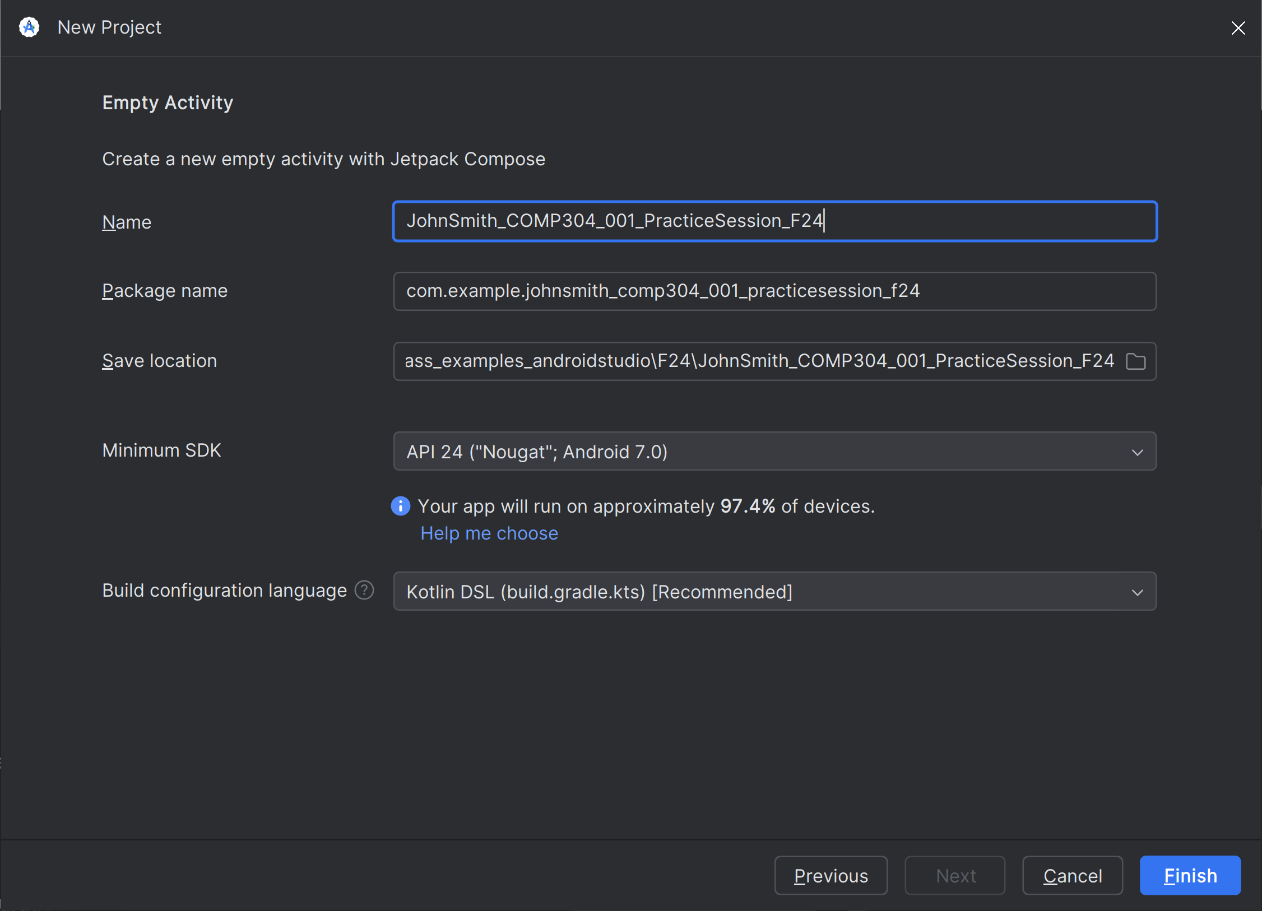

Step 1: Create a New Project
- Open Android Studio and select "New Project".
- Name the project following this format: YourFullName_COMP304_001_PracticeSession_F24.
  - Example: JohnSmith_COMP304_001_PracticeSession_F24
- Choose Empty Activity as the project template.
- Set the minSdkVersion to 24 and the targetSdkVersion to 34 (Android 14).
- Click Finish.

Step 2: Main Activity - Setting Up the UI
- Rename MainActivity to YourFirstNameActivity.kt file, for example JohnActivity.kt.
- Create a simple UI using Jetpack Compose:
  - Add a logo (Image) at the top.
  - Add an ImageButton below the logo, which navigates to the second activity on click.
  - Use a Column layout with vertical alignment for this UI structure.
- Here is the code of JohnActivity:
- // JohnActivity.kt
package com.example.johnsmith_comp304_001_practicesession_f24
import android.os.Bundle
import androidx.activity.ComponentActivity
import androidx.activity.compose.setContent
import androidx.compose.foundation.Image
import androidx.compose.foundation.layout.*
import androidx.compose.material3.*
import androidx.compose.runtime.Composable
import androidx.compose.ui.Alignment
import androidx.compose.ui.Modifier
import androidx.compose.ui.res.painterResource
import androidx.compose.ui.unit.dp
import androidx.navigation.NavHostController
import androidx.navigation.compose.NavHost
import androidx.navigation.compose.composable
import androidx.navigation.compose.rememberNavController
import com.example.johnsmith_comp304_001_practicesession_f24.SmithActivityContent
class JohnActivity : ComponentActivity() {
override fun onCreate(savedInstanceState: Bundle?) {
super.onCreate(savedInstanceState)
setContent {
MyNotesApp()
}
}
}
@Composable
fun MyNotesApp() {
val navController = rememberNavController()
NavHost(navController = navController, startDestination = "johnActivity") {
composable("johnActivity") {
JohnActivityContent {
navController.navigate("smithActivity")
}
}
composable("smithActivity") {
SmithActivityContent()
}
}
}
@Composable
fun JohnActivityContent(onNavigate: () -> Unit) {
Column(
modifier = Modifier
.fillMaxSize()
.padding(16.dp),
horizontalAlignment = Alignment.CenterHorizontally,
verticalArrangement = Arrangement.Center
) {
Image(
painter = painterResource(id = R.drawable.logo), // Replace with your logo image resource
contentDescription = "App Logo",
modifier = Modifier.size(128.dp)
)
Spacer(modifier = Modifier.height(16.dp))
Button(onClick = onNavigate) {
Text("Go to MyNotes")
}
}
}

Step 3: Creating the Second Activity (SmithActivity.kt)
- Add a New Kotlin File SmithActivity.kt
- // SmithActivity.kt
package com.example.johnsmith_comp304_001_practicesession_f24
import androidx.compose.foundation.layout.*
import androidx.compose.foundation.lazy.LazyColumn
import androidx.compose.foundation.text.BasicTextField
import androidx.compose.material3.*
import androidx.compose.runtime.*
import androidx.compose.ui.Modifier
import androidx.compose.ui.unit.dp
import androidx.lifecycle.viewmodel.compose.viewModel
@Composable
fun SmithActivityContent(notesViewModel: NotesViewModel = viewModel()) {
var title by remember { mutableStateOf("") }
var content by remember { mutableStateOf("") }
var priority by remember { mutableStateOf("Medium") }
val notes = notesViewModel.notes
Column(modifier = Modifier.padding(16.dp)) {
BasicTextField(
value = title,
onValueChange = { title = it },
modifier = Modifier
.fillMaxWidth()
.padding(8.dp),
decorationBox = { innerTextField ->
Box(modifier = Modifier.padding(8.dp)) {
if (title.isEmpty()) Text("Note Title")
innerTextField()
}
}
)
BasicTextField(
value = content,
onValueChange = { content = it },
modifier = Modifier
.fillMaxWidth()
.padding(8.dp),
decorationBox = { innerTextField ->
Box(modifier = Modifier.padding(8.dp)) {
if (content.isEmpty()) Text("Note Content")
innerTextField()
}
}
)
Spacer(modifier = Modifier.height(8.dp))
Text("Select Priority")
Row {
RadioButton(selected = (priority == "High"), onClick = { priority = "High" })
Text("High")
Spacer(modifier = Modifier.width(8.dp))
RadioButton(selected = (priority == "Medium"), onClick = { priority = "Medium" })
Text("Medium")
Spacer(modifier = Modifier.width(8.dp))
RadioButton(selected = (priority == "Low"), onClick = { priority = "Low" })
Text("Low")
}
Spacer(modifier = Modifier.height(16.dp))
Button(onClick = {
if (title.isNotEmpty() && content.isNotEmpty()) {
notesViewModel.addNote(Note(title, content, priority))
}
}) {
Text("Add Note")
}
Spacer(modifier = Modifier.height(16.dp))
LazyColumn {
items(notes.size) { index ->
Text("${notes[index].title}: ${notes[index].content} [${notes[index].priority}]")
}
}
}
}

Explanation
- SmithActivityContent handles the form for creating notes.
- The form includes text fields for the title and content, a radio button group for priority, and a button to add a note.
- Notes are displayed using a LazyColumn.

Step 4: Implementing the ViewModel (NotesViewModel.kt)
- Add a New Kotlin File NotesViewModel.kt
- // NotesViewModel.kt
package com.example.johnsmith_comp304_001_practicesession_f24
import androidx.compose.runtime.mutableStateListOf
import androidx.lifecycle.ViewModel
data class Note(
val title: String,
val content: String,
val priority: String
)
class NotesViewModel : ViewModel() {
private val _notes = mutableStateListOf<Note>()
val notes: List<Note> get() = _notes
fun addNote(note: Note) {
_notes.add(note)
}
}

Explanation
- NotesViewModel manages the list of notes using a mutable state list.
- addNote adds a new note to the list.

Step 5: Adding Resources
- Add Image Resources
  - Place a logo image (e.g., logo.png) and any other icons in the res/drawable directory.
  - Update the res/values/strings.xml for any string resources.
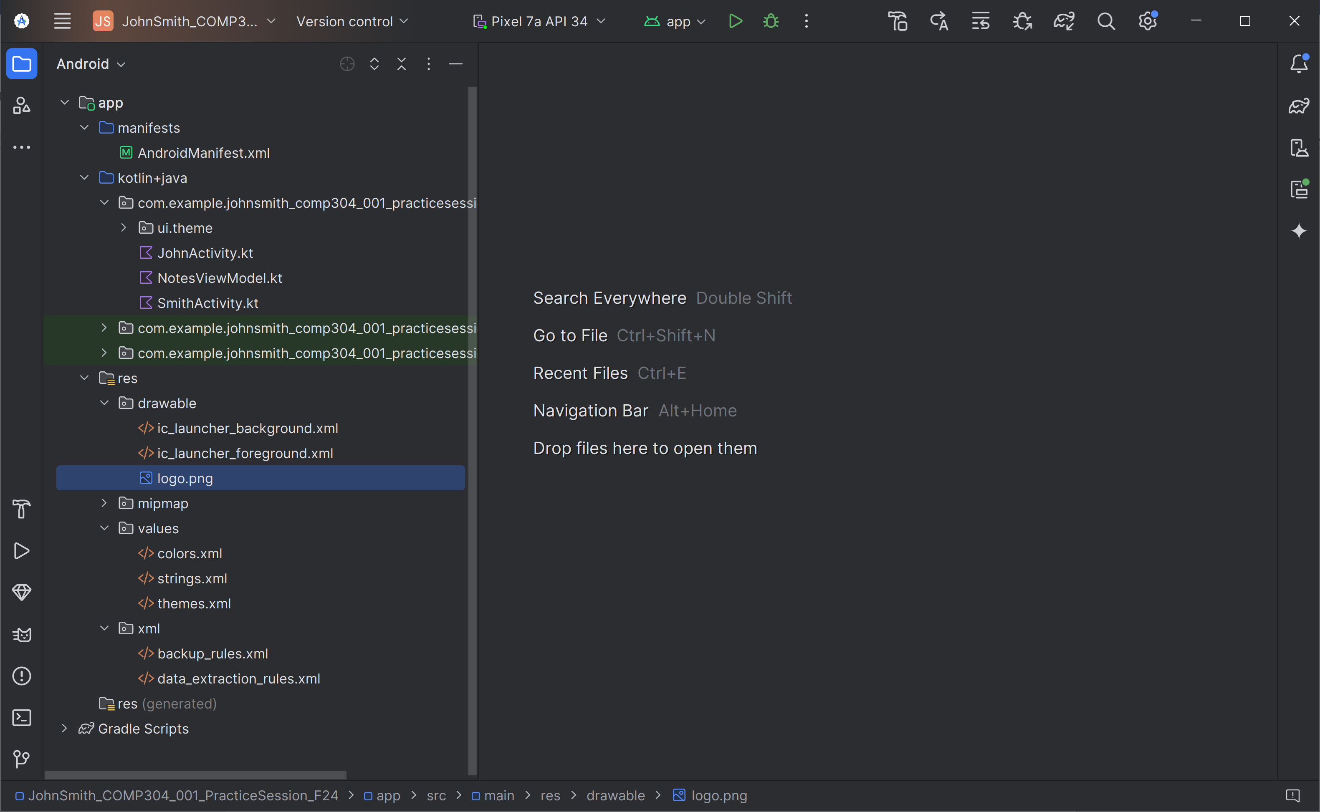

- Modify the Manifest (AndroidManifest.xml)
  - Ensure that the activities are declared correctly in the manifest.
- <?xml version="1.0" encoding="utf-8"?>
<manifest xmlns:android="http://schemas.android.com/apk/res/android"
xmlns:tools="http://schemas.android.com/tools">
<application
android:allowBackup="true"
android:dataExtractionRules="@xml/data_extraction_rules"
android:fullBackupContent="@xml/backup_rules"
android:icon="@mipmap/ic_launcher"
android:label="@string/app_name"
android:roundIcon="@mipmap/ic_launcher_round"
android:supportsRtl="true"
android:theme="@style/Theme.JohnSmith_COMP304_001_PracticeSession_F24"
tools:targetApi="31">
<activity
android:name=".JohnActivity"
android:exported="true"
android:label="@string/app_name"
android:theme="@style/Theme.JohnSmith_COMP304_001_PracticeSession_F24">
<intent-filter>
<action android:name="android.intent.action.MAIN" />
<category android:name="android.intent.category.LAUNCHER" />
</intent-filter>
</activity>
</application>
</manifest>

Step 6: Running the App
- Build and Run
  - Ensure all dependencies are installed.
Build.gradle.kts (app):
plugins {
alias(libs.plugins.android.application)
alias(libs.plugins.jetbrains.kotlin.android)
}
android {
namespace = "com.example.johnsmith_comp304_001_practicesession_f24"
compileSdk = 34
defaultConfig {
applicationId = "com.example.johnsmith_comp304_001_practicesession_f24"
minSdk = 24
targetSdk = 34
versionCode = 1
versionName = "1.0"
testInstrumentationRunner = "androidx.test.runner.AndroidJUnitRunner"
vectorDrawables {
useSupportLibrary = true
}
}
buildTypes {
release {
isMinifyEnabled = false
proguardFiles(
getDefaultProguardFile("proguard-android-optimize.txt"),
"proguard-rules.pro"
)
}
}
compileOptions {
sourceCompatibility = JavaVersion.VERSION_1_8
targetCompatibility = JavaVersion.VERSION_1_8
}
kotlinOptions {
jvmTarget = "1.8"
}
buildFeatures {
compose = true
}
composeOptions {
kotlinCompilerExtensionVersion = "1.5.1"
}
packaging {
resources {
excludes += "/META-INF/{AL2.0,LGPL2.1}"
}
}
}
dependencies {
implementation(libs.androidx.core.ktx)
implementation(libs.androidx.lifecycle.runtime.ktx)
implementation(libs.androidx.activity.compose)
implementation(platform(libs.androidx.compose.bom))
implementation(libs.androidx.ui)
implementation(libs.androidx.ui.graphics)
implementation(libs.androidx.ui.tooling.preview)
implementation(libs.androidx.material3)
implementation(libs.androidx.navigation.runtime.ktx)
implementation(libs.androidx.navigation.compose)
testImplementation(libs.junit)
androidTestImplementation(libs.androidx.junit)
androidTestImplementation(libs.androidx.espresso.core)
androidTestImplementation(platform(libs.androidx.compose.bom))
androidTestImplementation(libs.androidx.ui.test.junit4)
debugImplementation(libs.androidx.ui.tooling)
debugImplementation(libs.androidx.ui.test.manifest)
}

libs.versions.toml:
[versions]
agp = "8.5.0"
kotlin = "1.9.0"
coreKtx = "1.13.1"
junit = "4.13.2"
junitVersion = "1.2.1"
espressoCore = "3.6.1"
lifecycleRuntimeKtx = "2.8.3"
activityCompose = "1.9.0"
composeBom = "2024.04.01"
navigationRuntimeKtx = "2.8.2"
navigationCompose = "2.8.2"
[libraries]
androidx-core-ktx = { group = "androidx.core", name = "core-ktx", version.ref = "coreKtx" }
junit = { group = "junit", name = "junit", version.ref = "junit" }
androidx-junit = { group = "androidx.test.ext", name = "junit", version.ref = "junitVersion" }
androidx-espresso-core = { group = "androidx.test.espresso", name = "espresso-core", version.ref = "espressoCore" }
androidx-lifecycle-runtime-ktx = { group = "androidx.lifecycle", name = "lifecycle-runtime-ktx", version.ref = "lifecycleRuntimeKtx" }
androidx-activity-compose = { group = "androidx.activity", name = "activity-compose", version.ref = "activityCompose" }
androidx-compose-bom = { group = "androidx.compose", name = "compose-bom", version.ref = "composeBom" }
androidx-ui = { group = "androidx.compose.ui", name = "ui" }
androidx-ui-graphics = { group = "androidx.compose.ui", name = "ui-graphics" }
androidx-ui-tooling = { group = "androidx.compose.ui", name = "ui-tooling" }
androidx-ui-tooling-preview = { group = "androidx.compose.ui", name = "ui-tooling-preview" }
androidx-ui-test-manifest = { group = "androidx.compose.ui", name = "ui-test-manifest" }
androidx-ui-test-junit4 = { group = "androidx.compose.ui", name = "ui-test-junit4" }
androidx-material3 = { group = "androidx.compose.material3", name = "material3" }
androidx-navigation-runtime-ktx = { group = "androidx.navigation", name = "navigation-runtime-ktx", version.ref = "navigationRuntimeKtx" }
androidx-navigation-compose = { group = "androidx.navigation", name = "navigation-compose", version.ref = "navigationCompose" }
[plugins]
android-application = { id = "com.android.application", version.ref = "agp" }
jetbrains-kotlin-android = { id = "org.jetbrains.kotlin.android", version.ref = "kotlin" }

  - Test the app on an Android 14 emulator or physical device.
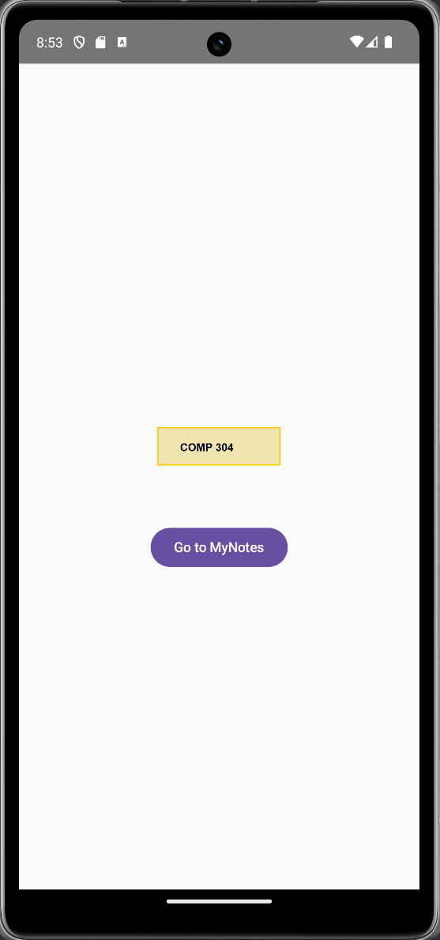 | 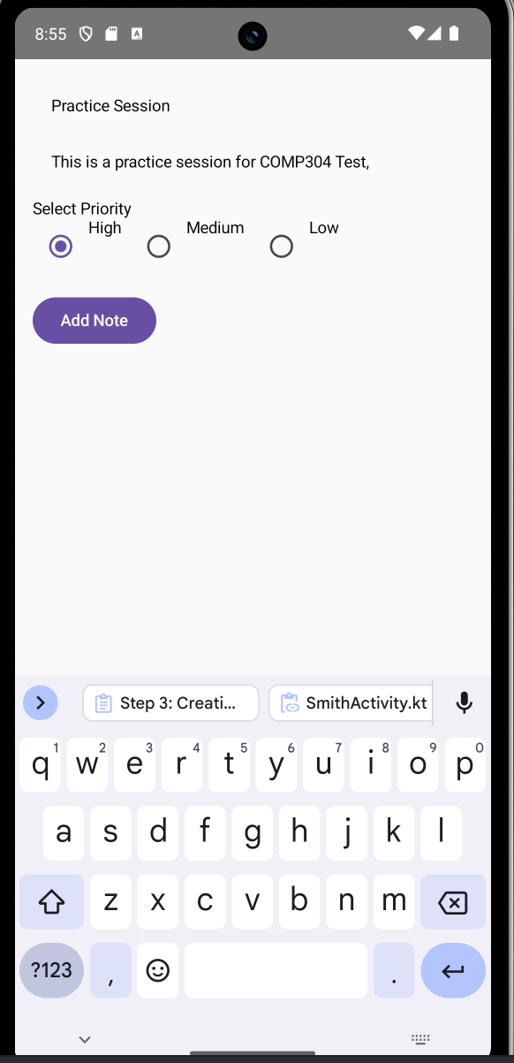 | 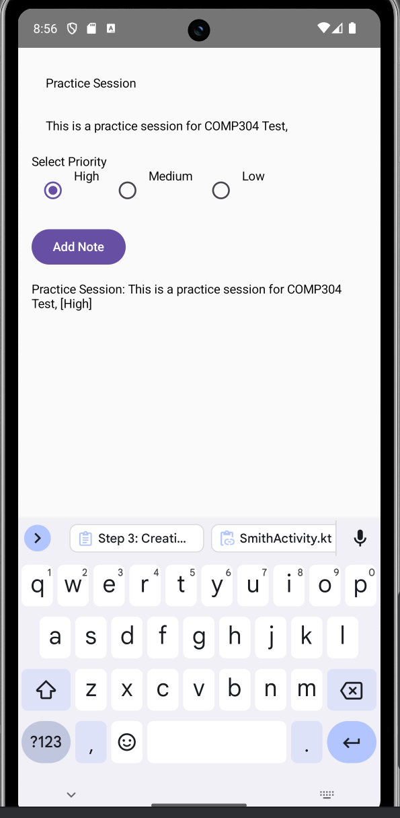

Easy eh!

