| Chomper Studios | | |
| --- | --- | --- |
| Tim Hortons | | |
| M/M/1 Queue System Simulation | | |
| All work Copyright © 2025 by Chomper Studios.  Written by  Christopher Rojas 301189137  Denisjann Reyes 301249768  Yiu Yiu Yoyo Ho 301256477  Version #01  March 04 2025 | | |

Table of Contents

**Name of Game**

**Design History 4**

Version 1.10 4

Version 2.00 4

Version 2.10 4

**Game Overview 5**

Philosophy 5

*Philosophical point #1 5*

*Philosophical point #2 5*

*Philosophical point #3 5*

Common Questions 5

*What is the game? 5*

*Why create this game? 5*

*Where does the game take place? 5*

*What do I control? 5*

*How many characters do I control? 5*

*What is the main focus? 5*

*What’s different? 5*

**Feature Set 6**

General Features 6

Multiplayer Features 6

Editor 6

Game play 6

**The Game World 7**

Overview 7

Story Layout 7

Travel & movement 7

Objects in the world 7

*Time mechanics 7*

Rendering System 7

*Overview 7*

*2D/3D Rendering 7*

Camera 7

*Overview 7*

Game Engine 8

*Overview 8*

*Game Engine Detail #1 8*

*Water 8*

*Collision Detection 8*

Lighting Models 8

*Overview 8*

*Lighting Model Detail #1 8*

*Lighting Model Detail #2 8*

**The World Layout 8**

Overview 11

World Layout Detail #1 8

World Layout Detail #2 8

**Game Characters 9**

Overview 9

**User Interface 9**

Overview 9

User Interface Detail #1 9

User Interface Detail #2 9

**Musical Scores and Sound Effects 9**

Overview 9

Red Book Audio 9

3D Sound 9

Sound Design 10

**Single Player Game 10**

Overview 10

Single Player Game Detail #1 10

Single Player Game Detail #2 10

Story 10

Hours of Game-play 10

Victory Conditions 10

**Character Rendering 11**

Overview 11

Character Rendering Detail #1 11

Character Rendering Detail #2 11

**World Editing 11**

Overview 11

World Editing Detail #1 11

World Editing Detail #2 11

**Extra Miscellaneous Stuff 11**

Overview 11

Junk I am working on… 11

**“Objects Appendix” 12**

**“User Interface Appendix” 14**

**“Character Rendering and Animation Appendix” 15**

**“Conclusion” 15**

# **Design History**

It is a simulation of Tim Hortons with opening hours from 08:00 to 16:00, where 6 hours are simulated in 1 minute.

## **Version 1.10**

Version 1.10 includes some tuning and tweaking that I did after making my initial pass at the design. Here is what I changed.

1. I rewrote the section about what systems the game runs on.
2. I incorporated feedback from the team into all parts of the design however no major changes were made.
3. Just keep listing your changes like this.

## **Version 2.00**

Version 2.00 is the first version of the design where a major revision has been made now that much more is known about the game. After many hours of design, many decisions have been made. Most of these large design decisions are now reflected in this document.

Included in the changes are:

1. Paring down of the design scope. (Scope, not design)
2. More detailed descriptions in many areas, specifically A, B and C.
3. Story details.
4. World layout and design.

## **Version 2.10**

Version 2.10 has several small changes over that of version 2.00. The key areas are in many of the appendixes.

Included in the changes are:

1. Minor revisions throughout the entire document.
2. Added “User Interface Appendix”.
3. Added “Game Object Properties Appendix”.
4. Added concept sketches for the world.

# **Game Overview**

## **Philosophy**

The purpose of this simulation is to model the customer queue system at a Tim Hortons location using real-world data. The simulation aims to analyze customer waiting times, service efficiency, and queue behavior under different conditions.

By using the M/M/1 queue model, this project provides valuable insights into the operational performance of Tim Hortons at Centennial College - C Building Marketplace. It also serves as an educational tool for understanding queueing theory in a real-world application.

## **Common Questions**

**What is the game?**

The game is a queue simulation of a Tim Hortons location, where customer behavior such as arrival, waiting in line, ordering, and departing is modeled in Unity.

**Why create this game?**

The project is designed to help analyze and optimize service times in a fast-food environment using real-world queue data and improve our understanding of queue dynamics.

**Where does the game take place?**

The simulation is based on Tim Hortons at Centennial College, which operates from 08:00 to 14:00 on weekdays.

**What do I control?**

The user observes and interacts with the queue system through UI elements. There are buttons to pause, show data, and exit.

**How many characters do I control?**

The player does not control individual customers but can interact with the simulation.

**What is the main focus?**

The goal is to simulate and analyze queue performance, customer waiting times, and system efficiency using real statistical models.

**What’s different?**

This simulation is data-driven and follows a scientific approach by applying queueing theory principles to a Unity-based environment.

# **Feature Set**

## **General Features**

* Real-time simulation of customer flow.
* M/M/1 queue model with real Tim Hortons data.
* 6 hours simulated in 1 minute for rapid analysis.
* Data-driven statistical representation of customer behavior.
* Dynamic queue system responding to customer arrival rates.
* Statistical data visualization with graphs.

## **Multiplayer Features**

* Currently a single-player simulation.
* Future expansion: Possible collaborative queue management where multiple players can manage different counters.
* Potential for cloud-based data sharing for comparative analysis.

## **Editor**

* Simulation settings adjustable in Unity’s Inspector.
* Future expansion: User-configurable parameters such as service rate, number of counters, customer arrival patterns.
* Data export functionality to compare multiple simulation runs.

## **Gameplay**

* Observe customer behavior in a fast-food queue.
* Adjust service efficiency by tweaking simulation parameters.
* Track key statistics like waiting times, queue length, and service rate.
* Visual feedback on how queue congestion affects customer flow.
* Interactive UI elements to pause, reset, and analyze data.

# **The Game World**

## **Overview**

The game world is a simplified representation of a Tim Hortons store focusing on the queueing process. The environment consists of a waiting line, a service counter, and customers moving through the system.

### **Store Layout**

* Entrance: Customers arrive and join the queue.
* Service Counter: Customers place orders and receive service.
* Exit: Customers leave after receiving their order.

### **Travel & Movement**

* Customers move in a linear fashion from entry to service counter and then to the exit.
* No free roaming – movement is determined by queue progression.

### **Objects in the World**

* Customers (represented as simple 3D models or sprites).
* Counters (Regular, Express, Mobile Order).
* Timers to track service duration and queue times.

### **Time Mechanics**

* 6 hours of real-world operation simulated in 1 minute.
* Time acceleration for rapid analysis.
* Dynamic time-dependent arrival rates based on real observation data.

## **Rendering System**

### **Overview:**

The simulation is built using a Unity-based rendering system. It features a 2D/3D hybrid view to present queue dynamics clearly, ensuring that customers and counters are easily distinguishable. The camera angle is fixed in a top-down or isometric perspective, allowing users to observe the entire queueing process. Players can move around using the mouse for better visualization.

* Unity-based rendering system.
* 2D/3D hybrid view to present queue dynamics clearly.
* Camera angle showing the queue from a top-down or isometric perspective using a mouse.

## **Camera**

* Default View: Top-down angle for queue observation.
* Zoom & Pan: Future feature for more interactive exploration.
* You can move around with the mouse.

## **Game Engine**

### **Overview**

The simulation is developed in Unity with C#. It is responsible for handling real-time queue calculations, ensuring that customer arrivals, waiting times, and service durations are dynamically managed based on statistical models. The system leverages exponential probability distributions to simulate customer behavior accurately.

* Developed in Unity with C#.
* Handles real-time queue calculations.
* Uses exponential probability distributions to simulate customer arrivals and service durations.

### **Collision Detection**

* Customers move in a predefined path (no complex physics needed).
* No collision detection required – customers follow a queue sequence.

## **Lighting Models**

#### **Lighting Model Detail #1**

We are using a flat shading technique to light our world for clarity and simplicity.

#### **Lighting Model Detail #2**

We won’t be implementing advanced lighting techniques since the focus is on queue simulation rather than visual fidelity.

# **The World Layout**

## **Overview**

The world layout consists of distinct areas that facilitate the queue simulation.Provide an overview here.

## **World Layout Detail #1**

The primary simulation environment is modeled after a real-world Tim Hortons store, ensuring accurate queue flow representation. Customers enter, join the queue, proceed to the counter, and then leave once they receive their orders.

## **World Layout Detail #2**

## Different counter types (Regular, Express, and Mobile Order) are integrated into the layout, allowing for multiple queue variations and service efficiencies to be analyzed.

# **Game Characters**

## **Overview**

The Game characters provides a more relatable and friendly experience to the simulation

* Customers are the primary entities.
* No customization – all customers follow predetermined queue behaviors.

# 

# 

# **User Interface**

## **Overview**

The user interface provides key information about queue simulation metrics and interactions.Provide some sort of an overview to your interface and same as all the previous sections, break down the components of the UI below.

## **User Interface Detail #1**

Displays critical statistics such as total customers, arrival time, waiting time, and service time for each customer in real time.

## **User Interface Detail #2**

Interactive controls allow users to pause, resume, and display specific customer details, aiding in data analysis.

# 

# **Musical Scores and Sound Effects**

## **Overview**

Sound plays an essential role in enhancing the realism and immersion of the Tim Hortons queue simulation. Various audio effects have been incorporated to create an authentic coffee shop environment.

## **Red Book Audio**

We are not using Red Book Audio for this simulation. Instead, we rely on high-quality pre-recorded ambient sounds and effects to enhance the simulation's realism.

## **3D Sound**

The simulation utilizes spatial audio processing in Unity to provide a dynamic and immersive sound environment. Sound effects are placed in a 3D space, ensuring realistic audio perception based on the player's camera position.

## **Sound Design**

To recreate the atmosphere of a busy Tim Hortons location, we have integrated the following audio effects:

1. voices-in-cafe-68787 – Background chatter that simulates a lively coffee shop environment.
2. door-open-close-45475 – A subtle door opening and closing sound when customers enter or leave the shop.
3. door-slam-172171 – A heavier door slam effect for dramatic impact in specific moments.
4. jazz-cafe-164940 – A smooth jazz background music track to enhance the cozy café ambiance.

These sounds are played in loops or triggered dynamically based on in-game events such as customer arrivals, departures, and queue movements. Future enhancements could include more varied audio cues, such as machine noises for coffee preparation or specific customer reactions.

# 

# **Single-Player Game**

## **Overview**

The single-player experience allows users to observe queue behavior in a controlled simulation. Users can pause, and analyze the impact of different queue conditions on customer waiting times and service efficiency.

## **Single Player Game Detail #1**

The simulation runs autonomously.

## **Single Player Game Detail #2**

Real-time data collection provides insights into queue performance, helping users identify bottlenecks.

## **Story**

The simulation does not follow a traditional narrative but is structured around queue efficiency analysis. Any story elements would be based on real-world queueing scenarios.

## **Hours of Gameplay**

Each simulation session runs for a short duration but can be repeated multiple times with different parameters. Users can experiment with queue variations for extended engagement.

## **Victory Conditions**

There are no traditional win/loss conditions. Success is measured by the effectiveness of queue management and the accuracy of simulation results.

# **Character Rendering**

## **Overview**

Characters in the simulation are represented as simplified 3D models or sprites, ensuring clear visual tracking within the queue system.

## **Character Rendering Detail #1**

Characters have minimal animation to reflect movement and queue progression.

## **Character Rendering Detail #2**

Visual distinctions exist between different customer types (Regular, Express, Mobile Order) for ease of analysis.

# **World Editing**

## **Overview**

The simulation includes an internal world editor to adjust store layouts and queue dynamics.

## **World Editing Detail #1**

Users can modify counter placements and adjust queue configurations to test different service efficiencies.

## **World Editing Detail #2**

The system supports future expansions that allow importing real-world store layouts for simulation.

# **Extra Miscellaneous Stuff**

## **Overview**

Additional features or concepts that may be explored in future iterations of the project.

## **Junk I am working on…**

**Crazy idea #1**

Implementing a heatmap visualization for peak queue times.

**Crazy idea #2**

Integrating a VR mode to observe queue management in an immersive environment.

### **Objects Appendix:**

Additional imported assets from the Unity Asset Store:

1. BGM: Background music used in the simulation.
2. Clock: UI element showing real-time updates.
3. Free Food - Breakfast Time: Asset used for food representation.
4. Simple Cafe: Environmental assets representing the café.
5. Tavern Interior by I.We.D: Used for structural and decorative elements.
6. Toony Tiny People: Character models representing customers and employees.

List of all objects used in the simulation:

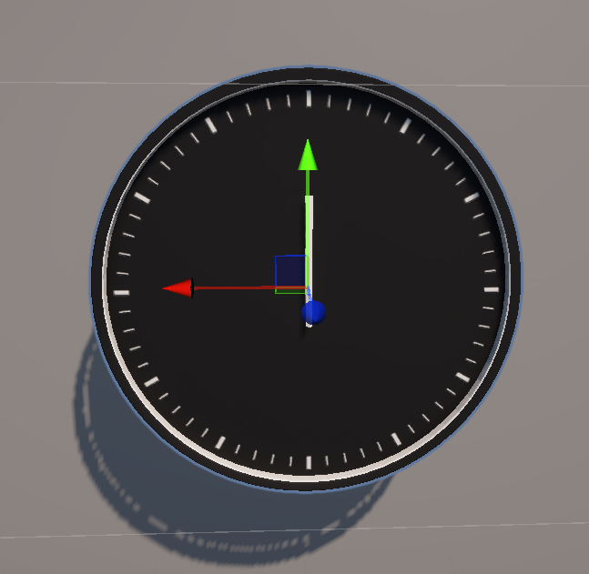 1. Clock: Representing the real time time in game

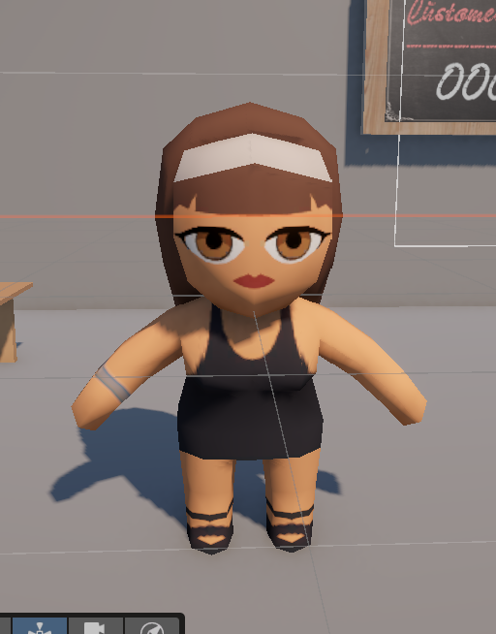 2. Waiter: character to represent the employees at Tim hortons

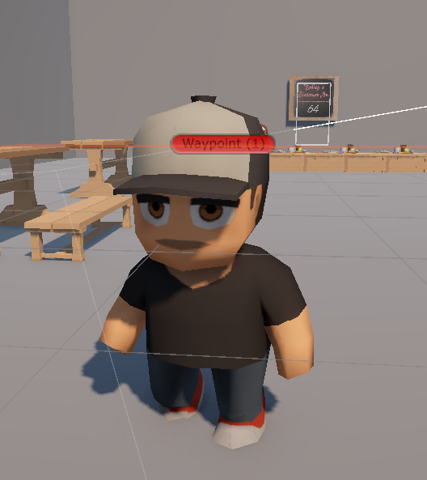 3. Customer: Representing the customer picking up order

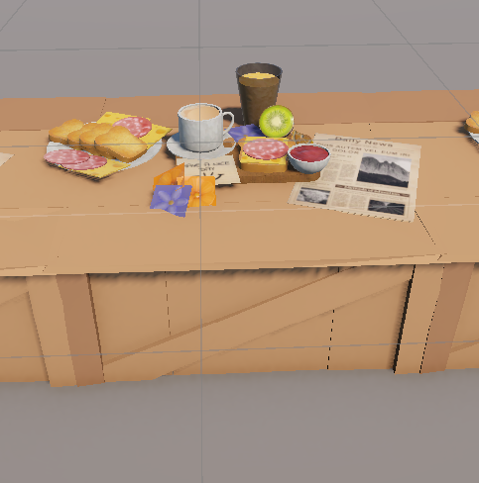 4. Bar/Counter: Representing the pick up area of the the order

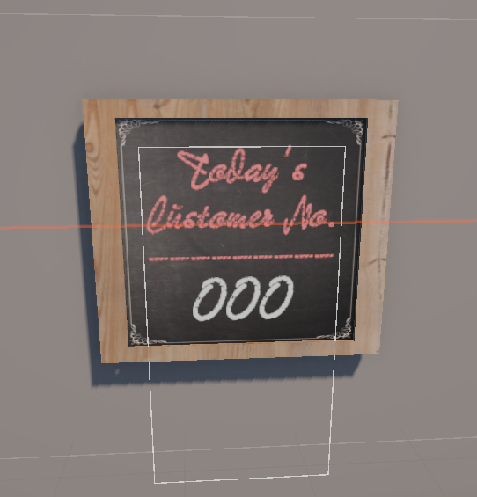 5. Customer count sign: Represents the real time countdown of the daily customers

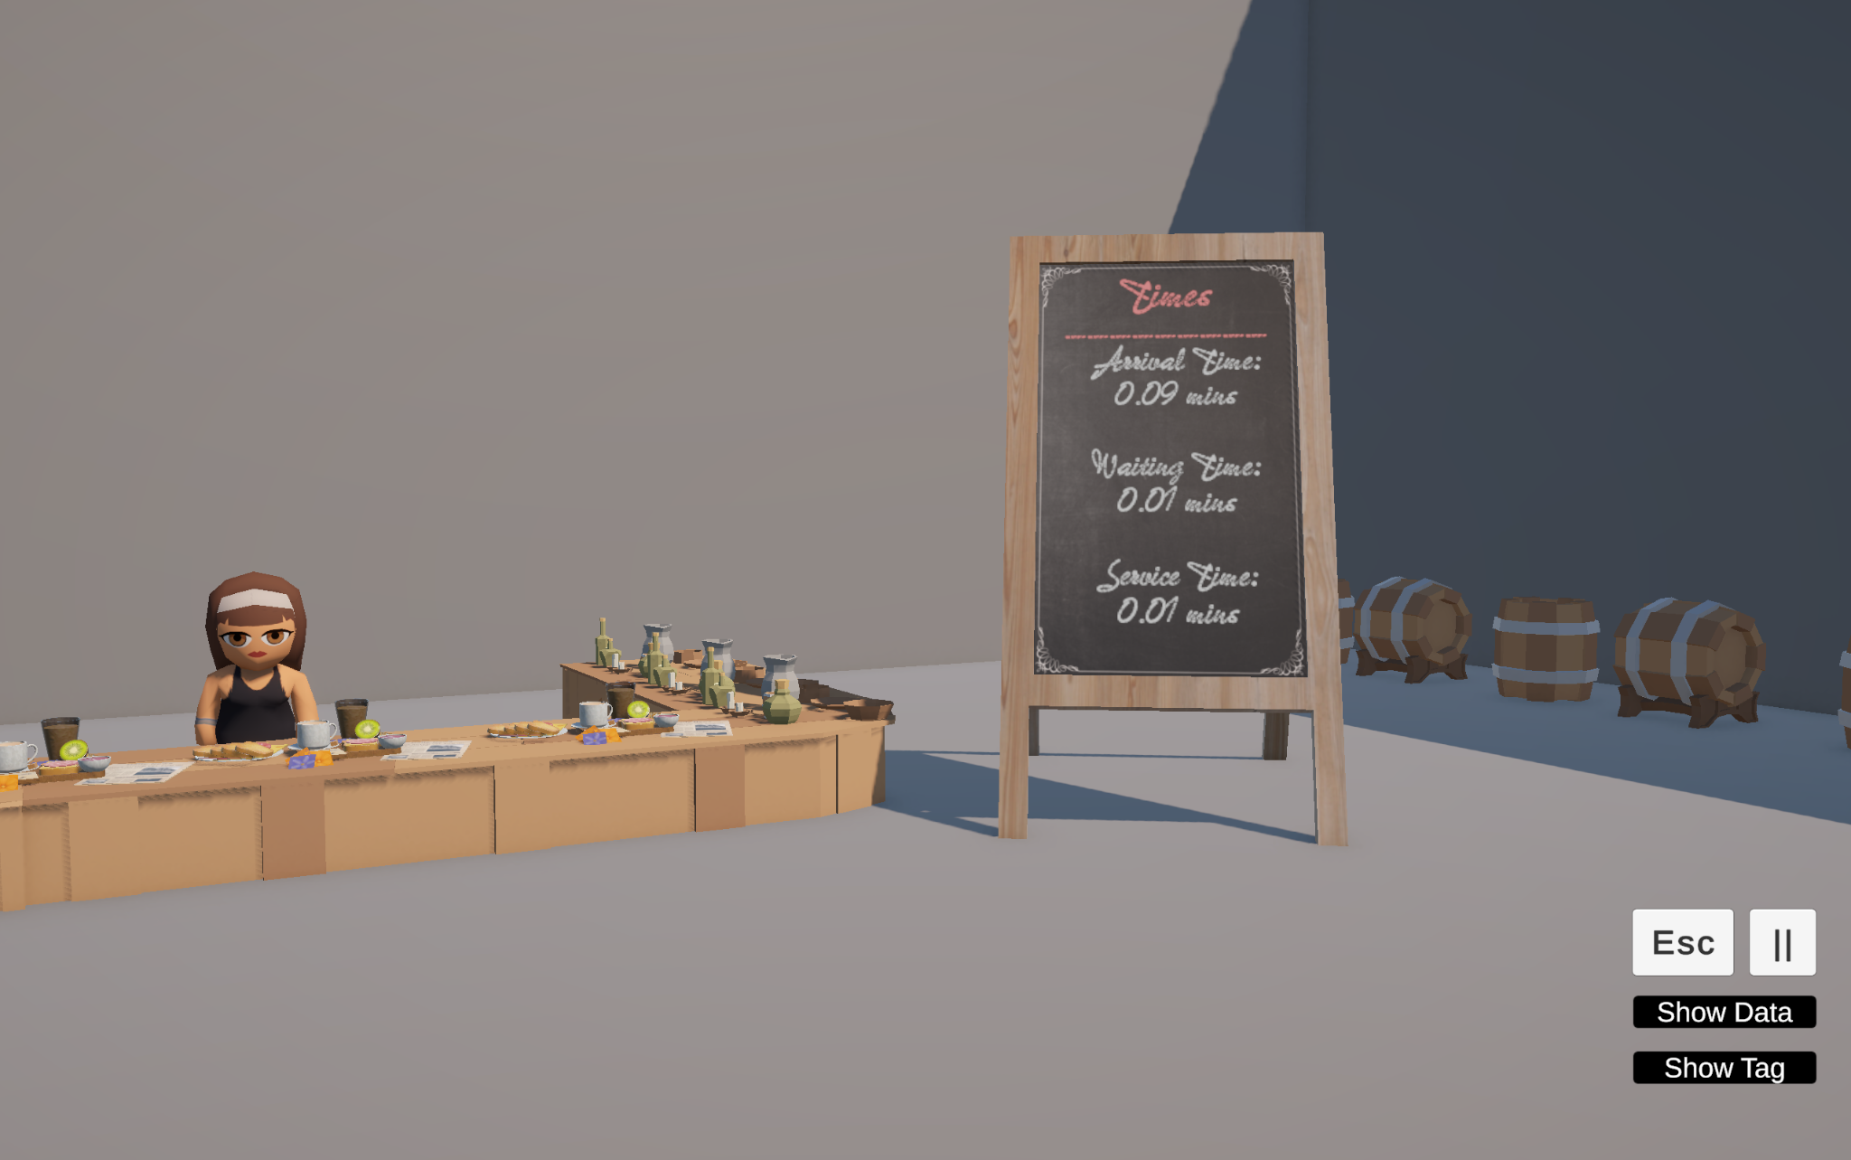 6. Customer time sign: representing waiting time per customer

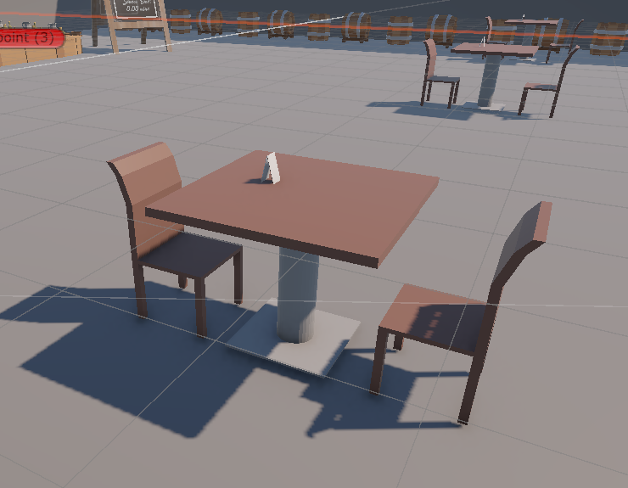 7. Customer tables: representing tables for customers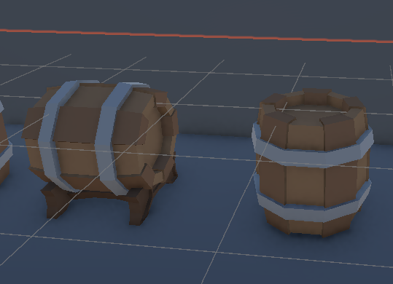 8. Supply barrels: Representing the supplies from the cafe

### **User Interface Appendix**

Detailed breakdown of the UI elements and their functionality.

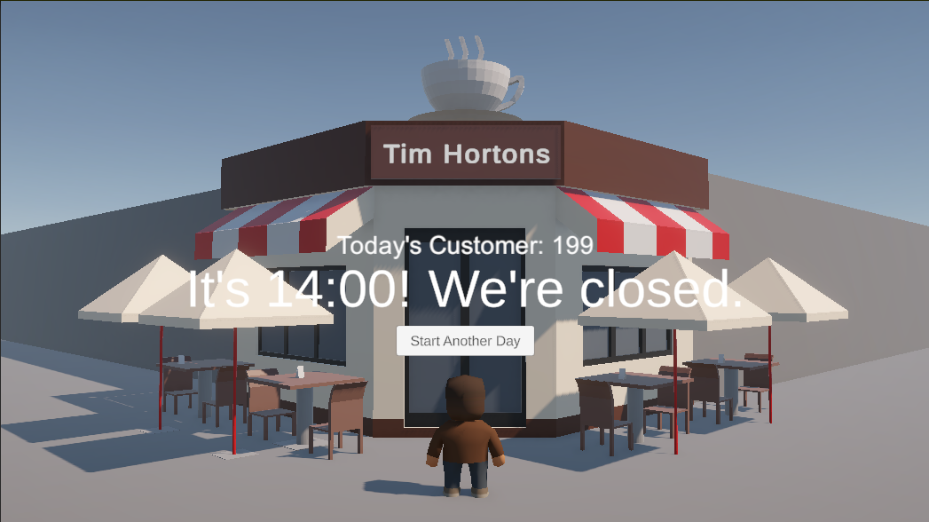 1. Ending Scene: Displays end of shift and total of customer

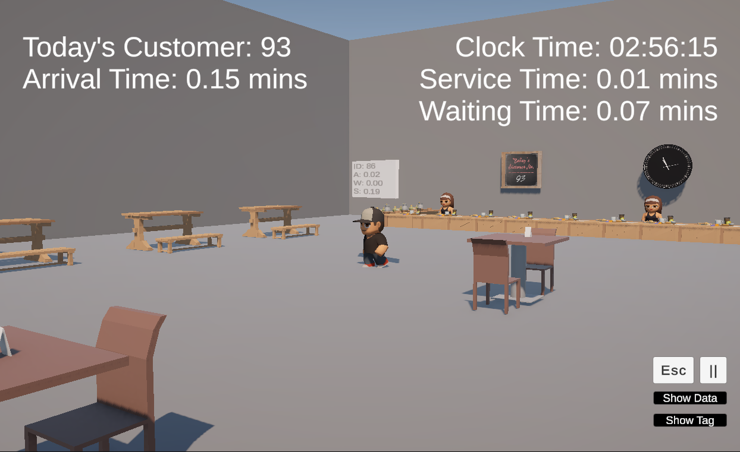 2. UI Simulation: Displays customers so far, the arrival time per customer, the current time, the service time and the waiting time to get the order

### 

### **Character Rendering and Animation Appendix**

Further details on customer visual representation and animation techniques.

1. Customer Animation diagrams: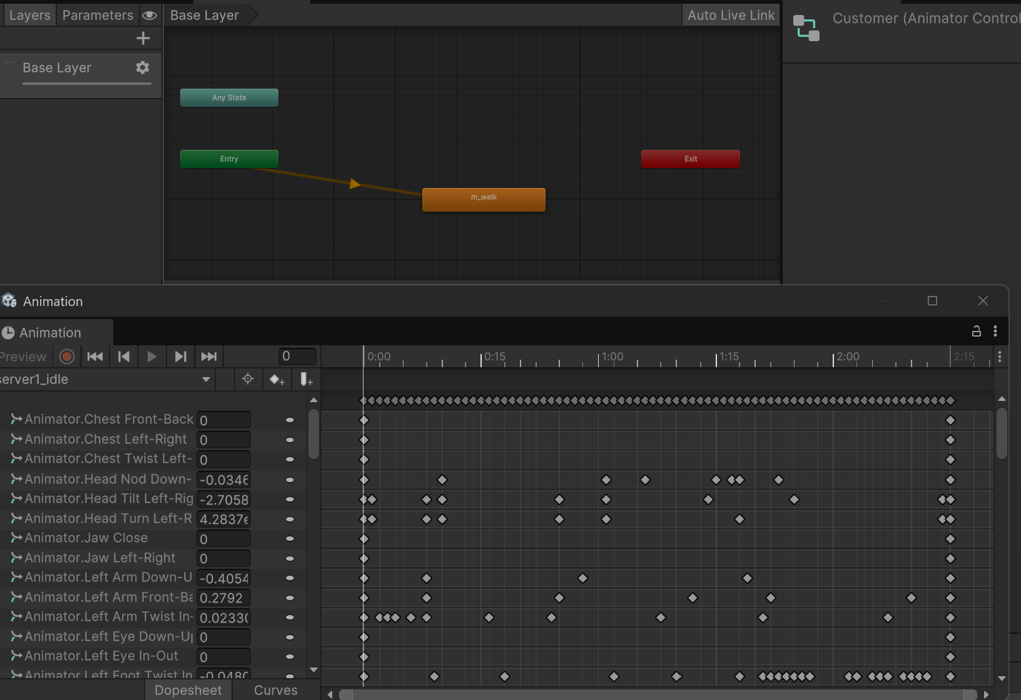
2. Customer Animation diagrams: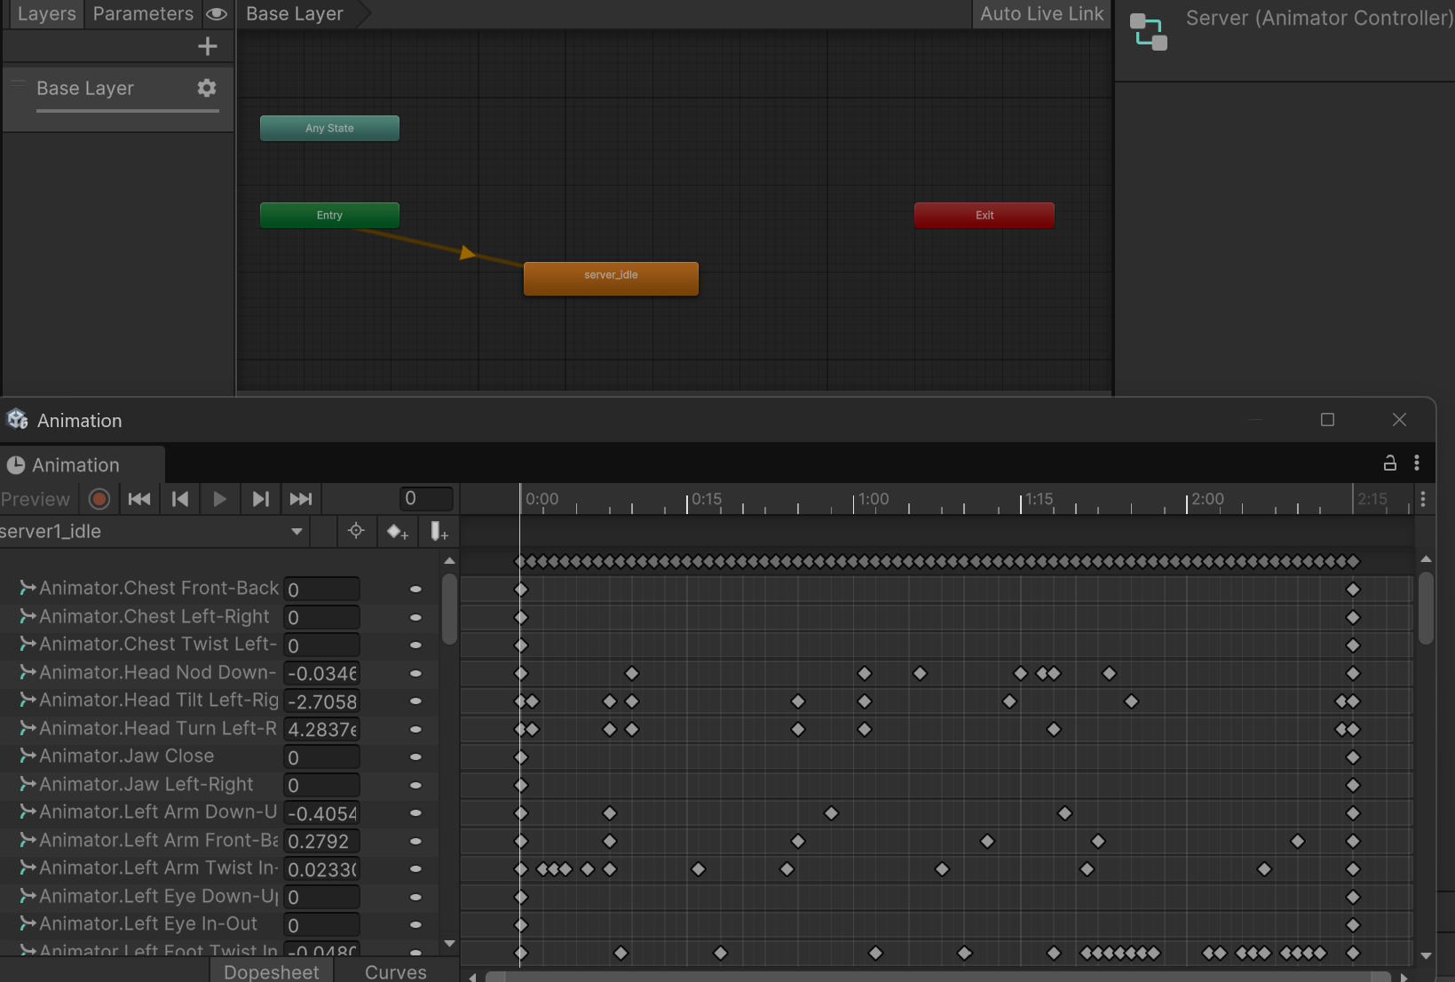

## **Conclusion**

This simulation provides a data-driven, research-based approach to analyzing queue efficiency at Tim Hortons using real-world data and queueing theory principles. With further refinements, this project can be expanded into a powerful educational and analytical tool.