Lab4 – COMP394-001 – Game Characters - Snapshots

Arben Tapia

Contents

Download, Install and Open MakeHuman: 1

Explore the settings: 2

Select at least clothes/hat/shoes: 2

In Pose/Animate tab select “Game Engine”: 3

# Download, Install and Open MakeHuman:

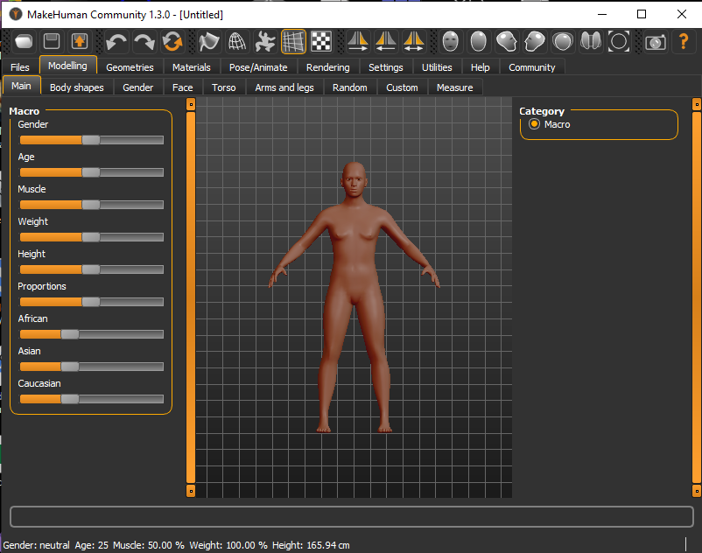

# Explore the settings:

## Select at least clothes/hat/shoes:

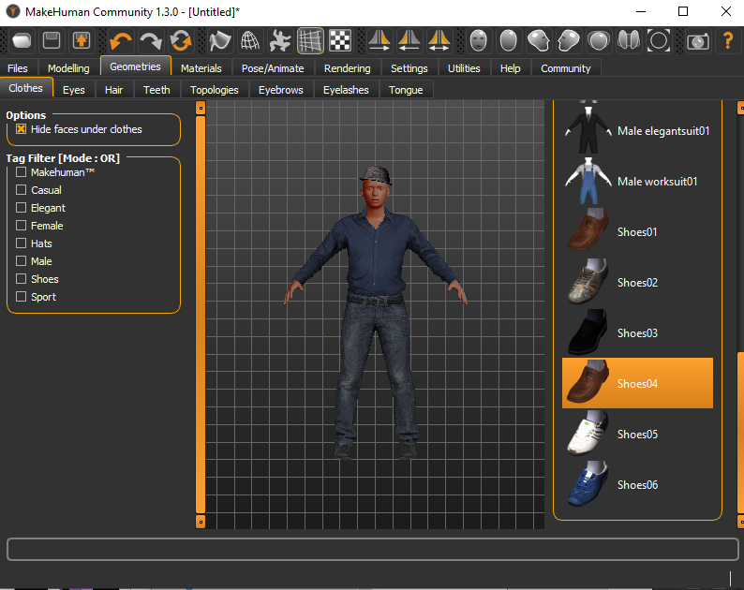

In “Settings”

## In Pose/Animate tab select “Game Engine”:

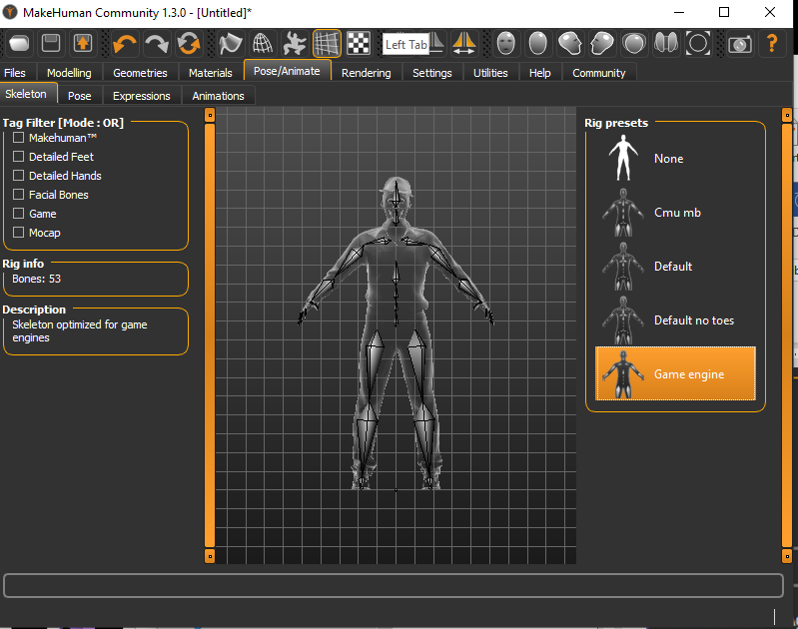

# In the “Settings” tab, select Units->Metric.

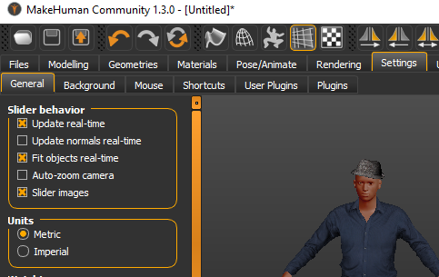

# Save as .fbx:

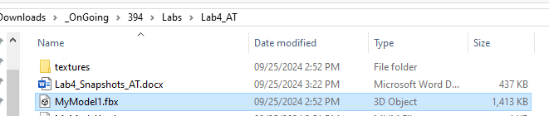

# Create a 3D Unity Project named **GameCharacters_{YourInitials}**:

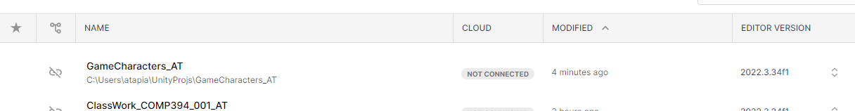

# Import the .fbx model:

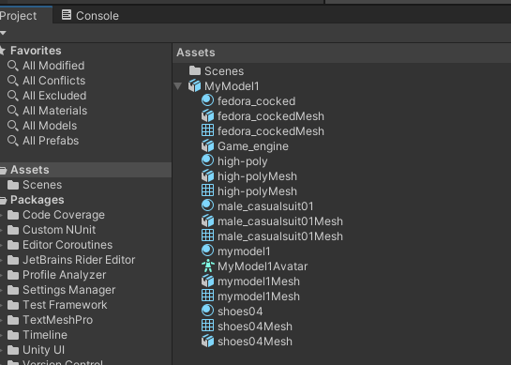

# Configure the .fbx model (Click on ‘Configure Avatar’):

## Select “Rig->Animation Type->Humanoid”, the “Apply”. The “Configure” button becomes available:

## 

## Click “Configure”; youll’see this:

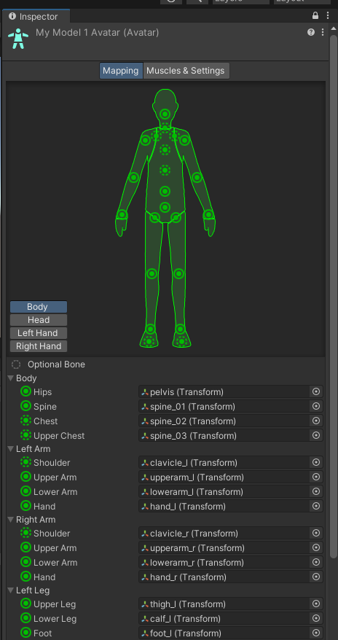

# Create a Plane, scale it (5,1,5):

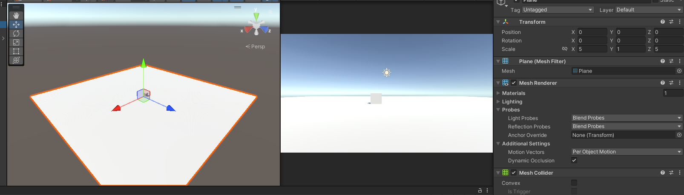

# Drop the model in the scene:

# Import the Character.unitypackage:

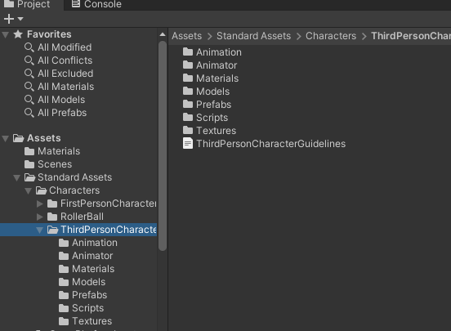

# Follow the ThirdPersonCharacterGuidelines:

