**Writeup**

Start server with: npm run dev

**What were some challenges you faced while making this app?**

Backend is easier than I thought but Frontend is harder than I thought. It really takes me long time to connect them together.

**Given more time, what additional features, functional or design changes would you make**

1. Everyone can modify or delete anyone's posts
2. Unable to stay logged in. If you click “Home” while logged in, you will return to the Home Page with guest status
3. No Deployed App Link, can only run local

> backend

> server.js

> line 14 const MONGO_URI = process.env.MONGO_URI || 'mongodb://127.0.0.1:27017/mydatabase';

Change this to your local IP address.

1. User Page cannot modify account yet. It can only be modified through the backend (Postman).

**What assumptions did you make while working on this assignment?**

I assume that people will know Type strings when they create accounts.

**How long did this assignment take to complete?**

About 3 days, but I didn’t meet all requirements.

Since in the frontend, it can’t change user’s name or password. I will put the evidence to prove it works in the backend.

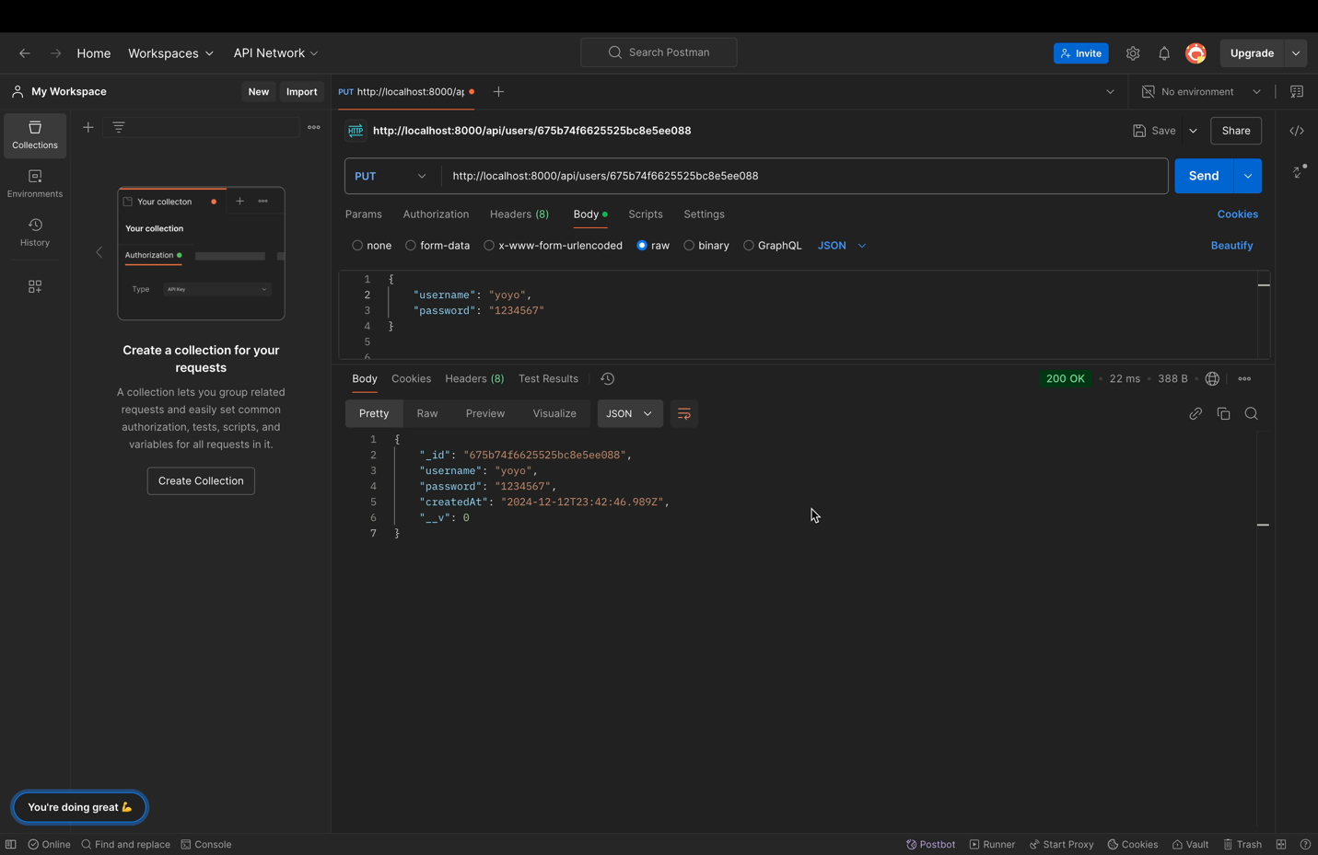Double click to start the video below:

Here is a video demo to show how this app looks like: