✅ Week 10 — Searching & Counting Algorithms
Theme: Basic algorithmic techniques for finding and counting

🎯 Learning Objectives
By the end of Week 10, students will be able to:
- ✅ Understand linear search and how to implement it
- ✅ Count occurrences of elements in a list or string
- ✅ Use iteration with conditions to analyze datasets
- ✅ Debug common logical errors in search/count algorithms
- ✅ Evaluate simple time complexity (O(n))

📘 Deep Concepts Explained

🔹 Linear Search
Definition: Sequentially check each element until the target is found.
Algorithm Steps:
- Input: list L and target x
- For each element in L, check if it equals x
- If found, return index or True
- If not found, return -1 or False
Real-world analogy: Searching for a book on a shelf by checking each one in order.

🔹 Python Implementation: Linear Search
def linear_search(lst, target):
for i in range(len(lst)):
if lst[i] == target:
return i
return -1
numbers = [5, 3, 8, 6, 7]
print("Index of 6:", linear_search(numbers, 6)) # Output: 3
print("Index of 10:", linear_search(numbers, 10)) # Output: -1

🔹 Counting Occurrences
Task: Count how many times an element appears.
numbers = [1,2,2,3,2,4,5]
count = 0
for num in numbers:
if num == 2:
count += 1
print("2 appears", count, "times")
Using dictionary for multiple elements:
words = ["apple", "banana", "apple", "cherry"]
freq = {}
for word in words:
if word in freq:
freq[word] += 1
else:
freq[word] = 1
print(freq) # {'apple': 2, 'banana': 1, 'cherry': 1}

🔹 Searching in Strings
text = "hello world"
target = "l"
count = 0
for char in text:
if char == target:
count += 1
print(f"'{target}' appears {count} times")

✅ Python Code Examples

Example 1 — Find First Even Number
numbers = [5,7,9,8,12]
for i, num in enumerate(numbers):
if num % 2 == 0:
print("First even number:", num)
break

Example 2 — Count Vowels
text = "programming is fun"
vowels = "aeiou"
count = 0
for char in text:
if char in vowels:
count += 1
print("Number of vowels:", count)

Example 3 — Frequency Dictionary
grades = [90,85,90,78,85,90]
freq = {}
for g in grades:
freq[g] = freq.get(g,0) + 1
print(freq) # {90: 3, 85: 2, 78: 1}

🖼️ Diagrams (Placeholders)
- 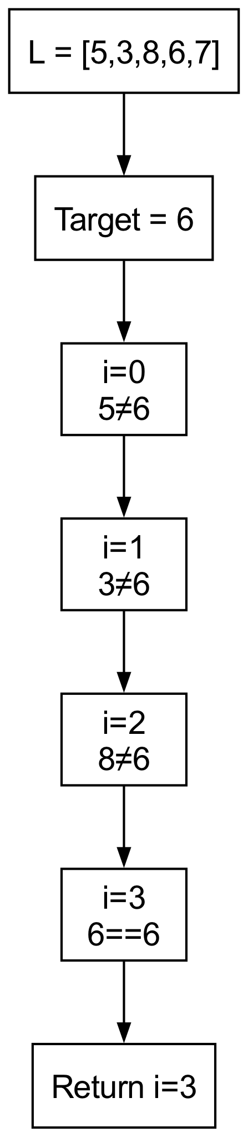
- Linear Search Flow
- 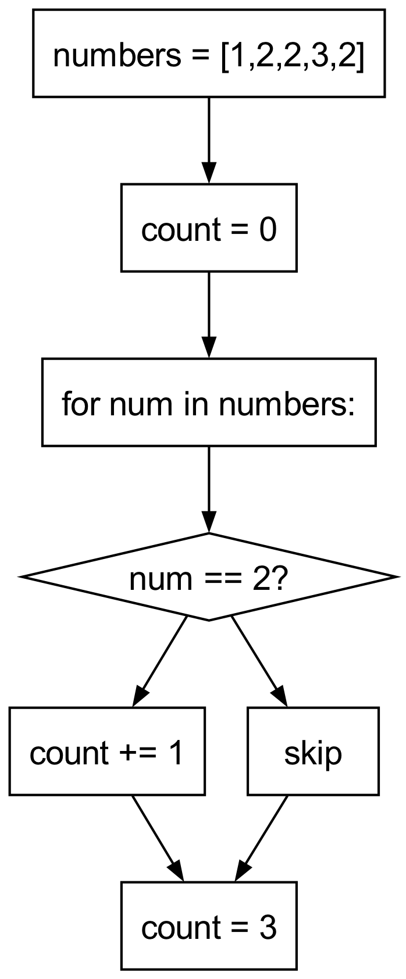
- Counting Elements Diagram
- 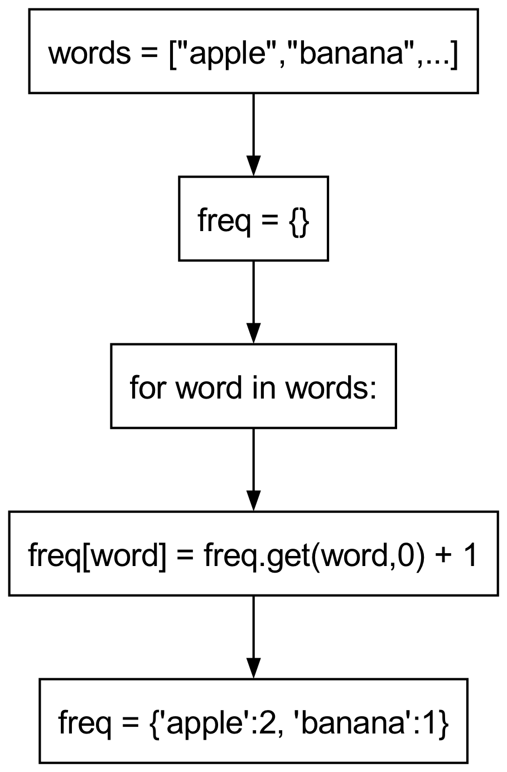
- Frequency Dictionary Flow

🏫 In-Class Exercises (3)
- Input a list of 10 numbers, find the index of number 7.
- Count how many odd numbers are in a list.
- Count the occurrence of each character in a string.

✅ Solutions
Exercise 1
numbers = [2,3,5,7,9,1,4,7,8,6]
def find_index(lst, target):
for i, num in enumerate(lst):
if num == target:
return i
return -1
print(find_index(numbers, 7)) # 3
Exercise 2
numbers = [1,2,3,4,5,6,7,8,9,10]
count = 0
for num in numbers:
if num % 2 != 0:
count += 1
print("Odd numbers:", count) # 5
Exercise 3
text = "hello world"
freq = {}
for char in text:
freq[char] = freq.get(char,0) + 1
print(freq)

🏠 Take-Home Assignments (3)
- Input a list of N integers, find the smallest and largest number.
- Count number of words in a sentence that start with a vowel.
- Count frequency of each digit in a string of numbers.

📚 References
- Think Python — Chapters 4–6: Loops & Conditionals
- Problem Solving with Algorithms and Data Structures — Linear Search Chapter

⚠️ Common Mistakes & Best Practices
Mistake | Solution
Forgetting break when found | Use break to stop search once found
Counting incorrectly | Initialize counter before loop
Overwriting dictionary | Use get() or check existence
Searching wrong type | Ensure consistent data types

🔮 Next Week Preview
Week 11 — Introduction to Algorithm Efficiency & Big O
- Time complexity concepts
- Constant, linear, quadratic examples
- Compare loop structures
- Practice evaluating efficiency
- Simple optimizations

