✅ Week 12 — Mini Project: Search & Counting Application
Theme: Applying sequences, search, counting, and exception handling

🎯 Learning Objectives
By the end of Week 12, students will be able to:
- ✅ Design a small project integrating lists, dictionaries, and loops
- ✅ Implement linear search and counting algorithms
- ✅ Handle user input and runtime exceptions
- ✅ Debug and test their program effectively
- ✅ Apply basic optimization to improve performance

📘 Deep Concepts Explained

🔹 Project Overview
Project Idea: Build a “Student Grades Analyzer” that:
- Stores students’ names and grades
- Allows searching for a student by name
- Counts how many students have grades above a threshold
- Displays statistics (highest, lowest, average)
Steps to approach project:
- Plan input/output
- Decide data structure (list of dictionaries)
- Implement functions:
  - Add student
  - Search student
  - Count above threshold
  - Calculate statistics
- Test with sample data
- Handle exceptions (invalid input, missing data)

✅ Python Code Example — Complete Mini Project
# Student Grades Analyzer
students = []
def add_student(name, grade):
students.append({"name": name, "grade": grade})
def search_student(name):
for student in students:
if student["name"].lower() == name.lower():
return student
return None
def count_above(threshold):
count = 0
for student in students:
if student["grade"] > threshold:
count += 1
return count
def statistics():
if not students:
return None
grades = [s["grade"] for s in students]
return {
"max": max(grades),
"min": min(grades),
"average": sum(grades)/len(grades)
}
# Sample data
add_student("Alice", 90)
add_student("Bob", 75)
add_student("Charlie", 85)
# User interaction
try:
name = input("Enter student name to search: ")
result = search_student(name)
if result:
print(f"{result['name']} → {result['grade']}")
else:
print("Student not found.")
except Exception as e:
print("Error:", e)
print("Students with grade > 80:", count_above(80))
stats = statistics()
print("Statistics:", stats)

🖼️ Diagrams (Placeholders)
- 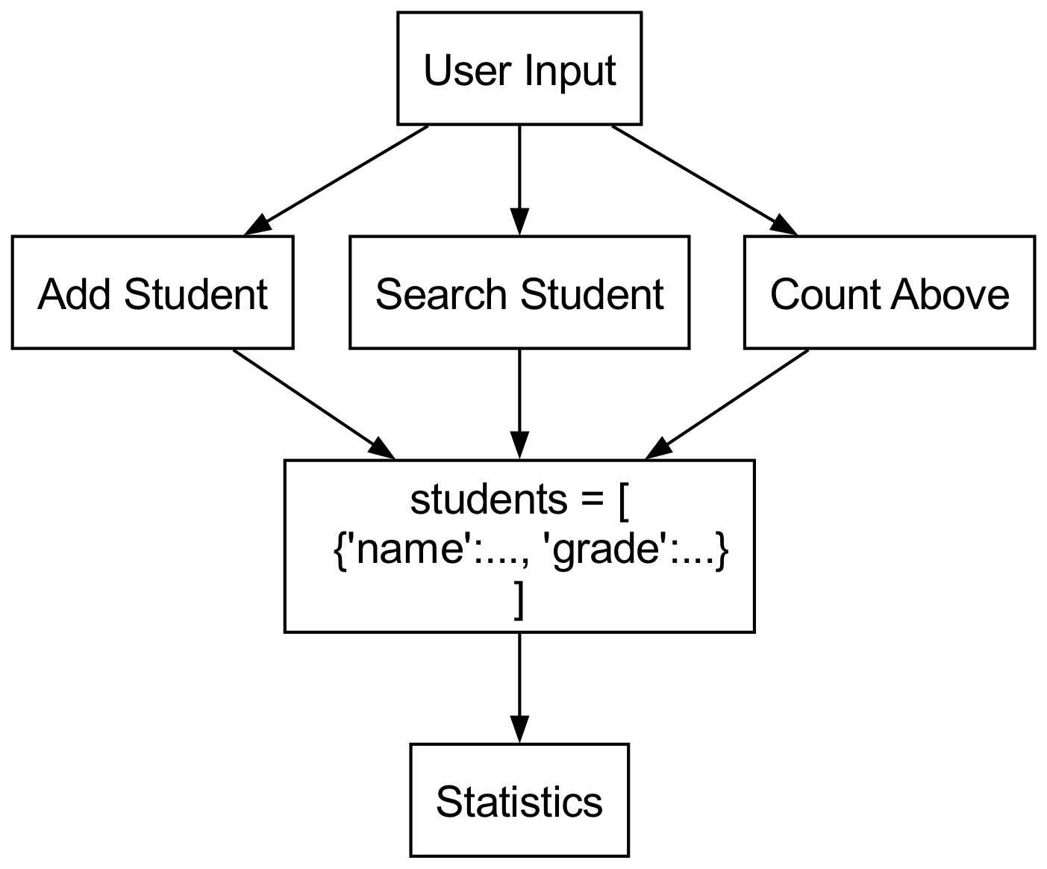
- Project Data Flow
- 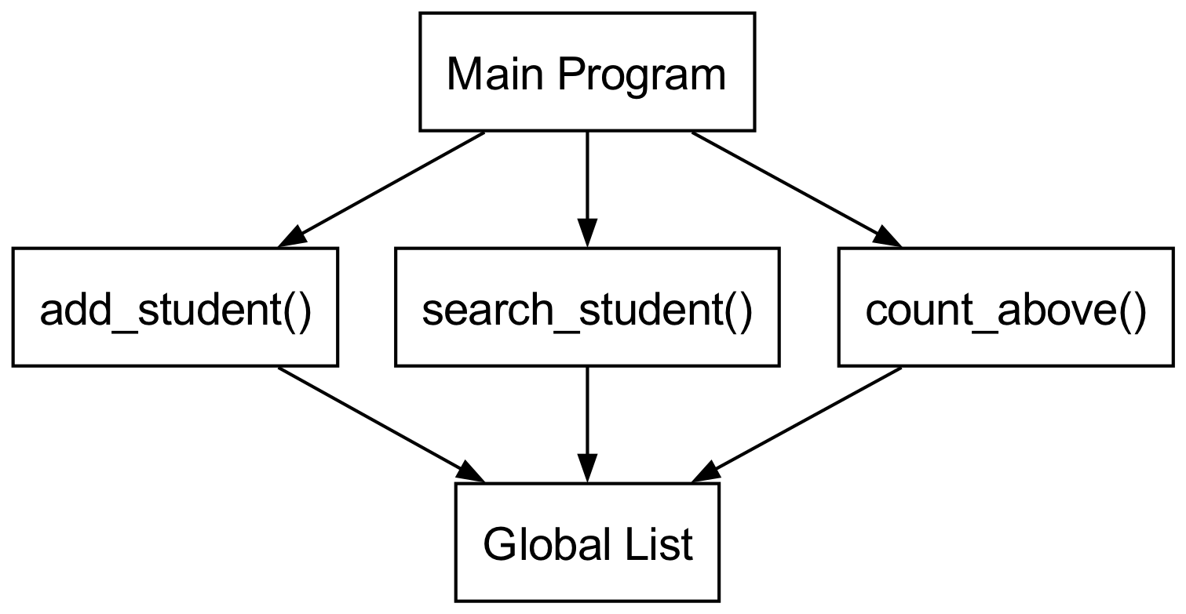
- Function Interaction Diagram
- 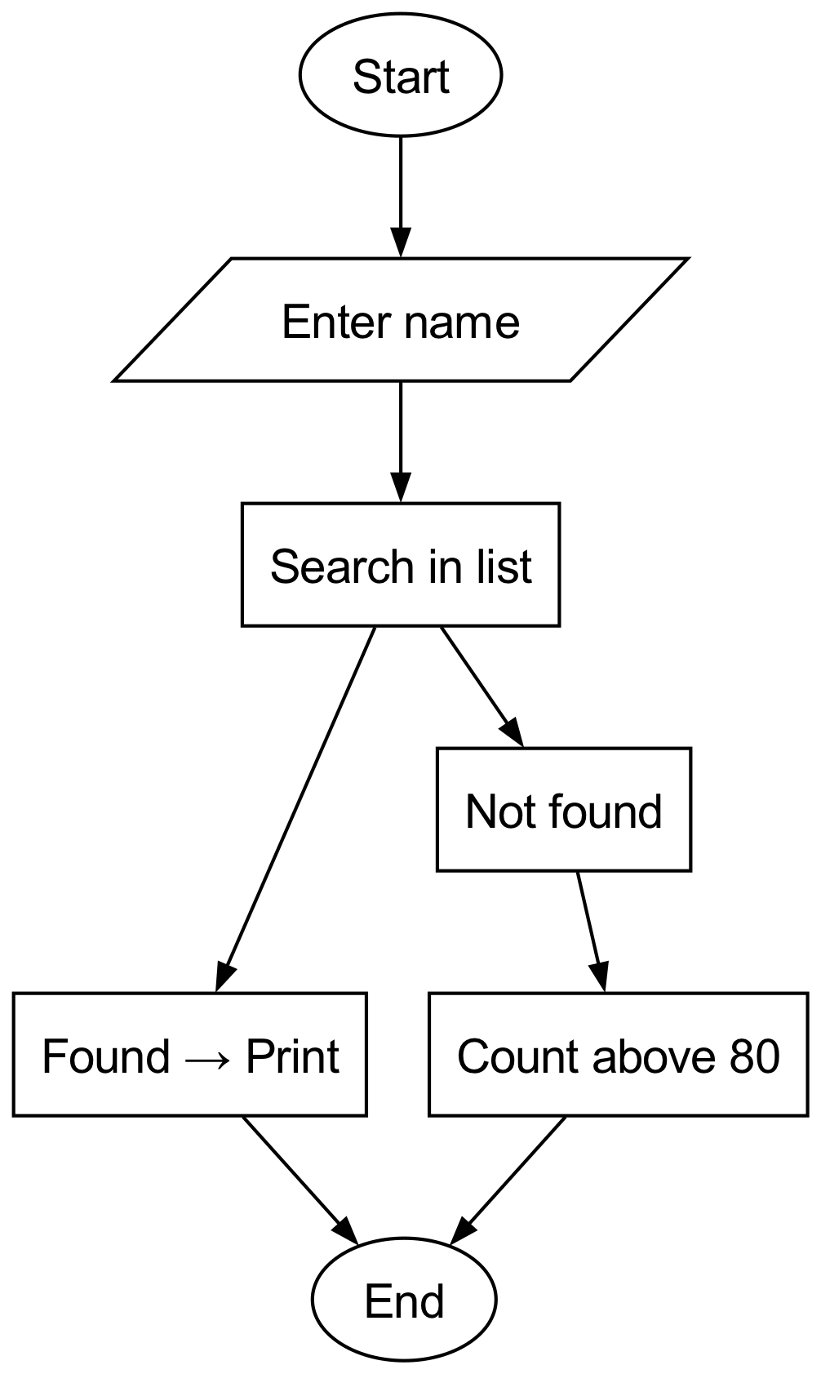
- Search & Count Flow

🏫 In-Class Exercises (3)
- Add 2 more students and test search function.
- Modify count_above() to accept user input threshold.
- Print the names of students with grades above the threshold.

✅ Solutions
Exercise 1
add_student("David", 92)
add_student("Eva", 88)
print(search_student("David")) # {'name': 'David', 'grade': 92}
Exercise 2
threshold = int(input("Enter grade threshold: "))
print("Count above threshold:", count_above(threshold))
Exercise 3
threshold = int(input("Enter grade threshold: "))
print("Students above threshold:")
for student in students:
if student["grade"] > threshold:
print(student["name"])

🏠 Take-Home Assignments (3)
- Extend project to allow deleting a student by name.
- Modify project to read student data from a CSV file.
- Implement a function to sort students by grade descending.

📚 References
- Think Python — Chapters 4–8
- Python Docs: https://docs.python.org/3/tutorial/datastructures.html

⚠️ Common Mistakes & Best Practices
Mistake | Solution
Not handling empty lists | Always check before processing
Case-sensitive search | Use .lower() for comparison
Redundant loops | Optimize with dictionary if frequent searches
Invalid user input | Use try/except for safety

🔮 Next Week Preview
Week 13 — Functions Recap & Advanced Problem Solving
- Modular programming review
- Functions with return values and parameters
- Recursive functions introduction
- Applying recursion to simple problems
- Debugging complex function calls

