✅ Week 13 — Functions Recap & Advanced Problem Solving
Theme: Modular programming, function design, and recursion introduction

🎯 Learning Objectives
By the end of Week 13, students will be able to:
- ✅ Understand the importance of functions for modular code
- ✅ Define functions with parameters and return values
- ✅ Call functions and pass data effectively
- ✅ Apply recursion to solve simple problems
- ✅ Debug multi-function programs

📘 Deep Concepts Explained

🔹 Why Use Functions?
- Functions modularize code → easier to read, test, reuse
- Avoid code repetition → DRY principle (Don’t Repeat Yourself)
- Allow logical separation → main program remains clean
Real-world analogy:
- Function = machine in factory → input raw material, process, output product

🔹 Function Syntax
def function_name(parameters):
"""
Optional docstring explaining function
"""
# function body
return result # optional
Example: Simple Sum Function
def add(a, b):
return a + b
result = add(5, 3)
print(result) # 8

🔹 Parameters vs Arguments
- Parameter: variable in function definition
- Argument: actual value passed when calling
def greet(name): # name = parameter
print(f"Hello, {name}!")
greet("Alice") # "Alice" = argument

🔹 Recursion Introduction
Definition: A function that calls itself to solve smaller instances of the same problem
Important Rules:
- Must have base case → stop recursion
- Must move toward base case
Example: Factorial
def factorial(n):
if n == 0:
return 1 # base case
else:
return n * factorial(n-1) # recursive call
print(factorial(5)) # 120
Visual intuition:
- factorial(5) → 5 * factorial(4) → 54factorial(3) → … → 1

🔹 When to Use Recursion
- Solving divide-and-conquer problems
- Tree/graph traversal
- Problems naturally defined recursively (factorial, Fibonacci)
Warning: Too deep recursion → stack overflow

✅ Python Code Examples

Example 1 — Function with Multiple Parameters
def calculate_average(a, b, c):
return (a + b + c) / 3
avg = calculate_average(80, 90, 85)
print("Average:", avg)

Example 2 — Recursive Fibonacci
def fibonacci(n):
if n <= 1:
return n
else:
return fibonacci(n-1) + fibonacci(n-2)
print([fibonacci(i) for i in range(10)]) # first 10 Fibonacci numbers

Example 3 — Modular Project Functions
def add_student(students, name, grade):
students.append({"name": name, "grade": grade})
def search_student(students, name):
for s in students:
if s["name"] == name:
return s
return None
students_list = []
add_student(students_list, "Alice", 90)
print(search_student(students_list, "Alice"))

🖼️ Diagrams (Placeholders)
- 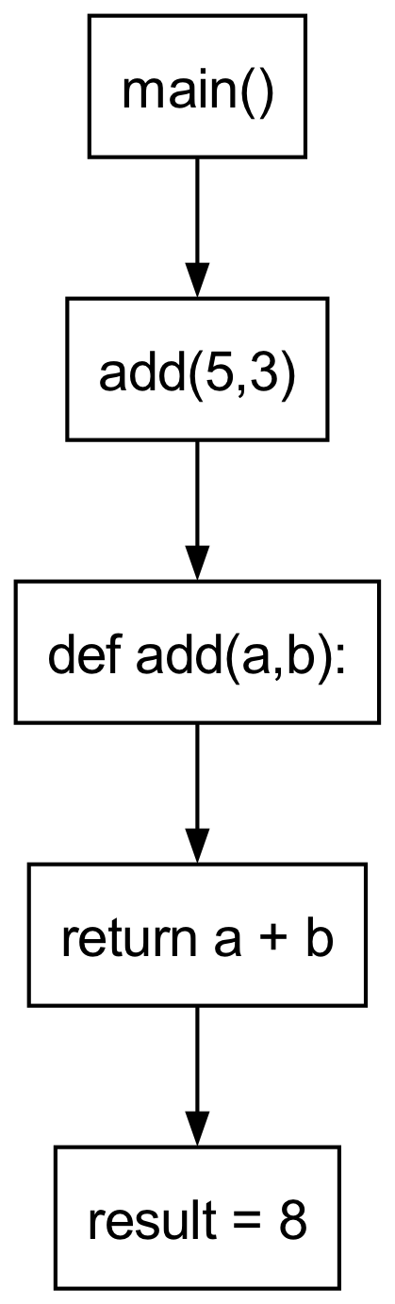
- Function Call Flow
- 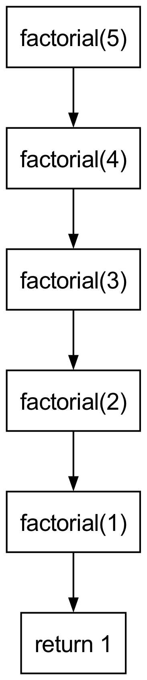
- Recursive Function Flow
- 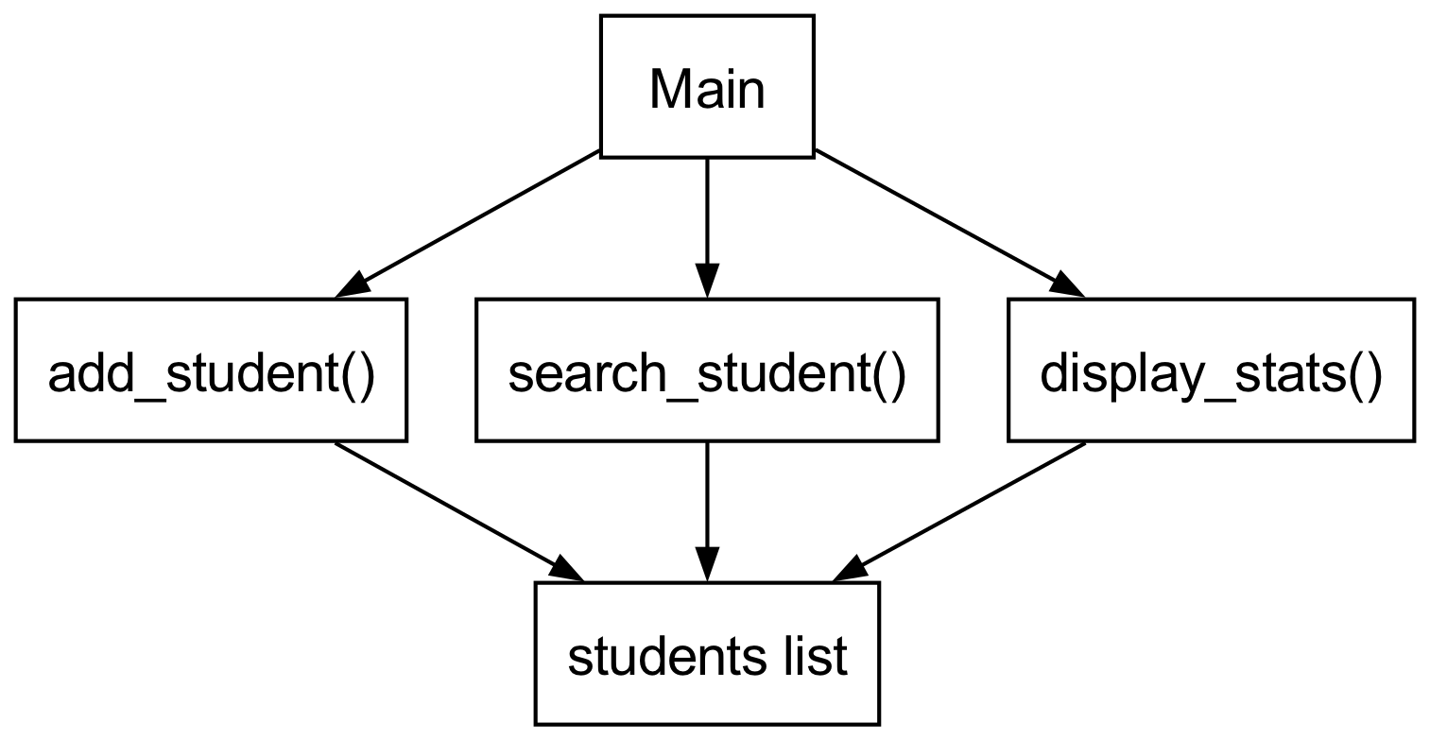
- Modular Project Functions

🏫 In-Class Exercises (3)
- Write a function to compute the square of a number and call it for 5 numbers.
- Write a recursive function to sum numbers 1 to N.
- Modify the Student Grades project: create separate functions for adding, searching, and displaying statistics.

✅ Solutions
Exercise 1
def square(n):
return n ** 2
for i in range(1, 6):
print(square(i))
Exercise 2
def sum_recursive(n):
if n == 0:
return 0
return n + sum_recursive(n-1)
print(sum_recursive(5)) # 15
Exercise 3
students = []
def add_student(name, grade):
students.append({"name": name, "grade": grade})
def search_student(name):
for s in students:
if s["name"] == name:
return s
return None
def display_stats():
grades = [s["grade"] for s in students]
print("Max:", max(grades))
print("Min:", min(grades))
print("Average:", sum(grades)/len(grades))
add_student("Alice", 90)
add_student("Bob", 85)
display_stats()

🏠 Take-Home Assignments (3)
- Write a recursive function to compute the factorial of a number.
- Write a recursive function to find the nth Fibonacci number.
- Refactor the mini project from Week 12 to use functions for all operations and improve modularity.

📚 References
- Think Python — Chapters 4–6, 6.1–6.2
- Problem Solving with Algorithms and Data Structures — Recursion chapter
- Python Docs: https://docs.python.org/3/tutorial/controlflow.html#defining-functions

⚠️ Common Mistakes & Best Practices
Mistake | Solution
Forgetting base case in recursion | Always define a clear base case
Reusing mutable defaults | Avoid def func(lst=[]) pattern
Redundant code | Modularize using functions
Stack overflow | Avoid deep recursion for large inputs

🔮 Next Week Preview
Week 14 — Intermediate Problem Solving & Algorithms
- Combining functions, loops, and data structures
- More complex counting/searching problems
- Introduction to sorting algorithms
- Debugging multi-function programs
- Time complexity review

