✅ Week 1 — Thinking Like a Computer Scientist
Theme: Computational Thinking, Algorithms, Flowcharts, and Pseudocode

🎯 Learning Objectives
By the end of Week 1, students will be able to:
- ✅ Break real-world problems into algorithmic steps (decomposition)
- ✅ Translate logical ideas into flowcharts and pseudocode
- ✅ Understand the cycle: Think → Plan → Code → Test
- ✅ Explain how computers interpret instructions
- ✅ Write their first simple algorithm and Python “Hello World” program

📘 Core Concepts Explained (Deep Theory + Plain English)

🧠 What is Computational Thinking?
Academic definition: A systematic approach to problem-solving used in computer science that involves decomposition, pattern recognition, abstraction, and algorithmic design.
Beginner explanation: Computational thinking teaches you to solve problems step-by-step like a computer, not randomly like humans often do.
Real-world analogy: Think like a chef using a recipe. Every step must be in the right order, clear, reproducible, and leave no room for guessing.

🔍 Core Thinking Components
Concept | Meaning | Real-World Example
Decomposition | Break big problem into smaller tasks | Cooking: prepare ingredients, heat pan, cook
Pattern Recognition | Notice repeated ideas | Buttons always click, login screens similar
Abstraction | Focus on important parts only | Driving: ignore trees, follow road signs
Algorithm Design | Write exact steps to solve | Recipe, ATM steps, Google Maps route

🧾 Algorithm vs Code
Term | Meaning
Algorithm | Human-readable steps to solve a problem
Code | Machine-readable instructions implementing algorithm
💡 First learn to think. Code comes after thought.

🔄 Flowcharts & Pseudocode
Flowchart = visual plan Pseudocode = English-like algorithm
Flowchart example (boiling egg):
Start → Fill pot → Add eggs → Boil water → Wait 7 minutes → Stop heat → Serve → End
Pseudocode version:
Start
Fill pot with water
Add eggs
Boil water
Wait 7 minutes
Turn off heat
Serve eggs
End

👨‍💻 First Python Program
# My first Python program
print("Hello, world!")

🖼️ Diagrams (Will be generated later)
- 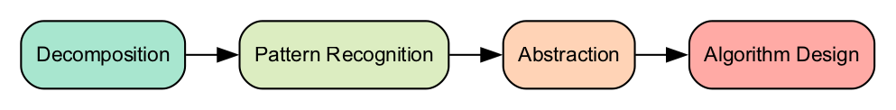
- Computational Thinking Components
- 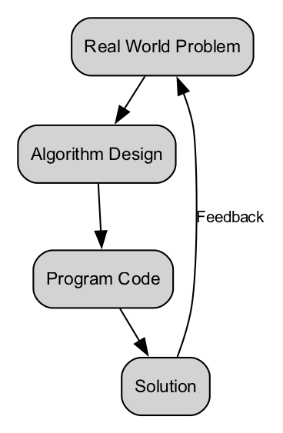
- Algorithm vs Program Flow
- 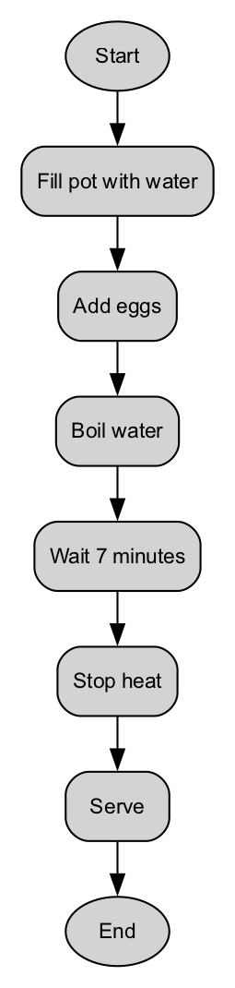
- Basic Flowchart for Simple Task
- 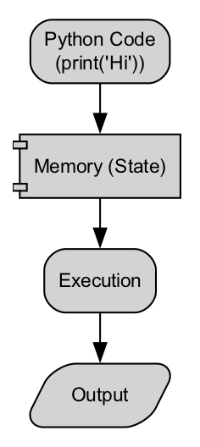
- First Python Execution Diagram

🏫 In-Class Exercises (3)

✅ Exercise 1: Toothbrushing Algorithm
Write a step-by-step algorithm to brush teeth.

✅ Exercise 2: Flowchart for making tea
Draw a flowchart for: boil water → add tea → steep → add sugar → serve

✅ Exercise 3: First Python Output
Write a program to print your name and reason for learning programming.
print("My name is ___")
print("I want to learn programming because ___")

🧠 Solutions to In-Class Exercises

✅ Solution 1: Toothbrushing
Pick toothbrush
Apply toothpaste
Wet toothbrush
Brush teeth for 2 minutes
Rinse mouth
Rinse brush
Store brush

✅ Solution 2: Tea Flowchart (pseudocode)
Start
Boil water
Add tea leaves
Wait 3-5 minutes
Add sugar
Serve
End

✅ Solution 3: Python Output Example
print("My name is Sam")
print("I want to learn programming because I love building apps")

🏠 Take-Home Assignments (3)

1️⃣ Algorithm — Preparing for school
Write steps a student follows to get ready for school.

2️⃣ Flowchart — Buying a bus ticket
Include decisions (cash or card?).

3️⃣ Python — Personal introduction script
Print:
- Name
- Hometown
- Your goal for this course

📚 Weekly References
Books
- How to Think Like a Computer Scientist — Python Edition
- Jeannette Wing — Computational Thinking (2006)
Online
- MIT OpenCourseware — Intro to CS
- Python Official Docs — Getting Started

⚠️ Common Mistakes & Best Practices
Mistake | Fix
Writing code without planning | Always sketch flowchart/pseudocode first
Too many steps or too few steps | Steps must be clear, complete, logical
Using natural language, not algorithmic | Use simple short commands
Skipping debugging | Test small programs frequently

🔮 Next Week Preview
Week 2 — Variables, Data Types & Memory
- What is data?
- Variables & assignment
- Memory model
- Input & output

