✅ Week 3 — Expressions, Operators & Control Flow
Theme: Logic building, decision making, and program branching

🎯 Learning Objectives
By the end of Week 3, students will be able to:
- ✅ Use arithmetic, comparison, and logical operators
- ✅ Explain expression evaluation (order of operations)
- ✅ Write programs that make decisions using if, elif, and else
- ✅ Apply boolean logic to real-world problem solving
- ✅ Validate input & detect simple errors in programs

📘 Deep Concepts Explained

🧮 Expressions & Operators
An expression produces a value. Operators define how values combine.
Category | Operators | Meaning
Arithmetic | + - * / // % ** | Math operations
Comparison | == != > < >= <= | True/False checks
Logical | and or not | Combine conditions
Assignment | = | Store value
Compound Assignment | += -= *= /= | Update variable
Example expression:
x = (10 + 5) * 2

⚖️ Order of Evaluation (PEMDAS in Python)
- Parentheses ()
- Exponent **
- Multiplication, Division, Floor *, /, //, %
- Addition, Subtraction +, -
- Comparison >, <, ==, ...
- Logical and, or, not
Example:
result = (4 + 3) * 2 > 10 and not False
Breakdown:
- (4 + 3) = 7
- 7 * 2 = 14
- 14 > 10 = True
- not False = True
- True and True = True
✅ Program thinking, not guessing.

🧠 Boolean Logic in Real Life
Expression | Human Meaning
age > 18 | Adult check
money > price and card == True | Can purchase item
temp < 0 or raining == True | Weather warning
Computers need exact logic, no assumptions.

🔀 Control Flow: if / elif / else
Programs adjust behavior based on conditions.
age = int(input("Enter age: "))
if age >= 18:
print("Adult")
elif age >= 13:
print("Teenager")
else:
print("Child")
Computers think in conditions and consequences.

✅ Python Code Examples

✅ Example 1 — Even or odd
num = int(input("Enter a number: "))
if num % 2 == 0:
print("Even")
else:
print("Odd")

✅ Example 2 — Login simulation
username = input("Username: ")
password = input("Password: ")
if username == "admin" and password == "1234":
print("Welcome!")
else:
print("Invalid credentials")

✅ Example 3 — Grade calculator
score = float(input("Enter score: "))
if score >= 90:
print("A")
elif score >= 80:
print("B")
elif score >= 70:
print("C")
elif score >= 60:
print("D")
else:
print("F")

🖼️ Diagrams (Generated later)
- 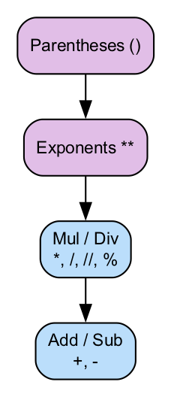
- Expression Order Diagram
- 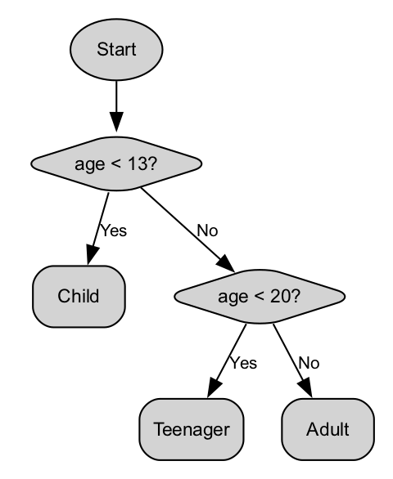
- Boolean Decision Tree
- 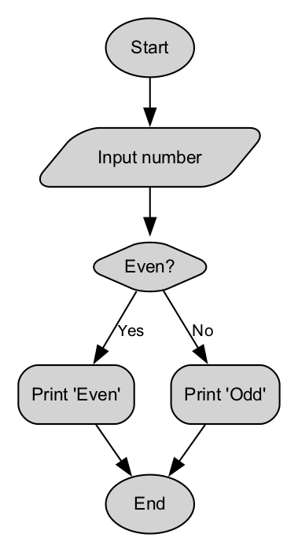
- If-Else Program Flowchart
- 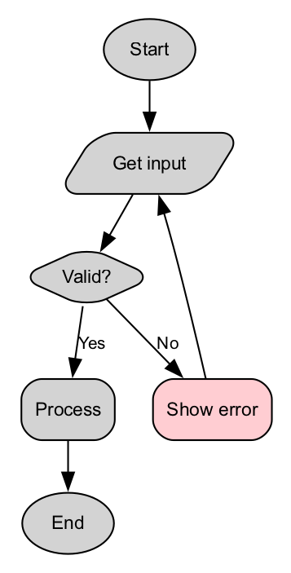
- Input Validation Flow

🏫 In-Class Exercises (3)

Exercise 1
Ask for a number, print whether it’s positive, negative, or zero.

Exercise 2
Input three numbers, print the largest.

Exercise 3
Student attendance system: If attendance >= 75% → “Allowed for exam” Else → “Not allowed”

✅ Solutions

Solution 1
num = float(input("Enter number: "))
if num > 0:
print("Positive")
elif num < 0:
print("Negative")
else:
print("Zero")

Solution 2
a = float(input("A: "))
b = float(input("B: "))
c = float(input("C: "))
if a >= b and a >= c:
print(a, "is largest")
elif b >= a and b >= c:
print(b, "is largest")
else:
print(c, "is largest")

Solution 3
attendance = float(input("Attendance %: "))
if attendance >= 75:
print("Allowed for exam")
else:
print("Not allowed")

🏠 Take-Home Assignments (3)

1️⃣ ATM Menu Simulation
Input: “withdraw”, “deposit”, or “balance” Print correct response.

2️⃣ Simple calculator
Input 2 numbers + operator (+ - * /)

3️⃣ Eligibility checker
Input age & nationality: If age >= 17 AND nationality = Indonesian → eligible for ID card.

📚 References
- Think Python Chapter: Expressions, Booleans, Conditionals
- Python Docs: If statements, comparison operators

⚠️ Common Mistakes & Fixes
Mistake | Solution
Using = instead of == | == is comparison
Stacking unrelated if instead of elif | Use structured branching
Forgetting int() input conversion | Always convert when comparing numbers
Writing unclear logic | Use parentheses for clarity

🔮 Next Week Preview
Week 4 — Loops & Iteration
- Why loops?
- for and while
- Counting, Summing, Ranges
- Loop flow diagrams
- Infinite loop mistakes

