✅ Week 7 — Dictionaries & Sets
Theme: Key-value mapping, unique collections, and efficient lookups

🎯 Learning Objectives
By the end of Week 7, students will be able to:
- ✅ Understand dictionaries as key-value pairs
- ✅ Access, add, update, and delete dictionary entries
- ✅ Iterate through keys, values, and items
- ✅ Understand sets as unordered collections of unique elements
- ✅ Perform basic set operations: union, intersection, difference
- ✅ Apply dictionaries and sets in practical problem solving

📘 Deep Concepts Explained

🔹 Dictionaries (dict)
- Definition: Unordered, mutable collection of key-value pairs
- Syntax: {key1: value1, key2: value2}
- Access: dict[key]
student = {"name": "Alice", "age": 20, "major": "CS"}
print(student["name"]) # Alice
Add/Update:
student["year"] = 2
student["age"] = 21
Delete:
del student["major"]
Iterate:
for key, value in student.items():
print(key, ":", value)

🔹 Sets
- Definition: Unordered collection of unique elements
- Syntax: {element1, element2}
numbers = {1,2,3,3,4}
print(numbers) # {1, 2, 3, 4} → duplicates removed
Set Operations:
A = {1,2,3}
B = {2,3,4}
print(A.union(B)) # {1,2,3,4}
print(A.intersection(B)) # {2,3}
print(A.difference(B)) # {1}
Use-case: Removing duplicates, membership checks, math operations

✅ Python Code Examples

Example 1 — Dictionary Operations
person = {"name": "Bob", "age": 25}
person["city"] = "Jakarta" # Add
person["age"] = 26 # Update
print(person)
for key, val in person.items():
print(f"{key} -> {val}")

Example 2 — Set Operations
fruits1 = {"apple", "banana", "cherry"}
fruits2 = {"banana", "kiwi", "apple"}
print("Union:", fruits1 | fruits2)
print("Intersection:", fruits1 & fruits2)
print("Difference:", fruits1 - fruits2)

Example 3 — Using Dictionaries for Counting
text = "hello world"
count = {}
for char in text:
if char in count:
count[char] += 1
else:
count[char] = 1
print(count)

🖼️ Diagrams (Placeholders)
- 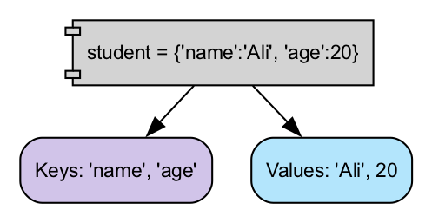
- Dictionary Key-Value Flow
- 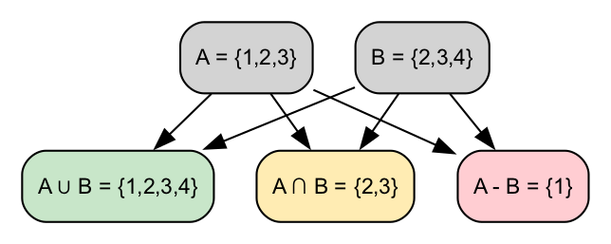
- Set Operations Diagram
- 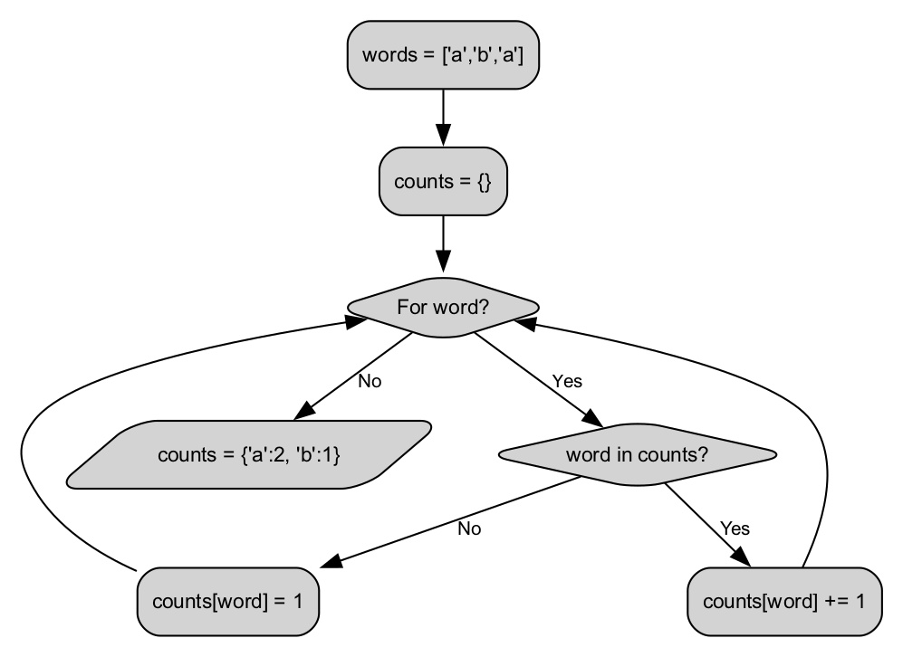
- Counting with Dictionary

🏫 In-Class Exercises (3)
- Create a dictionary with 3 students’ names and grades, print all keys and values.
- Input a list with duplicates, convert it into a set, and print unique elements.
- Count frequency of each word in a short sentence using a dictionary.

✅ Solutions
Exercise 1
grades = {"Alice": 90, "Bob": 85, "Charlie": 78}
for student, grade in grades.items():
print(f"{student}: {grade}")
Exercise 2
numbers = [1,2,3,2,4,1,5]
unique_numbers = set(numbers)
print(unique_numbers)
Exercise 3
sentence = "hello world hello python"
words = sentence.split()
freq = {}
for word in words:
if word in freq:
freq[word] += 1
else:
freq[word] = 1
print(freq)

🏠 Take-Home Assignments (3)
- Student Directory: Create a dictionary with at least 5 students and their info (name, age, grade). Print students above grade 80.
- Unique Words: Input a paragraph, output all unique words using sets.
- Letter Count: Input a sentence, output count of each letter using a dictionary.

📚 References
- Think Python — Chapter 6: Dictionaries
- Python Docs: https://docs.python.org/3/tutorial/datastructures.html#dictionaries
- Python Docs: https://docs.python.org/3/tutorial/datastructures.html#sets

⚠️ Common Mistakes & Best Practices
Mistake | Solution
Accessing non-existent dictionary key | Use dict.get(key) or check if key in dict:
Assuming order in sets | Sets are unordered; use sorted() if needed
Modifying set while iterating | Avoid; iterate over a copy or convert to list
Counting without init | Initialize dictionary or use defaultdict(int)

🔮 Next Week Preview
Week 8 — File I/O & Exception Handling
- Reading and writing files (txt, csv)
- Context managers (with)
- Handling exceptions (try, except)
- Practical examples: log processing, simple data persistence

