✅ Week 8 — File I/O & Exception Handling
Theme: Persisting data and handling runtime errors

🎯 Learning Objectives
By the end of Week 8, students will be able to:
- ✅ Open, read, and write text files in Python
- ✅ Use context managers (with) for safe file handling
- ✅ Read and write CSV files using csv module
- ✅ Understand exceptions and handle errors gracefully
- ✅ Apply file I/O and exception handling to real-world scenarios

📘 Deep Concepts Explained

🔹 File I/O Basics
Files: Persistent storage for data outside program memory.
Modes:
Mode | Description
r | Read (default)
w | Write (overwrite)
a | Append
r+ | Read & write
# Writing to a file
file = open("example.txt", "w")
file.write("Hello World\nPython is fun!")
file.close()
# Reading from a file
file = open("example.txt", "r")
content = file.read()
print(content)
file.close()

🔹 Using with (Context Manager)
Automatically closes the file:
with open("example.txt", "r") as f:
content = f.read()
print(content)
# file is automatically closed

🔹 CSV File Handling
import csv
# Writing CSV
with open("data.csv", "w", newline="") as csvfile:
writer = csv.writer(csvfile)
writer.writerow(["Name", "Age", "Grade"])
writer.writerow(["Alice", 20, 90])
writer.writerow(["Bob", 21, 85])
# Reading CSV
with open("data.csv", "r") as csvfile:
reader = csv.reader(csvfile)
for row in reader:
print(row)

🔹 Exception Handling
Problem: Programs crash on runtime errors (e.g., division by zero, missing file).
Solution: Use try, except:
try:
num = int(input("Enter number: "))
result = 10 / num
except ValueError:
print("Invalid input! Enter a number.")
except ZeroDivisionError:
print("Cannot divide by zero!")
finally:
print("Execution finished.")
Notes:
- try → block that may cause error
- except → handles specific error
- finally → optional, runs always

✅ Python Code Examples

Example 1 — Writing & Reading Text
# Write data
with open("notes.txt", "w") as f:
f.write("Line 1\nLine 2\nLine 3")
# Read data
with open("notes.txt", "r") as f:
for line in f:
print(line.strip())

Example 2 — Handling File Not Found
try:
with open("missing.txt", "r") as f:
print(f.read())
except FileNotFoundError:
print("File does not exist!")

Example 3 — CSV Read/Write
import csv
students = [["Alice",90], ["Bob",85], ["Charlie",78]]
# Write CSV
with open("students.csv", "w", newline="") as f:
writer = csv.writer(f)
writer.writerow(["Name", "Score"])
writer.writerows(students)
# Read CSV
with open("students.csv", "r") as f:
reader = csv.reader(f)
for row in reader:
print(row)

🖼️ Diagrams (Placeholders)
- 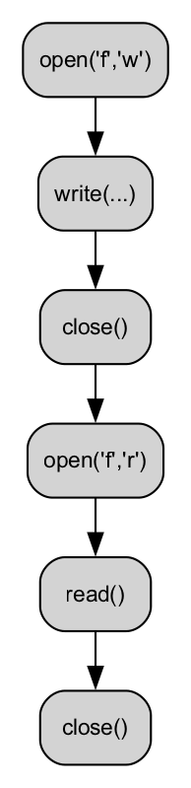
- File Read/Write Flow
- 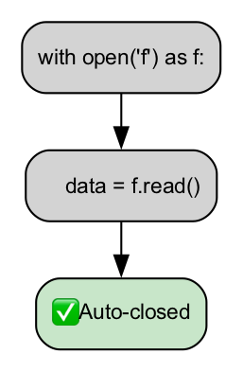
- Context Manager Flow
- 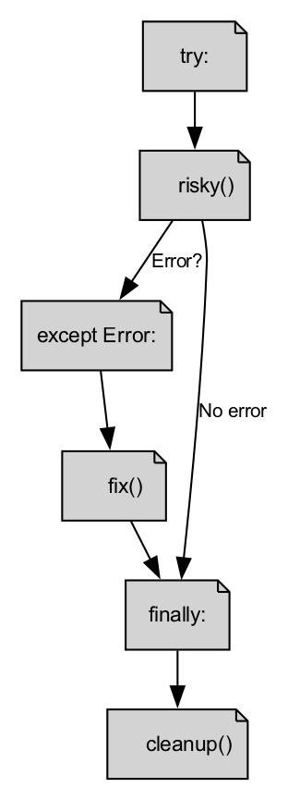
- Exception Handling Flow
- 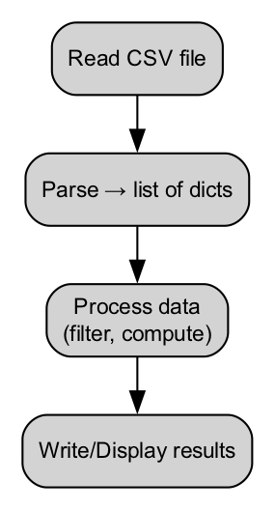
- CSV Data Flow

🏫 In-Class Exercises (3)
- Create a text file todo.txt and write 5 tasks into it.
- Read todo.txt and print each line with numbering.
- Ask user for a filename to read. If file does not exist, display friendly error.

✅ Solutions
Exercise 1
tasks = ["Task 1","Task 2","Task 3","Task 4","Task 5"]
with open("todo.txt", "w") as f:
for task in tasks:
f.write(task + "\n")
Exercise 2
with open("todo.txt", "r") as f:
for i, line in enumerate(f, 1):
print(f"{i}. {line.strip()}")
Exercise 3
filename = input("Enter filename: ")
try:
with open(filename, "r") as f:
print(f.read())
except FileNotFoundError:
print("Sorry, file not found!")

🏠 Take-Home Assignments (3)
- Log Analyzer: Read a log file, count number of lines, words, and characters.
- CSV Processor: Create CSV of 5 students with grades. Read CSV, calculate average grade.
- Safe Calculator: Input two numbers and division operation. Handle division by zero and invalid input.

📚 References
- Think Python — Chapter 8: Files
- Python Docs: https://docs.python.org/3/tutorial/inputoutput.html#reading-and-writing-files

⚠️ Common Mistakes & Best Practices
Mistake | Solution
Not closing files | Use with context manager
Reading large files at once | Read line by line to save memory
Ignoring exceptions | Always handle expected errors
Assuming CSV separator | Always check delimiter, use csv module

🔮 Next Week Preview
Week 9 — Introduction to Algorithms & Problem Solving
- Algorithm concept and pseudocode
- Stepwise problem solving
- Flowchart creation
- Simple search & counting algorithms
- Debugging logic

