✅ Week 15 — Advanced Topics: Recursion, Searching, and Sorting
Theme: Recursive problem solving, searching algorithms, and introduction to efficient sorting

🎯 Learning Objectives
By the end of Week 15, students will be able to:
- ✅ Apply recursion to common algorithmic problems
- ✅ Implement linear and binary search
- ✅ Understand the difference between O(n) and O(log n) complexity
- ✅ Explore recursive sorting strategies (merge sort overview)
- ✅ Debug recursive and search-based algorithms

📘 Deep Concepts Explained

🔹 Recursion Recap
- Recursion = function calls itself
- Must have base case and progress toward it
- Useful for tree structures, divide-and-conquer problems, and factorial/Fibonacci sequences
Example: Sum of List Recursively
def sum_list(lst):
if not lst: # base case: empty list
return 0
return lst[0] + sum_list(lst[1:])
print(sum_list([1,2,3,4,5])) # Output: 15

🔹 Linear Search
- O(n) complexity, simple sequential check
def linear_search(lst, target):
for i, val in enumerate(lst):
if val == target:
return i
return -1
numbers = [3,5,7,9,11]
print(linear_search(numbers, 7)) # 2
Real-world analogy: Searching for a name in an unordered guest list by checking each entry.

🔹 Binary Search
- Requires sorted list
- Divides search space by half each step → O(log n)
def binary_search(lst, target):
left, right = 0, len(lst)-1
while left <= right:
mid = (left + right) // 2
if lst[mid] == target:
return mid
elif lst[mid] < target:
left = mid + 1
else:
right = mid - 1
return -1
numbers = [1,3,5,7,9,11]
print(binary_search(numbers, 7)) # 3
Visual intuition:
- Search range halves each iteration: [1,3,5,7,9,11] → mid = 5 → target>mid → search [7,9,11] → mid = 9 → target<mid → found 7

🔹 Merge Sort (Overview)
- Divide list → sort halves → merge sorted halves
- O(n log n) complexity → much faster than bubble/selection sort for large datasets
def merge_sort(lst):
if len(lst) <= 1:
return lst
mid = len(lst)//2
left = merge_sort(lst[:mid])
right = merge_sort(lst[mid:])
return merge(left, right)
def merge(left, right):
result = []
i = j = 0
while i < len(left) and j < len(right):
if left[i] < right[j]:
result.append(left[i])
i += 1
else:
result.append(right[j])
j += 1
result += left[i:]
result += right[j:]
return result
numbers = [38,27,43,3,9,82,10]
print(merge_sort(numbers))

✅ Python Code Examples

Example 1 — Recursive Fibonacci
def fibonacci(n):
if n <= 1:
return n
return fibonacci(n-1) + fibonacci(n-2)
print([fibonacci(i) for i in range(10)]) # First 10 Fibonacci numbers

Example 2 — Linear vs Binary Search
lst = [1,3,5,7,9,11]
print("Linear Search:", linear_search(lst, 9))
print("Binary Search:", binary_search(lst, 9))

Example 3 — Recursive Sum of Nested Lists
def recursive_sum(lst):
total = 0
for item in lst:
if isinstance(item, list):
total += recursive_sum(item)
else:
total += item
return total
nested = [1, [2,3], [4, [5,6]]]
print(recursive_sum(nested)) # Output: 21

🖼️ Diagrams (Placeholders)
- 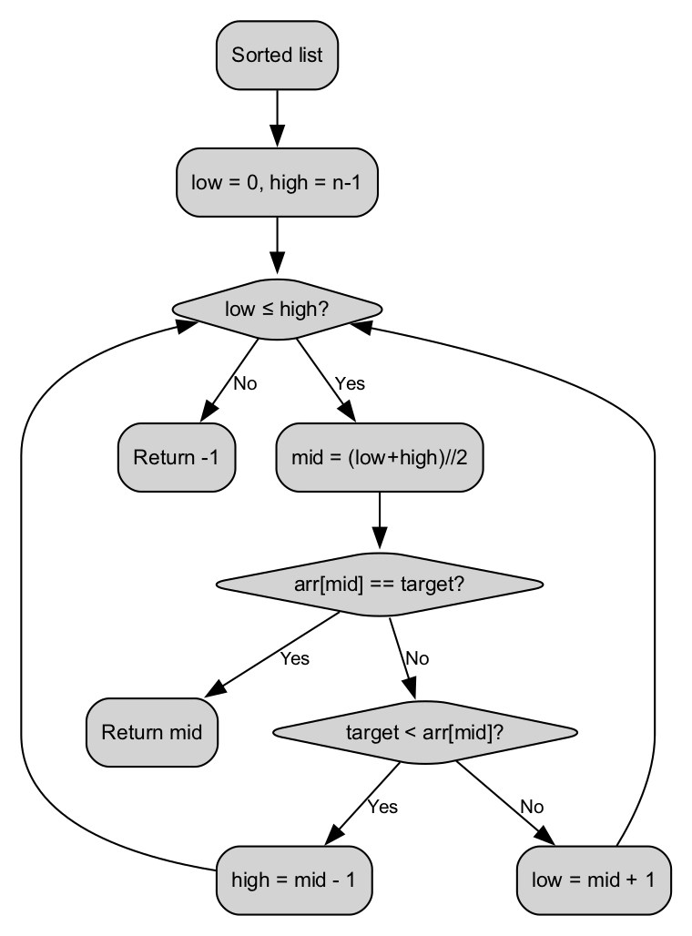
- Binary Search Flow
- 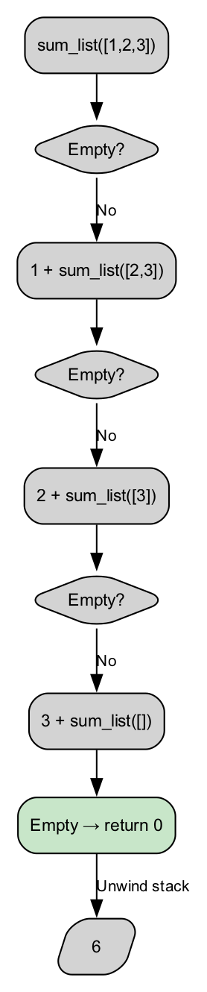
- Recursive List Sum Flow
- 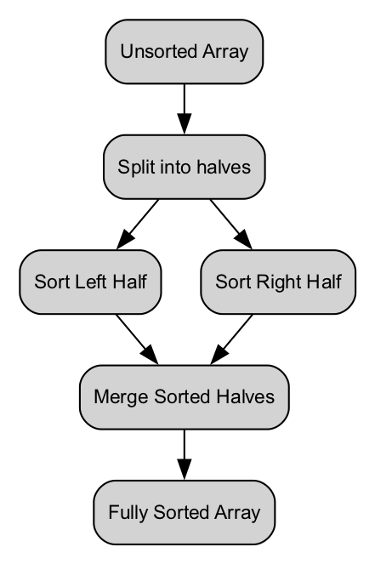
- Merge Sort Flow

🏫 In-Class Exercises (3)
- Implement linear search and binary search, compare number of steps for target.
- Write a recursive function to reverse a string.
- Implement merge sort on a small list of integers and print intermediate steps.

✅ Solutions
Exercise 1
numbers = [1,3,5,7,9,11]
def linear_search(lst, target):
for i, val in enumerate(lst):
if val == target:
return i
return -1
def binary_search(lst, target):
left, right = 0, len(lst)-1
while left <= right:
mid = (left+right)//2
if lst[mid] == target:
return mid
elif lst[mid] < target:
left = mid+1
else:
right = mid-1
return -1
print(linear_search(numbers, 7)) # 3
print(binary_search(numbers, 7)) # 3
Exercise 2
def reverse_string(s):
if s == "":
return ""
return s[-1] + reverse_string(s[:-1])
print(reverse_string("hello")) # "olleh"
Exercise 3
numbers = [38,27,43,3,9,82,10]
def merge_sort(lst):
if len(lst) <= 1:
return lst
mid = len(lst)//2
left = merge_sort(lst[:mid])
right = merge_sort(lst[mid:])
return merge(left, right)
def merge(left, right):
result = []
i = j = 0
while i < len(left) and j < len(right):
if left[i] < right[j]:
result.append(left[i])
i += 1
else:
result.append(right[j])
j += 1
result += left[i:]
result += right[j:]
return result
print(merge_sort(numbers))

🏠 Take-Home Assignments (3)
- Implement a recursive function to find the maximum in a list.
- Implement binary search on a sorted list of strings.
- Compare merge sort and bubble sort on a list of 20 integers and count operations.

📚 References
- Grokking Algorithms — Chapters 2–5
- Problem Solving with Algorithms and Data Structures — Recursion & Sorting
- Python Docs: https://docs.python.org/3/tutorial/controlflow.html#defining-functions

⚠️ Common Mistakes & Best Practices
Mistake | Solution
Missing base case in recursion | Always define clear termination
Binary search on unsorted list | Sort list first
Modifying list while iterating recursively | Use slices or helper functions
Deep recursion → stack overflow | Use iterative approach for large data

🔮 Next Week Preview
Week 16 — Final Capstone Project
- Integrate all learned concepts: loops, functions, recursion, search, sorting
- Design and implement a complete application
- Apply debugging and optimization strategies
- Prepare project report and test cases

