✅ Week 5 — Functions & Modular Programming
Theme: Creating reusable code, abstraction, and problem decomposition

🎯 Learning Objectives
By the end of Week 5, students will be able to:
- ✅ Define and call functions in Python
- ✅ Pass arguments and return values from functions
- ✅ Understand local vs global variables
- ✅ Break problems into smaller reusable modules
- ✅ Apply functions to improve readability and maintainability

📘 Deep Concepts Explained

🔹 What is a Function?
Academic definition: A function is a block of code that performs a specific task and can be called multiple times.
Beginner analogy: Think of a function like a blender: you put ingredients in, press a button, and get the smoothie. You can reuse it anytime without rewriting the steps.
Python Syntax:
def function_name(parameters):
"""
Optional documentation
"""
# code block
return value # optional

🔹 Example 1: Simple Function
def greet():
print("Hello, welcome to Python!")
greet()
greet() # can call multiple times
Output:
Hello, welcome to Python!
Hello, welcome to Python!

🔹 Parameters and Arguments
Parameters allow functions to receive input.
def greet_user(name):
print(f"Hello, {name}!")
greet_user("Alice")
greet_user("Bob")
Output:
Hello, Alice!
Hello, Bob!

🔹 Return Values
Functions can process data and return a result.
def add(a, b):
return a + b
result = add(5, 3)
print("Sum is:", result)
Output:
Sum is: 8

🔹 Local vs Global Variables
- Local variable: Exists inside function, disappears after function ends
- Global variable: Declared outside, accessible everywhere
x = 10 # global
def demo():
y = 5 # local
print("Inside function:", x, y)
demo()
print("Outside function, x =", x)
# y is not accessible here → error
💡 Best practice: minimize global variables. Functions should be self-contained.

🔹 Why Functions?
- Reusability
- Readability
- Debugging easier
- Avoid repetition
Example: Temperature conversion
def celsius_to_fahrenheit(c):
return (c * 9/5) + 32
temps = [0, 20, 37, 100]
for t in temps:
print(celsius_to_fahrenheit(t))

🖼️ Diagrams (Placeholders)
- 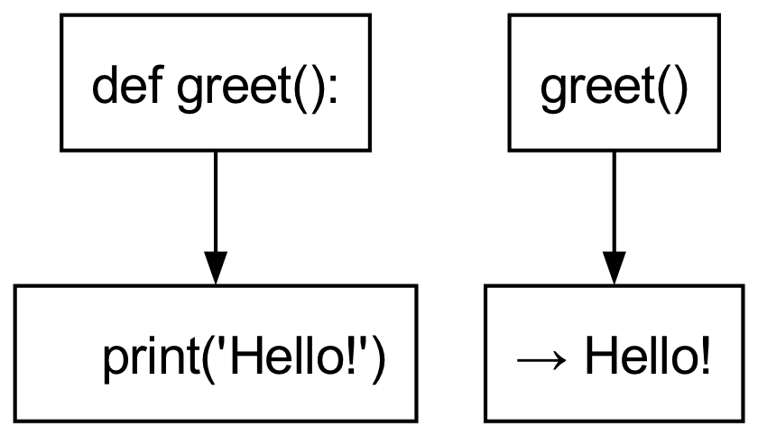
- Function Structure Diagram
- 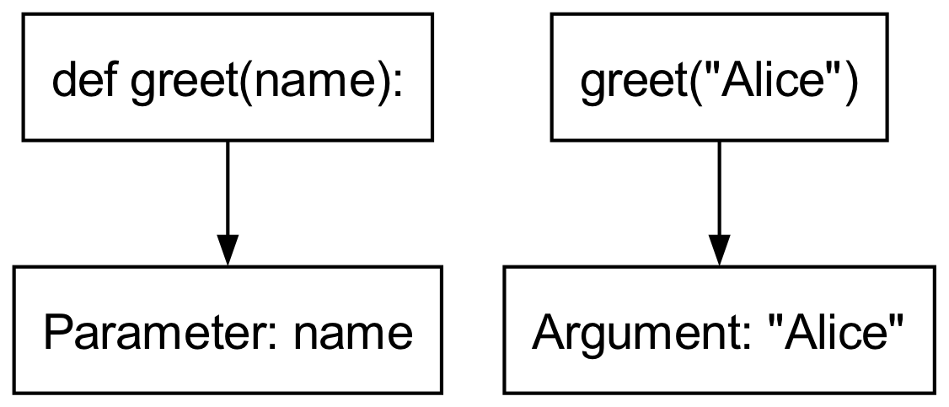
- Parameter vs Argument Illustration
- 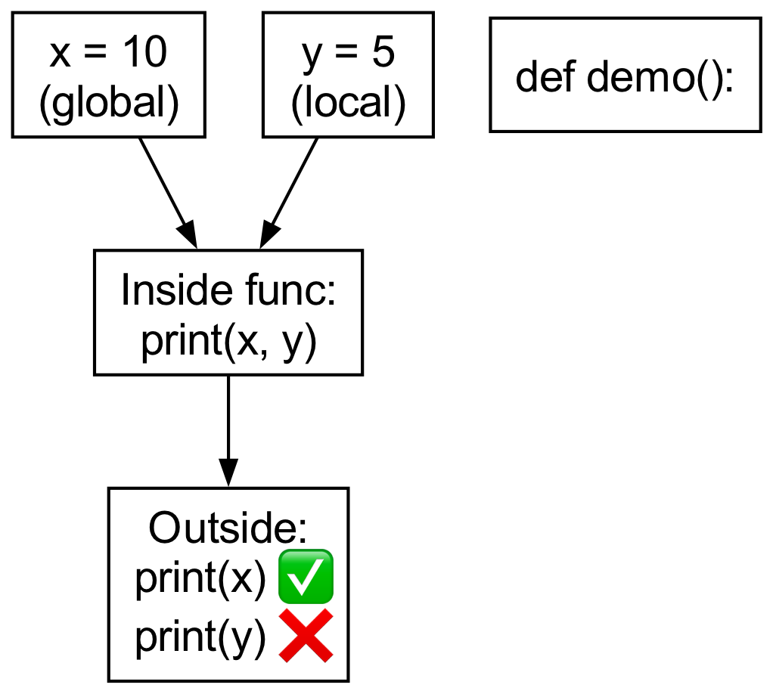
- Local vs Global Variable Flow

🏫 In-Class Exercises (3)
- Write a function square(n) that returns the square of a number.
- Write a function is_even(n) that returns True if the number is even, else False.
- Write a function greet_person(name, age) that prints: "Hello <name>, you are <age> years old!"

✅ Solutions
Exercise 1:
def square(n):
return n * n
print(square(5)) # 25
Exercise 2:
def is_even(n):
return n % 2 == 0
print(is_even(4)) # True
print(is_even(7)) # False
Exercise 3:
def greet_person(name, age):
print(f"Hello {name}, you are {age} years old!")
greet_person("Alice", 20)

🏠 Take-Home Assignments (3)
- Factorial Function: Write a function that returns factorial of a number.
- Palindrome Checker: Write a function that checks if a string is a palindrome.
- Temperature Converter: Write two functions: c_to_f() and f_to_c(); convert input values.

📚 References
- Think Python — Chapter 4: Functions
- Python Docs: https://docs.python.org/3/tutorial/controlflow.html#defining-functions

⚠️ Common Mistakes & Best Practices
Mistake | Solution
Calling function before defining it | Define functions first
Modifying global variable inside function | Use global carefully or avoid it
Using wrong number of arguments | Match function parameters exactly
Not returning value | Use return when output is needed

🔮 Next Week Preview
Week 6 — Lists, Tuples & Strings
- Introduction to sequences
- Accessing, modifying, iterating
- Slicing and indexing
- Basic operations and methods

