✅ Week 14 — Intermediate Problem Solving & Algorithms
Theme: Combining functions, loops, data structures, and introducing sorting

🎯 Learning Objectives
By the end of Week 14, students will be able to:
- ✅ Solve intermediate problems combining functions, loops, and lists/dictionaries
- ✅ Implement simple sorting algorithms (e.g., bubble sort, selection sort)
- ✅ Apply multiple problem-solving strategies in one program
- ✅ Debug multi-function and multi-loop programs
- ✅ Analyze time complexity of sorting and combined algorithms

📘 Deep Concepts Explained

🔹 Combining Functions, Loops, and Data Structures
- Modular functions allow splitting problems into smaller, manageable units
- Loops allow repetition to process lists, strings, or dictionaries
- Example: Counting grades above a threshold using a function
def count_above_threshold(grades, threshold):
count = 0
for grade in grades:
if grade > threshold:
count += 1
return count
grades = [70,85,90,60,95]
print(count_above_threshold(grades, 80)) # Output: 3

🔹 Introduction to Sorting Algorithms
1. Bubble Sort
- Repeatedly swaps adjacent elements if they are in the wrong order
- O(n²) complexity
def bubble_sort(lst):
n = len(lst)
for i in range(n):
for j in range(0, n-i-1):
if lst[j] > lst[j+1]:
lst[j], lst[j+1] = lst[j+1], lst[j]
return lst
numbers = [64, 34, 25, 12, 22, 11, 90]
print(bubble_sort(numbers))
2. Selection Sort
- Repeatedly selects the smallest element and moves it to the front
- O(n²) complexity
def selection_sort(lst):
n = len(lst)
for i in range(n):
min_idx = i
for j in range(i+1, n):
if lst[j] < lst[min_idx]:
min_idx = j
lst[i], lst[min_idx] = lst[min_idx], lst[i]
return lst
numbers = [64, 25, 12, 22, 11]
print(selection_sort(numbers))

🔹 Applying Problem-Solving Strategies
- Understand the problem → inputs, outputs
- Break into functions → modular code
- Choose proper data structure → list, dict, set
- Implement logic using loops and conditionals
- Test with small examples → verify correctness
- Analyze performance → check time complexity

✅ Python Code Examples

Example 1 — Count Occurrences in List Using Functions
def count_occurrences(lst, target):
count = 0
for item in lst:
if item == target:
count += 1
return count
numbers = [1,2,3,2,4,2,5]
print(count_occurrences(numbers, 2)) # Output: 3

Example 2 — Sorting Student Grades
grades = [88, 92, 75, 60, 85]
# Bubble sort
for i in range(len(grades)):
for j in range(0, len(grades)-i-1):
if grades[j] > grades[j+1]:
grades[j], grades[j+1] = grades[j+1], grades[j]
print("Sorted Grades:", grades)

Example 3 — Combined Problem
students = [{"name":"Alice","grade":90},{"name":"Bob","grade":75},{"name":"Charlie","grade":85}]
def top_students(students, threshold):
top = []
for s in students:
if s["grade"] > threshold:
top.append(s["name"])
return top
print(top_students(students, 80)) # ['Alice','Charlie']

🖼️ Diagrams (Placeholders)
- 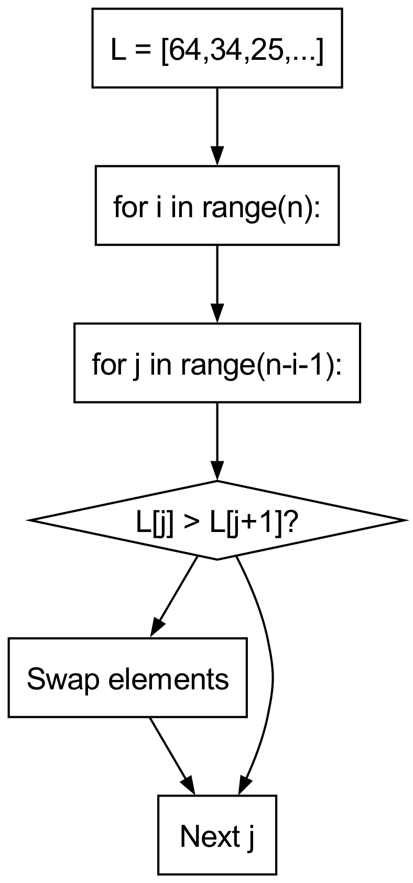
- Bubble Sort Flow
- 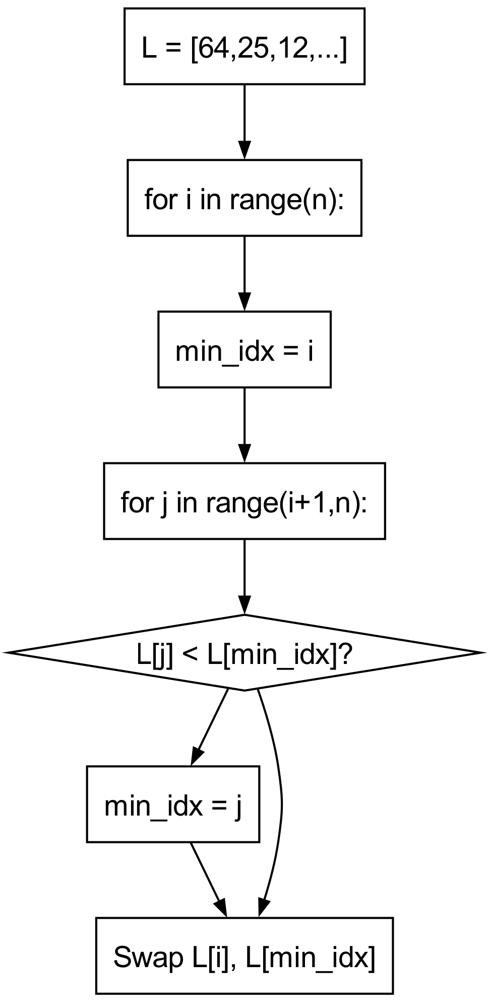
- Selection Sort Flow
- 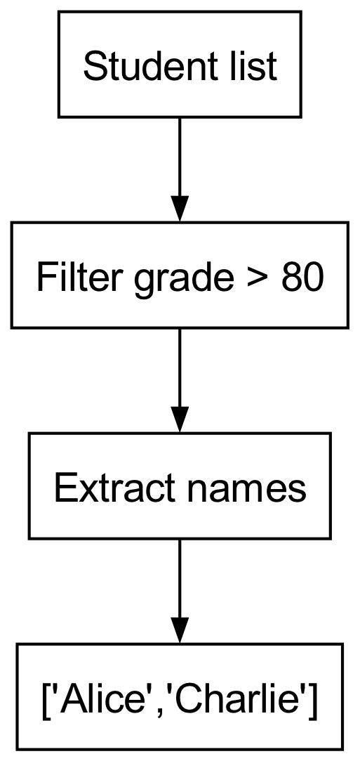
- Combined Problem Flow

🏫 In-Class Exercises (3)
- Implement bubble sort on a list of 8 numbers and print each pass.
- Count how many students have grades between 70 and 90 using a function.
- Sort a list of strings alphabetically using selection sort.

✅ Solutions
Exercise 1
numbers = [64, 34, 25, 12, 22, 11, 90]
for i in range(len(numbers)):
for j in range(0, len(numbers)-i-1):
if numbers[j] > numbers[j+1]:
numbers[j], numbers[j+1] = numbers[j+1], numbers[j]
print("Pass", i+1, ":", numbers)
Exercise 2
students = [{"name":"Alice","grade":90},{"name":"Bob","grade":75},{"name":"Charlie","grade":85}]
def count_between(students, low, high):
count = 0
for s in students:
if low <= s["grade"] <= high:
count += 1
return count
print(count_between(students,70,90)) # 3
Exercise 3
strings = ["banana","apple","cherry","date"]
n = len(strings)
for i in range(n):
min_idx = i
for j in range(i+1,n):
if strings[j] < strings[min_idx]:
min_idx = j
strings[i], strings[min_idx] = strings[min_idx], strings[i]
print(strings) # ['apple','banana','cherry','date']

🏠 Take-Home Assignments (3)
- Implement bubble sort and selection sort on a list of 15 random integers, compare number of swaps.
- Input a list of students (name & grade), output names sorted by grade descending.
- Write a function that counts vowels in a list of strings and returns a dictionary of counts.

📚 References
- Think Python — Chapters 5–6
- Problem Solving with Algorithms and Data Structures — Sorting chapter
- Python Docs: https://docs.python.org/3/tutorial/controlflow.html#defining-functions

⚠️ Common Mistakes & Best Practices
Mistake | Solution
Not swapping correctly in sort | Use a,b = b,a syntax
Incorrect loop ranges | Verify start/end indices for nested loops
Modifying list while iterating | Use indices or separate list
Redundant code | Use functions to modularize repeated logic

🔮 Next Week Preview
Week 15 — Advanced Topics: Recursion, Searching, and Sorting
- Recursive solutions for common problems
- Linear vs binary search
- Recursive sorting (merge sort introduction)
- Debugging recursive algorithms
- Combining efficiency with recursion

