✅ Week 2 — Variables, Data Types & Memory
Theme: Understanding data, variables, memory, input/output

🎯 Learning Objectives
By the end of Week 2, students will be able to:
- ✅ Explain what data and variables are in computing
- ✅ Understand how memory stores values
- ✅ Use Python variables correctly
- ✅ Work with basic data types: int, float, str, bool
- ✅ Use input() to receive information from the user
- ✅ Print formatted output to the screen

📘 Deep Concepts Explained

💾 What is Data?
Academic definition: Data is raw information that a program stores, manipulates, and processes to produce meaningful output.
Beginner analogy: Data is like ingredients in cooking. Your program is a kitchen that turns ingredients (data) into dishes (results).

📦 What is a Variable?
Academic definition: A variable is a named memory location used to store data.
Beginner analogy: A variable is like a labeled container. You store something inside and use its label to find it later.
Example:
Variable Name | Stored Value
age | 21
name | “Sarah”
is_student | True

🧠 How Memory Works (Simplified)
Action | Memory Meaning
x = 5 | A box labeled x is created and stores value 5
x = x + 1 | Retrieve x, add 1, store new value in same location
Computers don’t “understand” meaning — only numbers and addresses.

🧮 Data Types in Python
Type | Example | Meaning
Integer (int) | 5, -3 | Whole numbers
Float (float) | 3.14 | Decimal numbers
String (str) | “Hello” | Text
Boolean (bool) | True/False | Logical values

🖨️ Input & Output
Output: display information
print("Hello!")
Input: ask user for info
name = input("Enter your name: ")
Python treats input as string by default Convert when needed:
age = int(input("Enter your age: "))

✅ Python Code Examples

Example 1: Simple variables
name = "Ari"
age = 19
height = 1.70
print(name, age, height)

Example 2: Input & formatted output
name = input("What is your name? ")
city = input("Where do you live? ")
print("Hello", name + "! You live in", city)

Example 3: Convert string input to int
year = int(input("Enter your birth year: "))
age = 2025 - year
print("Your age is", age)

🖼️ Diagrams (Generated later)
- 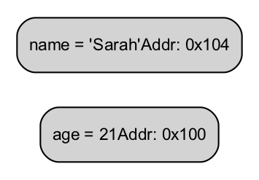
- Memory Storage Diagram
- 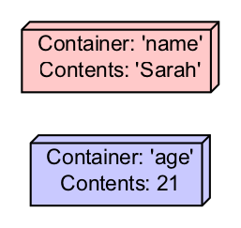
- Variable Container Illustration
- 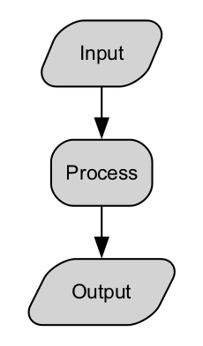
- Input Output Flow
- 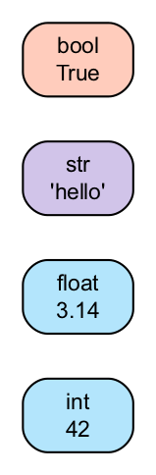
- Data Type Mapping Diagram

🏫 In-Class Exercises (3)

✅ Exercise 1
Define variables for:
- your name
- your age
- your favorite hobby
Print them on separate lines.

✅ Exercise 2
Ask user for two numbers and print their sum.

✅ Exercise 3
Write a program to calculate area of a rectangle: Area = width × height Ask user for width & height.

🧠 Solutions

Solution 1
name = "Dina"
age = 20
hobby = "Reading"
print(name)
print(age)
print(hobby)

Solution 2
a = int(input("Enter first number: "))
b = int(input("Enter second number: "))
print("Sum is:", a + b)

Solution 3
width = float(input("Width: "))
height = float(input("Height: "))
area = width * height
print("Area =", area)

🏠 Take-Home Assignments (3)

1️⃣ User Profile Program
Ask name, age, major, and print:
Hello ___, you are ___ years old and study ___

2️⃣ Temperature Converter
Input Celsius, output Fahrenheit
Formula: F = (C × 9/5) + 32

3️⃣ Rectangle Perimeter
Perimeter = 2 × (width + height)
Ask values → compute → print

📚 References
- Think Python — Allen Downey (Ch. 1–3)
- Python official documentation: input(), variables, data types
- W3Schools Python Variables section

⚠️ Common Mistakes & Best Practices
Mistake | Correct Approach
Using numbers like "5" instead of 5 | Convert input properly: int()
Forgetting print() | Always output results
Spaces in variable names | Use underscores: user_name
Meaningless names like x1, dataA | Use descriptive variable names

🔮 Next Week Preview
Week 3 — Expressions, Operators & Control Flow
- Arithmetic & comparison operators
- Logic (and, or, not)
- if / elif / else branching
- Basic validation programs

