✅ Week 4 — Loops & Iteration
Theme: Repetition, automation, and algorithm cycles using for and while

🎯 Learning Objectives
By the end of Week 4, students will be able to:
- ✅ Explain why loops are necessary in programming
- ✅ Use for and while loops to repeat tasks
- ✅ Understand iteration sequences (range())
- ✅ Apply loop counters, accumulators, and conditions
- ✅ Identify and avoid infinite loops
- ✅ Solve problems using loops (counting, summing, searching)

📘 Deep Concepts Explained

🔁 What is a Loop?
Academic definition: A loop is a control structure that repeats a block of code until a condition is met.
Beginner analogy: Loops are like alarm clocks that ring every morning until you turn them off — repetition until condition ends it.

🧠 Why Do We Need Loops?
Without loops:
print("Hello")
print("Hello")
print("Hello")
print("Hello")
print("Hello")
With loop:
for i in range(5):
print("Hello")
Loops = write once, repeat many times

🔄 Two Types of Loops
Type | Best for | Structure
for | Known number of repetitions | loop over sequence or range
while | Loop until condition changes | condition evaluates each iteration

🧮 for loop with range()
Range patterns:
Pattern | Meaning
range(n) | 0 → n-1
range(a, b) | a → b-1
range(a, b, step) | step increments
for i in range(1, 6):
print(i) # prints 1 to 5

🧷 Accumulator Pattern (Very Important)
total = 0
for i in range(1, 6):
total = total + i
print(total) # 1+2+3+4+5 = 15
This pattern appears constantly in computing: sum, count, search, average, etc.

🔁 while Loop
count = 1
while count <= 5:
print(count)
count += 1

⚠️ Infinite Loop Warning
while True:
print("Never stops")
Always ensure a stop condition changes.

✅ Python Code Examples

Example 1 — Count 1 to 10
for i in range(1, 11):
print(i)

Example 2 — Sum first 100 numbers
total = 0
for n in range(1, 101):
total += n
print(total)

Example 3 — While loop input validation
age = int(input("Enter age (positive number): "))
while age <= 0:
print("Age must be positive!")
age = int(input("Re-enter age: "))
print("Thanks!")

🖼️ Diagrams (Generated later)
- 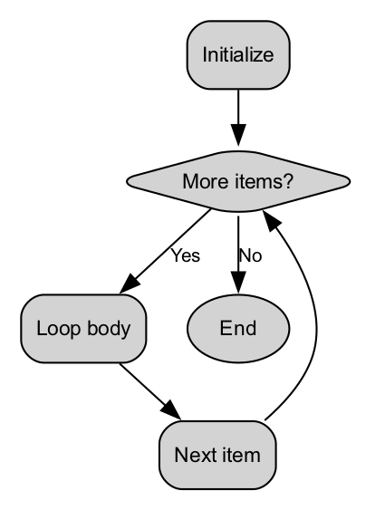
- For Loop Flow Diagram
- 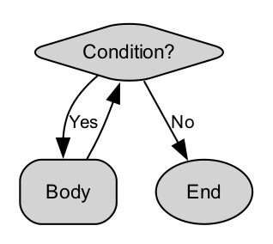
- While Loop Flow Diagram
- 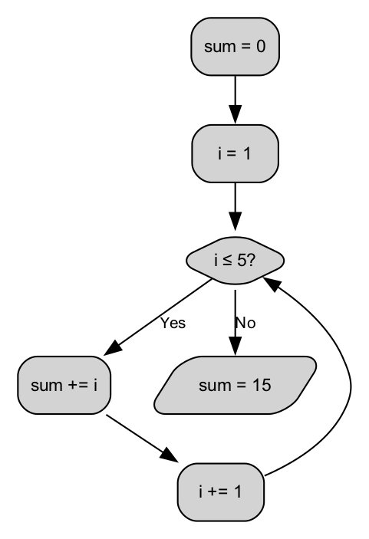
- Accumulator Concept Diagram
- 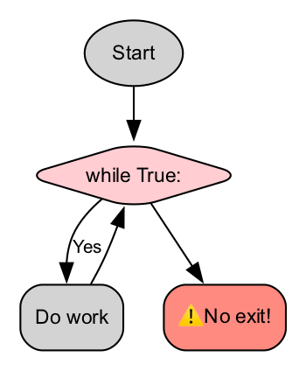
- Infinite Loop Hazard

🏫 In-Class Exercises (3)

Exercise 1
Print numbers from 10 down to 1.

Exercise 2
Calculate the sum of numbers from 1 to N (N from input).

Exercise 3
Keep asking password until user enters "python123".

✅ Solutions

Solution 1
for i in range(10, 0, -1):
print(i)

Solution 2
n = int(input("Enter N: "))
total = 0
for i in range(1, n+1):
total += i
print("Sum =", total)

Solution 3
password = input("Enter password: ")
while password != "python123":
print("Wrong, try again.")
password = input("Enter password: ")
print("Access granted.")

🏠 Take-Home Assignments (3)

1️⃣ Multiplication table generator
Input: a number Output: multiplication table 1–10

2️⃣ Sum of even numbers 1–100
Use a loop + condition

3️⃣ Guessing game
Computer asks user to enter number until correct guess (simple fixed number now)

📚 References
- Think Python — Loops & Iteration
- Python Docs: for, while, range()

⚠️ Common Mistakes & Fixes
Problem | Fix
Forgetting increment in while | Always update loop variable
Using range() incorrectly | Remember end is exclusive
Infinite loops | Check termination logic
Using wrong accumulator (=+ not +=) | Correct form: total += x

🔮 Next Week Preview
Week 5 — Functions & Modular Programming
- Function definition & calling
- Parameters vs arguments
- Return values
- Local vs global variables
- Problem decomposition with functions

