✅ Week 6 — Lists, Tuples & Strings
Theme: Sequence data types and basic operations

🎯 Learning Objectives
By the end of Week 6, students will be able to:
- ✅ Understand what sequences are in Python: lists, tuples, and strings
- ✅ Create, access, and modify lists and tuples
- ✅ Iterate through sequences using loops
- ✅ Use string methods and slicing
- ✅ Apply sequences to solve simple real-world problems

📘 Deep Concepts Explained

🔹 Lists
- Definition: Ordered, mutable collection of items
- Syntax: [item1, item2, item3]
- Access: list[index] (0-based indexing)
fruits = ["apple", "banana", "cherry"]
print(fruits[0]) # apple
fruits.append("date") # add item
fruits[1] = "blueberry" # modify item

🔹 Tuples
- Definition: Ordered, immutable collection of items
- Syntax: (item1, item2)
- Access: Same as list, but cannot modify
coordinates = (10, 20)
print(coordinates[1]) # 20
# coordinates[0] = 5 → Error
Use-case: Fixed data like coordinates, RGB values, constants.

🔹 Strings as Sequences
- Strings are immutable sequences of characters
- Access by indexing or slicing
text = "Hello World"
print(text[0]) # H
print(text[0:5]) # Hello
print(text[-5:]) # World
Useful string methods:
- len(text) — length of string
- text.upper() — uppercase
- text.lower() — lowercase
- text.replace("Hello","Hi")
- text.split() — split into list by spaces

🔹 Iterating Over Sequences
numbers = [1,2,3,4,5]
for num in numbers:
print(num * 2)
for char in "Python":
print(char)

✅ Python Code Examples

Example 1 — List Operations
colors = ["red", "green", "blue"]
colors.append("yellow")
colors.remove("green")
print(colors) # ['red', 'blue', 'yellow']

Example 2 — Tuple Unpacking
point = (10, 20)
x, y = point
print("X:", x, "Y:", y)

Example 3 — String Manipulation
message = "hello python"
print(message.upper())
print(message.split())
print(message.replace("python","world"))

🖼️ Diagrams (Placeholders)
- 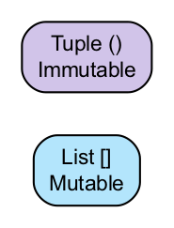
- List vs Tuple Comparison
- 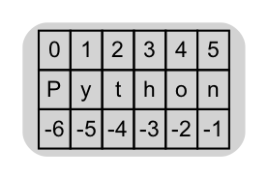
- Sequence Indexing Diagram
- 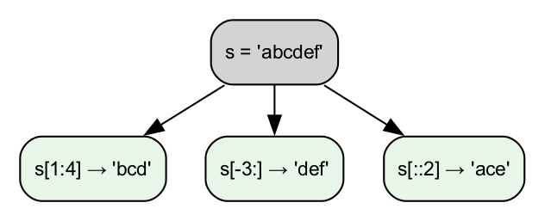
- String Slicing Flow

🏫 In-Class Exercises (3)
- Create a list of 5 numbers, print their squares using a loop.
- Given a tuple of 3 elements, unpack and print each element.
- Input a string, print it in reverse using slicing.

✅ Solutions
Exercise 1
numbers = [1,2,3,4,5]
for n in numbers:
print(n ** 2)
Exercise 2
data = (10, 20, 30)
a, b, c = data
print(a, b, c)
Exercise 3
text = input("Enter string: ")
print(text[::-1])

🏠 Take-Home Assignments (3)
- Shopping List Manager: Create a list of 5 items, remove 2, add 1, and print final list.
- Sentence Analyzer: Input a sentence, output number of words, uppercase version, and first 5 characters.
- Tuple Calculator: Store 3 numbers in a tuple, calculate sum and product (without modifying tuple).

📚 References
- Think Python — Chapter 5: Lists and Strings
- Python Docs: https://docs.python.org/3/tutorial/datastructures.html

⚠️ Common Mistakes & Best Practices
Mistake | Solution
Trying to modify a tuple | Use list if mutable needed
Using wrong index | Remember Python is 0-based
Forgetting slicing syntax | [start:end:step]
Confusing string methods vs list methods | Strings immutable; use methods that return new string

🔮 Next Week Preview
Week 7 — Dictionaries & Sets
- Dictionary key-value mapping
- Accessing and updating entries
- Iterating through dictionaries
- Sets: unique collections and operations

