✅ Week 9 — Introduction to Algorithms & Problem Solving
Theme: Algorithmic thinking, problem decomposition, and basic strategies

🎯 Learning Objectives
By the end of Week 9, students will be able to:
- ✅ Understand what an algorithm is and why it is important
- ✅ Represent algorithms using pseudocode and flowcharts
- ✅ Apply step-by-step problem-solving strategies
- ✅ Solve simple computational problems: counting, summing, searching
- ✅ Debug logical errors in small programs

📘 Deep Concepts Explained

🔹 What is an Algorithm?
Definition: A finite sequence of steps to solve a problem.
Real-world analogy:
- Cooking a recipe → steps, order, input ingredients → final dish
- Algorithm = Recipe, Program = Cooked Dish
Properties of algorithms:
- Finiteness → terminates after finite steps
- Definiteness → each step is clear and unambiguous
- Input → zero or more values
- Output → produces at least one result
- Effectiveness → steps are basic and executable

🔹 Pseudocode
- Plain-English, step-by-step representation of an algorithm
- Not language-specific, focuses on logic
Example: Sum first N numbers
Algorithm SumFirstN
Input: integer N
Output: sum of numbers 1 to N
1. Initialize sum = 0
2. For i = 1 to N
sum = sum + i
3. Output sum

🔹 Flowcharts
- Visual representation of an algorithm using shapes:
Shape | Meaning
Oval | Start/End
Rectangle | Process/Instruction
Diamond | Decision/Condition
Parallelogram | Input/Output
Example: Flowchart for sum 1 to N
- Start → Input N → sum=0 → i=1 → Is i≤N? → Yes → sum=sum+i → i=i+1 → repeat → No → Output sum → End

🔹 Problem-Solving Steps
- Understand the problem → inputs, outputs, constraints
- Break problem into smaller tasks
- Identify patterns and repetition
- Choose suitable data structures
- Write pseudocode or flowchart
- Implement in Python
- Test and debug

✅ Python Code Examples

Example 1 — Sum of First N Numbers
N = int(input("Enter N: "))
total = 0
for i in range(1, N+1):
total += i
print("Sum =", total)

Example 2 — Count Even Numbers in List
numbers = [2,3,4,5,6,7,8]
count = 0
for num in numbers:
if num % 2 == 0:
count += 1
print("Even numbers =", count)

Example 3 — Find Maximum in List
numbers = [5, 10, 3, 8, 2]
max_num = numbers[0]
for num in numbers:
if num > max_num:
max_num = num
print("Maximum:", max_num)

🖼️ Diagrams (Placeholders)
- 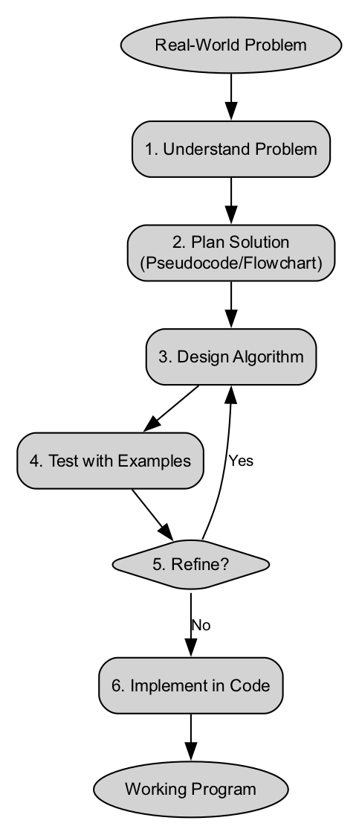
- Algorithm Flowchart
- 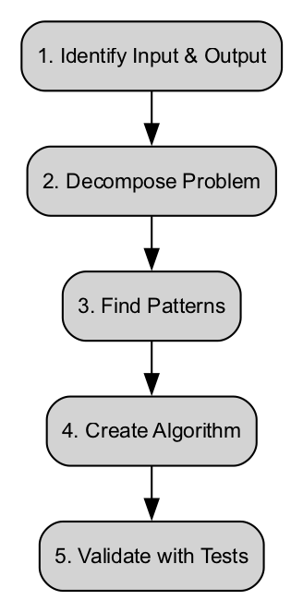
- Problem-Solving Steps Diagram
- 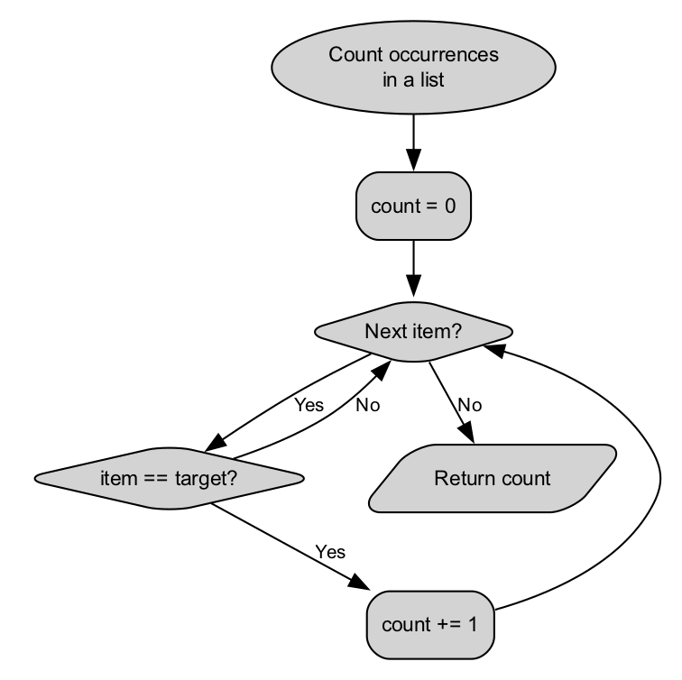
- Counting Algorithm Flow

🏫 In-Class Exercises (3)
- Input a number N, print all odd numbers from 1 to N.
- Input a list of numbers, count how many are greater than 10.
- Input a list of numbers, find the minimum value using a loop.

✅ Solutions
Exercise 1
N = int(input("Enter N: "))
for i in range(1, N+1):
if i % 2 != 0:
print(i)
Exercise 2
numbers = [5,12,7,15,3,20]
count = 0
for num in numbers:
if num > 10:
count += 1
print("Numbers greater than 10:", count)
Exercise 3
numbers = [5,12,7,15,3,20]
min_num = numbers[0]
for num in numbers:
if num < min_num:
min_num = num
print("Minimum:", min_num)

🏠 Take-Home Assignments (3)
- Input a list of N numbers, output the sum of all even numbers.
- Create a program that finds both the maximum and minimum in a list.
- Input a sentence, count frequency of each vowel using a dictionary.

📚 References
- Think Python — Chapters 4–6: Loops, Lists, Conditionals
- Problem Solving with Algorithms and Data Structures — Chapters 1–2

⚠️ Common Mistakes & Best Practices
Mistake | Solution
Not understanding the problem | Write inputs, outputs clearly
Incorrect loop boundaries | Always check range() limits
Not updating accumulator | Initialize and increment correctly
Confusing flowchart shapes | Use proper standard shapes consistently

🔮 Next Week Preview
Week 10 — Searching & Counting Algorithms
- Linear search
- Counting occurrences
- Simple metrics on lists
- Debugging iterative algorithms
- Time complexity discussion (O(n))

