✅ Week 11 — Introduction to Algorithm Efficiency & Big O
Theme: Understanding time complexity and evaluating algorithm efficiency

🎯 Learning Objectives
By the end of Week 11, students will be able to:
- ✅ Explain the concept of algorithm efficiency
- ✅ Identify constant, linear, and quadratic time complexity
- ✅ Analyze loops and nested loops for performance
- ✅ Compare multiple solutions based on efficiency
- ✅ Apply basic optimization strategies to code

📘 Deep Concepts Explained

🔹 What is Algorithm Efficiency?
Definition: How fast a program runs or how much memory it uses as the input grows.
Real-world analogy:
- Searching for a book in a small bookshelf (fast) vs. a huge library (slow)
- Algorithm efficiency measures scalability

🔹 Big O Notation
- Describes upper bound of runtime growth as input size increases
- Common examples:
Complexity | Symbol | Example
Constant | O(1) | Accessing first element of a list
Linear | O(n) | Looping through list of n items
Quadratic | O(n²) | Nested loops over n items
Logarithmic | O(log n) | Binary search

🔹 Examples
O(1) — Constant Time
numbers = [1,2,3,4,5]
print(numbers[0]) # Always one operation
O(n) — Linear Time
for i in range(5):
print(i) # Number of operations grows linearly with n
O(n²) — Quadratic Time
for i in range(5):
for j in range(5):
print(i, j) # Nested loops → n*n operations

🔹 Analyzing Loops
- Single loop over n items → O(n)
- Nested loop (loop inside loop over same n) → O(n²)
- Multiple consecutive loops → O(n) + O(n) = O(n)
- Nested loops + separate loops → O(n² + n) = O(n²)
Key: Only the dominant term matters for large n.

🔹 Practical Tip
- Avoid unnecessary nested loops
- Use data structures (sets, dicts) to reduce repeated scanning
- Precompute values if needed
# Example: Count duplicates efficiently using dictionary
numbers = [1,2,3,1,2,1]
freq = {}
for num in numbers:
freq[num] = freq.get(num,0) + 1 # O(n)

✅ Python Code Examples

Example 1 — Linear vs Quadratic
# Linear
numbers = [1,2,3,4,5]
for n in numbers:
print(n)
# Quadratic
for i in numbers:
for j in numbers:
print(i,j)

Example 2 — Optimized Counting
numbers = [1,2,3,1,2,1]
freq = {}
for num in numbers:
freq[num] = freq.get(num,0) + 1
print(freq)

🖼️ Diagrams (Placeholders)
- 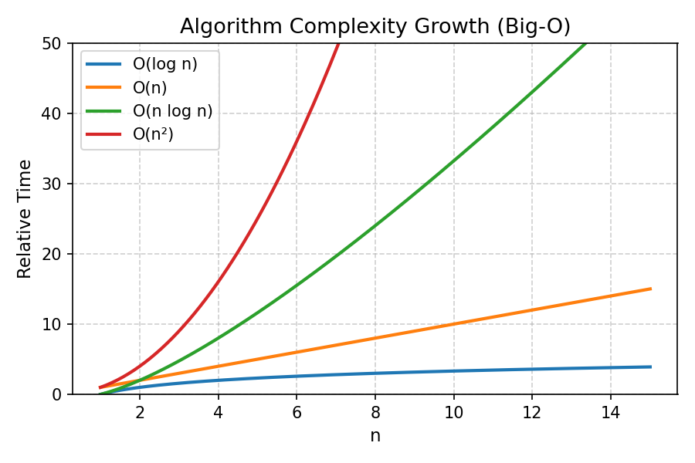
- Big O Growth Chart
- 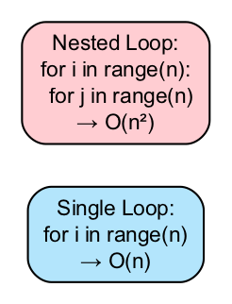
- Loop Complexity Comparison
- 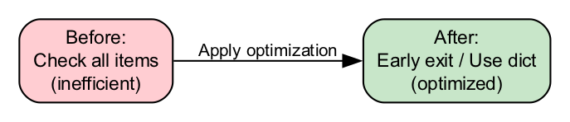
- Optimization Example Flow

🏫 In-Class Exercises (3)
- Identify the time complexity of single vs nested loops in a code snippet.
- Count elements greater than 10 in a list and determine Big O.
- Compare two algorithms that find duplicates in a list: brute-force vs dictionary.

✅ Solutions
Exercise 1
# Single loop → O(n)
for i in range(n):
print(i)
# Nested loop → O(n^2)
for i in range(n):
for j in range(n):
print(i,j)
Exercise 2
numbers = [5,12,7,15,3]
count = 0
for num in numbers: # O(n)
if num > 10:
count += 1
print(count)
Exercise 3
# Brute force → O(n^2)
numbers = [1,2,3,1,2]
for i in numbers:
for j in numbers:
if i == j and i != j:
print("Duplicate found")
# Dictionary → O(n)
freq = {}
for num in numbers:
freq[num] = freq.get(num,0)+1
print(freq)

🏠 Take-Home Assignments (3)
- Input a list of N numbers, determine whether there are duplicates (use efficient method).
- Compare two different implementations of summing numbers 1…N, analyze Big O.
- Create a nested loop program and analyze its time complexity; suggest optimizations.

📚 References
- Grokking Algorithms — Chapters 1–2
- Introduction to Algorithms — Section 2.1
- Python Docs: https://wiki.python.org/moin/TimeComplexity

⚠️ Common Mistakes & Best Practices
Mistake | Solution
Assuming single operation for all loops | Count iterations properly
Ignoring dominant term | Only the largest term matters for large n
Nested loops when not needed | Use dictionaries/sets to reduce O(n²)

🔮 Next Week Preview
Week 12 — Mini Project: Search & Counting Application
- Build a small application combining lists, dictionaries, loops
- Apply linear search and counting algorithms
- Handle user input and exceptions
- Optimize performance and test with sample data

