✅ Week 16 — Final Capstone Project
Theme: Integrating all concepts learned into a complete application

🎯 Learning Objectives
By the end of Week 16, students will be able to:
- ✅ Design a complete Python application using loops, functions, and data structures
- ✅ Apply searching, counting, and sorting algorithms effectively
- ✅ Implement recursive solutions where appropriate
- ✅ Handle user input, exceptions, and program errors
- ✅ Test, debug, and optimize the application
- ✅ Present a mini report with project results

📘 Deep Concepts Explained

🔹 Capstone Project Overview
Project Idea: “Student Performance Manager”
Features:
- Add, update, and delete students
- Search for a student by name (linear or binary search)
- Count students above/below a grade threshold
- Display statistics (highest, lowest, average)
- Sort students by grade (bubble sort / merge sort)
- Recursive features (e.g., calculating factorial, sum, or nested list sums)
- Handle invalid input and exceptions
Design Steps:
- Plan modules: separate functions for each feature
- Choose data structures: list of dictionaries for student records
- Implement algorithms: search, count, sort, recursion
- Test extensively: small datasets first
- Add input validation: ensure program doesn’t crash
- Optimize performance: avoid redundant loops, use dictionaries where needed

✅ Python Code Example — Capstone Skeleton
students = []
def add_student(name, grade):
students.append({"name": name, "grade": grade})
def update_student(name, grade):
for s in students:
if s["name"].lower() == name.lower():
s["grade"] = grade
return True
return False
def delete_student(name):
global students
students = [s for s in students if s["name"].lower() != name.lower()]
def search_student(name):
for s in students:
if s["name"].lower() == name.lower():
return s
return None
def count_above(threshold):
return sum(1 for s in students if s["grade"] > threshold)
def statistics():
if not students:
return None
grades = [s["grade"] for s in students]
return {"max": max(grades), "min": min(grades), "average": sum(grades)/len(grades)}
# Example: Recursive function for factorial
def factorial(n):
if n == 0: return 1
return n * factorial(n-1)
# Sorting: Bubble Sort by grade
def sort_students_by_grade():
n = len(students)
for i in range(n):
for j in range(0, n-i-1):
if students[j]["grade"] > students[j+1]["grade"]:
students[j], students[j+1] = students[j+1], students[j]
# Sample usage
add_student("Alice", 90)
add_student("Bob", 75)
add_student("Charlie", 85)
print("Student Stats:", statistics())
print("Students above 80:", count_above(80))
sort_students_by_grade()
print("Sorted Students:", students)

🖼️ Diagrams (Placeholders)
- 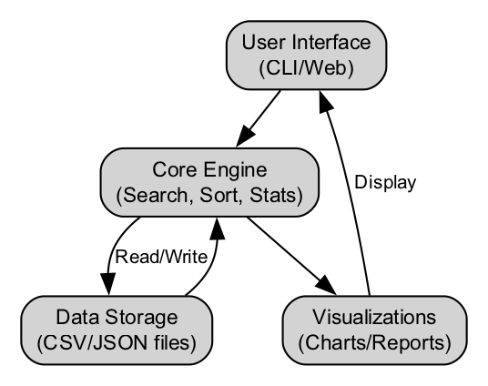
- Capstone Project Data Flow
- 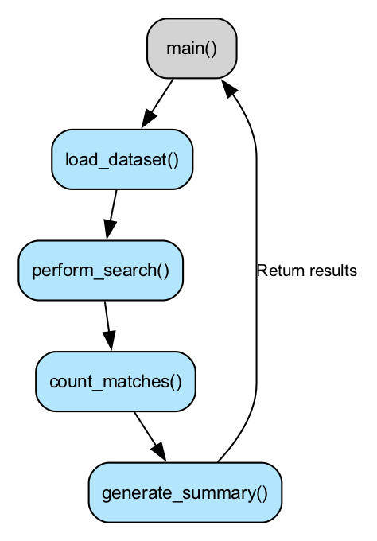
- Function Interaction Diagram
- 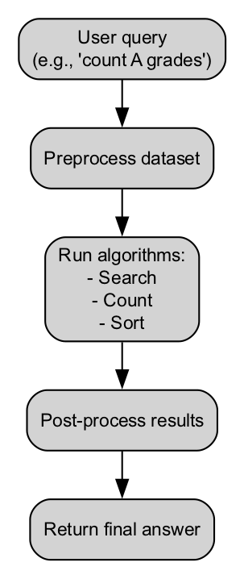
- Algorithm Integration Flow

🏫 In-Class Exercises (3)
- Add a menu system for user interaction: Add, Search, Update, Delete, Statistics.
- Implement recursive sum of all grades.
- Test sorting students by name alphabetically instead of grade.

✅ Solutions
Exercise 1 — Menu System Skeleton
while True:
print("\nMenu: 1-Add, 2-Search, 3-Update, 4-Delete, 5-Stats, 6-Exit")
choice = input("Choose: ")
if choice == "1":
name = input("Name: ")
grade = int(input("Grade: "))
add_student(name, grade)
elif choice == "2":
name = input("Search Name: ")
print(search_student(name))
elif choice == "3":
name = input("Update Name: ")
grade = int(input("New Grade: "))
print(update_student(name, grade))
elif choice == "4":
name = input("Delete Name: ")
delete_student(name)
elif choice == "5":
print(statistics())
elif choice == "6":
break
Exercise 2 — Recursive Sum of Grades
def recursive_sum_grades(lst):
if not lst:
return 0
return lst[0]["grade"] + recursive_sum_grades(lst[1:])
print("Total Grades:", recursive_sum_grades(students))
Exercise 3 — Sort by Name
students.sort(key=lambda x: x["name"])
print("Students sorted by name:", students)

🏠 Take-Home Assignments (3)
- Extend project: allow saving/loading data from CSV files.
- Implement a function to display top N students by grade.
- Optimize search: implement binary search on sorted student names.

📚 References
- Think Python — Chapters 4–8
- Problem Solving with Algorithms and Data Structures — Sorting, Searching, Recursion
- Python Docs: https://docs.python.org/3/tutorial/

⚠️ Common Mistakes & Best Practices
Mistake | Solution
Not modularizing | Split program into functions for each feature
Unsorted list for binary search | Sort first before applying binary search
Invalid user input | Always validate and use try/except
Redundant loops | Use dictionaries or generator expressions where possible

🔮 Next Steps After Week 16
- Mini Projects Review: Week 4, 8, 12
- Final Capstone Project: Week 13–16 (current)
- Detailed Rubrics: evaluation of code structure, correctness, efficiency
- References List: Books, papers, and videos
- Python Script to Generate All Diagrams: automate images creation

This completes Course 1 — Programming Logic & Algorithms with Python.
Next phase:
- Mini Projects (Week 4, 8, 12)
- Final Capstone Project evaluation and rubric
- Python script for diagram generation

