電通二乙微處理器實驗 實驗預報

實驗名稱 | Lab03
組別 | 31 | 組員 | 徐聞佐03050273 許孟宸03050592

- 實驗目的
1.使用 USB-Serial 做為輸入輸出
2.讀取類比輸入之數值

- 實驗步驟
- 由 Arduino 傳送訊息給PC，PC 經由 Serial Monitor 接收，由 PC 傳送指令至 Arduino
- Part I: 量測電壓值
- Part II: 量測可變電阻值
- Part III: 量測光敏電阻值

- 程式碼
1. void setup()
{
Serial.begin(9600);
}

void loop()
{
float Analogin=0;
int i;
float Vin=0;
for(int i=0 ; i<=5;i++ )
{
Analogin=analogRead(A1);
Analogin = 0.7*Analogin + 0.3* analogRead(A0);
}
Vin = Analogin * 5/1024;

Serial.println(Vin);
Serial.println("\n");
delay(500);

}

2. float R1=2.02,R2=972000;

const int analogInPin=A2;
double ResisterValue = 106.67*1000; //量測可變電阻的最大值 (R1+R2)
// the loop routine runs over and over again forever:

int Vin = 5;
float sensorValue = 0;
float sensorVoltage;
float r1,r2;

/* for (int i=0;i<20;i++) {
for (int k=0;k<5;k++) {

sensorValue = 0.7* sensorValue + 0.3* analogRead(analogInPin);}*/

/*sensorVoltage = sensorValue * 5 / 1024;
R1= sensorVoltage*ResisterValue/Vin;*/

//Calculate R1 by sensorVoltage = Vin * R1 / (R1+R2)
//Output sensorValue, sensorVoltage, and R1 to serial
//Sleep 0.5 seconds

void setup() {
// initialize the digital pin as an output.
Serial.begin(9600);

}

// the loop routine runs over and over again forever:
void loop() {
for (int i=0;i<5;i++)
{
sensorValue = 0.7* sensorValue + 0.3* analogRead(analogInPin);
sensorVoltage = sensorValue * 5 / 1024 ;
//Output sensorVoltage to serial
Serial.print("sensor = ");
Serial.println(sensorValue);
delay(250);
}
Serial.print("sensorVoltage = " );
Serial.println(sensorVoltage);
Serial.print("sensorValue = " );
Serial.println(sensorValue);
Serial.print("R1= " );
Serial.println(R1);
delay(1000);
}

3. int Vin = 5;
const int analogInPin = A3;
const int analogInPin1 = A2;
double sensorValue = 0;
double sensorValue1 = 0;
double sensorVoltage = 0;
double sensorVoltage1 = 0;
double ResisterValue = 1000;
double ResisterValue1 = 981300;
double R2,R1; void setup() {
Serial.begin(9600);
for(int i=1;i<=5;i++) {
sensorValue += analogRead(analogInPin);
}
sensorValue = sensorValue/5;
}
void loop()
{
for(int i=1;i<=20;i++)
{
for(int i=1;i<=5;i++)
{
sensorValue = 0.7* sensorValue + 0.3 * analogRead(analogInPin);
sensorValue1 = 0.7* sensorValue1 + 0.3 * analogRead(analogInPin1);
}
sensorVoltage = sensorValue * 5 / 1024;
sensorVoltage1 = sensorValue1 * 5 / 1024;
R2 = (sensorVoltage * ResisterValue)/(Vin-sensorVoltage);
R1 = 981300 - (sensorVoltage1 * ResisterValue1)/Vin; Serial.print("sensorValue = ");
Serial.println(sensorValue1); Serial.print("sensorVoltage = ");
Serial.println(sensorVoltage1); Serial.print("Potentiometer = ");
Serial.println(R1);
Serial.println("--------------");
Serial.print("LDR = "); Serial.println(R2);
Serial.println("**************");
delay(500);
}
delay(1000);
}

4. void setup()
{
Serial.begin(9600);
}
float sensorValue ;
float sensorVoltage;
float R1=0,R2=1083000,Vin=5;
int i;
void loop()
{
for (i=0;i<=5;i++)
{
sensorValue = 0.7* sensorValue + 0.3* analogRead(A2);
}
sensorVoltage = sensorValue * 5 / 1024 ;// sensorVoltage= Vin * R1 / (R1+R2)

delay(100);
Serial.print("sensorVoltage=");
Serial.print(sensorVoltage);
Serial.print("\n");

}

- 實驗結果分析
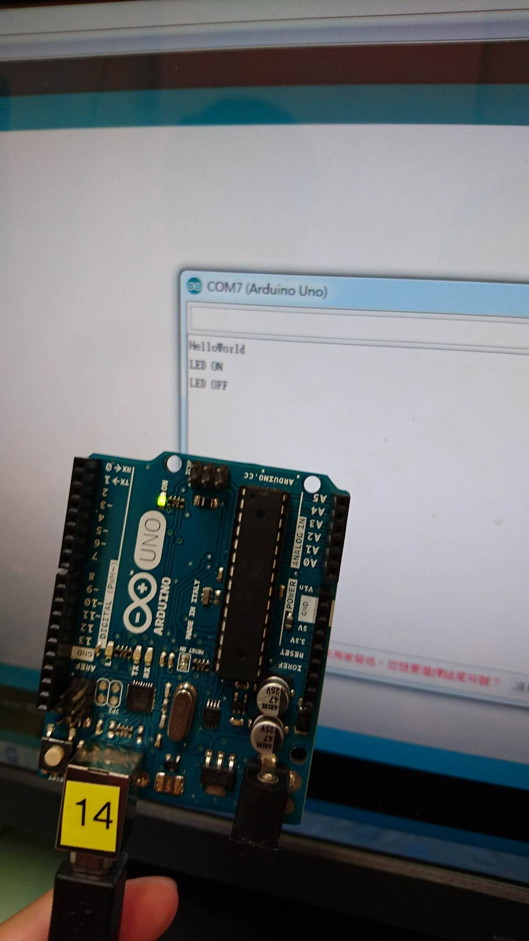

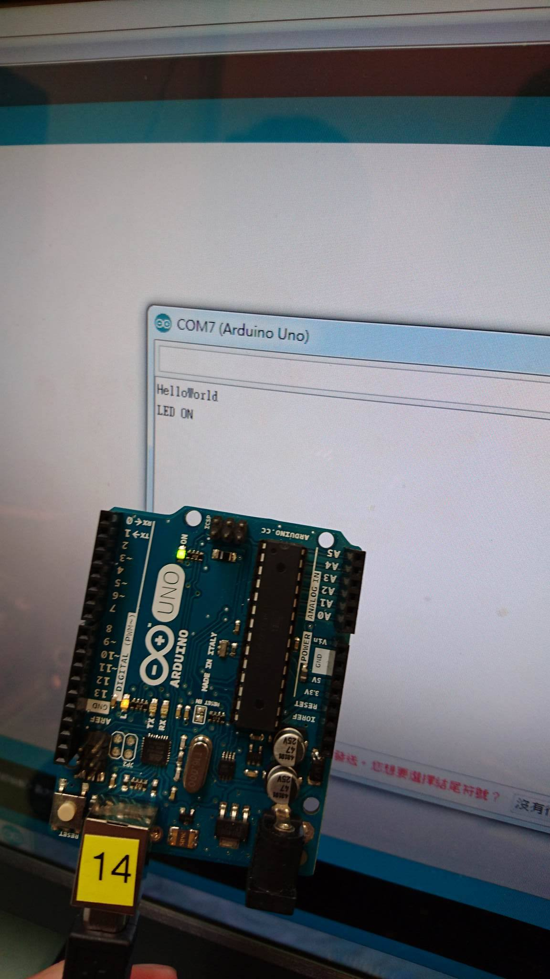

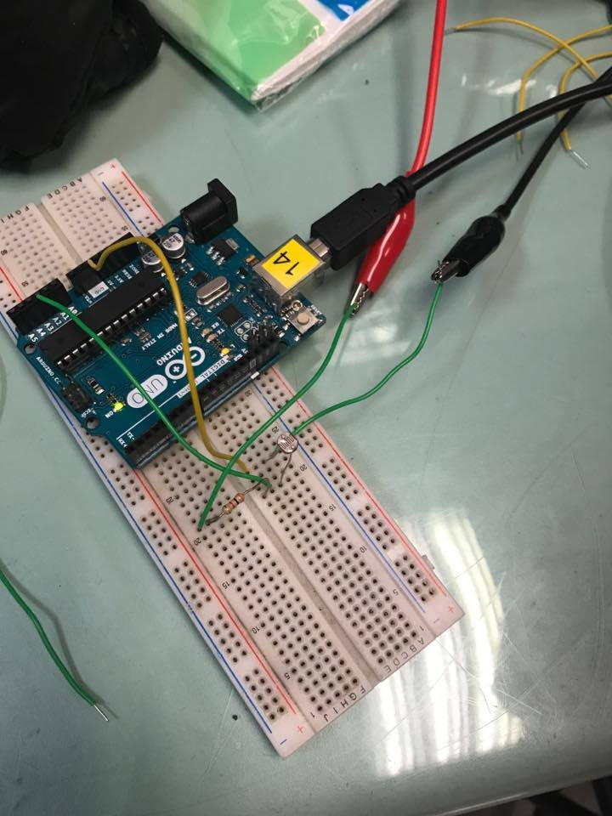

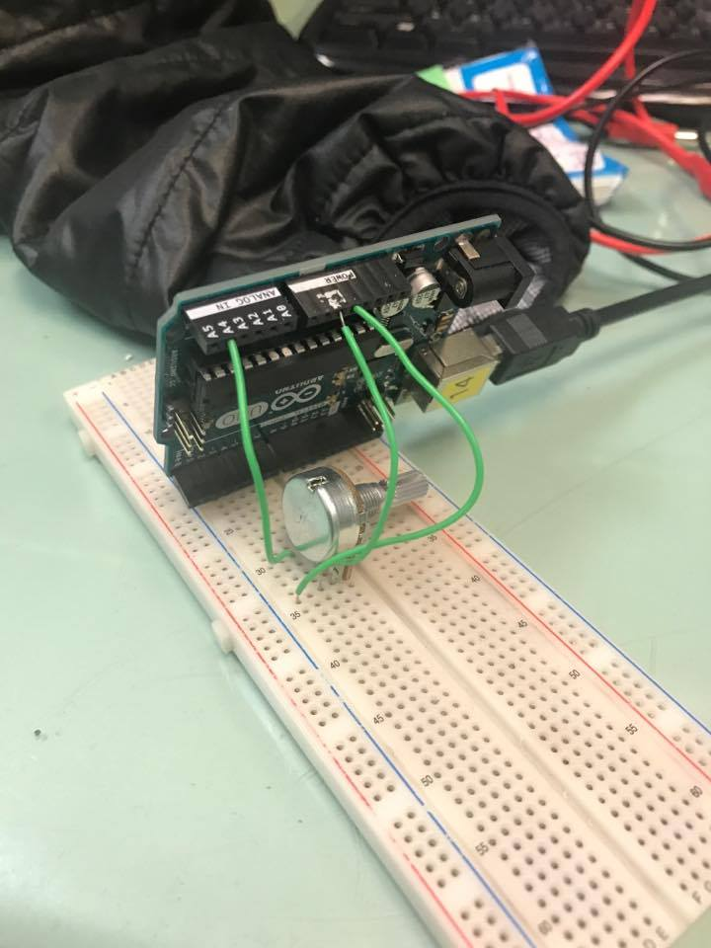

- 心得討論
此次實驗總共有四個項目,前兩個很快就靠老師的講義完成,而後面兩個因
測量與計算花了許多時間才完成。

