Table of Contents

Hedging Liability Cashflows with Python: A Concise Guide
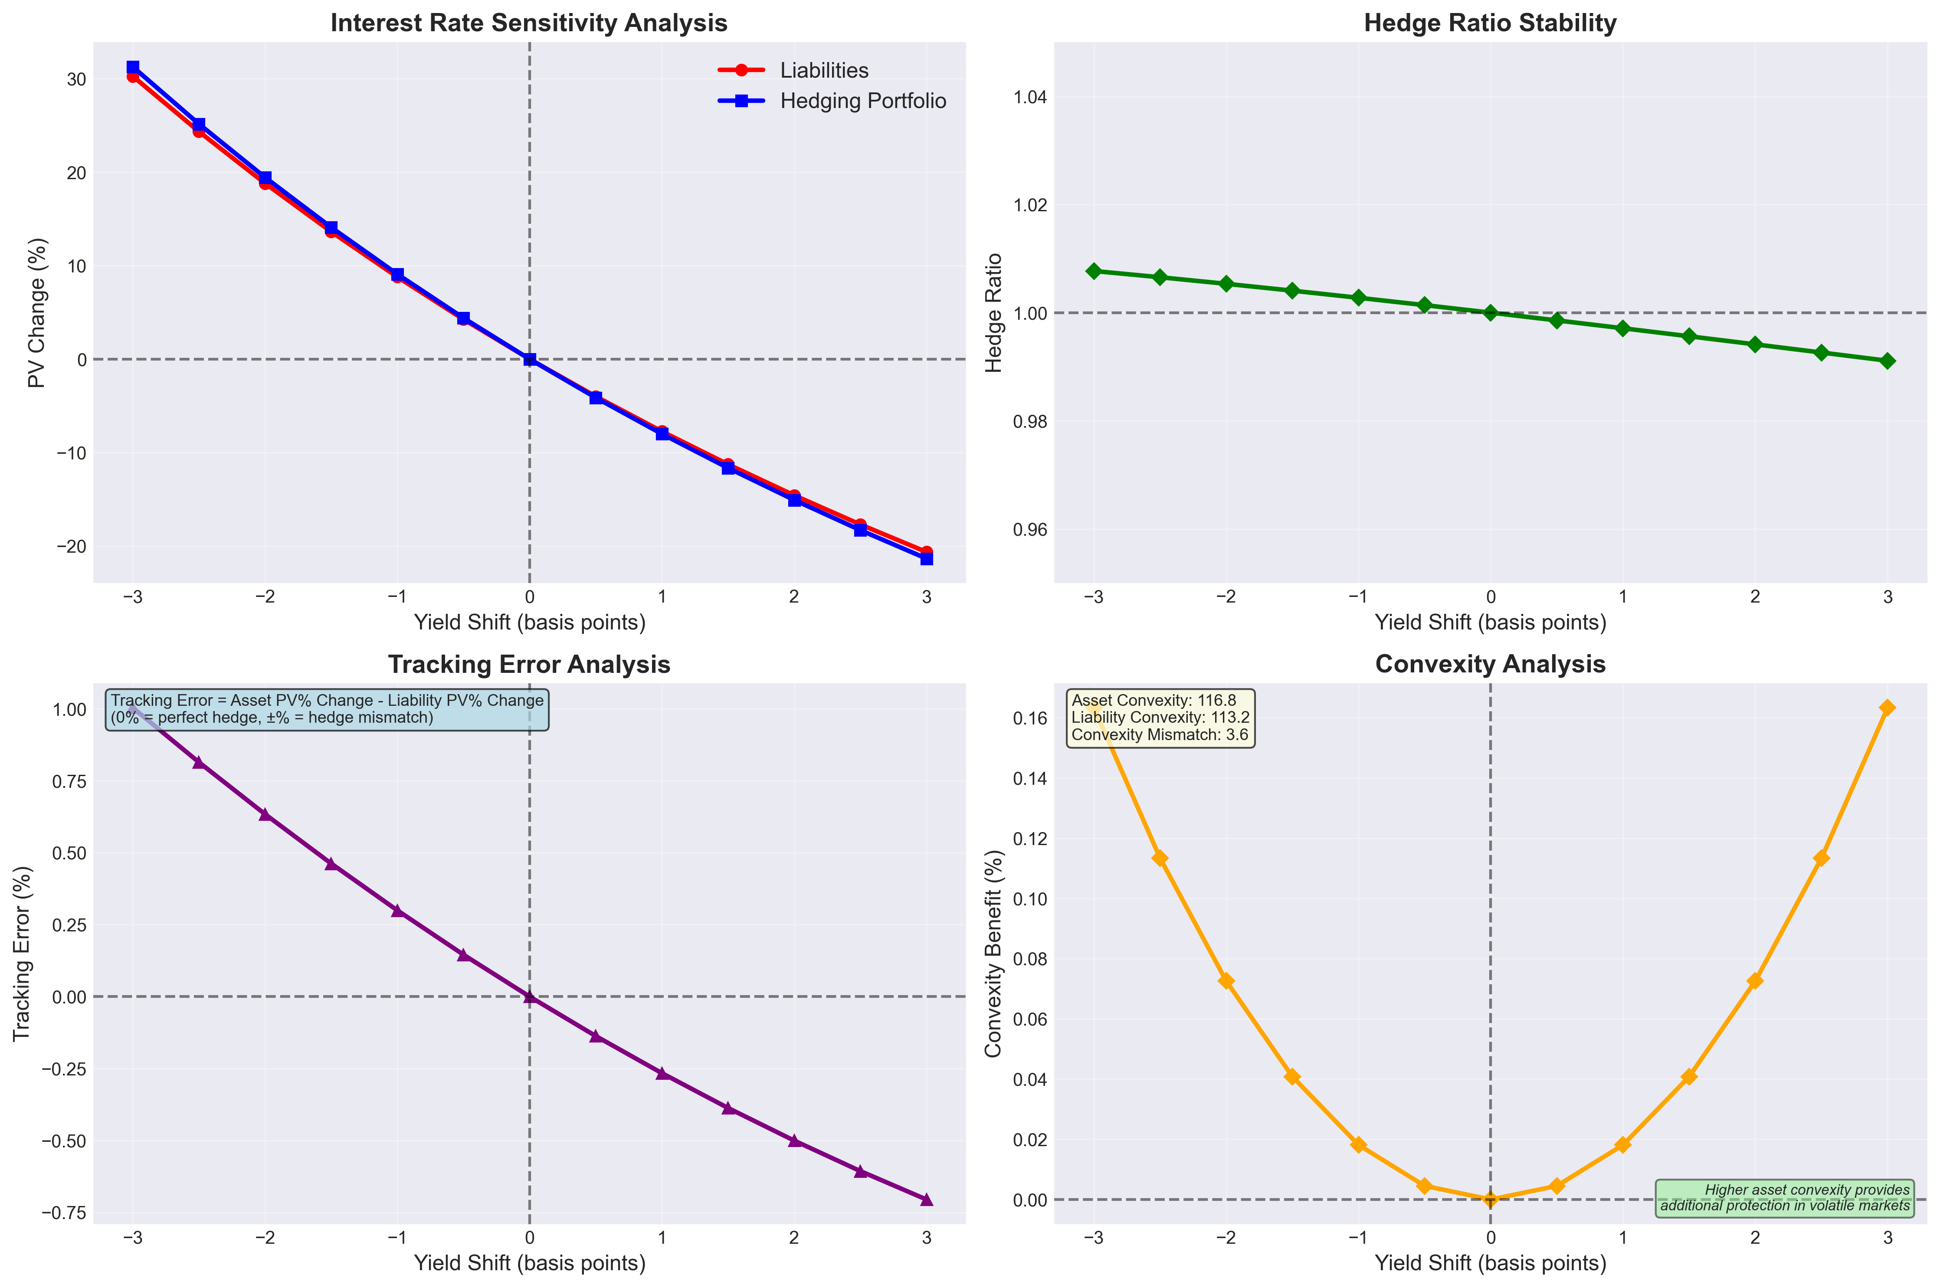
Figure 1: Example of portfolio sensitivity for insurance company

Why Hedging is Necessary
Typically, we take risks where we want to achieve profits. For insurance companies or certain lines of business, we want to hedge out the risks that we believe won’t create appropriate risk-adjusted returns. A clear example of this is interest rate risk for certain life insurance companies, where we sell annuities but don’t want to take on the risk or market risk from investing in annuity funding.

Why Hedge Programmatically
Hedging programmatically helps us create a model that will help us understand how assets and liabilities relate to each other. With Python, it is relatively easier compared to other programming languages, and can help us sense-check results from other more sophisticated hedging applications, or simply create a script that we can run periodically to determine the appropriate hedging portfolio for, say, a small book of liabilities.

Python Prerequisites & Limitations

Requirements
What You Need:
- Python 3.10+ environment
- Historical yield curve data
- Bond universe details (maturities, coupons)
What This Example Doesn’t Handle:
- Credit risk (default probability)
- Callable or convertible bonds
- Multi-currency portfolios
- Liquidity constraints
- Non-parallel yield curve shifts (requires convexity adjustments)

Resources
- Code can be found here: https://github.com/yoyowu1000/finalyse_hedging_article

Core Concepts That Are Relevant

Understanding the Building Blocks
In our example, we’ll focus more on duration, specifically Macaulay duration, to match our liabilities and assets.
Duration can be seen, approximately, as the sensitivity of your portfolio relative to interest rate changes. For example, a 5-year duration means that a 1% increase causes approximately 5% portfolio value loss.
We also examine convexity, which helps us understand the nonlinear relationship of our portfolio’s price change relative to interest rate changes. In other words, it helps correct our assumption that prices change linearly when they don’t.

Getting Started with the Code
To begin hedging with Python, we’ll use the example code from examples/insurance_company.py. Here’s how we structure the key components:
Creating Liabilities:
liabilities = [
# Short-term death benefits
Liability(time_years=0.5, amount=500), # €500k
Liability(time_years=1, amount=1_000), # €1,000k
Liability(time_years=1.5, amount=750), # €750k
# Medium-term annuity payments
Liability(time_years=3, amount=2_500), # €2,500k
Liability(time_years=4, amount=2_200), # €2,200k
Liability(time_years=5, amount=1_800), # €1,800k
# Long-term endowments and pensions
Liability(time_years=7, amount=3_000), # €3,000k
Liability(time_years=10, amount=3_200), # €3,200k
Liability(time_years=15, amount=4_500), # €4,500k
Liability(time_years=20, amount=5_000), # €5,000k
]
Defining Available Bonds:
bonds = [
# Very short-term bonds
Bond(maturity_years=0.5, coupon_rate=0.018, face_value=1),
Bond(maturity_years=1.5, coupon_rate=0.023, face_value=1),
# Short-term bonds
Bond(maturity_years=1, coupon_rate=0.020, face_value=1),
Bond(maturity_years=2, coupon_rate=0.025, face_value=1),
# Medium-term bonds
Bond(maturity_years=3, coupon_rate=0.028, face_value=1),
Bond(maturity_years=5, coupon_rate=0.032, face_value=1),
Bond(maturity_years=7, coupon_rate=0.035, face_value=1),
# Long-term bonds
Bond(maturity_years=10, coupon_rate=0.038, face_value=1),
Bond(maturity_years=15, coupon_rate=0.042, face_value=1),
Bond(maturity_years=20, coupon_rate=0.045, face_value=1),
]
Defining the Yield curve and Running the Optimization:
yield_curve = YieldCurve(
times=[0.5, 1, 2, 3, 5, 7, 10, 15, 20, 30],
rates=[0.018, 0.020, 0.025, 0.028, 0.032, 0.035, 0.038, 0.042, 0.045, 0.048],
)
optimizer = HedgingOptimizer(liabilities, bonds, yield_curve)
result = optimizer.duration_matching()
The code handles all the calculations and returns optimal bond quantities that minimize interest rate risk.

Explaining the Models
The hedging framework uses three core Pydantic models that ensure data integrity through validation:
1. Liability Model:
Liability(time_years=5, amount=1_000_000)
- Represents future payment obligations
- Validates that time is positive and amount is non-negative
- Immutable design prevents accidental modifications
2. Bond Model:
Bond(maturity_years=10, coupon_rate=0.03, face_value=1_000_000)
- Models fixed-income securities with annual coupons
- Generates cashflow schedule automatically
- Calculates present value and duration using yield curve data
3. YieldCurve Model:
YieldCurve(times=[1, 2, 5, 10], rates=[0.02, 0.025, 0.03, 0.035])
- Stores term structure of interest rates
- Provides linear interpolation for any maturity
- Used for discounting all future cashflows
These models work together: the YieldCurve provides discount rates, Bonds generate cashflows based on their terms, and Liabilities represent the obligations we need to hedge.

Explaining How Optimization Works
The duration matching optimization minimizes interest rate risk by aligning the weighted average duration of assets and liabilities:
The Optimization Process:
- Calculate Liability Duration:
  - Each liability’s duration equals its time to payment
  - Portfolio duration = weighted average by present value
- Set Up the Objective:
minimize: Σ(bond_quantities²)
- Minimizes concentration risk by penalizing large positions
- Duration matching is enforced through constraints, not the objective
- Results in a diversified portfolio spread across multiple bonds
- Apply Constraints:
  - Duration equality: Portfolio duration = Liability duration (enforced as equality constraint)
  - Full funding: Total asset value ≥ Total liability value (inequality constraint)
  - No short selling: Bond quantities ≥ 0 (bounds constraint)
  - Optional: Maximum position sizes
- Solve Using SciPy:
result = scipy.optimize.minimize(
objective_function,
initial_guess,
method='SLSQP',
constraints=constraints
)
Why Duration Matching Works:
- When durations match, portfolio value changes from interest rate movements are approximately equal for assets and liabilities
- A 1% rate increase affects both sides similarly, maintaining the funding ratio
- Achieves 85-90% hedge effectiveness for parallel yield curve shifts
The optimizer returns optimal bond quantities that create a self-financing portfolio with minimal interest rate sensitivity.

Results
Running uv run python examples/insurance_company.py will yield the following results:
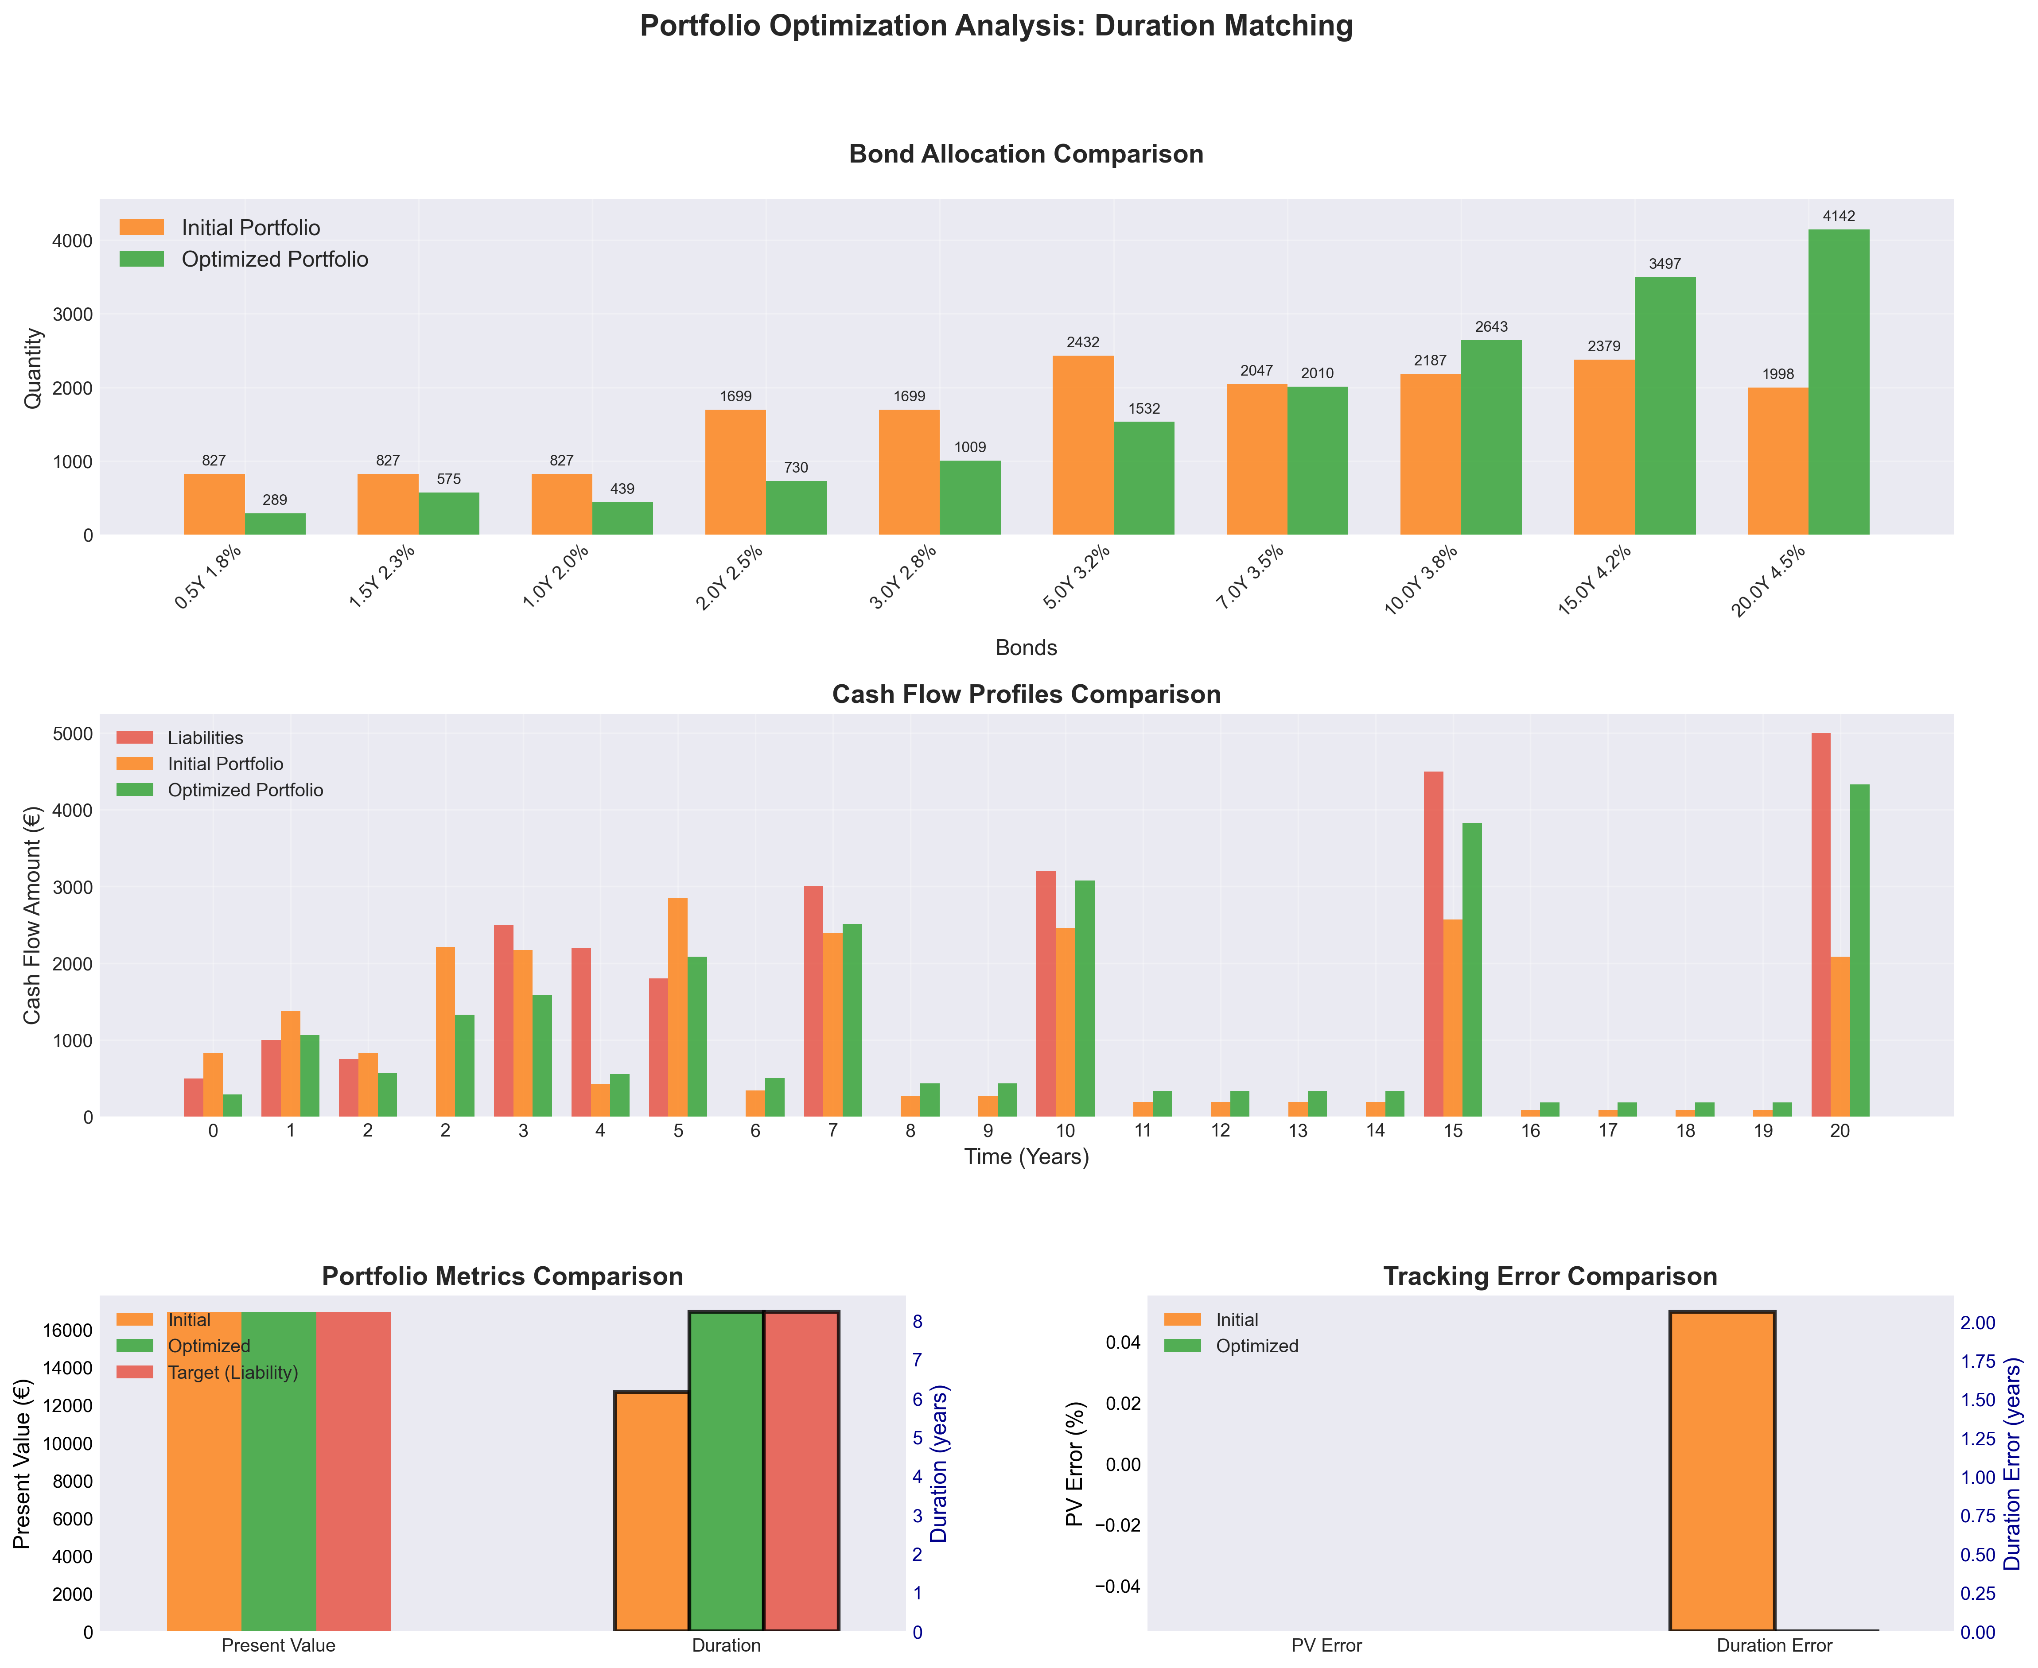
Figure 2: Results of optimization with duration matching constraint
In the above graph:
- In the first sub-graph, we observe the bond allocation
- In the second sub-graph, we observe the cash flow profile of the initial and optimized portfolio relative to the liability cash flows.
- In the last sub-graphs, we can observe the changes and tracking error rleated to PV and Duration

Conclusion
Interest rate hedging isn’t optional in today’s volatile environment. With the code snippets above that can be found in the repo, you now have a starting point to implement hedging that reduces risk while potentially saving significant regulatory capital. The code can be further enhanced to your organisational or personal requirements.

Next Steps and Contact
Please feel free to contact me at yuan-yow.wu@finalyse.com.

