1. Idea: <http://bmcbioinformatics.biomedcentral.com/articles/10.1186/1471-2105-14-93>
2. Used: <http://www.longair.net/edinburgh/imagej/tubeness/>
3. Product: ImageJ Plug-in:

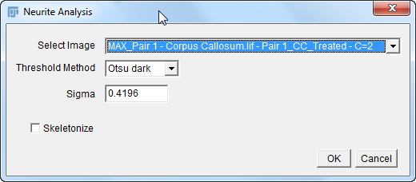

1. Batch Mode: macro

