**Shaheed Bhagat Singh State University**

**(Moga Road, Ferozepur-152004 (PB),India)**

**DEPARTMENT OF COMPUTER SCIENCE AND ENGINEERING**



­

**SIX WEEK SUMMER TRAINING (WEB DEVELOPMENT)**

(JUNE12,2023 – JULY 22,2023)

AT

**INFOWIZ , BATHINDA, PUNJAB**

**PROJECT REPORT**

ON

**SAFECITY SOLUTIONS (WEB DEVELOPMENT)**

UNDER THE GUIDANCE OF

**(AJAY MAINDOLA)**

**SUBMITTED BY:**

**Yashpal Puri**

**R.no. 211499**

**Sem- 5TH**

**B.Tech CSE B Group**

**Batch- 2021**

**TABLE OF CONTENT**

**ACKNOWLEDGEMENT** 1

**TRAINING CERTIFICATE** 2

**ABOUT INFOWIZ** 3

**WEB DEVELOPMENT** 4

**SAFECITY SOLUTIONS** 5

**INTRODUCTION TO SAFECITY SOLUTIONS** 6

**STUDY: EXISTING SYSTEM** 7

**OBJECTIVE OF SAFECITY SOLUTIONS** 8

**SAFECITY SOLUTIONS: USER MODULE** 9

**SAFECITY SOLUTIONS: ADMIN MODULE** 11

**CONCLUSION** 14

**FUTURE PLANNING** 15

# **ACKNOWLEDGEMENT**

I would like to sincerely thank Mr. Kamaljot Kansal, the Chief Executive Officer of Infowiz, for his essential advice, insights, and recommendations during this course.

I would especially like to express my gratitude to Mr. Ajay Mandola, my training mentor, who has always inspired me to work harder and provided me with important support.

I also want to thank my parents for their support and encouragement. I may not be able to finish this program to the best of my ability without their unwavering support. In addition, I want to express my gratitude to my friends for supporting me when I needed it.

# **TRAINING CERTIFICATE**

# **ABOUT INFOWIZ**

**INFOWIZ** is a nationally recognized IT company which is committed to provide highly customized integrated IT solution to clients and also renowned for superior training programs delivered by an enviable team of qualified experts and highly experienced trainers.

**INFOWIZ** is a 8 years young organization which has won the NATIONAL AWARD for 3 consecutive years 2014-15 and 2015-16 for BEST Industrial Training from Hon’able GOVERNOR of Punjab and Haryana Sh. Kaptan Singh Solanki. INFOWIZ is a member of Confederation of Indian Industry (CII membership number- N4654P) and also with an **ISO Certification** which has been working in the field of CSE, IT, ECE, MECHANICAL, CIVIL and EE, BBA & MBA.

Our skilled team of professionals make sure that the product is developed as per the customer’s needs and keeping the customer informed about the development of their project from time to time.In INFOWIZ our Research & Development arm offers SEO tools for SEM professionals.

**INFOWIZ** also provides **Technical Support & Consultancy** to Software Companies like JIA Group, Newzealand, Sagitech solutions Panchkula, Jarc infotech Mohali, Infonet Solution, Delhi etc.



# **WEB DEVELOPMENT**

Web development is the work involved in developing a website for the internet. Web development can range from developing a simple single static page of plain text to complex web based internet applications, electronic business and the social network services.

There are two broad visions of web development Front-End development (also called client side development) and back and development (also called server side development).

Front-End development refers to constructing what a user see when they load a web application.This is done with three codes HTML CSS and JavaScript.

Back-End development controls what goes on behind the scenes of a web application database. To generate the front end, back-end scripts are written in many different coding languages and frame such as PHP,Java, python,node.js etc. But I have learnt PHP as a back-end script In My summer training because PHP is the most popular script language and easy to learn.I also learnt structured query language (SQL) for handling relational database management system.

**Technology I learnt :**

I learnt these technology during the 6 weeks train period-

* HTML
* CSS
* Javascript
* Bootstrap
* PHP
* SQL

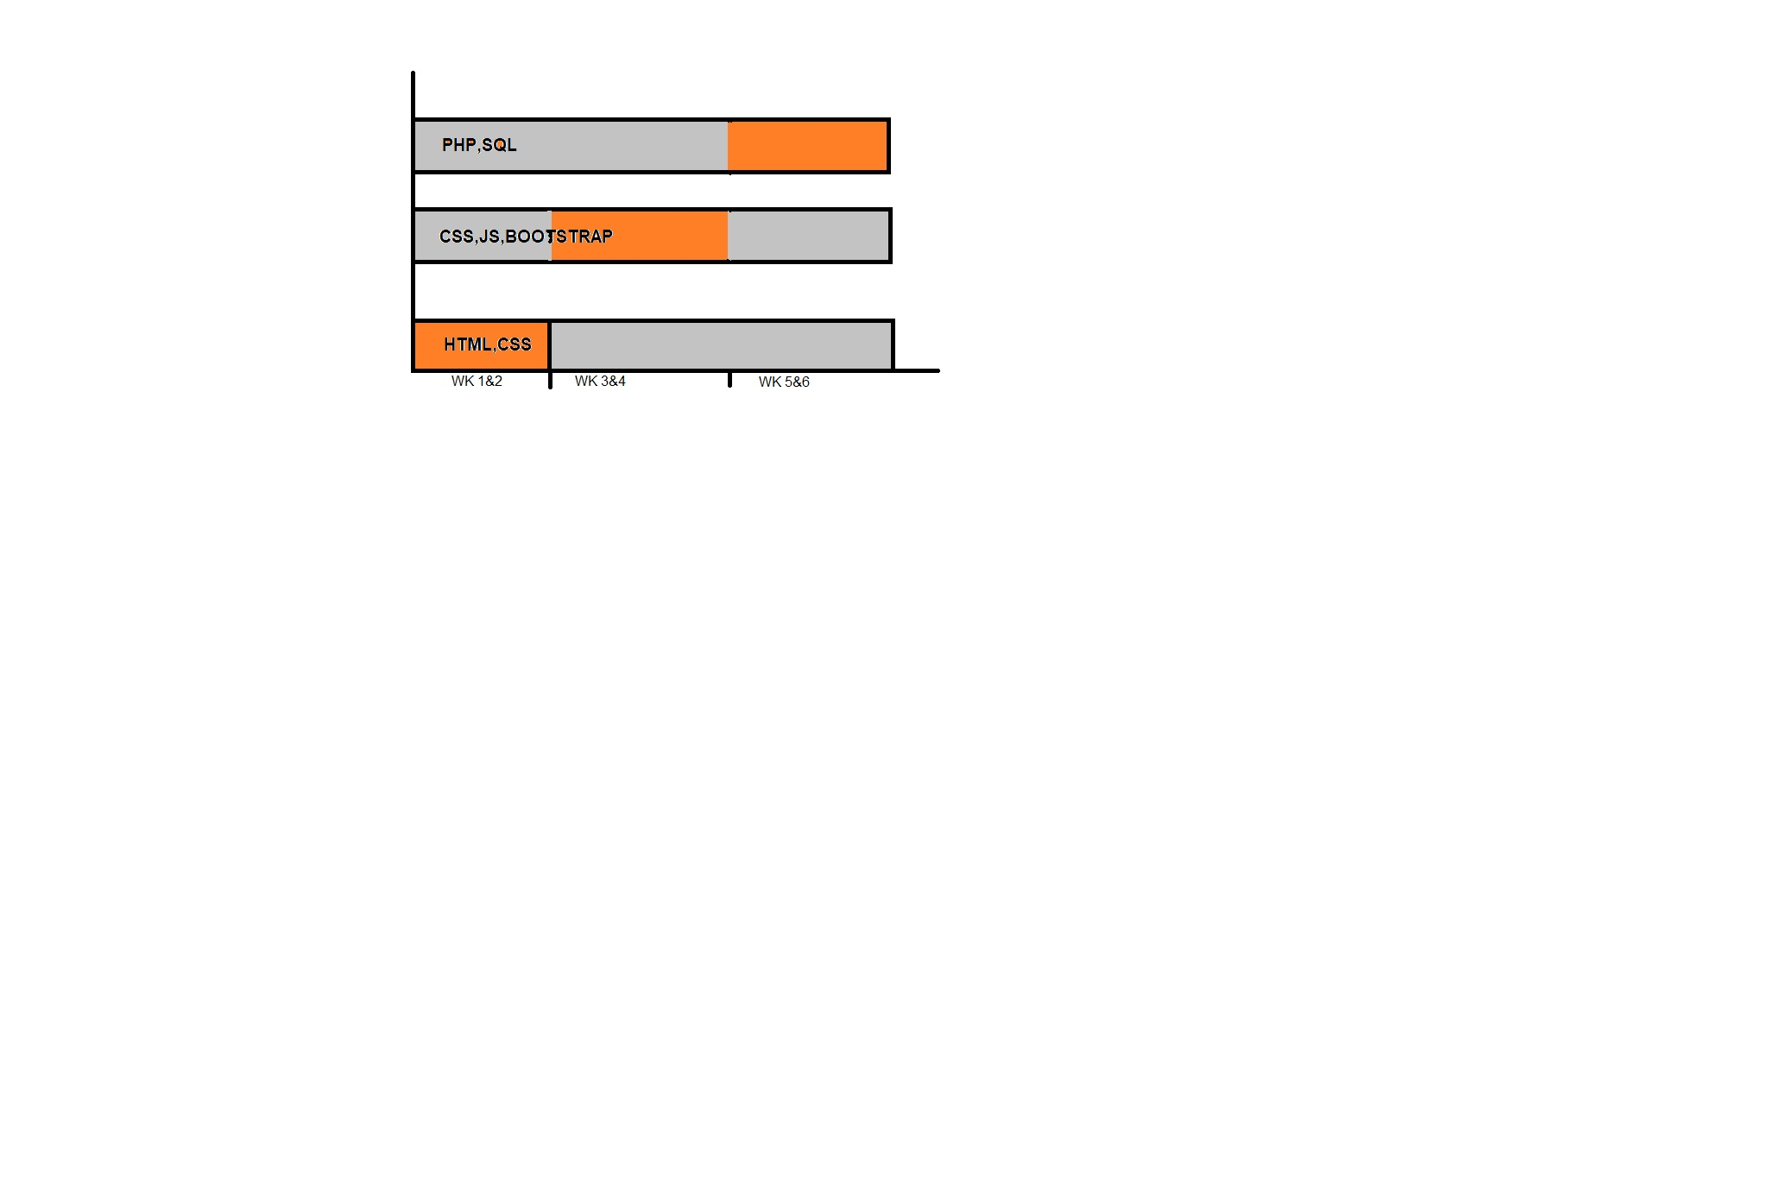

# **SAFECITY SOLUTIONS**



We can not promise to fix all your problems,

but We can promise you that you will not

face all problems alone.

**PROBLEM STATEMENT:**

The project title is to develop an online Complaint Reporting System which is easily accessible to the public and the Admin Department (high Authorities like Police).

This system registers the complaints from people through online mode. It will also helpful to police department in catching criminals. Person can give any complaint at any time.

# **INTRODUCTION TO SAFECITY SOLUTIONS**

* The project titled as “Safecity Solutions“ is a web based application. This software provides facility for reporting online Complaints’s & viewing their status. The Admin can view as well as update the status of the complaints.
* Any Number of clients can connect to the server. Each user first makes their login to sever to show their availability.
* The “Safecity Solutions” project is to provide all crime management solutions which are easily accessible to the user as well as the higher authority. The Crime application starts with the common people who want to log a complaint through the website, so it can be very useful for police department to find out the problem in the society without people are coming to the police station every time.

# **STUDY: EXISTING SYSTEM**

In the existing system only we can see the details of particular information about the police stations in a particular state, the existing system has more workload for the authorized person, but in the case of **Proposed System**, the user can registered in our site and register fir about a particular city or person.

**Limitations of Existing System:**

* More manpower
* Time Consuming
* Consumes a Lot of Hardwork

To avoid all these limitations and make the working more accurately system needs to be one step advance i.e. computerized.

# **OBJECTIVE OF SAFECITY SOLUTIONS**

* We know users are of many categories, like users from who know working with computers very well and users who didn’t know about computers. So all the category can use the system. So it should be **user friendly**.
* The software is made to work efficiently and effectively. It results in regular and timely action against crime reported. It can be observed that the information can be obtained easily and accurately.
* Better communication, Reducing crime and the Entire functioning should be less time consuming.
* The main aim of this project is to secure and make privacy on crime data over manually data storage. This website base project allow the users limited rights to access their own data.

# **SAFECITY SOLUTIONS: USER MODULE**

User can Perform Following activities on our System:

* **Registration:** User can create his/her account by simple registration process.
* **Login:** If User is already registered then he/she can login to get access.
* **Add Complaint:** After Successful login he/she can add new complaints.
* **View Complaints:** He/she can view all the complaints registered earlier from his/her account
* **View complaint Status:** He/she can see the status of the complaints registered by him/her.

**WORKING OF USER SECTION**

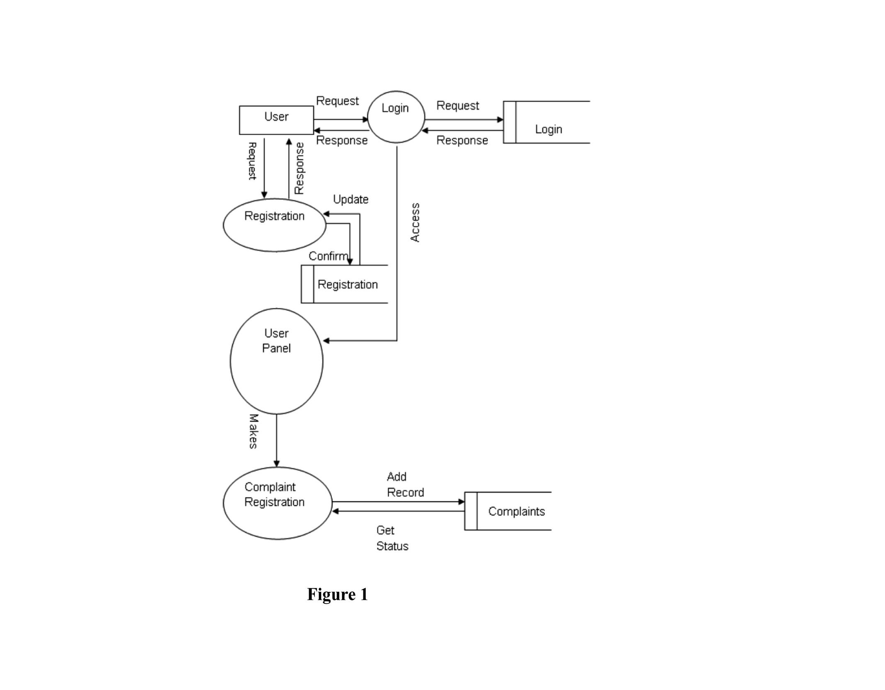

# **SAFECITY SOLUTIONS: ADMIN MODULE**

Admin can Browse Following activities on our System:

* **Registration:** Admin can’t create his/her account. Only Developer can create admin account.
* **Login:** Admincan login to get access.
* **View Complaints:** After Successful login he/she can View all the complaints registered by the user and the basic details of the user.
* **Update Complaints:** Admin can update the Complaint status of the respective user.
* **View complaint Status:** Admin can see the current status of compliants as well.

**WORKING OF ADMIN SECTION**

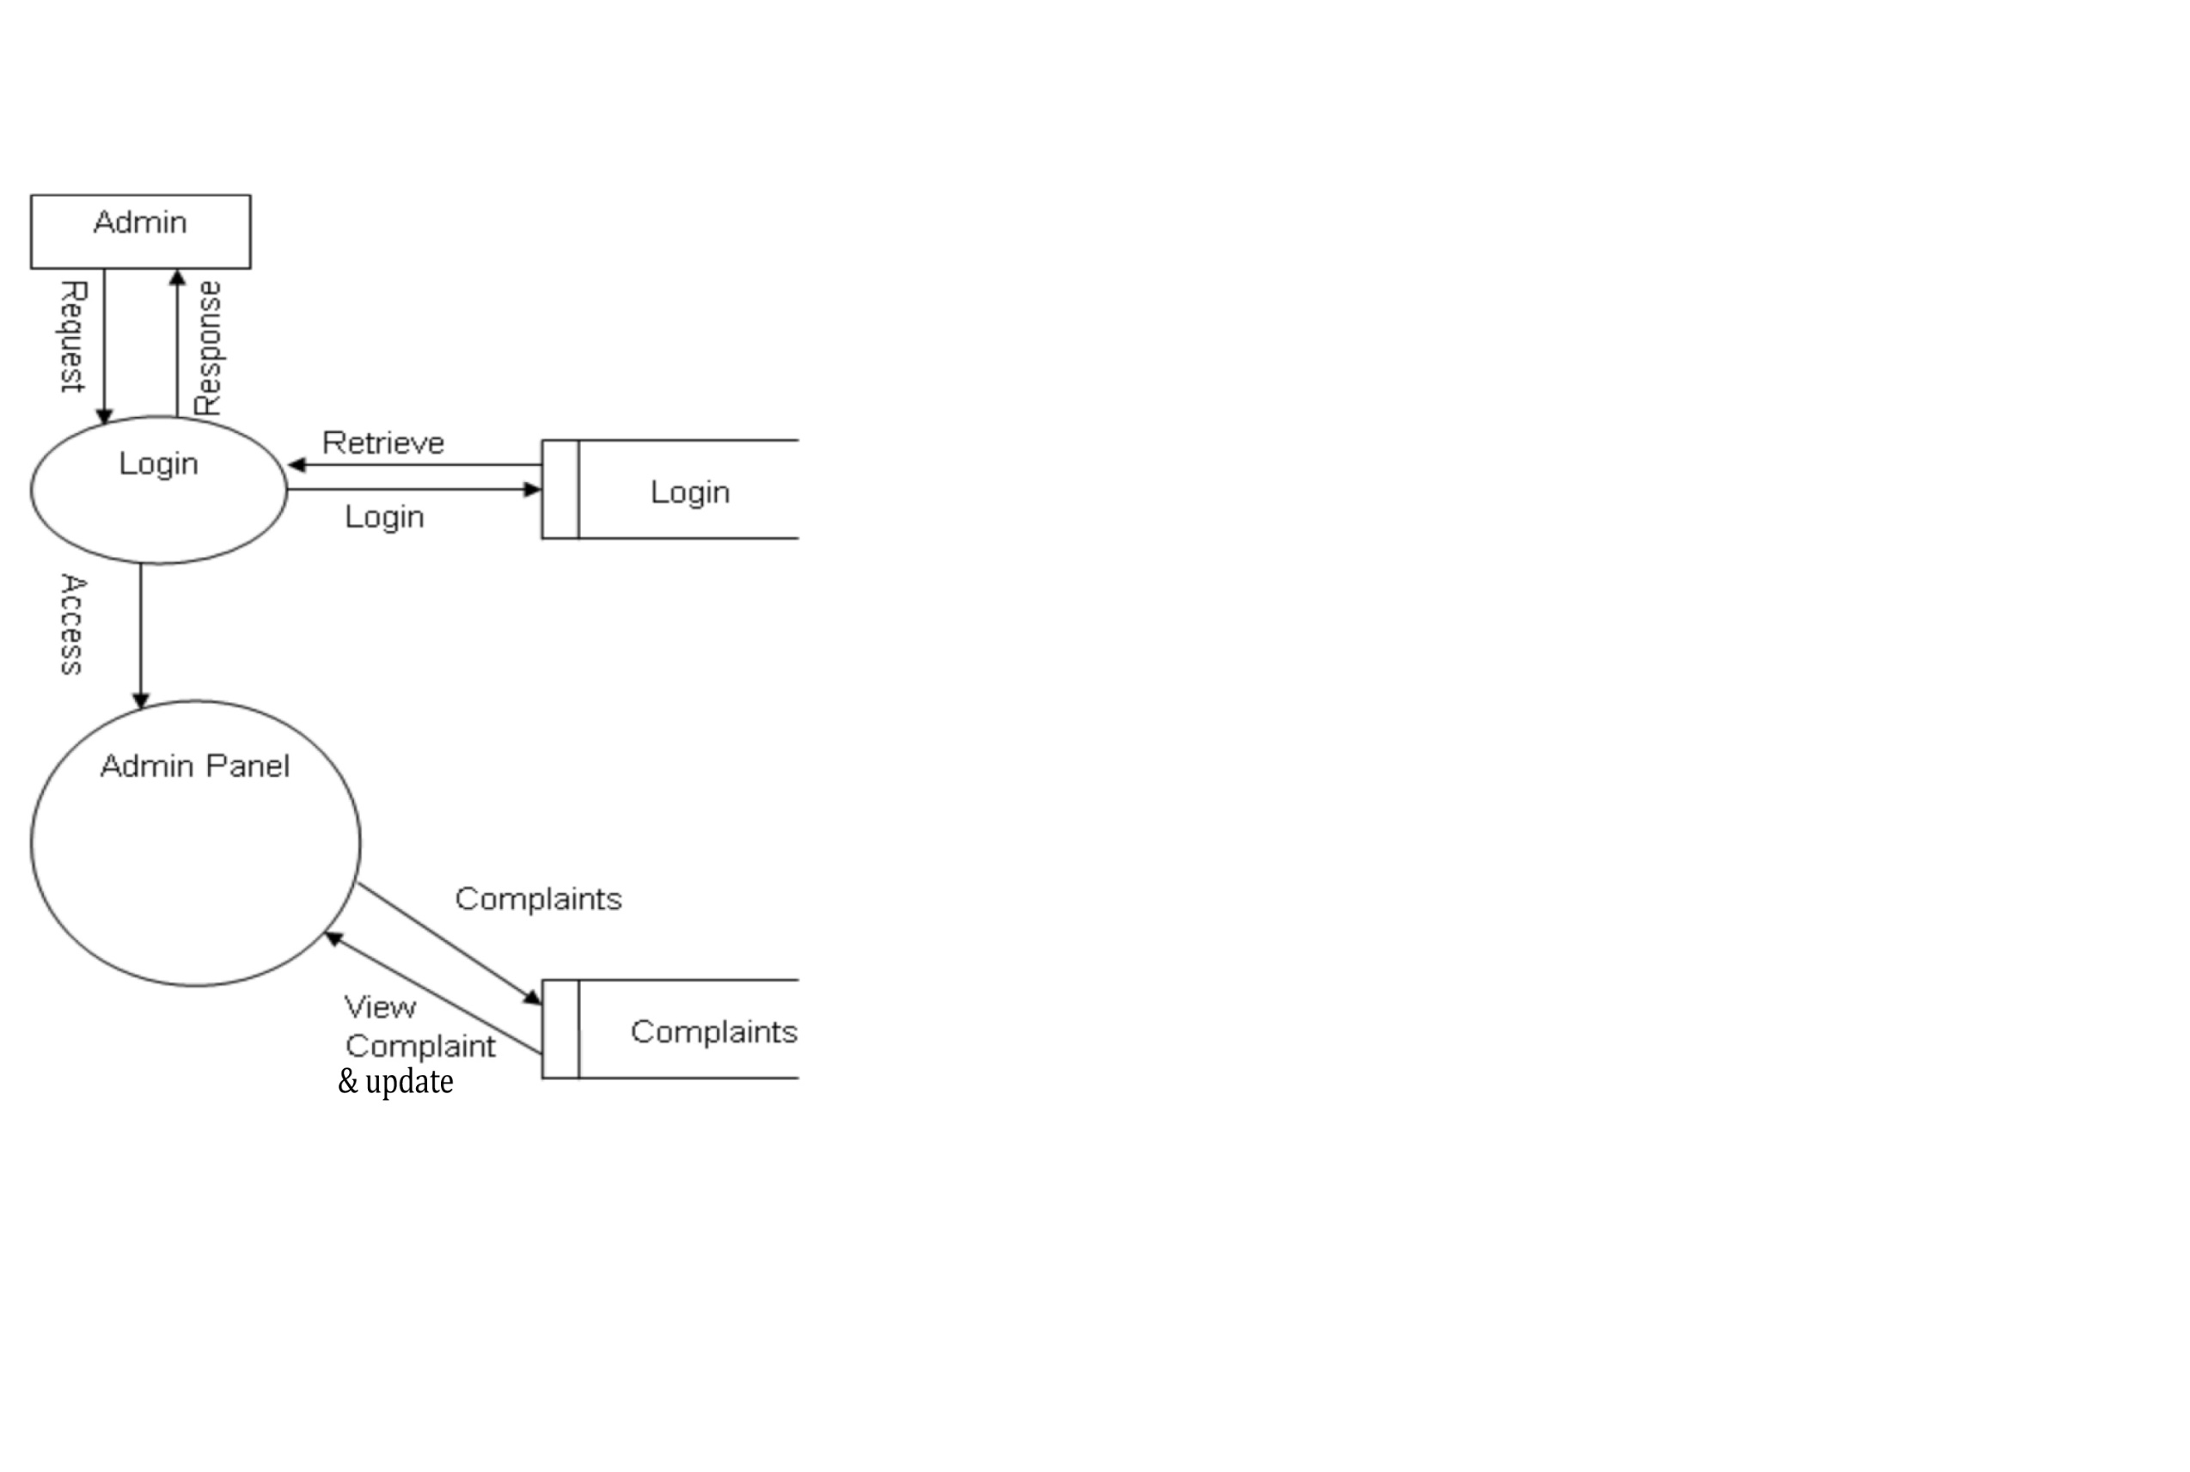

**PROCESSING OF SAFECITY SOLUTIONS**

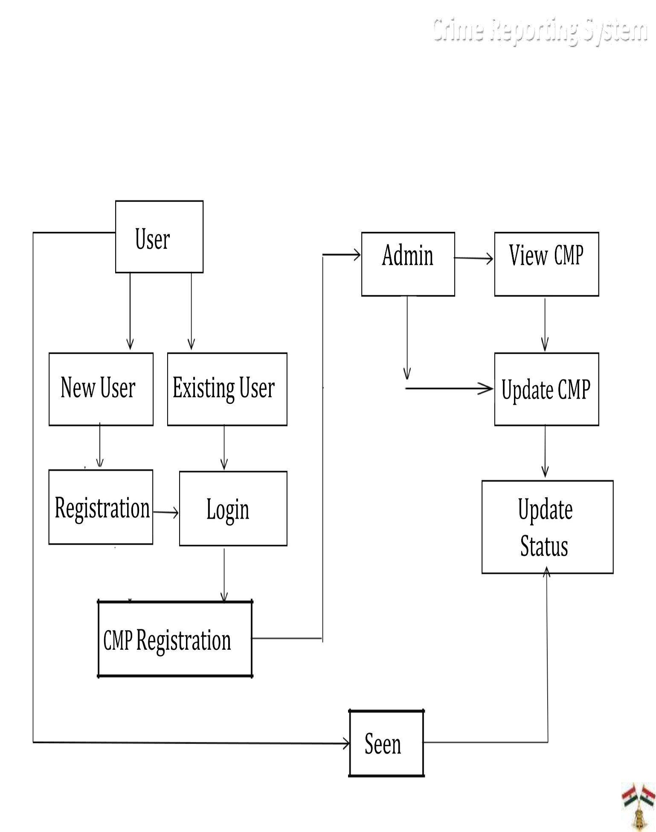

# **CONCLUSION**

In the modern world, the use of computers and Mobile phones is becoming so popular that nobody has time to go physically to any police station or any crime center to register their complaints. Because we are familiar with the slow processing of Indian rules and regulation. As a result this, **Safecity Solutions** system provides new technologies. It provide simple and effective interface to the user as well as admin so they can use it easily to enhance their work. By using this system the increasing rate of crime can be reduced.

This report has presented a simple, convenient, cost-effective, but efficient online complaint registration system with a user-friendly, sensitive and intelligible web interface. Whereby it can be accessed at any time anywhere provided that there should be good internet connection.

# **FUTURE PLANNING**

There are lot of limitations of the system. We are planning about the future Enhancement which shall be included in this software:

1. We are looking forward to work with the Government in implementing the recommendations and seeing an improvement in the effectiveness of the system.
2. There is only singe section of admin. We can add more sections like head, incharge, police stations and handover the complaints to incharges to allocate the complaints to the respective police station according to the location of crime.The head can control overall activity.
3. The method of video conferencing can be added with the employees.
4. There can be shown the details of the most wanted persons/criminals, news to the users at their interface.
5. This system is only for limited area of Punjab. We are planning to add more areas of India.

***THANK YOU***