**How to run QTP regression from website portal (so that it is running on 2 machines - QALAB1 and QALAB2 simultaneously.)**

**Prerequisite (IMPORTANT!)**: make sure you’re logged in to QALAB1 and QALAB2 remotely.

1. From your own machine’s browser navigate to: <http://qalab5.nti.notification.com/> (if this doesn’t work use <http://qalab5/>

You should see a web portal that looks like the following:

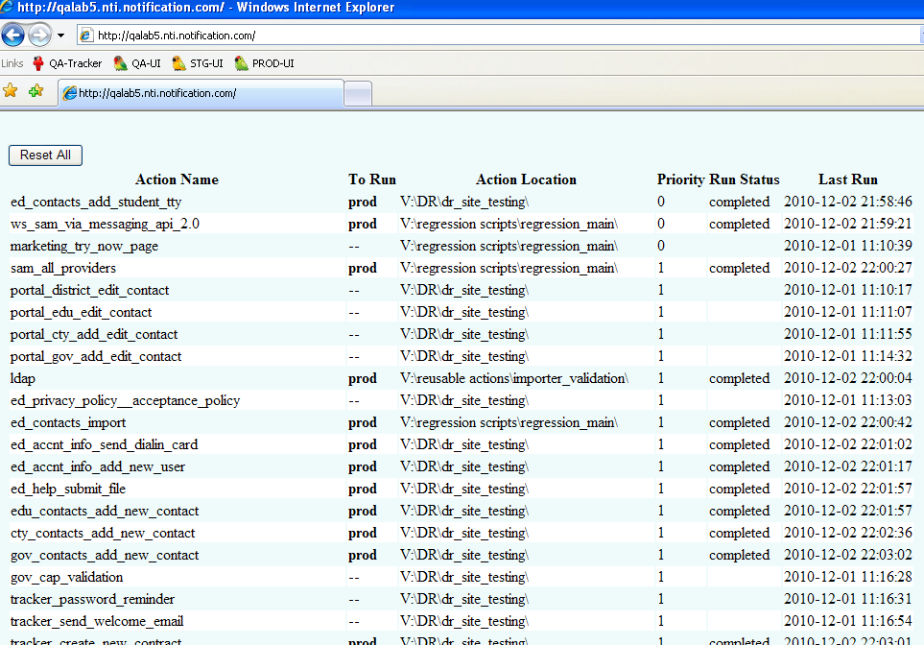

1. Click **Reset All** button on top of the page.

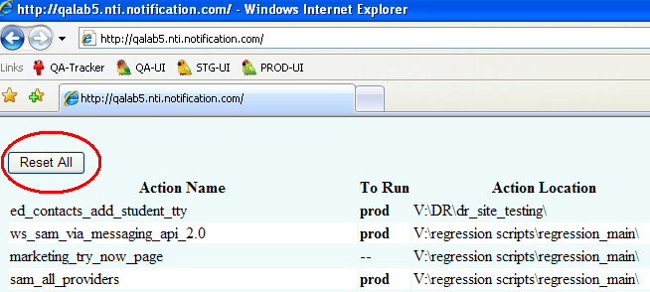

It should take you to reset page that looks like the following:

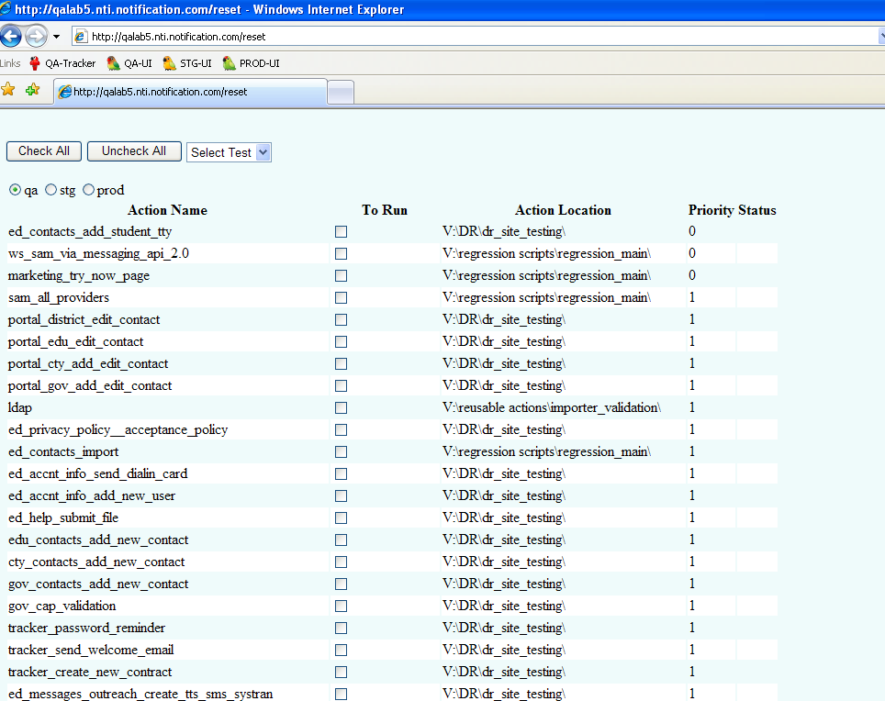

1. If you want to run comprehensive regression in QA or STG environments, click **Check All** button and select corresponding radio button for environments, (Note: you can manually select or un-select these checkboxes under **To Run** column.)

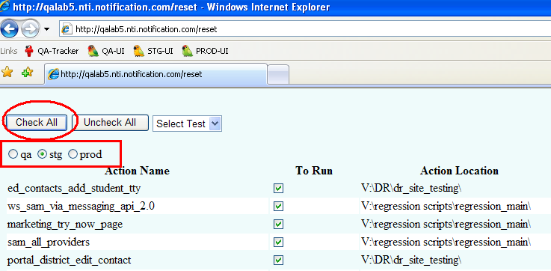

1. Scroll to the bottom of the reset page, and then click on **Run Selected** button.

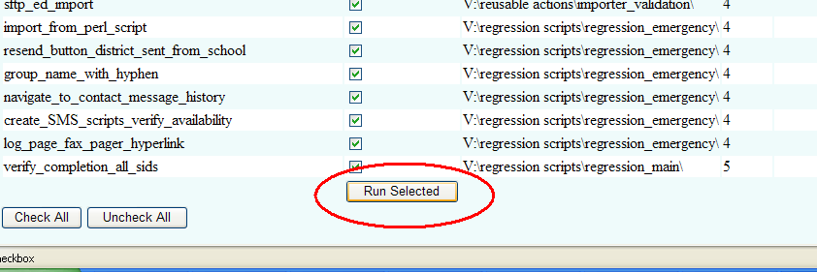

You will be taken back to the main web page in (Step 1), and you’ll notice that **To Run** column is marked with environment name to be run.

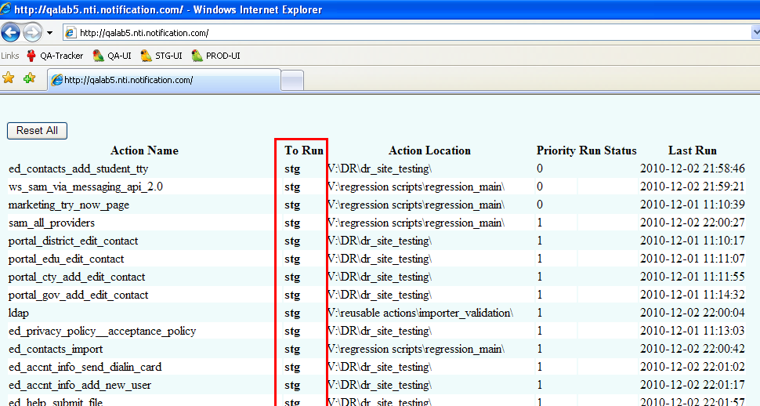

**What you just did…**

This will create schedule tasks to run a QTP test on QALAB1 and QALAB2. Notice that on QALAB1 and QALAB2 if you go to **Control Panel** > **Scheduled Tasks** you will see a task entry appear to be run 1 minute from current present time (see below screen shot on QALAB1 desktop):

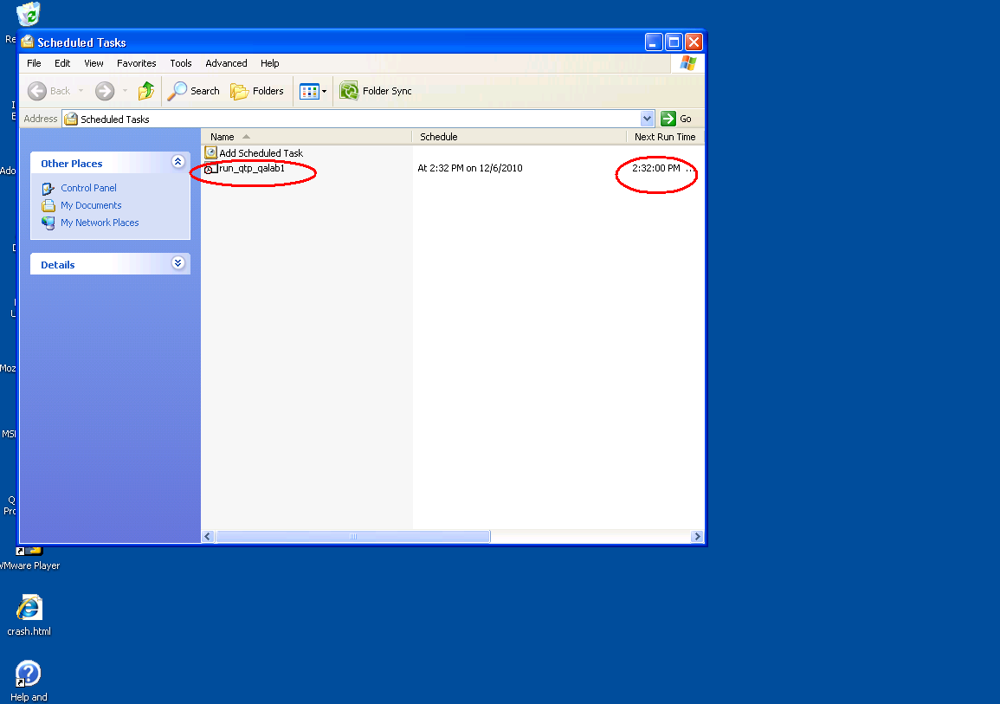

After 1 minute, you will see 2 things happen on QALAB1.

1. A python result generator will launch and wait (it says waiting..
2. A QTP test will start running

On QALAB 2, only QTP test will launch automatically and run.

If you refresh your browser, you start seeing action items “running…” and completed as QTP tests on QALAB1 and QALAB2 keep running one action after another.

Python script running/waiting on QALAB1 will kick off result generator once all tests are in ‘completed’ status. But this python script has a timeout for waiting: if QTP tests on either QALAB1 or QALAB2 or both are taking longer than 1+ hours it will just quit. In that case you will have to find raw QTP results in V:\test_res2\current\QALAB1\ and V:\test_res2\current\QALAB2\ folders.

Alternatively, you can manually run python result generator on QALAB1 from command line as follows:

On QALAB1: From **Start Manu** > Click **Run** > type in **cmd** > Click **OK**

>*c:* <Enter>

>*cd runsctipts* <Enter>

>*python result_gen.py* <Enter>

You should receive e-mail results in a few seconds.