

**AMRITA SCHOOL OF ENGINEERING, BANGALORE**

**AQUA-BOT**

**Submitted by**

BL.EN.U4ECE18155 T.LIKESH

BL.EN.U4ECE18008 ARANI SUSHMITHA

BL.EN.U4ECE18160 TEJESH ALANKA

BL.EN.U4ECE18122 POLINENI UDAY KIRAN

**15ECE495 PROJECT PHASE-1**

**MIDSEM PROJECT REPORT**

In partial ***fulfilment*** for Project Phase 1(15ECE495)

of

BACHELOR OF TECHNOLOGY

IN

ELECTRONICS AND COMMUNICATION ENGINEERING

# AMRITA VISHWA VIDYAPEETHAM

AMRITA SCHOOL OF ENGINEERING, BANGALORE, 560035



## 

This is to certify that the project report entitled “**AQUA BOT”** submitted by

BL.EN.U4ECE18155 T.LIKESH

BL.EN.U4ECE18008 ARANI SUSHMITHA

BL.EN.U4ECE18160 TEJESH ALANKA

BL.EN.U4ECE18122 POLINENI UDAY KIRAN

in partial fulfilment of the requirements of the Project Phase 1(15ECE 495) in

“**ELECTRONICS AND COMMUNICATION ENGINEERING”** is a bonafide record of the work carried out under my(our) guidance and supervision at Amrita School of Engineering, Bangalore.

Dr.Neelima

Project guide

Dept. of ECE

# Table of contents

1. INTRODUCTION…………………...…………………….….…………………4
   1. Overall System/scenario …………….………………………………….………4-5
   2. Objective…….……………………….………………………………………….6
   3. Methodology……………………………………….……………………………7
   4. Time table………………………………………………………………………..8

1. STATE OF ART ……………………….………………………………………...9
   1. INTRODUCTION …………….………………………………….……………..9
   2. Basic background with citations…….……………………….…………………9-10
   3. Related literature in detail……………………………………………………..10-12
2. DESIGN AND ANALYSIS ……………………………………………………..13
   1. System architecture …………….………………………………….…………13-14
   2. Design and analysis ………….…….……………………….…………………14-17
3. RESULTS AND DISCUSSIONS………………………………………………18
4. CONCLUSION AND FURTHER WORK………………..……………………19
   1. Conclusion,,,,,,,,,,,,,, …………….………………………………….…………19
   2. Further work…….. ………….…….……………………….…………………...19
5. REFERENCES……………………………….…………………………………20

**CHAPTER 1: INTRODUCTION**

**1.1 Overall System/Scenario**

**Problem Statement**

Plastic pollution has become one of the most pressing environmental issues, as rapidly increasing production of disposable plastic products overwhelms the world’s ability to deal with them. Plastic pollution is most visible in developing Asian and African nations, where garbage collection systems are often inefficient or non-existent. But even in developed countries, especially countries with low recycling rates, have trouble properly collecting discarded plastics. Plastic trash has become so ubiquitous that it has prompted efforts to write a global treaty negotiated by the United Nations. Most of the plastic trash in the oceans, Earth’s last sink, flows from land. Trash is carried to sea by major rivers, which act as conveyor belts, picking up more and more trash as they move downstream. Once at sea, much of the plastic trash remains in coastal waters. But once caught up in ocean currents, it can be transported around the world. Rivers are known to play a crucial role in transporting land-based plastic waste to the world's oceans, but riverine ecosystems are also directly affected by plastic pollution. Materials that can be recycled but get put into regular bins often will end up in landfills, and some countries don’t even have recycling programs as an option. When these items end up in landfills, the toxins can seep into the soils and make their way to the ocean through rivers; alternatively, many lightweight plastics can blow away in transit or from the landfill into drainage and rivers. Whether by autonomous drones, remote-controlled robots or swarms of conveyor belts, it’s clear that something drastic needs to be happen to clean up the world’s oceans. We’re currently on track to have more plastic than fish in the ocean by 2050, at which point it will be too late to save the oceans, and ourselves.

**Abstract**

Ocean plastic pollution has become one of the most pressing environmental issues. Every year, around 8 million tonnes of plastic end up in oceans. By 2025, the number of plastics in the ocean is predicted to double. Currently, according to researchers 245 million tonnes of plastic is floating on the ocean’s surface, but heavier plastics have sunk to the seafloor, where it is impossible to catalogue or quantify. plastic is carried to the sea by major rivers, which act as conveyor belts, picking up more and more plastic as they move downstream. The condition of the lakes and ponds in majority of the developing countries are abysmal. A lot of money and efforts are being spent by the government and private firms on cleaning and maintaining them at regular intervals. In order to address these issues trash vortex (autonomous robot) is built for rivers and lakes that can detect and collect plastic and other floating debris and also find the status of pollutants in water ensuring the safety of the drinking water supply. The system is IOT enabled with raspberry-pi and an internet dongle, embedded with a 4k camera, and sensors. The motion of the aqua-bot is supported by lithium batteries, propellers, motors and motor driver IC, navigation in water is based on the open cv technique. Open CV based navigation is achieved through mapping algorithms. The object detection technique is used to detect the floating debris and also differentiate between recyclable & non-recyclable waste. This project is aimed to control aqua bot wirelessly with remote. Developing Aqua bot reduces plastic growth on water bodies and collect critical water quality parameters. This will save a lot of human effort and provide a sustainable solution to the pervasive problem.

Few Citations:

* Hester, Ronald E. and Harrison, R.M. (eds.).”Marine Pollution and Human Health”.Royal Society of Chemistry,2011; pp. 84-85. ISBN 184973240X.
* Eriksen, Marcus. “Plastic Pollution in the World's Oceans: More than 5 Trillion Plastic Pieces Weighing over 250,000 Tons Afloat at Sea”. PLOS ONE, (10 Dec. 2014). 9: e111913. doi:10.1371/journal.pone.0111913.
* Ganguly, S. and Choudhary, S. (2018b) “Plastic pollution: an environmental concern.” Int. J. Emerg. Tech. Adv. Engg. 8(08): pp. 55.

**1.2 Objective**

Develop a sustainable solution that enhances the process of plastic waste collection on water bodies with less human interference, promote a healthier environment for marine life by using prime technology to promote sustainable development. Drone technology and its applications are ever-growing and are offering multiple and dynamic technological and social impacts such as low cost, carbon-free emission, require little preparation and infrastructure, and no fuel (other than batteries). Furthermore, they can be equipped with any number of sensors or cameras making them ideal for monitoring the environment and reducing human risk to visit poisonous water bodies to remove debris. Also, the proposed solution establishes a clear relationship between the Sustainable Development Goals, given by United Nations and the need to curb plastic pollution.

• SDG 3: Good health and well-being.

• SDG 6: Clean water and sanitation.

• SDG 11: Sustainable cities and communities.

• SDG 12: Responsible consumption and production.

• SDG 13: Climate action.

• SDG 14: Life below water (protection of the seas and oceans).

• SDG 15: Life on land (restore ecosystems and preserve diversity)

**Novelty:** To make aqua bot truly autonomous various prime techniques are brought together a collection of debris is done by autonomous navigation is achieved through open cv based on mapping algorithms, and operated by using remote .

**1.3 Methodology**

**Yolo architecture**:

YOLO is short for You Only Look Once. It is a real-time object recognition system that can

recognize multiple objects in a single frame. YOLO recognizes objects more precisely and

faster than other recognition systems.

The real-time recognition system will recognize multiple objects from an image and also

make a boundary box around the object. It can be easily trained and deployed in a

production system.

YOLO is based on a single Convolutional Neural Network (CNN). The CNN divides an

image into regions and then it predicts the boundary boxes and probabilities for each region.

It simultaneously predicts multiple bounding boxes and probabilities for those classes.

YOLO sees the entire image during training and test time so it implicitly encodes contextual

information about classes as well as their appearance.

**Open CV**:

OpenCV is an open-source computer vision and machine learning software library developed by Intel. It provides a common infrastructure for applications related to computer vision and its associated fields. It is used to speed up the use of real-time machine recognition of images, objects, and video processing applications.

The use of OpenCV library will allow you to:

* Read and write images
* Capture and save videos
* Image processing such as filtering and transformation
* Feature detection
* Video or image object detection such as human body parts, cars, signage, etc.
* Video analysis

**1.4 Time table:**

|  |  |
| --- | --- |
| **7th Sem Mid-Term** | * Identifying the problem statement. * Identifying techniques to implement. * Referred pre-existing models. * Discussed the flow of the implementation. * Learnt how YOLOV4 works * Implemented YOLOV4 architecture to detect plastic bottles. |
| **7th Sem end-sem** | * Finding distance from object to aqua bot * Navigation of aqua bot * Assembling raspberry pi and sensors |
| **8th Sem** | * Creating UI with dashboards * Connecting each pipeline to make it end to end * Hardware design |

**CHAPTER 2: STATE OF ART**

**2.1 Introduction**

In water waste object detection, the use of yolov4 in measuring accuracy is quite popular. It is an easy-to-use multi-purpose model which can be used for the detection, classification, and segmentation of day-to-day objects.

The Internet of Things (IoT) describes the network of physical objects “things” that are embedded with sensors, software, and other technologies for the purpose of connecting and exchanging data with other devices and systems over the internet.

**2.2 Basic background with few citations**

The original YOLO (You Only Look Once) was written by Joseph Redmon (now retired from CV) in a custom framework called Darknet. Darknet is a very flexible research framework written in low level languages and has produced a series of the best real time object detectors in computer vision: YOLO, YOLOv2, YOLOv3, and now, YOLOv4.

**The Original YOLO -**YOLO was the first object detection network to combine the problem of drawing bounding boxes and identifying class labels in one end-to-end differentiable network.

**YOLOv2 -**YOLOv2 made a number of iterative improvements on top of YOLO including Batch Norm, higher resolution, and anchor boxes.

**YOLOv3 -**YOLOv3 built upon previous models by adding an objectiness score to bounding box prediction, added connections to the backbone network layers, and made predictions at three separate levels of granularity to improve performance on smaller objects.

**IOT:**

**Internet of Things (IoT)** is the networking of physical objects that contain electronics embedded within their architecture in order to communicate and sense interactions amongst each other or with respect to the external environment. In the upcoming years, IoT-based technology will offer advanced levels of services and practically change the way people lead their daily lives. Advancements in medicine, power, gene therapies, agriculture, smart cities, and smart homes are just a very few of the categorical examples where IoT is strongly established.

**2.3 Related literature in detail**

**Yolo v4 architecture**

1. A CNN network using yolo architecture is trained for object detection for customized classes with various datasets. To detect and classify the images.

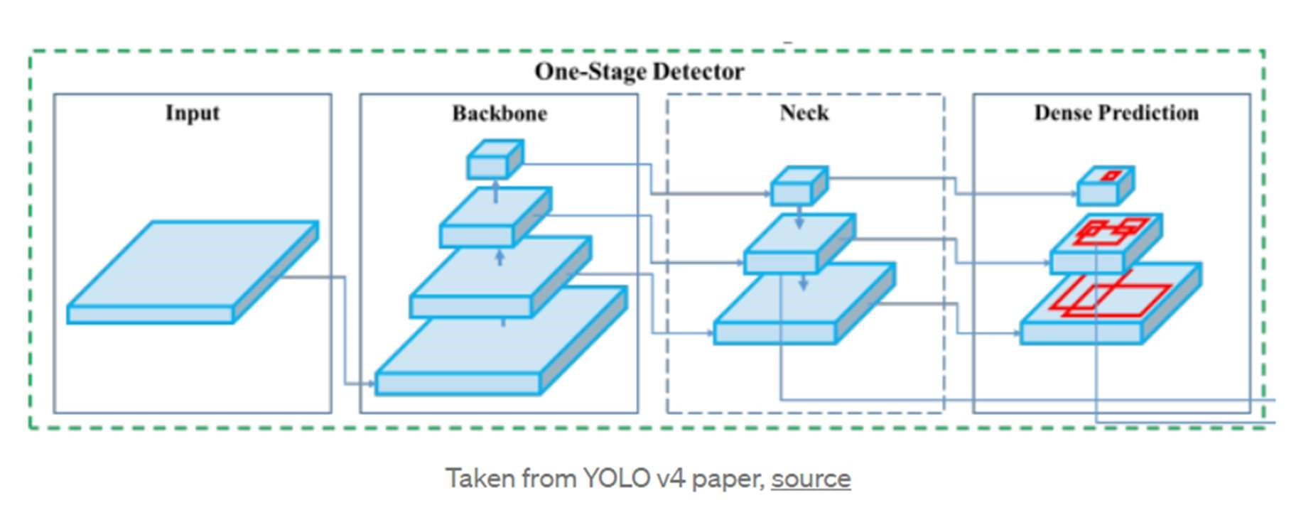

**Backbone**

Models such as ResNet, DenseNet, VGG, etc, are used as feature extractors. They are pre-trained on image classification datasets, like ImageNet, and then fine-tuned on the detection dataset. Turns out that, these networks that produce different levels of features with higher semantics as the network gets deeper (more layers), are useful for latter parts of the object detection network.

**Neck**

These are extra layers that go in between the backbone and head. They are used to extract different feature maps of different stages of the backbone.

**Head**

This is a network in charge of actually doing the detection part (classification and regression) of bounding boxes. A single output may look like (depending on the implementation): 4 values describing the predicted bounding box (x, y, h, w) and the probability of k classes + 1 (one extra for background). Objected detectors anchor-based, like YOLO, apply the head network to each anchor box. Other popular one-stage detectors, which are anchor-based, are: Single Shot Detector[6] and RetinaNet[4]. 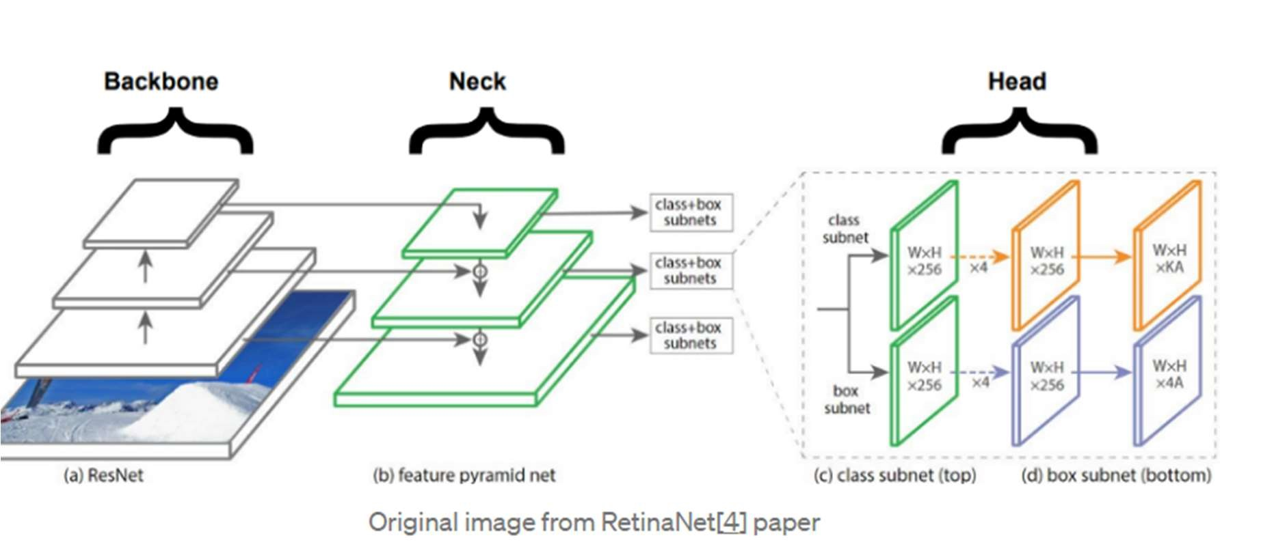

**What is new in YOLOv4?**

YOLOv4’s architecture is composed of CSPDarknet53 as a backbone, spatial pyramid pooling additional module, PANet path-aggregation neck and YOLOv3 head.

CSPDarknet53 is a novel backbone that can enhance the learning capability of CNN. The spatial pyramid pooling block is added over CSPDarknet53 to increase the receptive field and separate out the most significant context features.

**How does IoT work?**

An IoT ecosystem consists of web-enabled smart devices that use embedded systems, such as processors, sensors and communication hardware, to collect, send and act on data they acquire from their environments. [IoT devices](https://internetofthingsagenda.techtarget.com/definition/IoT-device) share the sensor data they collect by connecting to an [IoT gateway](https://whatis.techtarget.com/definition/IoT-gateway) or other edge device where data is either sent to the cloud to be analysed or analysed locally. Sometimes, these devices communicate with other related devices and act on the information they get from one another. The devices do most of the work without human intervention, although people can interact with the devices -- for instance, to set them up, give them instructions or access the data.

**CHAPTER 3: DESIGN AND ANALYSIS.**

**3.1 System Architecture:**

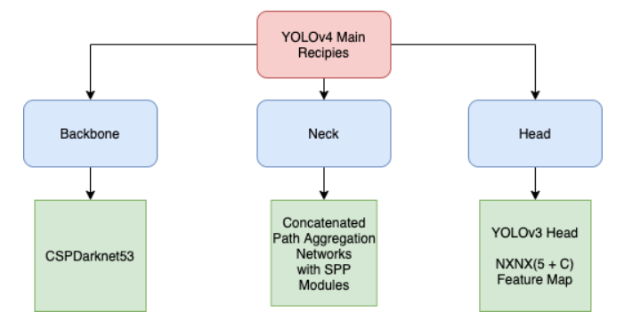

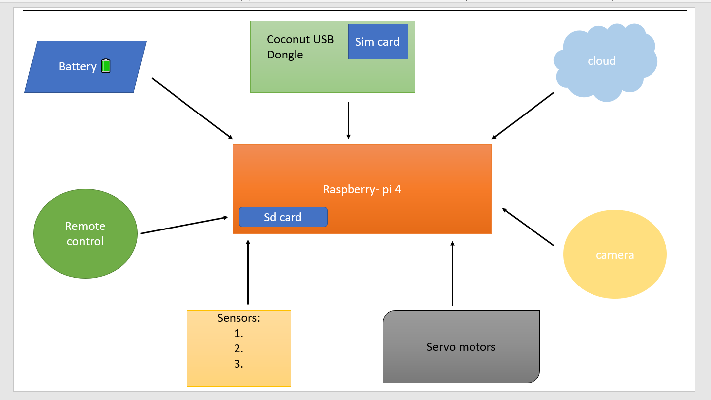

**3.2 Design and Analysis:**

We propose to design AQUABOT, an intelligent floating drone, embedded with a 4k camera above it and a filtering mesh underneath. The floating drone will move on the water with help of batteries and propellers detecting and collecting all floating waste (plastic, wood, paper cups, textile waste, nets) at the same time sending real-time data from embedded sensors regarding the water quality.

* 1.Detecting and collecting floating waste.
* 2.Detecting the obstacle.
* 3.Collecting Real-time data of water.
* 4.Categorizing the collected waste.
* 5.Remote control.
* 6.Adaptability.

**Datasets:**

**a. Dataset**

* Taco
* Trash net
* Aqua trash
* Collection of images of boats, rocks, riverbeds.

**b.Data points:**

* cardboard
* paper
* plastic
* trash
* Boats
* Rocks
* Riverbed

**c.Obstacle detection:**

* Boats
* Huge rocks
* River bed

**d.Categorizing the waste:**

* Non plastic waste
* Plastic waste
* Garbage waste

**Object Detection Code**

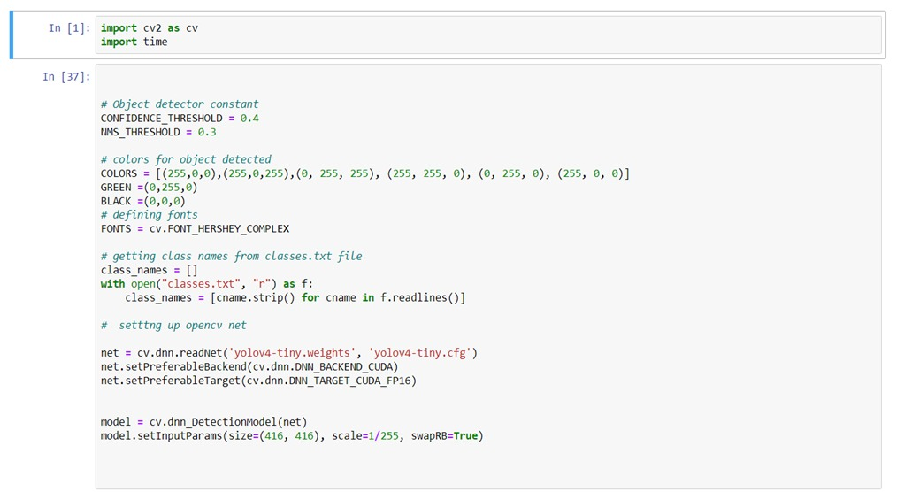

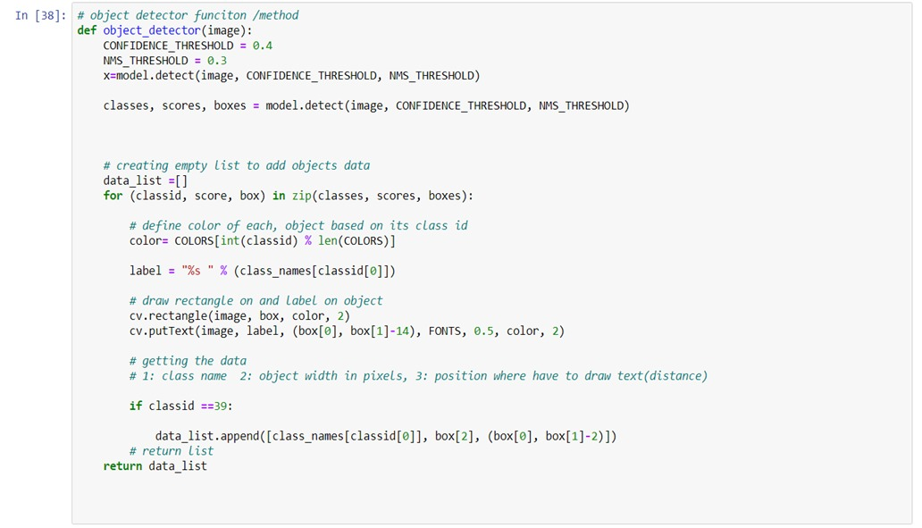

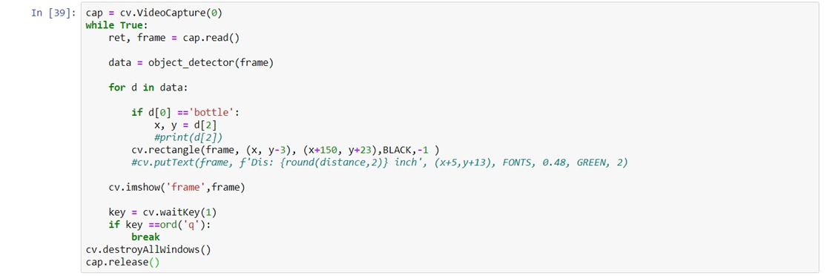

**CHAPTER 4: RESULTS AND DISCUSSIONS**

Predicted the output of the model with images taken on water bodies.

Successfully detected 90% of images of class plastic floating on water.

Successfully detected 80% of images of class paper floating on water.

**CHAPTER 5: CONCLUSION AND FURTHER WORK**

**5.1 Conclusion:**

Found an innovative method to remove floating debris on the water bodies to reduce ocean plastic. This is achieved using AI and IOT techniques together.

Object Detection using YOLO V4 successfully completed(i.e. successfully detected plastic and non plastic waste such as bottle, apple, paper, vase ,toothbrush, hair drier, etc).

**5.2 Further Work:**

•Finding distance from Aqua-Bot to the object identified.

•Implementing navigation techniques.

•Rigging sensors, camera and raspberry-pi together.

•Building Aqua-Bot.

•Connecting all pipelines to make end to end.

**References**

[1] J. Redmon, S. Divvala, R. Girshick, and A. Farhadi, “You only look once: Unified, real-time object detection,” in CVPR, Open CV: optical flow-Open CV documentation, (2016)16-21.

[2] P. Nowakowski, T. Pamu-la,” Application of deep learning object classifier to improve e- waste collection planning”, Waste Manag. 109 (2020) 1–9

[3] L. G. A. Barboza, A. Dick Vethaak, B. R. Lavorante, A.-K. Lundebye, L. Guilhermino, “Marine microplastic debris: An emerging issue for food security, food safety and human health, Marine Pollution Bulletin” 133 (2018) 336–348

[4] C. Schmidt, T. Krauth, S. Wagner,” Export of plastic debris by rivers into the sea, Environmental science & technology 51” (2017) 12246– 12253.

[5] A. Nollkaemper, “Land-based discharges of marine debris: from local to global regulation, Marine Pollution Bulletin” 28 (1994) 649–652.

[6] U. EPA, “Municipal solid waste generation, recycling, and disposal in the united states tables and figures for 2012,”, Office of Resource Conservation and Recovery (2014),23-29

[7] A. L. Andrady,” Microplastics in the marine environment, Marine pollution bulletin” (2011) ,1596–1605

[8] H. Panwar, P. Gupta, M. K. Siddiqui, R. Morales-Menendez, P. Bhardwaj, S. Sharma, I. H. Sarker, “Aquavision: Automating the detection of waste in water bodies using deep transfer learning”, Case Studies in Chemical and Environmental Engineering (2020), 10-26.

[9] S. Rech, V. Macaya-Caquilpán, J. Pantoja, M. Rivadeneira, D. J. Madariaga, M. Thiel, “Rivers as a source of marine litter–a study from the se pacific,Marine pollution bulletin” 82 (2014) 66–75

[10]A. Bochkovskiy, C.-Y. Wang, H.-Y. M. Liao, “Yolov4: Optimal speed and accuracy of object detection”, 2020,7-17

[11] G. Tata, “DeepPlastic: An Open Source Image Dataset for Epipelagic Marine Plastic Detection”, 2021,19-35